**Microservices Part 2 of 8**

Contents

Microservices Implementation 2

Evolution of Microservices Architecture 6

Spring Boot Framework 18

Implementing REST Services 19

Initial Setup 22

Accounts Microservice Implementation 69

Documentation – Swagger 174

Loans Microservice Implementation 219

# Microservices Implementation

<https://tsys.udemy.com/course/master-microservices-with-spring-docker-kubernetes/learn/lecture/27348378#overview>

Github Link: <https://github.com/eazybytes/microservices/tree/3.4.1/section4>

Microservices architecture makes applications easier to scale, faster to develop, enable innovation, and it is also going to help organizations by accelerating the time to take their new enhancements to the market.



How to build a microservices with the help of Spring Boot by following the production standards.

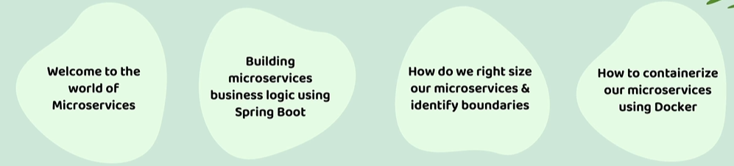

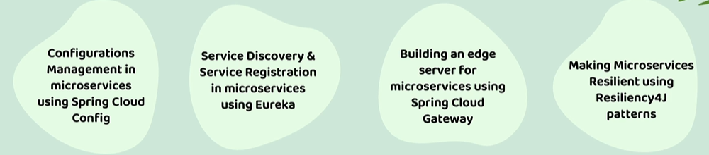

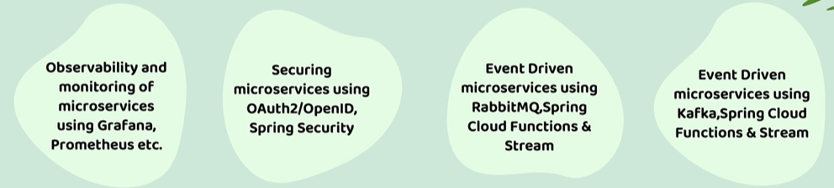

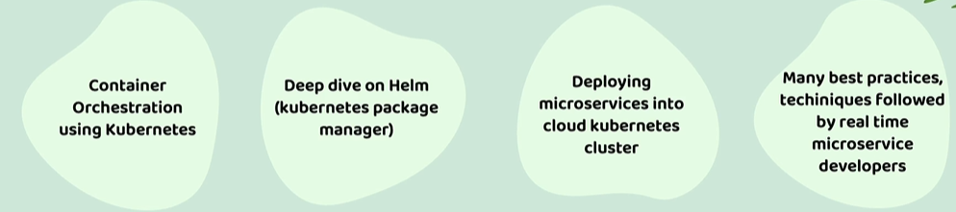

These standards includes best practices while building rest APIs, how to document your Rest APIs, how to perform validations on top of your rest APIs, all these standards and best practices we are going to discuss while building microservices throughout this course. And apart from building microservices, we will also see how to rightsize your microservices, how to identify boundaries and how to containerize your microservices with the help of Docker, because without knowing on how to containerize your spring boot application, you cannot really build microservices. That's why learning about Docker is very basic need for a microservice developer.

So once we learn about how to containerize our microservices, I'm going to explain you how to maintain configurations inside your microservices with the help of spring cloud config server, followed by how to build your own service discovery and service registration inside microservices using Eureka Server and how to build an edge server or an entry point into your microservice network with the help of Spring Cloud Gateway.

And apart from building your microservices, you should also take care of making your microservices resilient and fault tolerant by using standards like resiliency4j patterns. So these patterns are also discussed throughout this course in detail. Once building microservices is completed, you should also take care of how to implement observability and monitoring inside your microservices by using supporting components like Grafana, Prometheus. So all these components we are going to explore and we are going to implement observability and monitoring inside our microservices. And we can't climb our microservices as production ready without securing our microservices.

That's why we are also going to put good amount of efforts in understanding how to secure our microservices. Using Oauth2, OpenID, Spring Security Frameworks. And sometimes you may also want to build some microservices which can process the requests asynchronously. So to handle such scenarios, I'm going to explain you how to build event driven microservices with the help of Rabbitmq, Spring cloud functions and spring cloud stream. Very similarly, we are also going to explore how to build event driven microservices with the help of Kafka as well.

And at last we are also going to learn on how to deploy all our containers into a Kubernetes cluster. So Kubernetes cluster is an container orchestration product. At the end of the day, all our microservice has to be deployed into a Kubernetes cluster. That's why we are also going to focus on learning about Kubernetes, how to deploy your microservices into your Kubernetes cluster. And once we are clear about Kubernetes, we are also going to learn about Helm, which is a Kubernetes package manager.

Once we are clear about Helm, we are also going to deploy our microservices into one of the cloud environment. So by logging into your cloud environment, we are going to create a Kubernetes cluster and deploy all our microservices into cloud environment.

Apart from all these components, we are going to learn many best practices, techniques that are followed by the real time microservice developers. So with all these agenda, this course is going to help you to master microservices and clear any interviews. Apart from these course agenda I also want to highlight that entire course is built using easily understandable format. Any complex topic you will be able to easily understand with a beautiful visuals that we are going to discuss throughout this course. All these visuals is going to help you to easily digest any kind of complex topic. And I'm also going to share you all this content in an PDF format for your reference. So that in future, whenever you have some questions, you can always refer these PDF for any questions and quickly refresh your microservices skills.

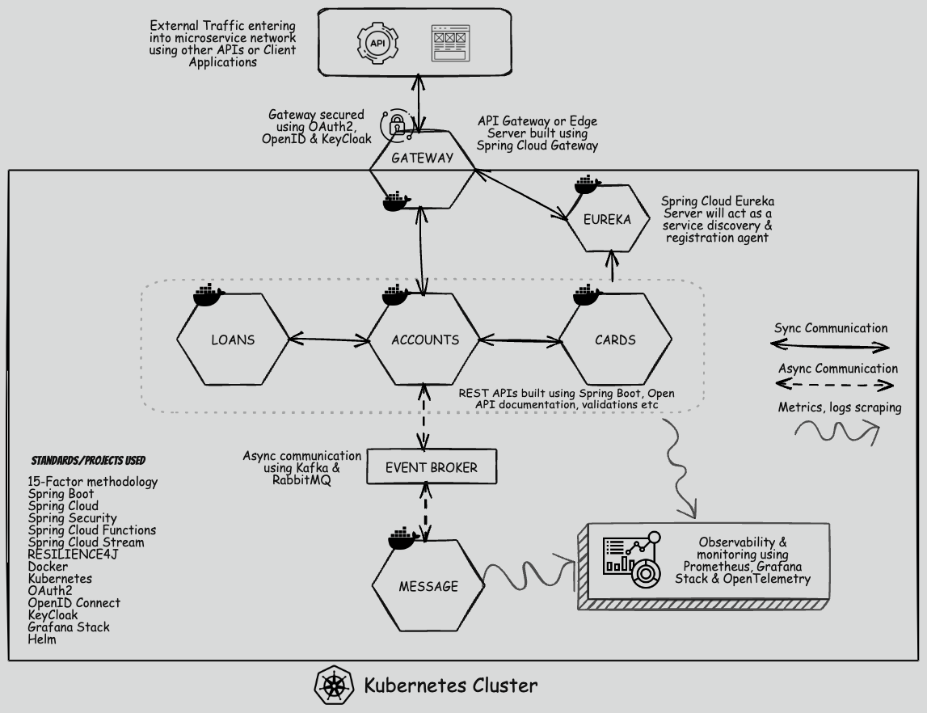

Code is here: <https://github.com/eazybytes/microservices>

## Evolution of Microservices Architecture

We can call these microservices as one of the architecture style that we can consider to build our web applications. So to understand more about microservices, let's try to take an bank application with the name EasyBank and this bank application, just like any other bank application, it provides various products to its customers with the name, accounts, cards and loans. So for these EasyBank, in order to build a web application, there are multiple architecture patterns available inside the industry.

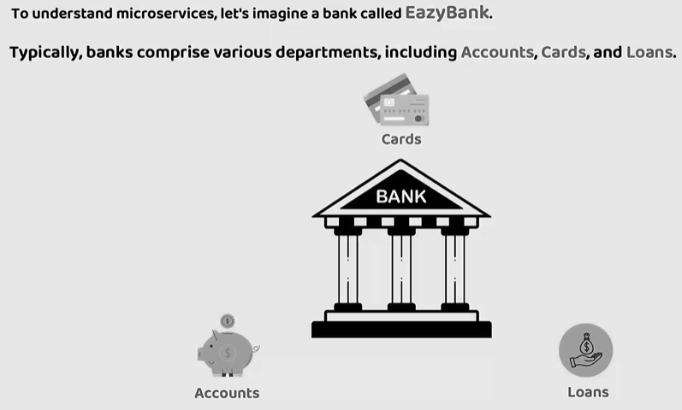

The very first are traditional approach for the Web application is Monolith. Back a decade, all applications used to be deployed as a Single unit where all functionality deployed together inside a single server. We call this architecture approach as Monolithic.

|  |  |  |
| --- | --- | --- |
|  | Pros | Cons |
| Simpler development and deployment for smaller teams and applications  Fewer cross-cutting concerns  Better performance due to no network latency | Difficult to adopt new technologies  Limited agility  Single code base and difficult to maintain  Not Fault tolerance  Tiny update and feature development always need a full deployment |

We have various forms of Monolithic with the names like

* Single-Process Monolith
* Modular Monolith
* Distributed Monolith

Whenever we are following the pattern of monolith, all the business functionality of a bank application, they will be deployed as a single unit. If you see here inside a single server, it has a presentation layer related logic like HTML code, JavaScript, CSS and post that there is going to be a backend business logic along with that data access layer. And one more important feature of monolithic is it is going to have a single supporting database where we store all the data related to accounts, cards and loans. This is the architecture style that companies are developers they use to follow back decade.

And off course this approach has its own advantages and disadvantages. So first let's try to understand what are the advantages of this monolithic architecture. The very first advantage is this architecture style supports simpler development and deployment for smaller teams and applications. If you have a small team or if your application is a very small application, definitely this pattern is going to make sense because it is going to ease your development and deployment with a single deployment all your web application is going to be deployed and it is going to be available for the end users. And on the similar lines, since we are deploying everything inside a single server, there are going to be a fewer cross-cutting concerns. When I say cross-cutting concerns, all your non-functional requirements like security, auditing, logging. This is going to be simple inside monolithic because all your code deployed inside a single server as an web application.

And the next advantage that we have with monolithic is, it is going to provide better performance due to no network latency. Why better performance? Because all the code is deployed inside a single server. If accounts business logic want to communicate with cards or loans, it is just going to be a method call inside the same server. There is no network call with the help of web services. So with this reason, monolithic applications, they are going to have a better performance. Now these are the advantages.

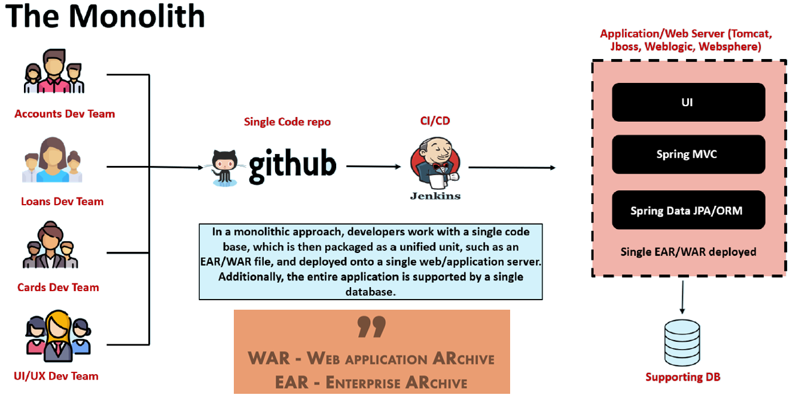

Let's go to the disadvantages of monolithic with the monolithic the primary disadvantage is it is difficult to adopt new technology. Like whenever I want to enhance my web application with the new frameworks or with the new languages or new technology, either I has to update my entire codebase or I need to continue with the old technology. Sometimes the accounts team members, they may want to move to a latest framework or latest language or latest version of the framework, but there will be a pushback coming from the Cards and Loans team members.

So with all these reasons, it is going to be difficult to adopt new technologies and with that reason, very limited agility inside a monolithic applications. It is not going to work like you decided to move to a framework or a new language today. And you can't do that immediately in a week or a month time. It is going to take a lot of time to upgrade your monolithic application because entire your code is tightly coupled. We never know what issues it is going to create when we try to migrate. With that reason a rigorous testing and regression has to be done on top of your web application. And since we are going to maintain everything inside a single server, all the code related to your web application is going to maintain as a single code base, which is going to be difficult to maintain over the time as your application is growing with the new enhancements day by day. And the next disadvantage that we have here is your application is not going to be a fault tolerance, which means you are going to be having a frequent issues with the scalability, availability of your monolithic application. And the last disadvantage like you can see since you deployed everything inside a single server if loans development team, they want to introduce a small feature or if they want to make a small enhancement inside their codebase, it will require a full deployment due to that reason your entire web application is going to be having a downtime and this is going to be a super drawback whenever you're dealing with the end users. Who uses your web application 24/7 ?

This monolithic architecture is developed in various forms inside the industry, like single process monolithic, modular monolithic, distributed monolithic, regardless of what is a form of monolithic pattern is being followed. It will have all these drawbacks that we discussed, and it is going to be having only a single supporting database. I hope you are clear. Like what is monolithic architecture pattern? Let me try to explain monolithic by taking a different perspective inside our EasyBank web application typically, there will be development team handling the accounts, loans, cards and UI, UX inside monolithic applications. All these developers, they are going to work on a single code base. And using these single code base, we are going to deploy the entire our web application into a web server or application server with the help of CI/CD tools like Jenkins.

Typically, we will package all our code base into a war format or an ear format and deploy into a single web application. And this single web application is going to be supported by a single database. So here the major drawback is there is no flexibility to the organization and developers to introduce new features, to introduce new enhancements With that reason, since the companies are growing a lot and since that demand from the end users is increasing on day to day basis, slowly the industry migrated to a new architecture pattern, which is SOA. SOA means Service Oriented Architecture. Let's try to understand what is this Service Oriented Architecture ? The main enhancement that happened inside this SOA architecture compared to monolithic Is organizations. They can segregate their UI logic and backend logic. Like you can see here

SOA emerged as an approach to combat the challenges of large, monolithic applications. It is an architectural style that focuses on organizing software systems as a collection of loosely coupled, interoperable services. It provides a way to design and develop large-scale applications by decomposing them into smaller, modular services that can be independently developed, deployed, and managed.

I'm going to deploy the presentation layer or UI logic into a server one and inside the server 2, I'm going to deploy all my logic related to accounts, cards and loans with the help of web services. With this pattern, at least I'm able to separate the tight coupling between UI and the backend logic.

But like you can see here, for these UI to communicate with the backend services, we should use a middleware component which is enterprise service bus. So whenever a request comes to these ESB, this ESB is going to redirect that request to the corresponding service, like whether the UI application is trying to fetch the accounts information, cards information or loans information. Accordingly, it is going to redirect the request to one of the web service inside the server 2. So we are able to separate the UI logic and backend logic into two different servers. But this architecture also has its own advantages and disadvantages. First, let's try to understand what are the advantages.

|  |  |  |
| --- | --- | --- |
|  | **Pros** | **Cons** |
| Reusability of services  Better maintainability  Higher reliability  Parallel development | Complex management due to communication protocols (e.g., SOAP)  High investment costs due to vendor in middleware  Extra overload |
| The advantages are like reusability of services, better maintainability, higher reliability and parallel development. The reason why we have these advantages is you have separated all your logic into separate components. Like all your accounts related logic is going to be stay inside the account service. Similarly for loans and card service and coming to the UI code, it is going to be separated into a separate code base and it is going to be deployed into a separate server as well. With all these reason we can achieve parallel development, better maintainability and reusability of services and higher reliability. | |

Now coming to the disadvantages of this architecture is, the communication is going to happen with the complex protocols like SOAP. Using SOAP and the XML format, the communication between the UI and backend server is going to happen compared to other protocols like rest, SOAP is very complex in nature and heavy in nature. That is one of the disadvantage that we have. And like you can see here, we have a middleware component which is ESB, and to set up that ESB, we need to put a lot of investment because these are not open source. These products are like commercial products, like Oracle has an ESB product which is costly in nature and it is an extra overload in between your UI and backend services. Why should we maintain a separate component just for communicating between UI and backend services?

So in the initial days projects they use this architecture and to some extent they got the benefits like parallel development, reusability of services and better maintainability. But slowly industry felt that this architecture pattern also very complex to maintain and it involves higher investment cost. So with all these reasons, everyone started looking for a better architecture style which will overcome the challenges of SOA and Monolithic. That's where we landed onto a new architecture style, which is microservices. So before I try to go to microservices, let's try to understand how SOA is going to look like by taking the perspective of GitHub and Jenkins that we discussed.

So initially, like you can see we are going to have UI, UX dev team accounts, team loans, team and cards development team. Inside SOA like you can see UI team, they are going to have separate code repo and all the backend team they are going to have separate backend repo and using these two separate code repos, we are going to have a separate deployments into separate web servers. But like you can see the catch is the communication between the UI server and the backend server is going to happen only with the help of a middleware component, which is enterprise service bus. So to some extent it has the advantages of parallel development and independent deployments between UI team and backend team. But like we discussed, it has its own disadvantages.

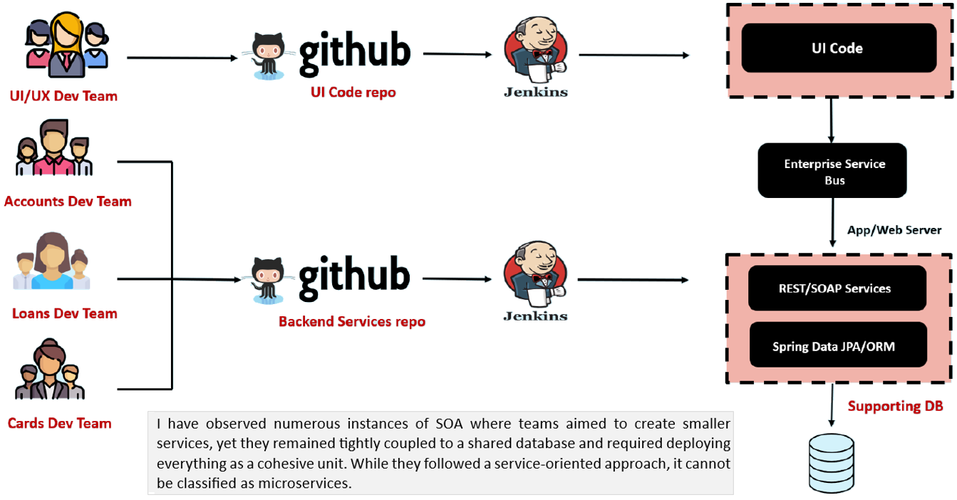

So now let's try to jump into the microservices architecture.

Microservices are independently releasable services that are modeled around a business domain. A service encapsulates functionality and makes it accessible to other services via networks-you construct a more complex system from these building blocks. One microservice might represent Accounts, another Cards, and yet another Loans, but together they might constitute an entire bank system.

|  |  |
| --- | --- |
|  | So whenever we are developing our web application, for example, the same easy bank web application, we are going to develop many services that are modeled around a business domain. I can have separate small microservice focusing entirely on accounts, logic and similarly for cards and loans. This way based upon separate, separate business domain logic, I can segregate them into separate services and all these microservices, they are going to have their own database. They are going to be deployed into their own servers or own containers. With that like you can see, we are going to have all our UI logic inside a server 1 coming to the backend services, we can create any number of micro services that can be deployed into separate servers and containers and all these services they are going to have their own supporting database.  So let's try to understand what are the advantages and disadvantages of this microservice pattern. Coming to the advantages. Like it is easy to develop, test and deploy because you loosely coupled all your business logic, all your accounts related logic is going to be stayed inside a small component. If you want to enhance accounts microservice with a new language or new framework, you can happily do that because it's entirely separate component which will have its own development life cycle deployment lifecycle. And with that reason it is going to increase the agility inside your organization. |

Since there is no tight coupling between your microservices or services, all the development teams, they can have their own enhancement lifecycle, they can have their own discussions, they can have their own deployment lifecycle. With that, we are going to achieve the parallel development. And the beauty of microservices is it is modeled around your business domain. Like for example, inside the bank we have accounts, loans and cards. So I can have three microservices focusing these three different business domains. And since we are going to deploy all these services into Docker containers, which I'm going to explain you in the coming lectures, it is also going to provide you a flexibility where you can scale horizontally and independently. For example, if your accounts microservice is going to receive higher traffic compared to loans and cards, you can scale only accounts microservice independently. So these are all the main advantages of microservices. And please don't assume that microservices is a silver bullet for all your problems inside the web application. You should not always jump into microservices because it is unnecessary for smaller applications or smaller companies.

|  |  |  |
| --- | --- | --- |
|  | **Pros** | **Cons** |
| Easy to develop, test, and deploy  Increased agility  Ability to scale horizontally  Parallel development  Modeled Around a Business Domain | Complexity  Infrastructure overhead  Security concerns |
| If there's one crucial takeaway from this course and the concept of microservices, it is to prioritize the independent deployability of your microservices. Develop the habit of deploying and releasing changes to a single microservice in production without requiring the deployment of other components. By doing so, numerous benefits will naturally emerge. | |

So that's why let's try to understand what are the disadvantages that we have with microservices. The very first disadvantage is it has complexity because when you have so many independent containers deployed separately in different, different servers and clusters, definitely connecting them and making sure they are able to communicate properly always is going to be a complex task and it is also going to be infrastructure overhead inside monolithic and SOA, you only have 1 or 2 servers to monitor, but inside microservices you are going to deploy your microservices into number of servers and containers. With that, you need to monitor all of them. That's why there is going to be infrastructure overhead and there are also going to be security concerns because previously any communication between your code used to happen with the help of method calls and a web service call from UI to backend. But now with microservice, even your backend services, they need to communicate with web services like rest based services. And this increases security concerns inside your web application.

But don't get demotivated with all these disadvantages because at the end of the day, organizations they want agility and they want the freedom to enhance their web applications and microservices whenever they want, and they want to go to the market as soon as possible. Since Microservice is going to provide all these advantages, they are ready to face these challenges. And off course we have various approaches to overcome these challenges inside microservices architecture. We are going to discuss all of them inside this course.

If there is one crucial takeaway that you want to take from this course and the concept of microservices is, microservices they're going to prioritize the independent deployability of your services. And whenever you're deploying your own microservice, you are not going to have any dependency on other microservices. With this primary advantage, all other numerous benefits will naturally emerge inside your microservices web application.

We are going to discuss what are those. Now let's try to see how the microservices is going to look like with the GitHub and Jenkins scenario.

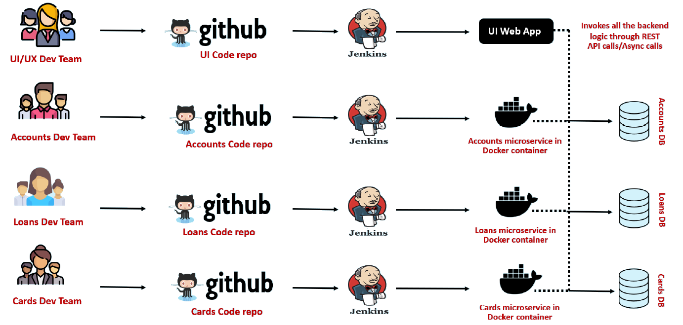

You can see there are four different development teams. Inside microservices architecture pattern, all of them they are going to have a separate code base. And from these separate code base, they are going to have a separate deployment lifecycles with the help of Jenkins or any other CI/CD tool and post the deployment all of them, they are deployed into multiple servers or containers and each of the service is going to have their own supporting database.

And apart from these independent deployment and parallel development, the other advantage that we have with microservices is, accounts microservice team they can have an SQL database and loans microservice they can have a NoSQL database. So they can choose their own database based upon their requirements. And even we can have accounts microservice built with the help of Python, loans microservice built with the help of Java and cards microservice built with the help of go language at the end of the day it is going to give super super freedom to your company and to the developers. They are free to explore because they are not bounded to a single codebase or to a single server. I hope you are clear with all the architecture patterns that we have, like monolithic, SOA and microservices, what are the advantages and disadvantages of each of these patterns?

Comparing Monolithic vs SOA vs Microservices Architectures

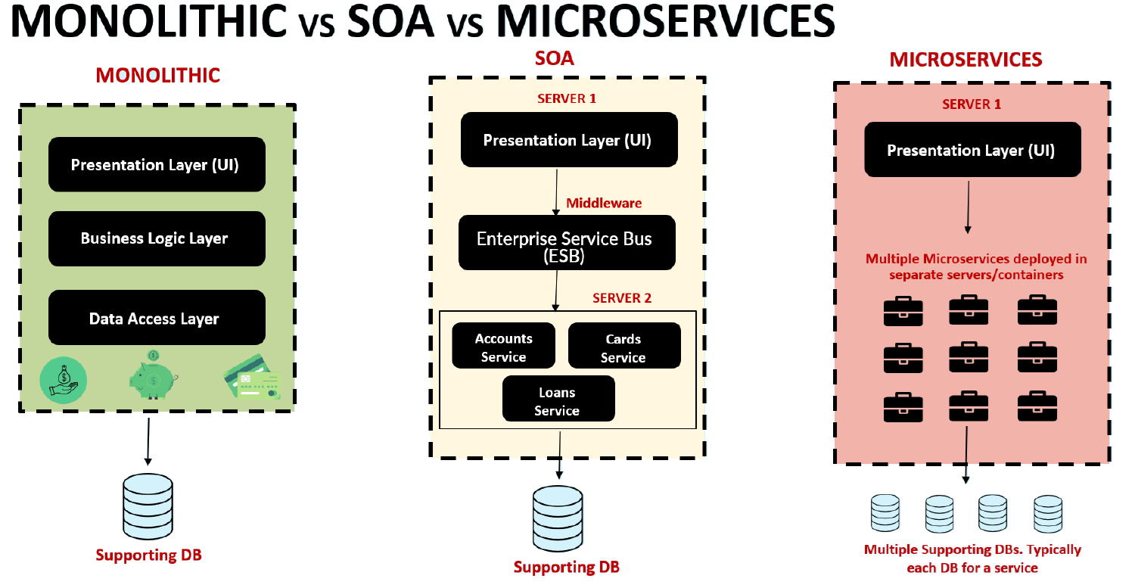

The primary characters of monolithic application is we're going to deploy all our code base inside a single server and it is going to be supported by a single database. With this, we have tightly coupled all our components of a web application and business logic into a single server.

Now moving on to the SOA, we separate the UI and backend logic, but we are going to add an middleware extra component which is complex to maintain and require a lot of investment. And SOA also is going to have a single supporting database.

And at last we have microservice where we can separate all our backend logic based upon the business domain and each of the microservice we can deploy into separate servers or containers. And one more important character of microservice is each of your microservice is going to have a supporting database and all these database don't have to be a single technology. You can have various types of databases like RDBMS NoSQL database, Redis cache. It's up to you based upon your business requirement, you can have a supporting database for your microservice.

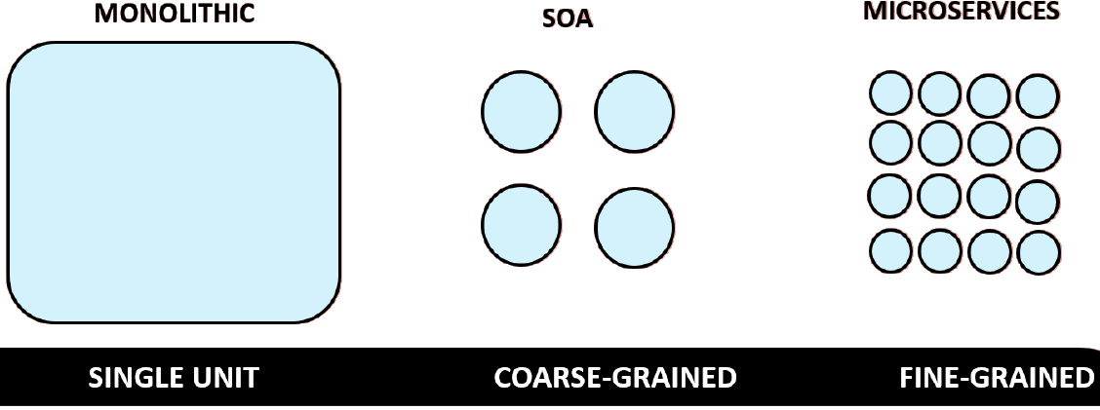

Now let's try to see a different perspective of monolithic server and microservices. Like you can see in simple words, monolithic is a single unit and SOA is a coarse grain, whereas microservices is fine grained in server. We are separating our backend services, but it is not going to give a lot of flexibility in terms of multiple database, multiple codebase. With that reason, we cannot really separate our services or code based around the business domains. That's why compared to SOA inside microservice, we can fine grain our microservice based upon the domains because all of them, they are going to have separate code base, separate development and deployment lifecycle.

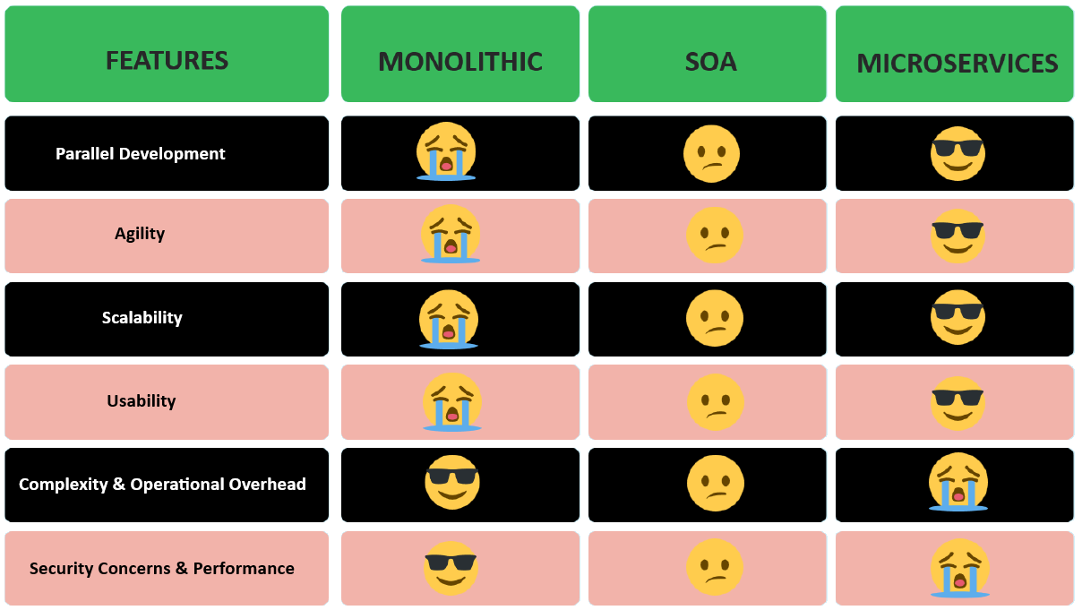

Now let me put one more perspective in terms of monolithic, SOA and microservice. So I'm going to compare these monolithic, SOA and microservice by taking different, different features. The very first feature is parallel development. You can see inside monolithic. There is no parallel development, the developers are going to cry, whereas in SOA it's not a happy scenario or a sad scenario. It is somewhere in the middle because at least you are providing some flexibility between UI and backend teams. Whereas in microservice it is going to be the winner. You are providing complete freedom to that different, different teams in terms of parallel development, deployment and enhancements.

The next feature is agility. With monolithic. There is no agility. You can't enhance your web application with the new frameworks and new languages because it requires a lot of effort. And SOA you can do to some extent, whereas in microservice you're going to have a lot of agility because all the teams are working independently. And in this scenario, also microservice is the winner. The next feature is scalability.

Coming to scalability inside monolithic it is going to be very, very tough to scale your web application because you're going to deploy all your code inside a single jumbo server. If you want to scale your web application, you need to bring one more jumbo server. You need to take care of load balancing between them, which is like very manual setup and it is going to be very challenging.

And to SOA also the scalability is going to be challenged because all your backend logic is staying inside a single jumbo server. And there is also an extra complexity with ESB, so you should also scale your ESB component. Whereas with microservice, the scalability is going to be super, super easy and it is also going to be automated with the help of products like Docker and Kubernetes. We are going to discuss about them. So in scalability, also the winner is microservice coming to the usability.

Inside usability also the clear winner is microservices because your developers, they are going to bring lot many new enhancements and they are going to deploy their new enhancements within a matter of days. Think of a scenario where accounts team, they are thinking to deploy a new change which will increase the usability of the end user. In such scenarios, they don't have to discuss with any other team members. They just have to discuss internally, get a client approval and they can do a deployment of their new feature within seconds with the help of Docker deployments and Kubernetes deployment. So inside usability also the winner is microservice.

Now coming to the complexity and operational overhead? Off course, here the winner is going to be monolithic because inside monolithic, you just have one server. You just need to take care of that one server. You just need to make sure that one server is running properly without any issues.



In SOA they are going to be three components. UI server, backend server and ESB component.

Whereas in microservice it is going to be super, super complex because there are some organizations where they are deploying thousands of microservice in hundreds of different, different servers. You can think of operational overhead and complexity that microservice need on day to day basis. But don't worry, we are going to discuss how to overcome these challenges with the help of various products frameworks that we have inside the microservice ecosystem.

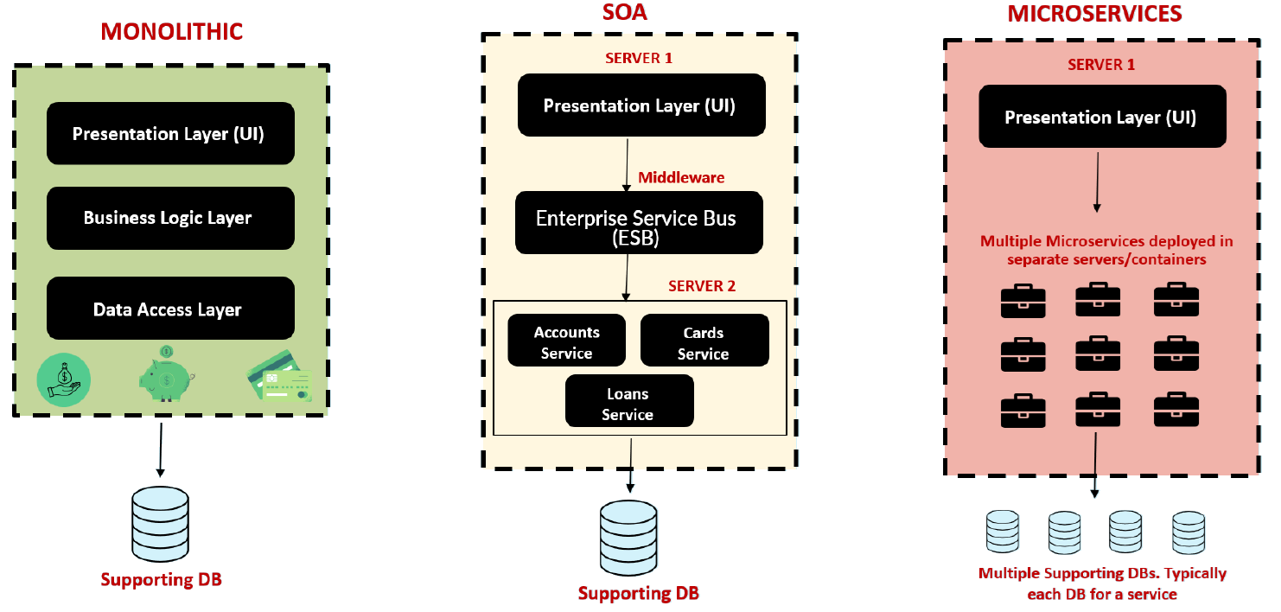

And the last feature is security concerns and performance. And here also the winner is going to be monolithic. And inside microservice, the security concerns are going to be more and there will be some performance issues because every communication between your backend logic like accounts, loans and cards, microservice, they have to communicate over the network with the help of REST APIs. Previously it used to be method calls inside the same server.

Now they are all deployed in different servers. With that there will be some network latency and since you are making so many API calls, off course we need to take care of security concerns as well. So like I said, microservice is not a silver bullet for all your problems, for all your web applications, You need to be aware under which scenarios we can go for monolithic, SOA and microservice. I think these days no one is following. SOA. It's a discussion about whether monolithic or microservice.

If your web application is small and your organization is very small and you don't need frequent deployments, then you can always go with monolithic. Whereas if your application is large and your organization requires frequent deployments, frequent enhancements, then you can always go with the microservices architecture. I hope you are clear, like the reason why I have discussed so much about monolithic SOA and microservices is, if you go to any interview, there will be definitely questions around microservice and they will ask you under which scenario I should go for microservice and monolithic.

When considering a web application, the traditional approach involves packaging it as a WAR or EAR file. These archive formats are commonly used to bundle Java applications, which are then deployed to web servers like Tomcat or application servers like WildFly.

Do you think the same approach works for building microservices? Off course not, because Organizations may need to build 100s of microservices. Building, packaging, and deploying all the microservices using traditional methods can be an extremely challenging and practically impossible task.

How to overcome this challenge? The clue is Spring Boot



"Microservices is an approach to developing a single application as a suite of small services, each running in its own process and communicating with lightweight mechanisms, business capabilities and built around independently deployable by fully automated deployment machinery."

From Article by James Lewis and Martin Fowler's

So like you can see, microservices is an approach to develop a single application as a suit of small services inside easy bank web application, we can develop a web application as a suit of small services with the name accounts, loans and cards. And each of these services, they can run in their own process and they can communicate with lightweight mechanisms like rest and all these microservices built around business capabilities or business domains. And most importantly, they can independently deployable by fully automated deployment machinery. We can automate everything like as soon as a developer check in into the code base of a microservice, the build will happen and the same build will be deployed automatically into dev and uat environment. And if needed, we can also automate the deployment into production using CI/CD concept. So there are many, many advantages with microservice which we are going to learn inside this course. But on a high level this is going to be your simple go to definition of microservice.

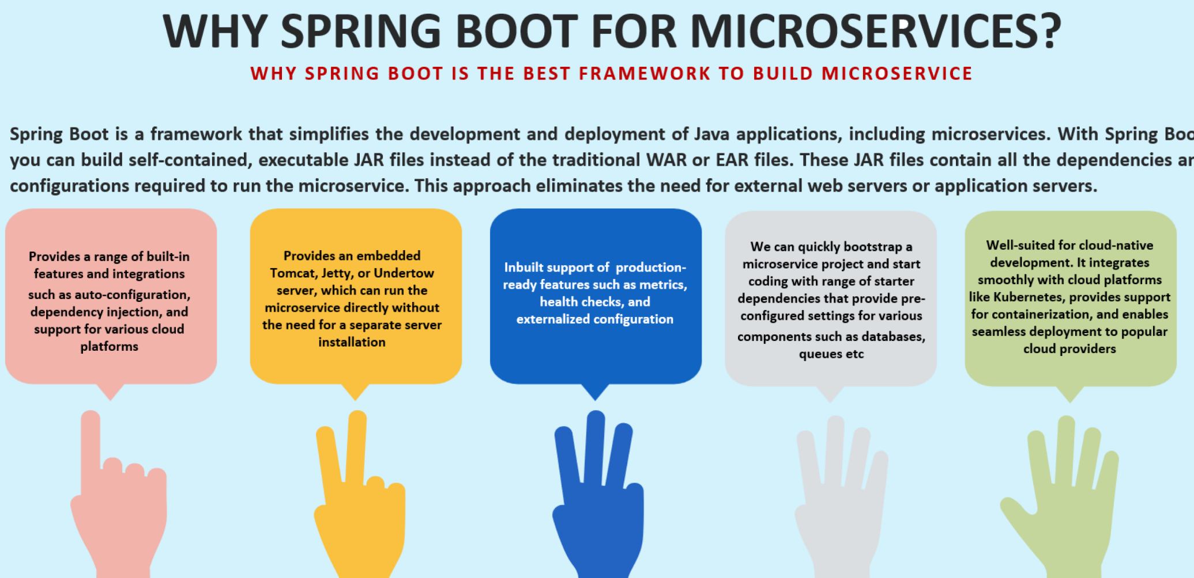

## Spring Boot Framework

Springboot is a framework that built based upon the spring framework. With the help of Spring Boot, we can develop and deploy Java based web applications, including microservices, very easily. It is going to improve the productivity of the developer. It is also going to make the life of developer and platform team and operations team very easy with all the features that it is going to support. And with the help of this spring boot framework, we can build self-contained and executable jar files instead of traditional war or ear files. Which means you as a developer just focus on your business logic and the framework is going to take care of starting your application and packaging your application and deploying your application into an embedded tomcat server or into an embedded web server. So whatever jars that we are going to generate with the help of this spring boot applications, these are self-contained, which means they're going to have all the dependencies that they require to run the microservices.

So this approach eliminates the need of external web server like Tomcat or JBoss or any other application servers. And we don't have to maintain all of them manually. Apart from these major advantages. We also have other advantages with Spring boot framework. So let's try to understand one by one. The very first advantage is whenever we are using spring boot framework, it is going to provide a lot, many built in features and integrations with the help of concepts like auto configuration dependency injection, and it also supports various cloud platforms. So let me break this into simple words. Whenever we are using spring boot framework, think like you are trying to create a web application. As soon as you're trying to create a web application with Spring boot framework, it is going to make auto configurations to deploy your web application into a web server like Tomcat at a default port of 8080. So all these kind of auto configurations, it will try to do by itself by assuming some default values.

If you as a developer, if you are not good with those default configurations, you can always override them with the help of properties inside the spring boot framework. Everything we are going to discuss in Spring Boot, I'm going to show you the demo of them when we are trying to build microservice with the spring boot in the coming lectures. The next advantage that we have is like we discussed whenever we are using Spring Boot framework, it provides an embedded service like Tomcat Jetty or Undertow, which you can use to run your microservices directly without the need of a separate server, installation and maintenance. After this, the next advantage that we have is this Spring boot framework supports a lot many production ready features, such as providing metrics about your web application, health monitoring and external configurations. So whenever we are trying to build web applications inside monolithic approach, we as a developer need to write lot of code to monitor our web application, to produce metrics from our web application and to configure some external configurations.

Whereas with Spring Boot, everything is going to be super, super easy with the dependencies like spring boot actuator. So we are going to explore what is spring boot actuator, how it is going to expose all the metrics, health information and configuration details about our web application in the coming lectures. The next advantage that we have is we can quickly bootstrap a microservice project and start coding with range of started dependencies. We can quickly and easily create a microservice project with the help of Spring Boot. And before Spring Boot whenever a developer wants to add a dependency related to some database or some message queues or some other framework, you need to do a lot of configurations inside his project and he need to add a lot of dependencies manually. But with the help of starter projects inside Spring Boot, it is going to be super, super easy.

You as a developer just tell what dependencies you have inside your web application. Suppose if I'm trying to connect to a MySQL database, I can define that and my spring boot is going to provide a starter project which will have a bundle of dependencies that will help me to connect with my MySQL database. The last advantage that we have here is, whenever we are building applications with the help of microservices. They are cloud ready, which means you can easily deploy them into any cloud platforms like Kubernetes, you can containerize your application with the help of Docker, you can easily deploy them into cloud providers like AWS, GCP, Azure. So this is the one more advantage that we have. I'm going to show you how to containerize our Spring Boot web application with the help of Docker in the coming lectures. We will also see how to deploy our microservices into a Kubernetes cluster.

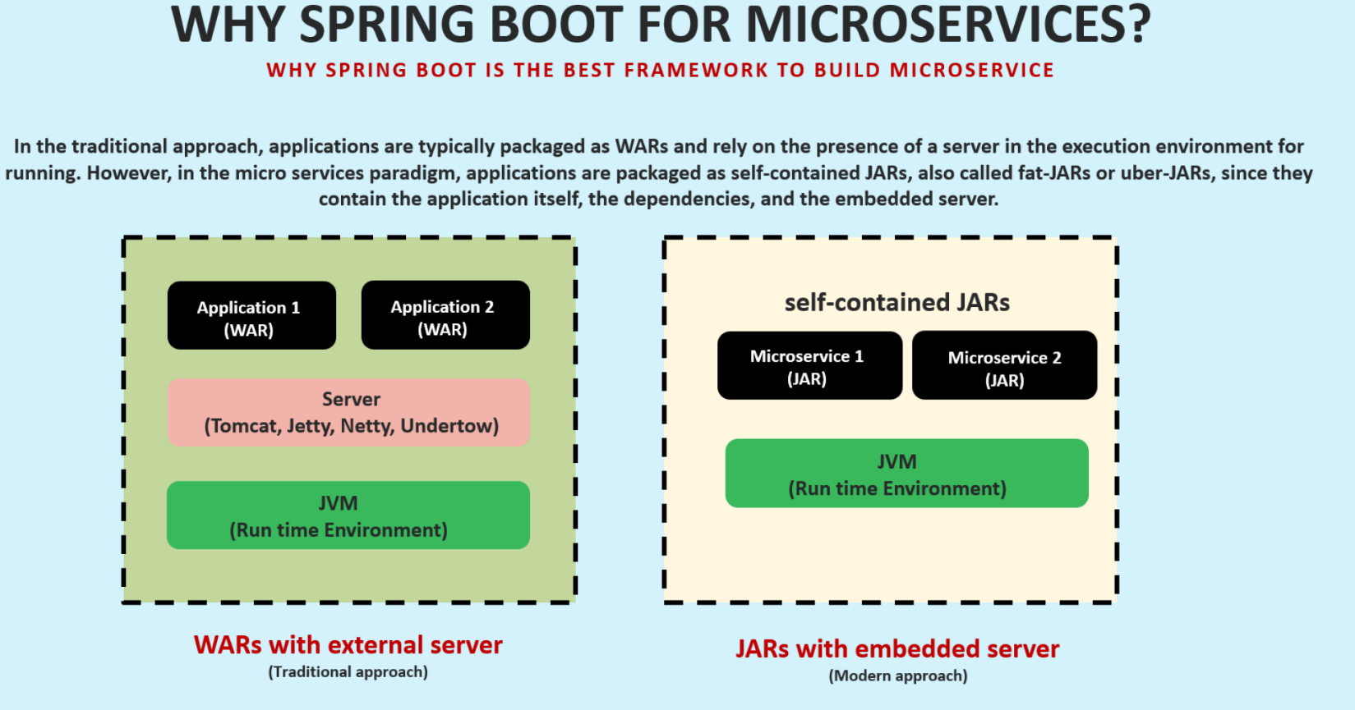

A different perspective on how Spring Boot is going to make our life easy - like you can see here on the left hand side, we have a traditional approach which we will use whenever we are building monolithic web application back a decade when Spring Boot is not yet released. So you can see to build and deploy monolithic web applications as we need to have Java runtime environment like JVM. On top of that, we should also install our web servers like Tomcat, Jetty, Netty, inside our server or inside our laptop. Once we have these two components ready, then we need to package our applications into war or ear format and we need to deploy them manually into a server. And with the help of runtime environment like JVM, our web applications will work where an end user can use them. Whereas with spring boot framework, you can see the middle component, which is servers. We got rid of this server component because this server component right now is embedded into the jar of your web application or of your microservice, which means whenever I'm trying to use spring boot to build my microservices, it is automatically going to package my application along with the embedded server. So as a developer, I don't need to worry about all the server installations and maintaining of all these servers configurations. And this is also going to make our platform team, our operations team life very easy. These self-contained jars were also going to call them as fat jars or uber jars because they will have everything packaged, including all the dependencies, all the business logic along with the embedded server. So that's why we call them with various names like self-contained jars, fat jars or Uber jars. I hope you are clear with the introduction of the spring boot framework. If you have any questions, don't worry. While building the microservices in the coming lectures, I'm going to show you a demo of all these advantages with that, you will be super, super clear and happy on choosing the Spring boot framework to build the microservices.

## Implementing REST Services

When we say that we need to build microservices with the help of input framework behind the scenes, we need to build the REST services. Because at the end of the day, what is a microservice? It is a service that exposes its business logic to other APIs or to external UI application with the help of Rest API. Using REST services, we can establish synchronous communication between multiple APIs or multiple services or multiple web applications. Synchronous communication means when a request comes from an external application to my microservice, the external application is going to wait for my response so that it can proceed to the next request. Off course, synchronous communication is not the only option that we have to build microservices, so this is the mostly commonly used approach in the coming sections of the course. I'm going to show you how to build asynchronous micro services by taking message queues and Kafka as an example. First the definition of what is REST service.

REST (Representational state transfer) services are one of the most often encountered ways to implement communication between two web apps. REST offers access to functionality the server exposes through endpoints a client can call.

Formally REST service works based upon Http protocol compared to soap based web services. REST services are very lightweight in nature because they can work with the help of lightweight data format, which is Json. That's why REST is the most commonly encountered approaches to establish communication between two web apps. So whenever we are building services with the help of REST APIs, our web application is going to expose certain endpoints which my client application can invoke by sending a request. So these are the various scenarios where we use REST services behind the scenes. It might be communicating with a backend server with the help of REST API.

Below are the different use cases where REST services are being used most frequently these days,

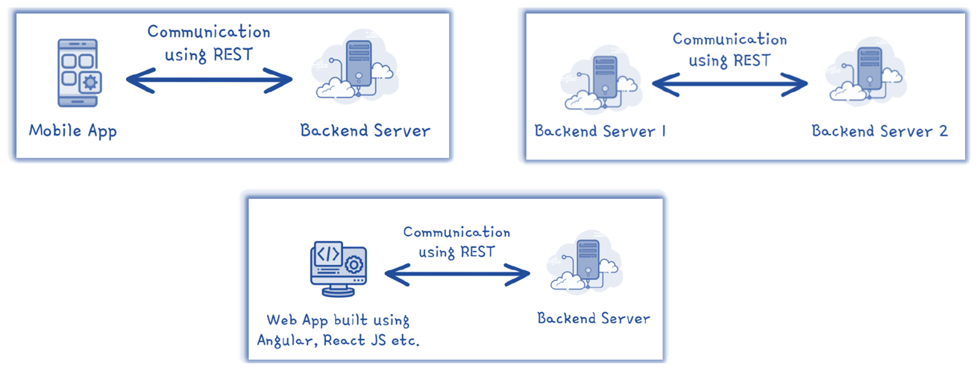

And similarly, if you see the second scenario, two different backend servers are two different microservices. They can also communicate with each other with the help of REST API. And the last scenario that we have is we can build a web applications with the help of UI frameworks like Angular, React and these frameworks they need to fetch the data or they need to store the data inside a backend database. The same they are going to communicate with the backend server with the help of REST services. I hope you are clear. What is REST services? Now let's try to understand what are the various standards that we need to follow while implementing REST services. Because at the end of the day, whenever we are trying to build REST services, we will write a business logic to calculate and to process some data and our REST APIs

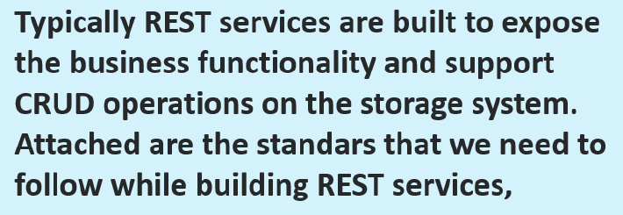 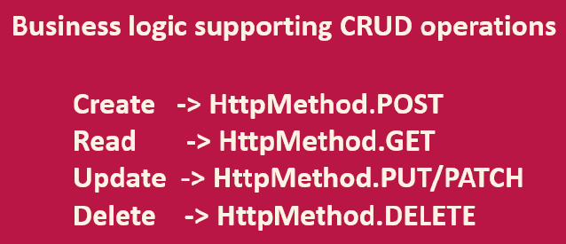

CRUD Operations – HTTP Methods: They are going to support crud operations and the storage system. For example, inside our Rest APIs, we are going to write business logic that supports creating the data, reading the data, updating the data and deleting the data inside a database or inside a storage system. So whenever we are trying to build APIs that expose these, create, read, update and delete operations to the external applications, we need to make sure we are following the standards of the Http methods.

Create Data – Http Post Method: For example, whenever you are trying to save the data or whenever you are trying to create the data with the help of your API, you need to make sure you are accepting the requests with the help of post method.

Read Data – Http GET Method: If your API support just reading the data from the storage system and sending the same to the client, then it is just a read operation for such scenarios we should use the get Http method

Update - Http Put or Patch Method: If your API is supporting update operation where a client can update the existing data, then we can use Http method put or http method patch. The difference between put and patch is if you are trying to update your entire record or major data inside your table record, then you should use put. Whereas if you're trying to update only a small set of information or a specific column, you should use Http patch method to support the update operation.

Delete - Http Delete Method: And at last, if the client application wants to delete a data inside your application, then you need to expose an API that supports delete operation. And in such scenarios we should use Http method, which is delete method. So please make sure you are following these standards whenever you are building REST services and microservices.

Input Validations: The next standard that you need to follow is you should perform proper input validation on your REST APIs because if you consider a UI application, it will have HTML forms, input elements using which you can perform lot of validations. But coming to the REST APIs, any application can invoke a backend application or a mobile application or an application. So that's why you should not rely on. The validations that is happening in external system. You should do your own input, validation and accordingly process the request.

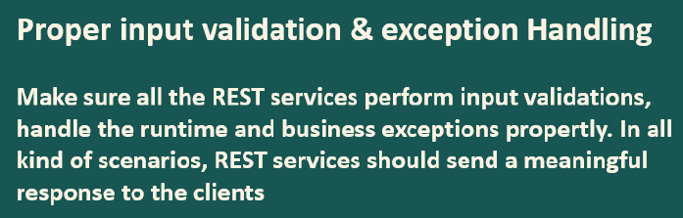

Exception Handling: We should also take care of exceptional handling. Regardless if you are getting a runtime exception or a business exception, you should properly handle it and you should always send a meaningful response to the clients. Otherwise you are going to have a very tough time with your clients because they cannot understand what is the issue with your APIs? Which data is wrong if they don't know which data is wrong or why the operation is failing, they will be clueless and you need to pitch in and make them understand manually, which is very cumbersome process. That's why always have exception handling covering all your scenarios.

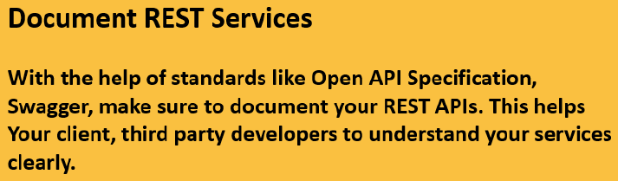

Documentation: We need to follow is document your services inside microservices we are going to build hundreds of REST services and in some cases thousands of REST services. So whenever you are building such large amount of APIs, it is a good idea or it is a good standard to document your REST services with the help of standards like Openapi specification, swagger when you document your REST services well with these standards, your life is going to be easy. Think like your organization has some 1000 REST API services and it is being consumed by hundreds of client applications from external world. If they all reach out to you, like what is the format of request? What is the validations that you are doing? What is the response format? What are the operations that you support to explain all these information through a document or through your email or through a KT session through a knowledge transfer session is going to be very cumbersome and it is going to be very complex. Whenever more and more clients are onboarding who are trying to consume your API services. That's why as a bare minimum, please make sure you are adhering to these standards that we discussed here.

## Initial Setup

### Intellij – Community Edition

Installed from: <https://www.jetbrains.com/idea/download/other.html>

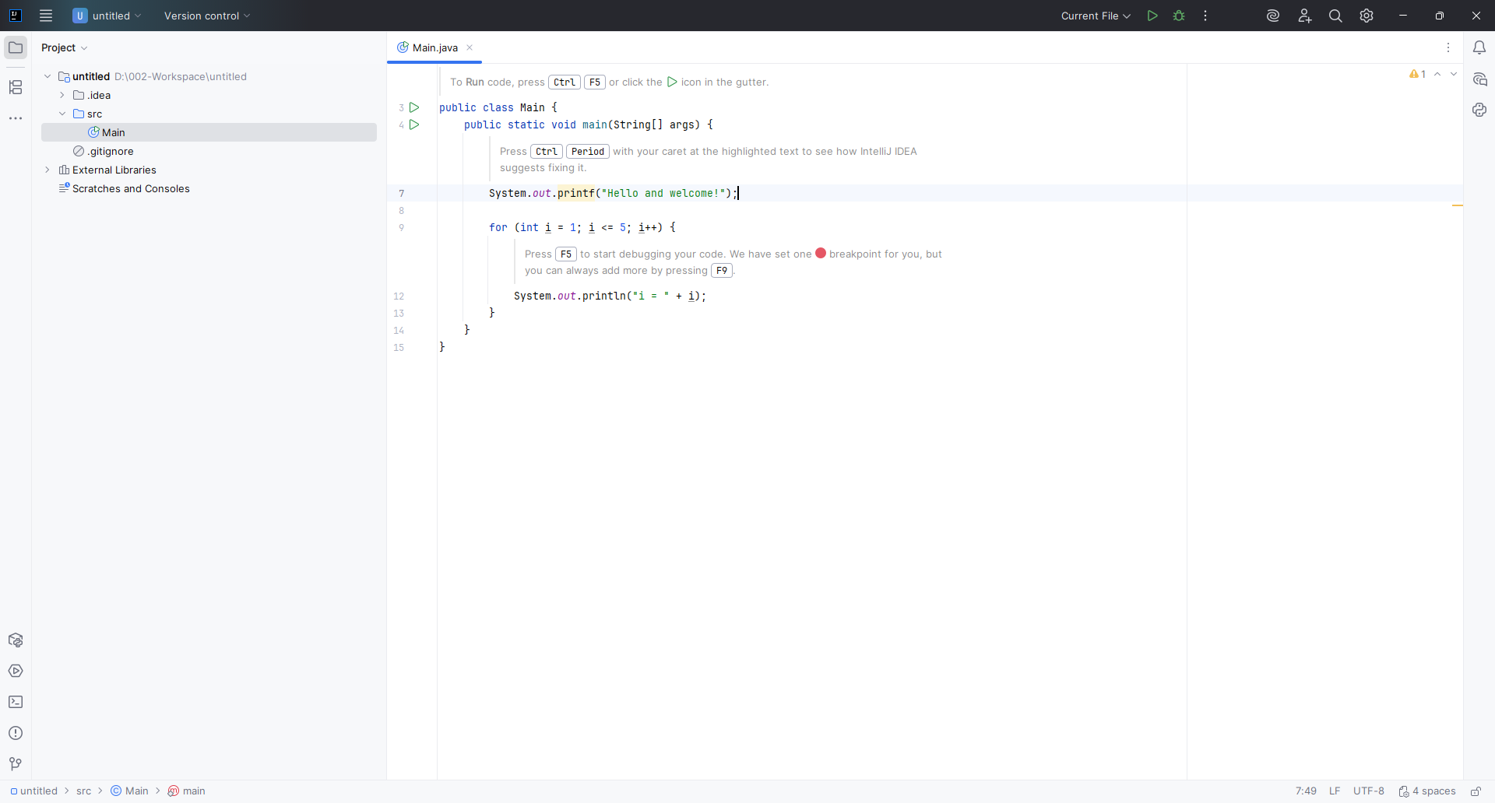

Useful plugins:

[https://digma.ai/25-best-intellij-idea-plugins-for-developers-in-2023/#wakatime](https://digma.ai/25-best-intellij-idea-plugins-for-developers-in-2023/%23wakatime)

Comparison of CE vs Ultimate Editions:

<https://www.jetbrains.com/products/compare/?product=idea-ce&product=idea>

**Accessing IntelliJ IDEA Ultimate**

While the Ultimate version typically offers a one-month trial, as a student of this course, you can access the Ultimate version for six months at no cost. This opportunity is made possible through our collaboration with JetBrains.

To get the Ultimate version for six months, visit the link below, follow the steps,

Get IntelliJ IDEA Ultimate

and use the promo code: Madan_Reddy

### Microservices using Spring Boot, Docker and Kubernetes

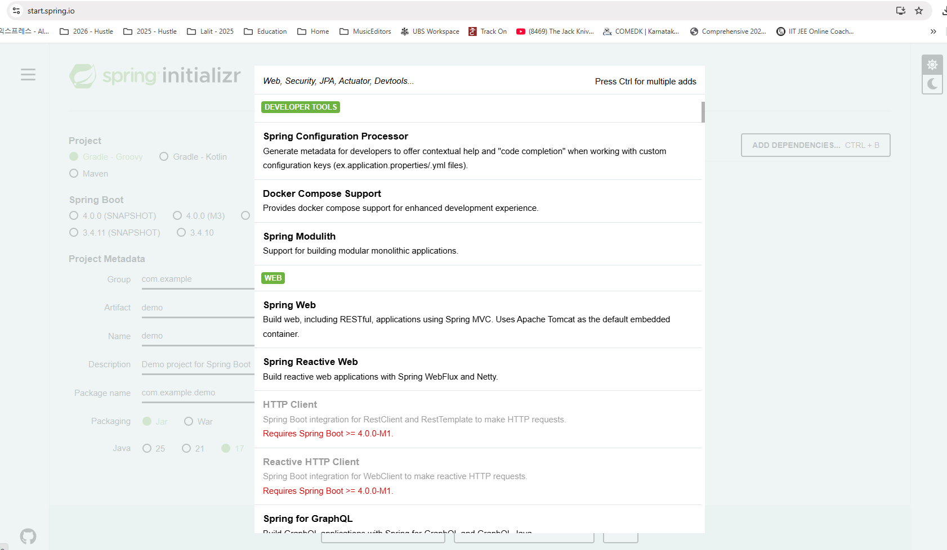

We will try to make our hands dirty by creating microservices with the help of spring boot framework. Creating a web application or building REST services or microservices with the help of spring boot framework is going to be super, super easyGo to the website start.spring.io. Select project specifications, language, the build tool, the spring boot version? So all such basic details we need to fill inside this website. So lets fill those details - Maven as a build tool, language is Java. Spring boot version, the most stable version available is 3.1.1. The same one is selected by default. Lets also make sure you are updating the GitHub code repo every quarter with the latest versions. That way you can always refer to the code present inside the GitHub repo. Now coming to the group, give the name as com.eazybytes. Artifact I want to give as accounts because first we'll try to build accounts microservice. If you can recall we discussed about Easy Bank, which will have three different types of microservices like accounts, loans and cards. So first we'll try to create accounts microservice. Similarly, we are going to do exercise to create loans and cards microservice, very similar to accounts microservice.

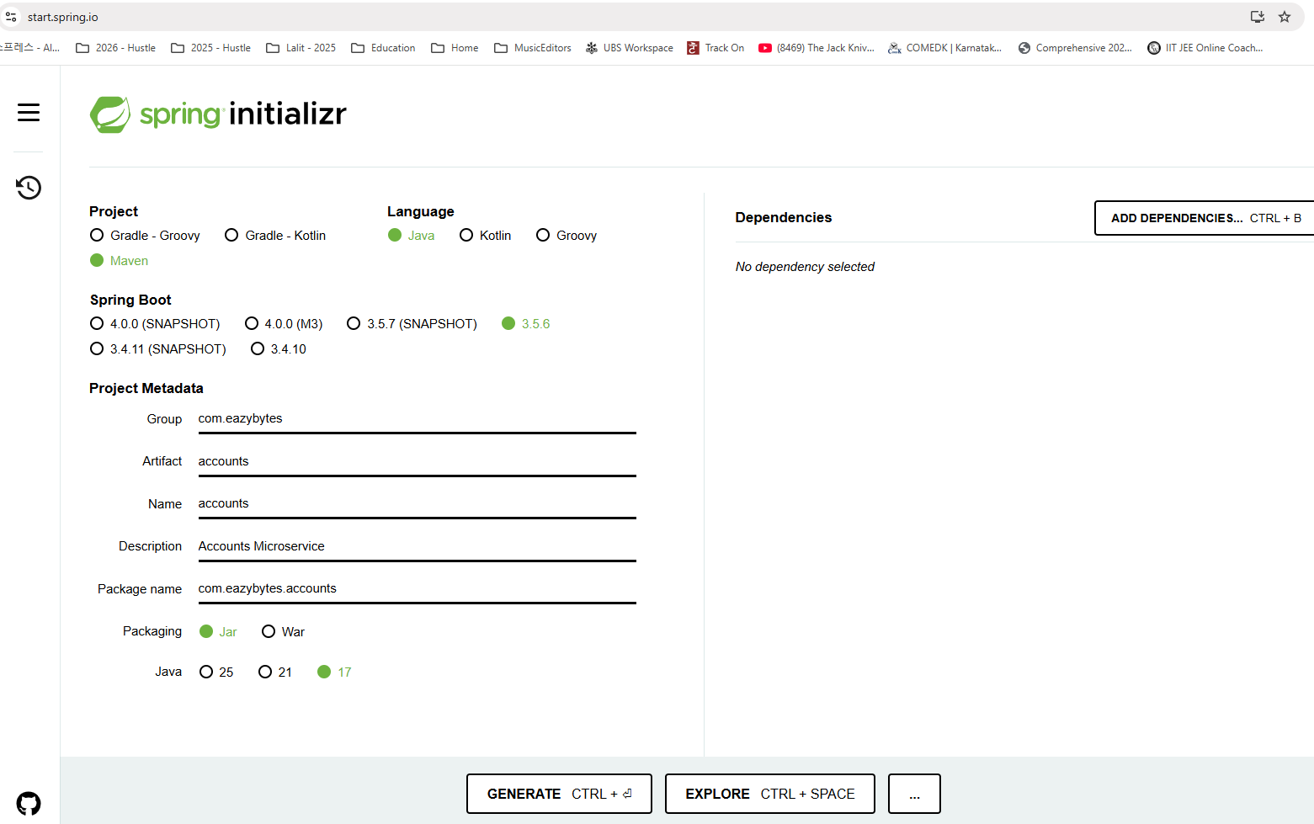

|  |  |
| --- | --- |
|  | Now, coming to the name, I also want to maintain the same name like artifact. So the name also going to be Accounts. Description I want to mention as microservice for accounts. Observe that the package name automatically populate based upon the group and artifact so com.eazybytes.accounts . I want to go with the default packaging which is jar. Since we are trying to build microservice and eventually in the coming sections we'll containerize our spring boot applications. I want to go with the packaging as Jar. And the Java version I want to go with the default Java version here, which is 17. So as of today, 17 is the stable and LTS version available. And please do make sure you are selecting at least Java 17. |

Please don't select 11 and 8 because the basic requirement for the spring boot 3 version and above is Java 17. If you want to use 11 or 8, you need to go with the spring boot version, which is less than spring boot 3. And in that case you need to go with the 2.7. 13. But I don't recommend that. Always go with the latest spring boot version and go with the Java 17 version. So now we have provided all the basic configuration details.

Now coming to the dependencies, we need to define what dependencies we need for our microservices. The very first dependency that we need to add is web. Since we decided to build REST services by adding these starter project, my spring boot is going to bring all the dependencies and libraries that I need to build web applications, including REST services, MVC based applications, and it is also going to use Apache Tomcat as a default embedded container. So that's a beauty of starter projects inside Spring Boot. You don't need to define the dependencies manually for all these libraries and dependencies by just selecting one of the starter project, which is spring web. I'm going to get all the dependencies that I need.

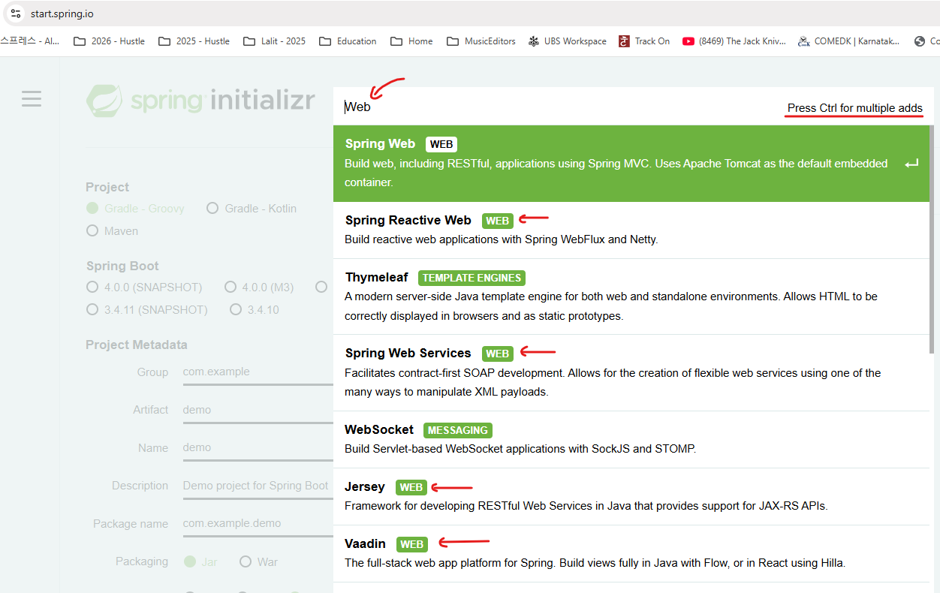

So let me select this post that since we need some storage supporting database now I'm going to go with the H2 database. So H2 database is an internal memory database which you can use inside spring boot web applications. It does not require any installation of MySQL servers or Oracle. You can use this simple internal memory database, so let me select that. But I'm going to change our microservices from H2 database to MySQL in the coming sections when we start using the Docker containers. For now, let's keep it very simple. We don't want to do unnecessary installations.

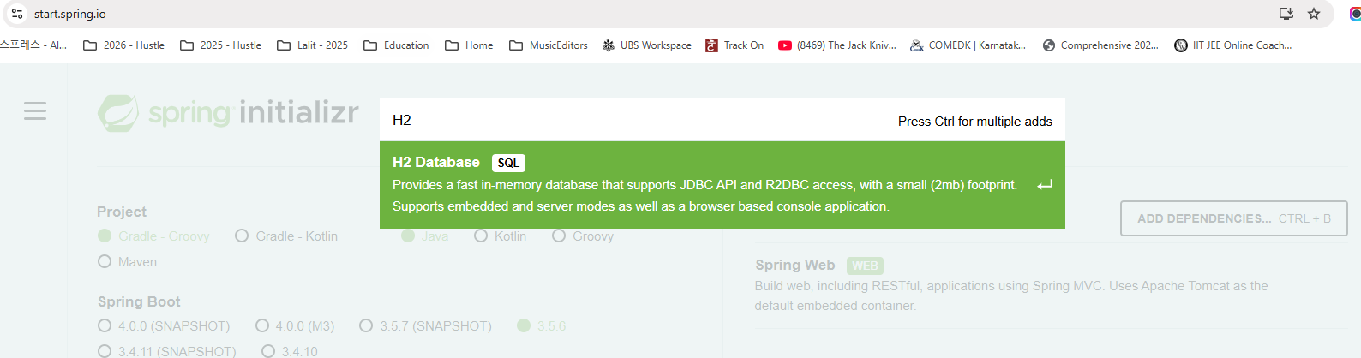

Post that since we want to connect with an database like H2 database, we need to have supporting framework. For the same, I want to add the Spring data JPA as a dependency inside my Spring boot web application. Using this starter projects, we can store the data into the database, we can retrieve the data so all the libraries related to database interaction will be available inside the spring data JPA. So let me select this after this spring Data JPA, I also want to go with the actuator.

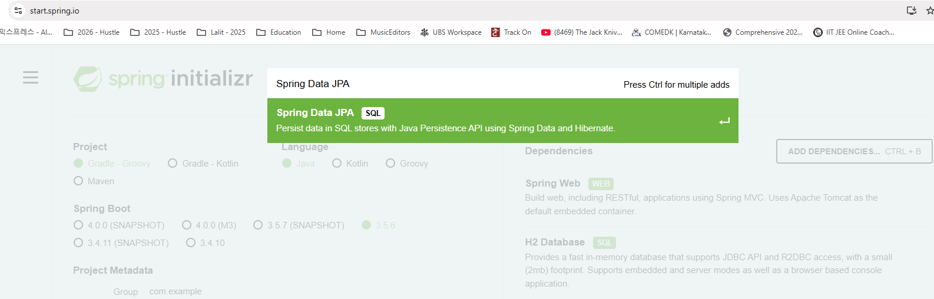

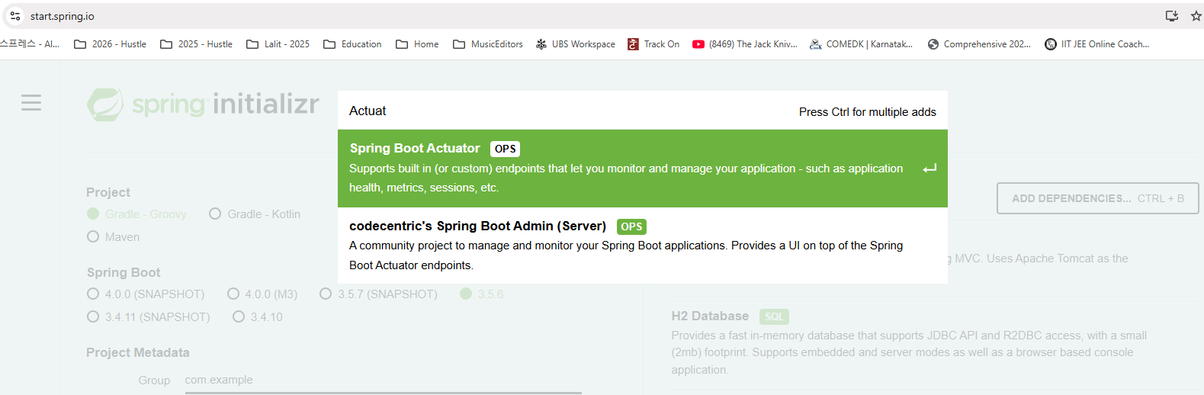

Like I said before, Spring Boot provides inbuilt endpoints to monitor and manage our application, such as like health of our application metrics of the application. Since we are building microservice and we want to monitor our microservices without writing any external code, I want to use this actuator dependency and the next dependency is dev tools.

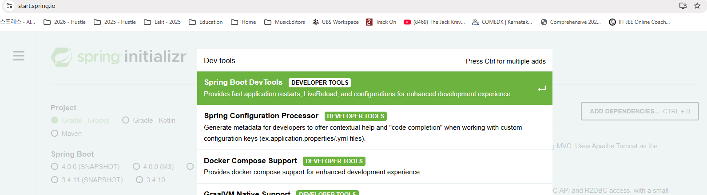

So this spring boot Dev Tools is a starter project which will improve the productivity of the developer. Like you can see, whenever we have this dependency inside our spring boot application, it is going to provide fast application restarts, live reload and configurations for enhanced development experience. Once we start our application, we do some code changes like Java changes, our property changes. In such scenarios, we don't have to manually restart the server of spring boot by default. Internally, this dev tools is going to restart very quickly by reloading only the changes that I have made. So let me select this as well. And the next dependency is Lombok.

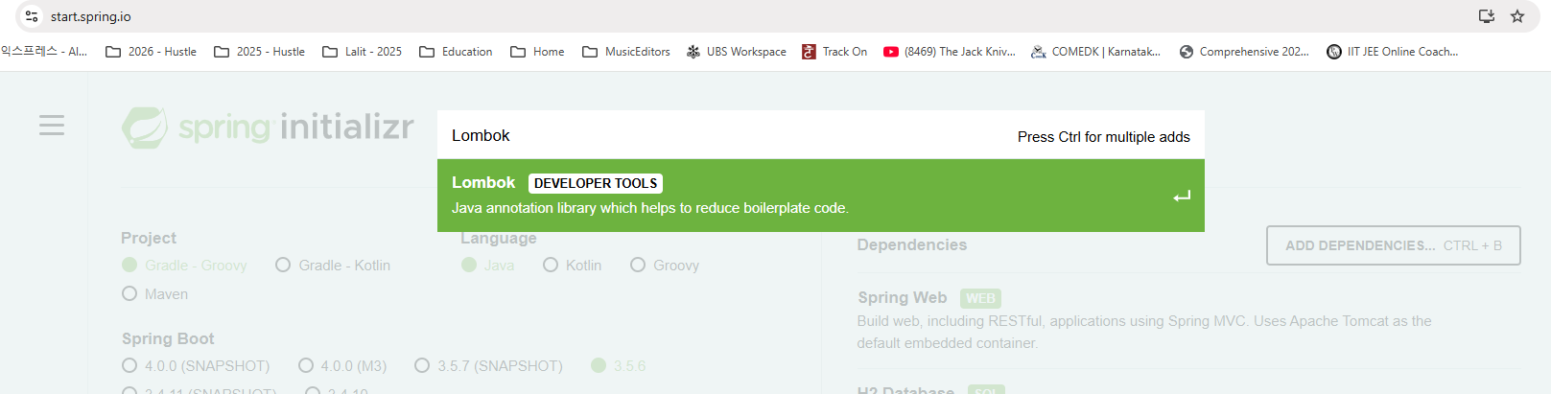

So using Lombok we can avoid all the setters and getter methods that we need to write inside a pojo class. At the end of the day, all the data that we get from UI application or from other applications will get converted into a pojo class and to access the data from the Pojo class, we will use setter methods. So writing these getter and setter methods is very cumbersome and introduce a lot of boilerplate code. So with the help of Lombok, we can reduce the boilerplate code.

For now, please add these dependency and the last dependency that we want to add here is validation.

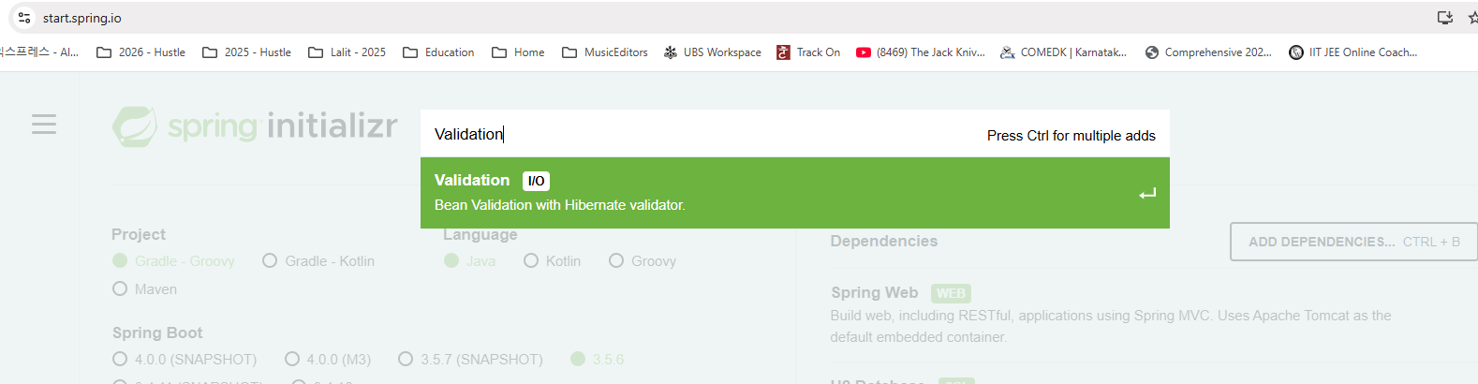

Since we decided to follow the standards of performing validations on the incoming requests, we need to add these starter project inside our spring boot application. So now I have added all the dependencies that I have needed. Please note that whatever dependency that I have added related to spring boot dev tools, this will work only for local development. Please don't be under the impression that automatic restarts will happen inside the production as well. That will never happen. Spring Boot team they are smart enough to activate these dependency only during the local development, but not for the production deployments. I hope you are clear. Now as a next step, I can click on this generate button which will generate a Maven application. So let me go to my downloads. You can see here inside my downloads I have this accounts.zip file. So let me copy this.

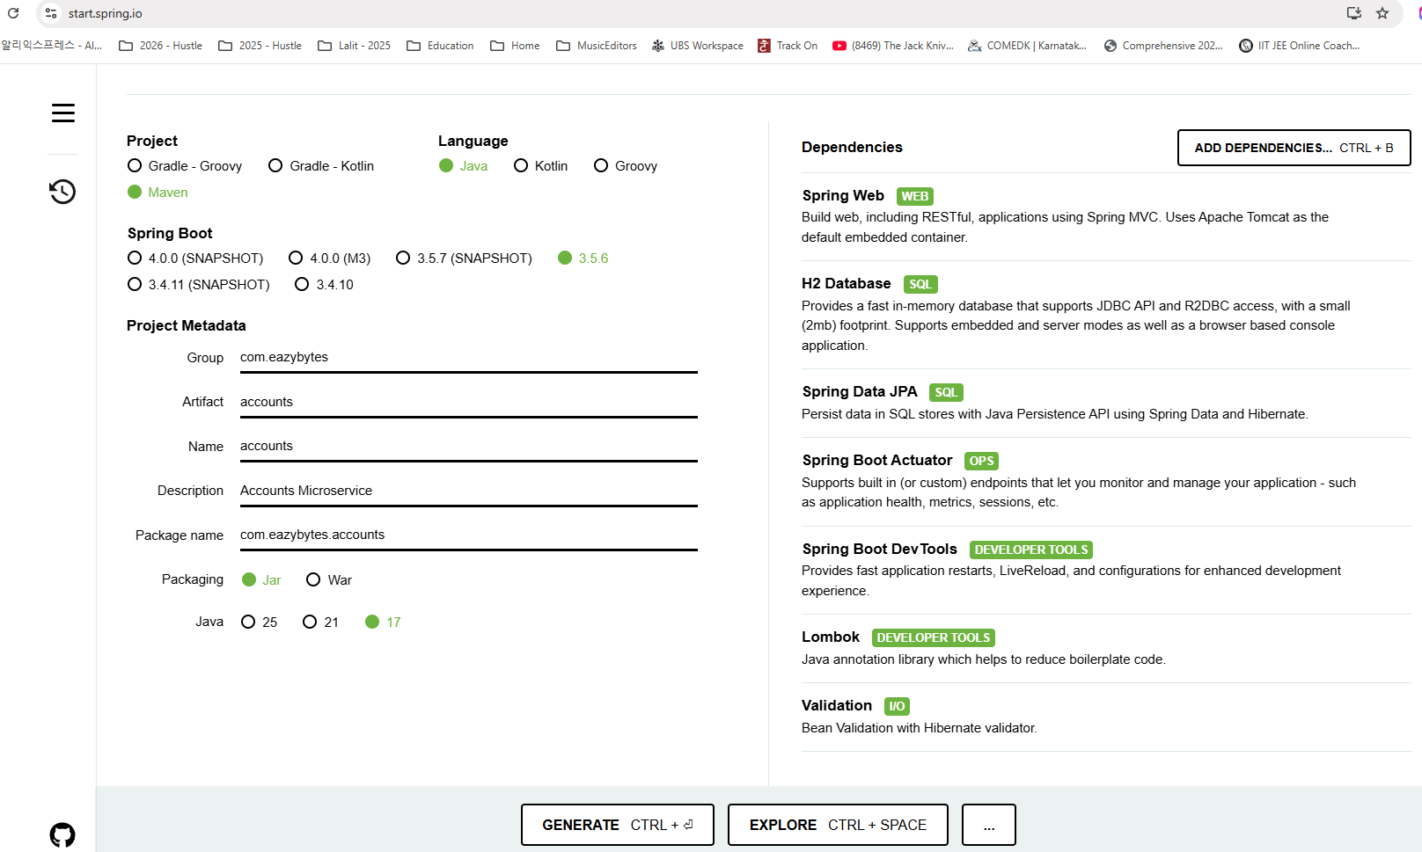

I'll go to the storage Inside workspace folder. I'm going to create a new workspace with the name Microservices inside this microservices folder. I'm going to create one more folder with the name section two because since I said I'm going to upload all the code that we are going to discuss inside the course as per the sections, I'm going to create separate, separate folders inside the workspace and the same way I'm going to upload to GitHub repos so that you have complete code based upon sections inside the GitHub repo. The reason why I'm creating section two but not section one is right now we are in the section two. Inside the section one, we just talked about the microservices introduction and it is a completely theory section. So now inside the section two, I'm going to copy these accounts.zip, let me double click and extract the same. So the file got extracted. I can now remove the .zip file. So here inside this you can see I have the maven structure. There is a source folder, there is a pom.xml and other maven related files inside my Maven project. Now I can import this into my IDE so that we can start working on it.

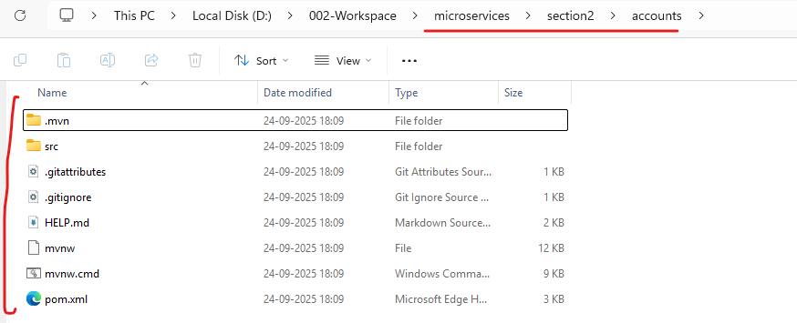

Here, I open my IntelliJ idea. So this is the ID that I'm going to use throughout this course. If you are using Eclipse or NetBeans or any other IDE, you can use the same, but I strongly recommend you switching to IntelliJ idea because this is the most commonly used by the developers. Inside the software industry. It has both community version, which is free and it also have enterprise version as well. If you are working in a organization, there is a good chance you may get enterprise version of this, but I'm going to use a community version inside this course so that all the students who are going to use a free version of this, they will be having same look and feel. So here I'm going to click on this open and I'll go to Storage Workspaces, Micro Services and Section2 . So I'll just select the Section2 and click open and this will open all the projects available inside the section2.

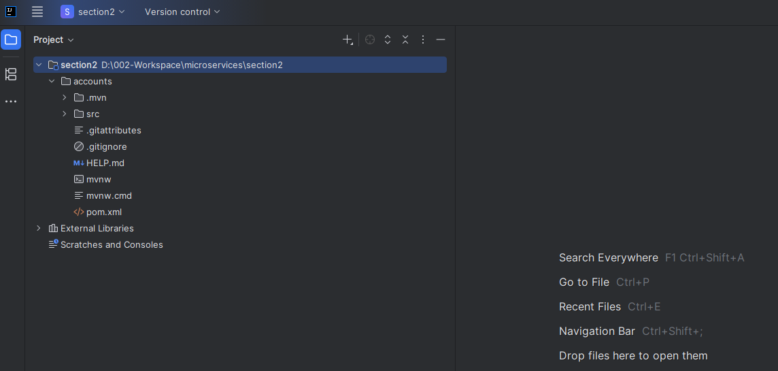

As of now, we are having only the accounts micro service. Later on we are going to add the loans and cards as well. As soon as you open you'll get this pop up, which is Maven build script found. So you need to click on this load. So this will recognize my accounts project as a Maven project.

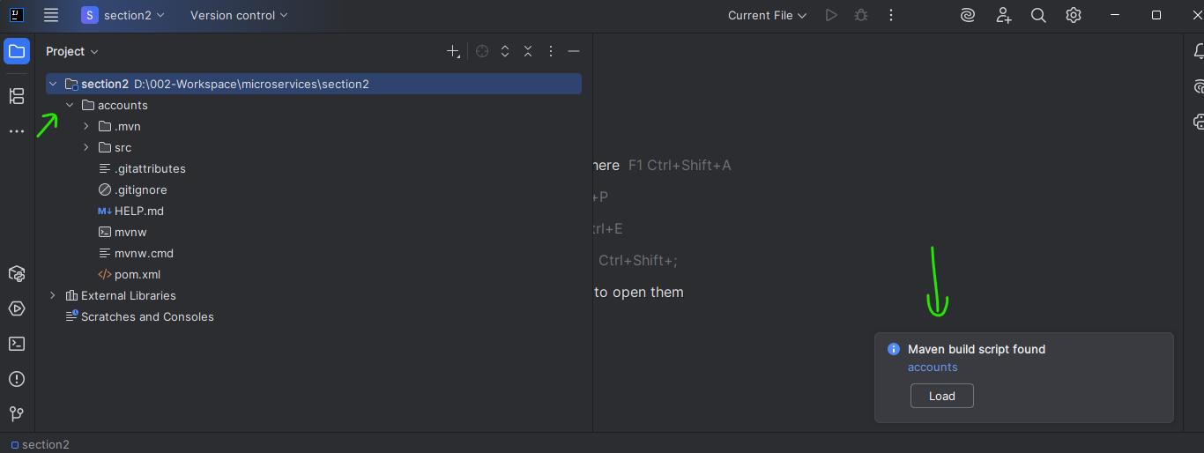

You can also confirm the same by clicking on this Maven tab. You can see I got this Maven accounts project reflected under this Maven. So with this we should be good.

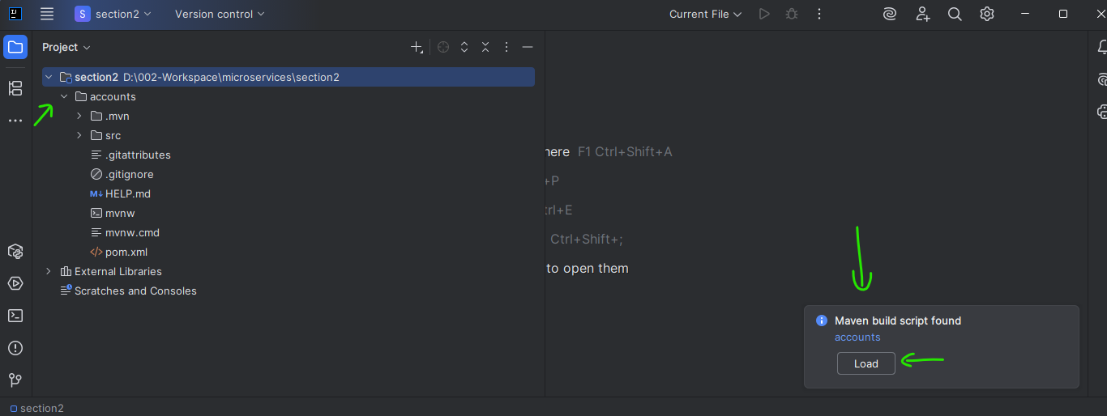

It will start building the maven project as soon as you click on load button.

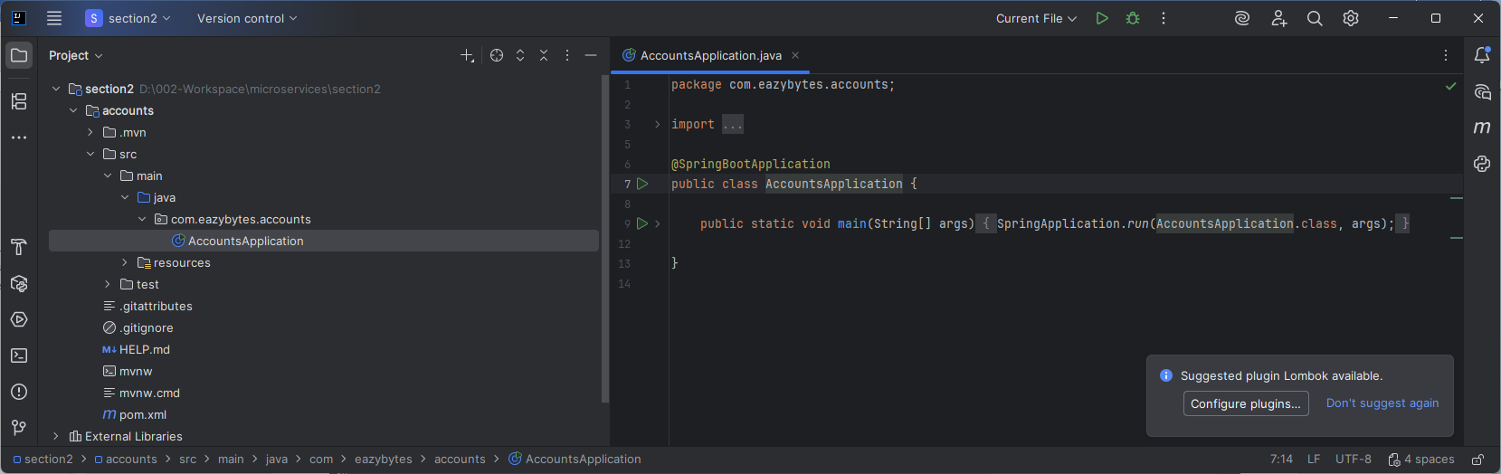

Now let me go to the source file, and under this source file, we'll be having a class with the name accounts application. And this is the main class inside your spring boot application because it has annotation @SpringBootApplication.

package com.eazybytes.accounts;

import org.springframework.boot.SpringApplication;

import org.springframework.boot.autoconfigure.SpringBootApplication;

@SpringBootApplication

public class AccountsApplication {

public static void main(String[] args) {

SpringApplication.run(AccountsApplication.class, args);

}

}

With these annotation, we are telling to the spring boot framework to perform auto configurations and to scan all the beans inside our spring boot application. So SpringBootApplication annotation is a combination of all these annotations like enable auto configuration, @SpringBootConfiguration and @ComponentScan. So these are very basic to spring and spring boot framework.

When you ctrl + click on @SpringBootApplication annotation, accept the compiler

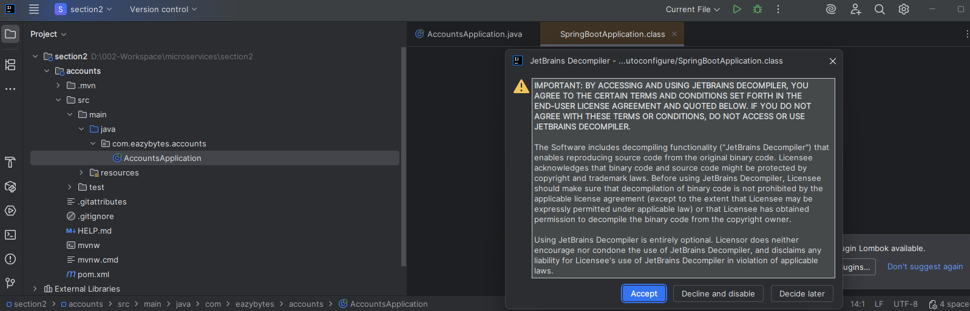

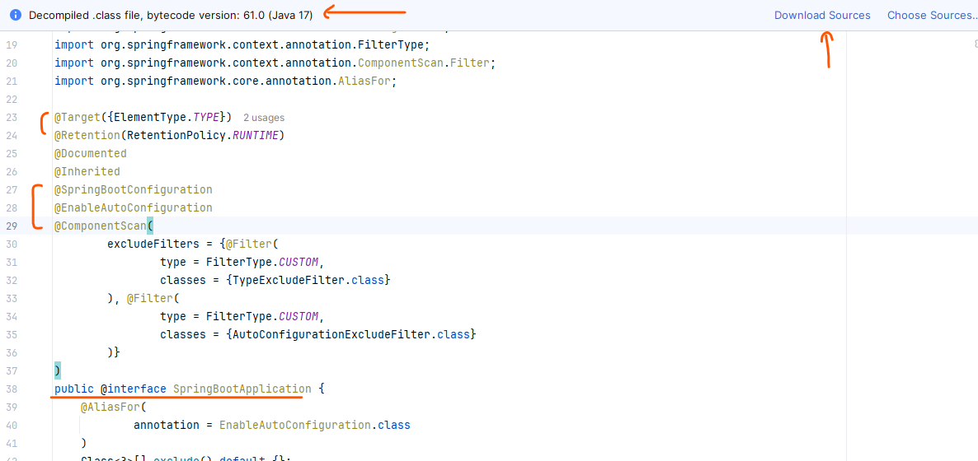

Now our application does not have any REST APIs, so let's try to build a Hello World Rest API in the next lecture, but I'm assuming your super, super clear with all the steps that we have discussed inside this lecture. I have not discussed about the Java installation, Maven installation, IDE installation because I'm assuming you are an mature developer who know all those basic concepts. Because once you learn core Java, Spring and Spring Boot, then only you will come to learn microservices with that assumption.

### Java and Maven Configuration – IntelliJ

Java configuration

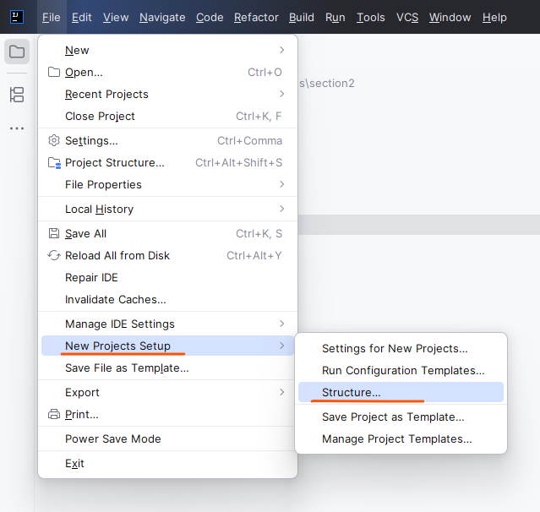

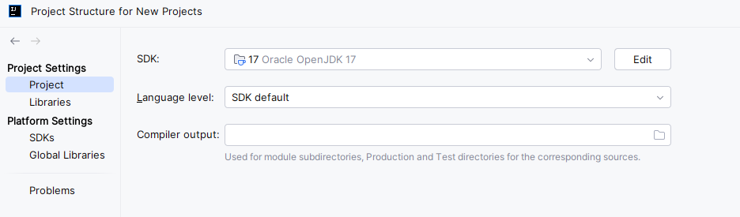

If you click on the edit button it will show you the complete path to your local Java 17

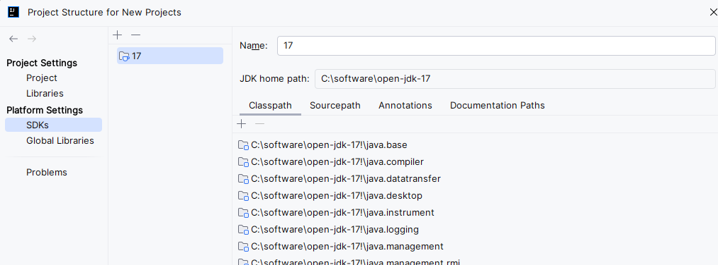

On doing a right click on accounts project you can see all the settings

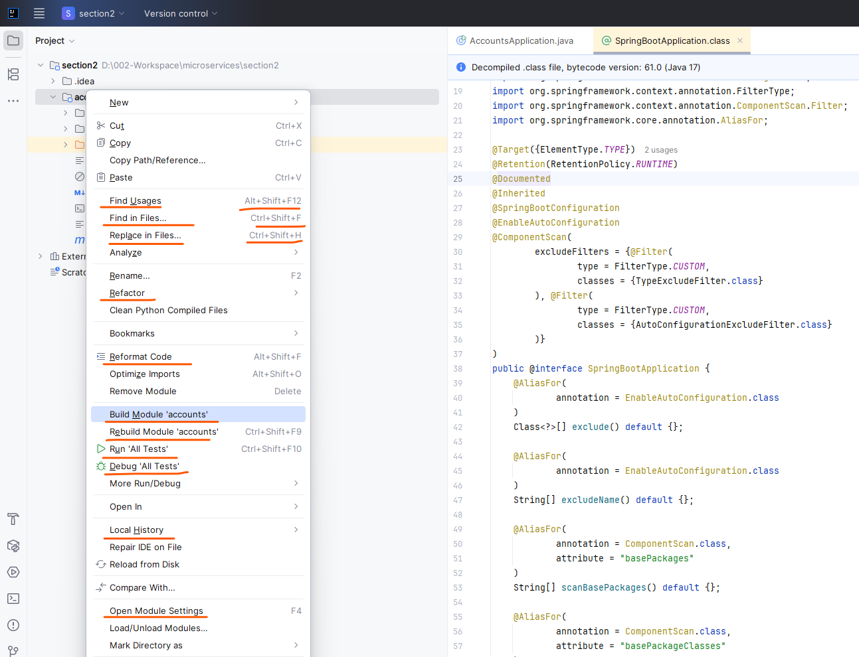

Maven configuration

|  |  |
| --- | --- |
|  | Under both these options we have the Build, Execution, Deployment option. Configure both ( so current project and new projects both get covered ). |

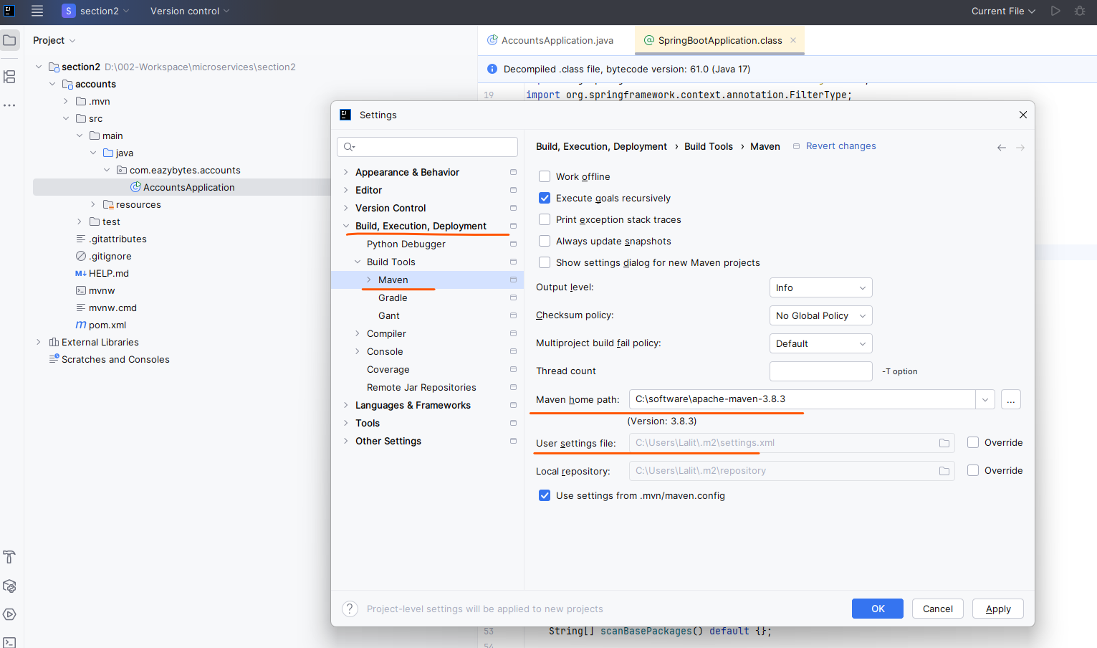

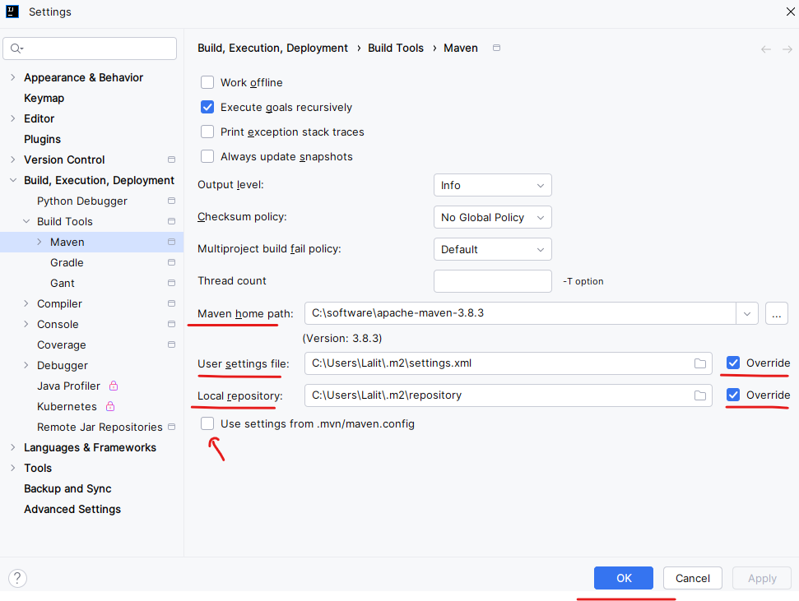

Put the settings.xml file from this location ( installation of Intellij and plugins and maven3 conf folder as below to the specified directory above ) – instructions here <https://www.youtube.com/watch?v=_bsQ8WC3TAg>

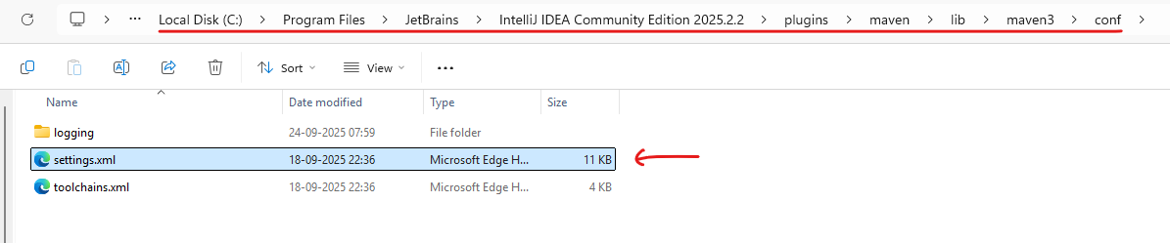

From C:\Program Files\JetBrains\IntelliJ IDEA Community Edition 2025.2.2\plugins\maven\lib\maven3\conf

copy to C:\Users\Lalit\.m2

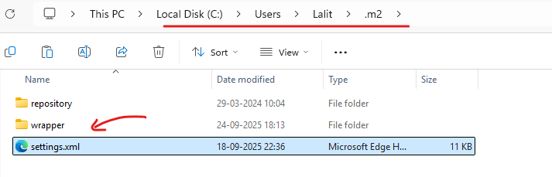

Settings.xml from Intellij comes as below

<?xml version="1.0" encoding="UTF-8"?>

<!--

Licensed to the Apache Software Foundation (ASF) under one

or more contributor license agreements. See the NOTICE file

distributed with this work for additional information

regarding copyright ownership. The ASF licenses this file

to you under the Apache License, Version 2.0 (the

"License"); you may not use this file except in compliance

with the License. You may obtain a copy of the License at

http://www.apache.org/licenses/LICENSE-2.0

Unless required by applicable law or agreed to in writing,

software distributed under the License is distributed on an

"AS IS" BASIS, WITHOUT WARRANTIES OR CONDITIONS OF ANY

KIND, either express or implied. See the License for the

specific language governing permissions and limitations

under the License.

-->

<!--

| This is the configuration file for Maven. It can be specified at two levels:

|

| 1. User Level. This settings.xml file provides configuration for a single user,

| and is normally provided in ${user.home}/.m2/settings.xml.

|

| NOTE: This location can be overridden with the CLI option:

|

| -s /path/to/user/settings.xml

|

| 2. Global Level. This settings.xml file provides configuration for all Maven

| users on a machine (assuming they're all using the same Maven

| installation). It's normally provided in

| ${maven.conf}/settings.xml.

|

| NOTE: This location can be overridden with the CLI option:

|

| -gs /path/to/global/settings.xml

|

| The sections in this sample file are intended to give you a running start at

| getting the most out of your Maven installation. Where appropriate, the default

| values (values used when the setting is not specified) are provided.

|

|-->

<settings xmlns="http://maven.apache.org/SETTINGS/1.2.0"

xmlns:xsi="http://www.w3.org/2001/XMLSchema-instance"

xsi:schemaLocation="http://maven.apache.org/SETTINGS/1.2.0 https://maven.apache.org/xsd/settings-1.2.0.xsd">

<!-- localRepository

| The path to the local repository maven will use to store artifacts.

|

| Default: ${user.home}/.m2/repository

<localRepository>/path/to/local/repo</localRepository>

-->

<!-- interactiveMode

| This will determine whether maven prompts you when it needs input. If set to false,

| maven will use a sensible default value, perhaps based on some other setting, for

| the parameter in question.

|

| Default: true

<interactiveMode>true</interactiveMode>

-->

<!-- offline

| Determines whether maven should attempt to connect to the network when executing a build.

| This will have an effect on artifact downloads, artifact deployment, and others.

|

| Default: false

<offline>false</offline>

-->

<!-- pluginGroups

| This is a list of additional group identifiers that will be searched when resolving plugins by their prefix, i.e.

| when invoking a command line like "mvn prefix:goal". Maven will automatically add the group identifiers

| "org.apache.maven.plugins" and "org.codehaus.mojo" if these are not already contained in the list.

|-->

<pluginGroups>

<!-- pluginGroup

| Specifies a further group identifier to use for plugin lookup.

<pluginGroup>com.your.plugins</pluginGroup>

-->

</pluginGroups>

<!-- TODO Since when can proxies be selected as depicted? -->

<!-- proxies

| This is a list of proxies which can be used on this machine to connect to the network.

| Unless otherwise specified (by system property or command-line switch), the first proxy

| specification in this list marked as active will be used.

|-->

<proxies>

<!-- proxy

| Specification for one proxy, to be used in connecting to the network.

|

<proxy>

<id>optional</id>

<active>true</active>

<protocol>http</protocol>

<username>proxyuser</username>

<password>proxypass</password>

<host>proxy.host.net</host>

<port>80</port>

<nonProxyHosts>local.net|some.host.com</nonProxyHosts>

</proxy>

-->

</proxies>

<!-- servers

| This is a list of authentication profiles, keyed by the server-id used within the system.

| Authentication profiles can be used whenever maven must make a connection to a remote server.

|-->

<servers>

<!-- server

| Specifies the authentication information to use when connecting to a particular server, identified by

| a unique name within the system (referred to by the 'id' attribute below).

|

| NOTE: You should either specify username/password OR privateKey/passphrase, since these pairings are

| used together.

|

<server>

<id>deploymentRepo</id>

<username>repouser</username>

<password>repopwd</password>

</server>

-->

<!-- Another sample, using keys to authenticate.

<server>

<id>siteServer</id>

<privateKey>/path/to/private/key</privateKey>

<passphrase>optional; leave empty if not used.</passphrase>

</server>

-->

</servers>

<!-- mirrors

| This is a list of mirrors to be used in downloading artifacts from remote repositories.

|

| It works like this: a POM may declare a repository to use in resolving certain artifacts.

| However, this repository may have problems with heavy traffic at times, so people have mirrored

| it to several places.

|

| That repository definition will have a unique id, so we can create a mirror reference for that

| repository, to be used as an alternate download site. The mirror site will be the preferred

| server for that repository.

|-->

<mirrors>

<!-- mirror

| Specifies a repository mirror site to use instead of a given repository. The repository that

| this mirror serves has an ID that matches the mirrorOf element of this mirror. IDs are used

| for inheritance and direct lookup purposes, and must be unique across the set of mirrors.

|

<mirror>

<id>mirrorId</id>

<mirrorOf>repositoryId</mirrorOf>

<name>Human Readable Name for this Mirror.</name>

<url>http://my.repository.com/repo/path</url>

</mirror>

-->

<mirror>

<id>maven-default-http-blocker</id>

<mirrorOf>external:http:*</mirrorOf>

<name>Pseudo repository to mirror external repositories initially using HTTP.</name>

<url>http://0.0.0.0/</url>

<blocked>true</blocked>

</mirror>

</mirrors>

<!-- profiles

| This is a list of profiles which can be activated in a variety of ways, and which can modify

| the build process. Profiles provided in the settings.xml are intended to provide local machine-

| specific paths and repository locations which allow the build to work in the local environment.

|

| For example, if you have an integration testing plugin - like cactus - that needs to know where

| your Tomcat instance is installed, you can provide a variable here such that the variable is

| dereferenced during the build process to configure the cactus plugin.

|

| As noted above, profiles can be activated in a variety of ways. One way - the activeProfiles

| section of this document (settings.xml) - will be discussed later. Another way essentially

| relies on the detection of a property, either matching a particular value for the property,

| or merely testing its existence. Profiles can also be activated by JDK version prefix, where a

| value of '1.4' might activate a profile when the build is executed on a JDK version of '1.4.2_07'.

| Finally, the list of active profiles can be specified directly from the command line.

|

| NOTE: For profiles defined in the settings.xml, you are restricted to specifying only artifact

| repositories, plugin repositories, and free-form properties to be used as configuration

| variables for plugins in the POM.

|

|-->

<profiles>

<!-- profile

| Specifies a set of introductions to the build process, to be activated using one or more of the

| mechanisms described above. For inheritance purposes, and to activate profiles via <activatedProfiles/>

| or the command line, profiles have to have an ID that is unique.

|

| An encouraged best practice for profile identification is to use a consistent naming convention

| for profiles, such as 'env-dev', 'env-test', 'env-production', 'user-jdcasey', 'user-brett', etc.

| This will make it more intuitive to understand what the set of introduced profiles is attempting

| to accomplish, particularly when you only have a list of profile id's for debug.

|

| This profile example uses the JDK version to trigger activation, and provides a JDK-specific repo.

<profile>

<id>jdk-1.4</id>

<activation>

<jdk>1.4</jdk>

</activation>

<repositories>

<repository>

<id>jdk14</id>

<name>Repository for JDK 1.4 builds</name>

<url>http://www.myhost.com/maven/jdk14</url>

<layout>default</layout>

<snapshotPolicy>always</snapshotPolicy>

</repository>

</repositories>

</profile>

-->

<!--

| Here is another profile, activated by the property 'target-env' with a value of 'dev', which

| provides a specific path to the Tomcat instance. To use this, your plugin configuration might

| hypothetically look like:

|

| ...

| <plugin>

| <groupId>org.myco.myplugins</groupId>

| <artifactId>myplugin</artifactId>

|

| <configuration>

| <tomcatLocation>${tomcatPath}</tomcatLocation>

| </configuration>

| </plugin>

| ...

|

| NOTE: If you just wanted to inject this configuration whenever someone set 'target-env' to

| anything, you could just leave off the <value/> inside the activation-property.

|

<profile>

<id>env-dev</id>

<activation>

<property>

<name>target-env</name>

<value>dev</value>

</property>

</activation>

<properties>

<tomcatPath>/path/to/tomcat/instance</tomcatPath>

</properties>

</profile>

-->

</profiles>

<!-- activeProfiles

| List of profiles that are active for all builds.

|

<activeProfiles>

<activeProfile>alwaysActiveProfile</activeProfile>

<activeProfile>anotherAlwaysActiveProfile</activeProfile>

</activeProfiles>

-->

</settings>

This is not fully setup yet ( we cannot see any profiles and we can see the maven build arrow in grey too )

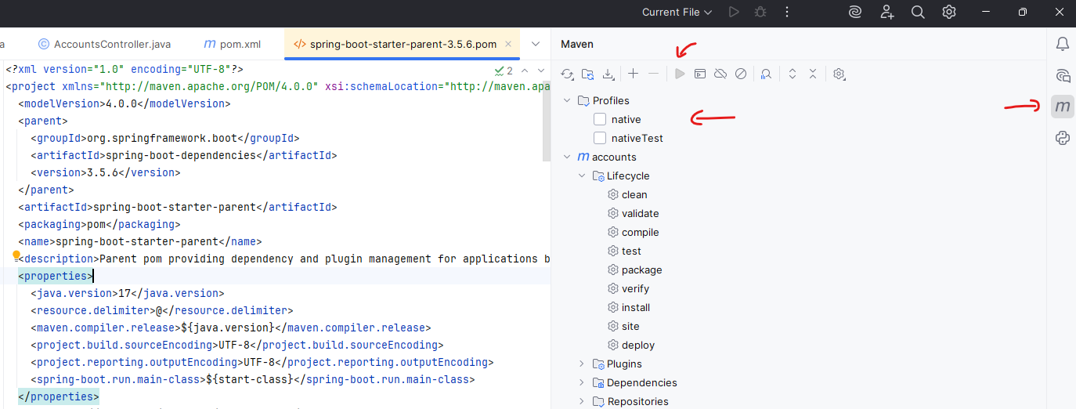

For our local work, we can reduce this to ( since we are not behind a company proxy or have our own nexus here )

<?xml version="1.0" encoding="UTF-8"?>

<settings xmlns="http://maven.apache.org/SETTINGS/1.2.0"

xmlns:xsi="http://www.w3.org/2001/XMLSchema-instance"

xsi:schemaLocation="http://maven.apache.org/SETTINGS/1.2.0

https://maven.apache.org/xsd/settings-1.2.0.xsd">

<localRepository>${user.home}/.m2/repository</localRepository>

<mirrors>

<mirror>

<id>central</id>

<url>https://repo.maven.apache.org/maven2/</url>

<mirrorOf>maven-central</mirrorOf>

</mirror>

</mirrors>

</settings>

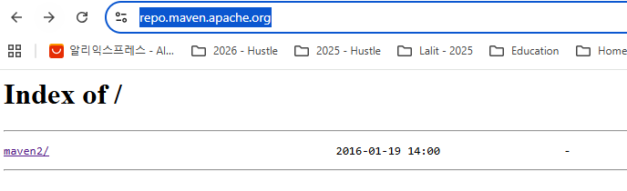

Now also create a profile

<?xml version="1.0" encoding="UTF-8"?>

<settings xmlns="http://maven.apache.org/SETTINGS/1.2.0"

xmlns:xsi="http://www.w3.org/2001/XMLSchema-instance"

xsi:schemaLocation="http://maven.apache.org/SETTINGS/1.2.0 https://maven.apache.org/xsd/settings-1.2.0.xsd">

<localRepository>${user.home}/.m2/repository</localRepository>

<mirrors>

<mirror>

<id>central</id>

<url>https://repo.maven.apache.org/maven2/</url>

<mirrorOf>maven-central</mirrorOf>

</mirror>

</mirrors>

<profiles>

<profile>

<id>central-repository</id>

<activation>

<activeByDefault>true</activeByDefault>

</activation>

<repositories>

<repository>

<id>maven-central</id>

<url>https://repo1.maven.org/maven2/</url>

</repository>

</repositories>

</profile>

</profiles>

</settings>

url path that we put is of below

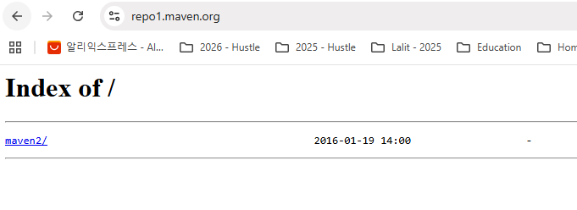

Add the activeProfiles now to this

<?xml version="1.0" encoding="UTF-8"?>

<settings xmlns="http://maven.apache.org/SETTINGS/1.2.0"

xmlns:xsi="http://www.w3.org/2001/XMLSchema-instance"

xsi:schemaLocation="http://maven.apache.org/SETTINGS/1.2.0

https://maven.apache.org/xsd/settings-1.2.0.xsd">

<localRepository>${user.home}/.m2/repository</localRepository>

<mirrors>

<mirror>

<id>central</id>

<url>https://repo.maven.apache.org/maven2/</url>

<mirrorOf>maven-central</mirrorOf>

</mirror>

</mirrors>

<profiles>

<profile>

<id>central-repository</id>

<activation>

<activeByDefault>true</activeByDefault>

</activation>

<repositories>

<repository>

<id>maven-central</id>

<url>https://repo1.maven.org/maven2/</url>

</repository>

</repositories>

</profile>

</profiles>

<activeProfiles>

<activeProfile>central-repository</activeProfile>

</activeProfiles>

</settings>

This should be enough to get your dependencies for the project

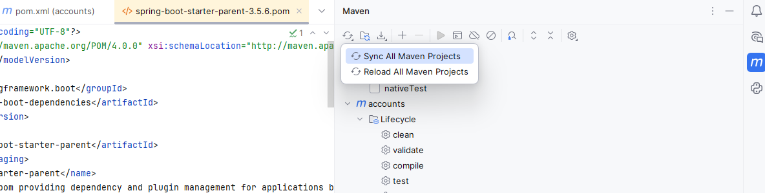

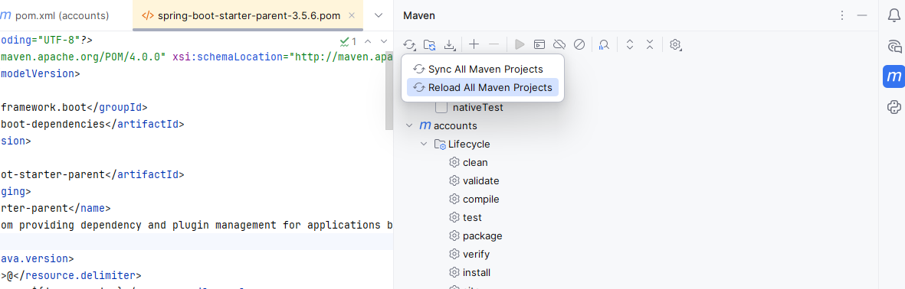

The profile starts appearing

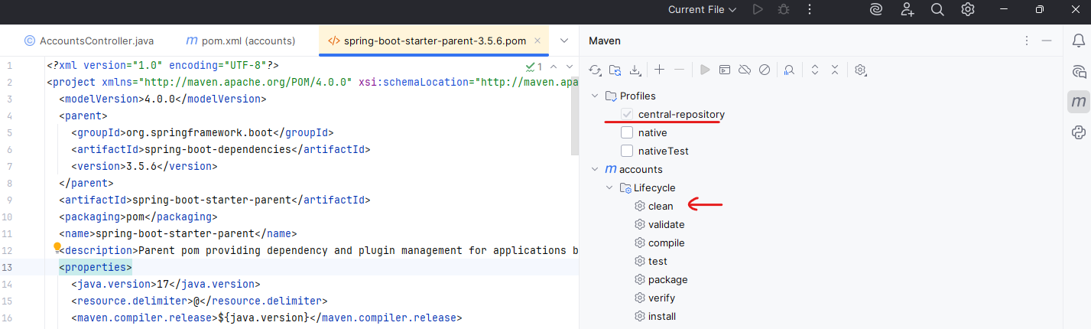

Run the maven clean goal highlighted by arrow here

Then Run the maven install goal

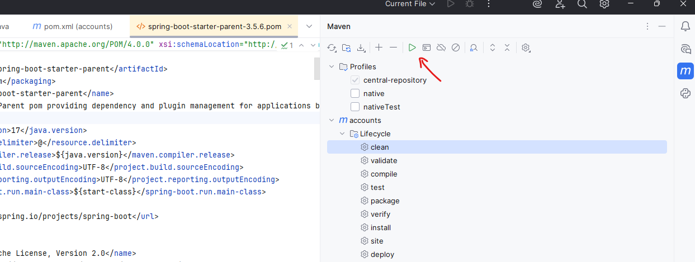

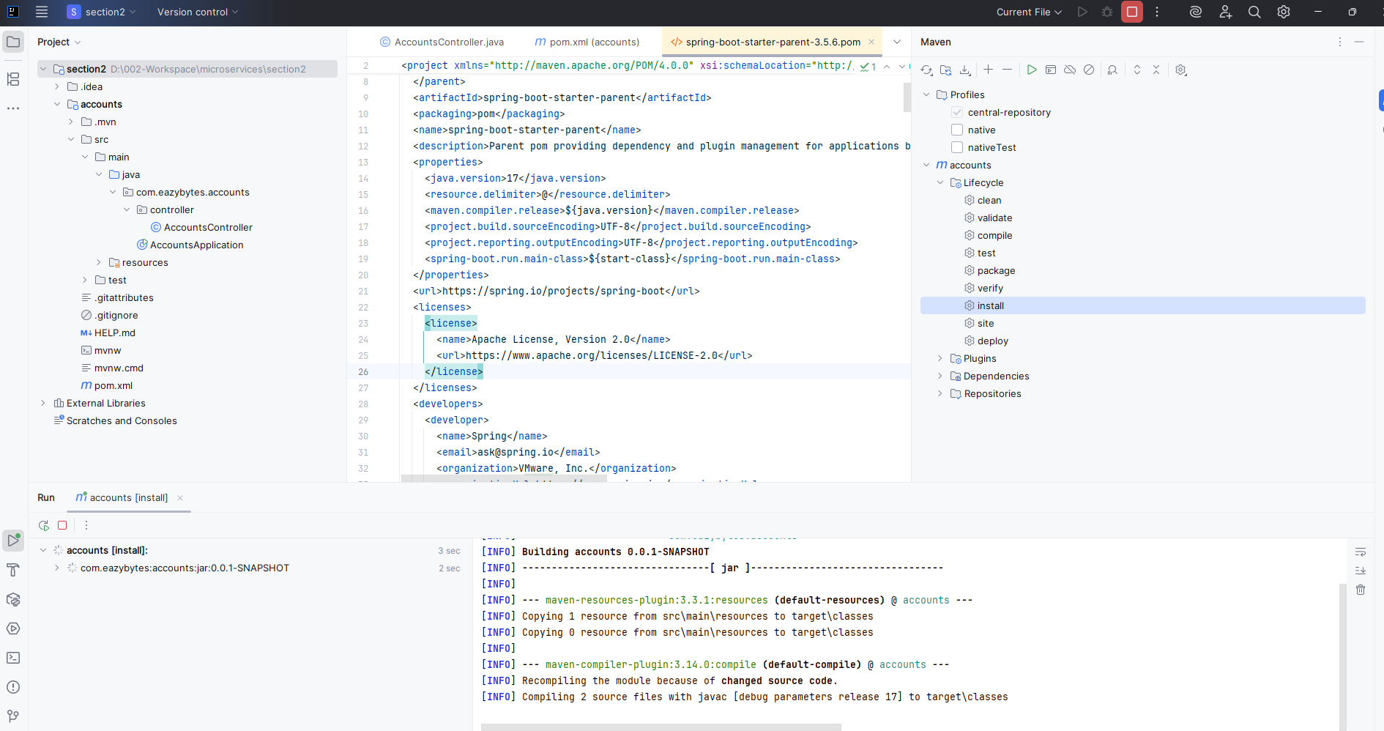

Creating the settings.xml file video > <https://www.youtube.com/watch?v=_bsQ8WC3TAg>

### Hello World REST API

Now let's try to update this basic spring boot application with a new Rest API that gives the response saying that Hello World. At the same, if you are already comfortable with all these basic concepts, I would recommend you to fast forward the discussion. That way you won't get feel bored. But if you're not aware about all these basic concepts, I would recommend you to follow the discussions carefully. So in order to create a new basic Rest API, I'm going to create a new package with the name com.eazybytes.accounts.controller.

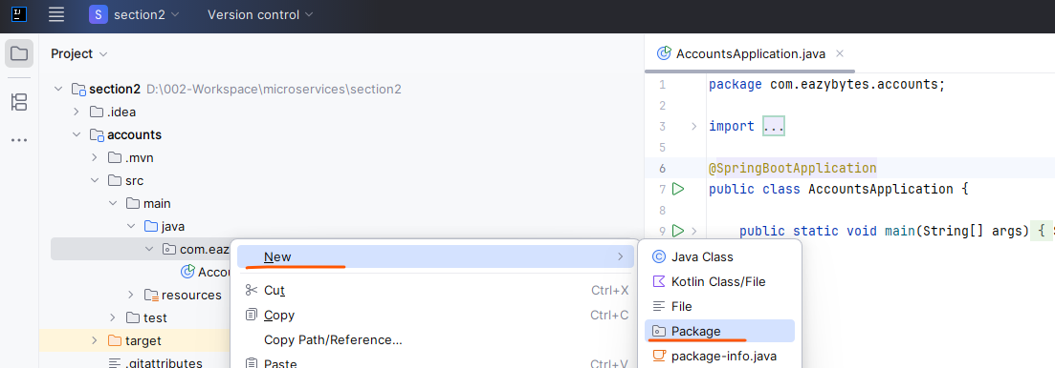

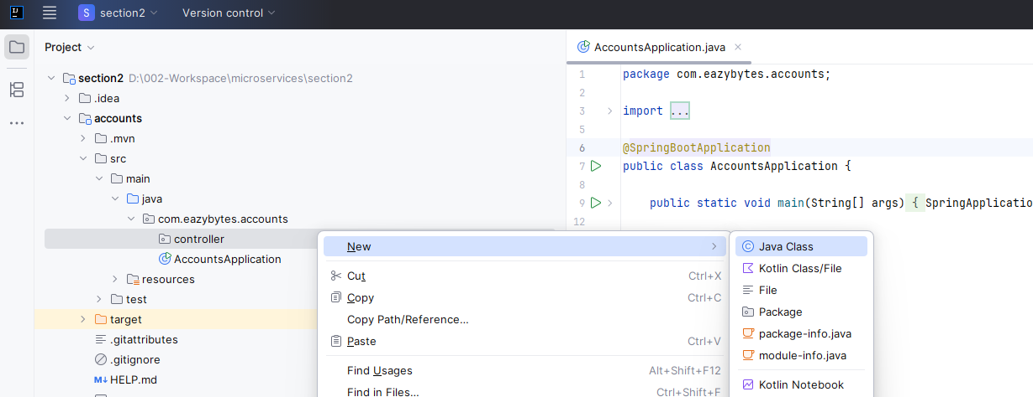

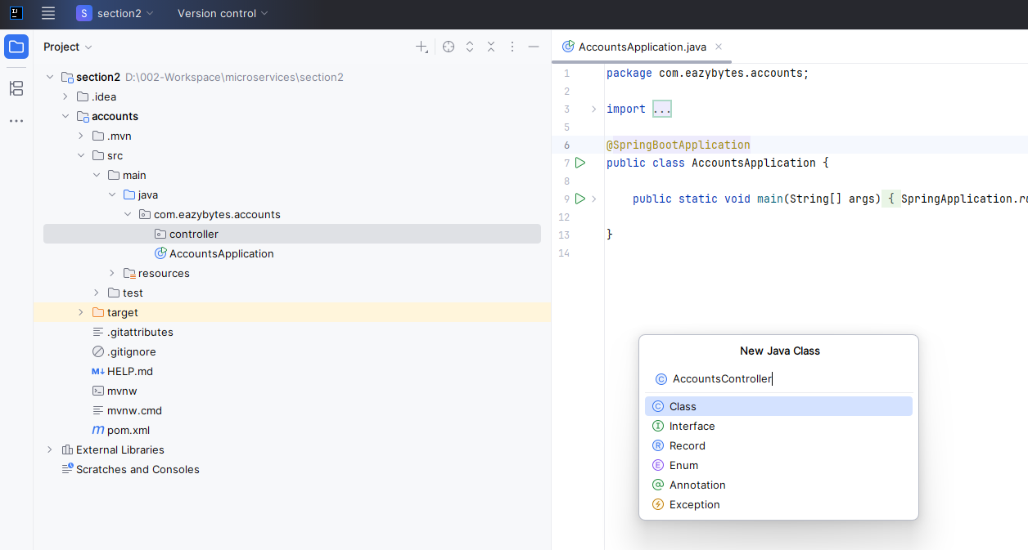

So inside this controller package I'm going to create a new class. The class name is going to be accounts controller. Inside this class only I'm going to create all the Rest APIs related to the accounts. Microservice First, let's try to put an annotation on top of this class. The annotation is @RestController.

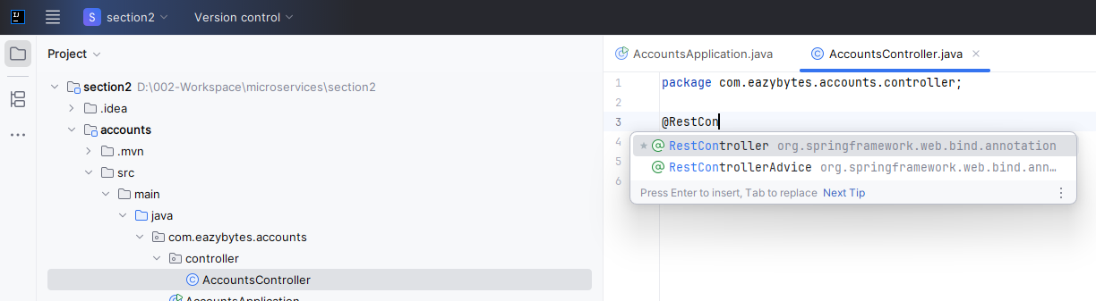

package com.eazybytes.accounts.controller;

import org.springframework.web.bind.annotation.RestController;

@RestController

public class AccountsController {

}

Whenever we mention this annotation on top of a class, we are instructing to the spring boot framework I'm going to write methods inside this class with the annotations related to the Http methods. Accordingly, please expose all these methods as a Rest APIs to the outside world.

So that is an indication that we are giving to the spring boot framework. So here I'm going to create a method. So let me type the method like public. It is going to return string and the method name is going to be say hello and it is not going to accept anything. It is simply going to return a string saying that Hello world. So this is the tradition that most developers, they follow whenever they are getting started with the new framework. So that's why I'm trying to follow the same tradition. Now, on top of this method, I'm going to mention an annotation which is get mapping. So whenever we are mentioning get mapping, we are telling to the spring boot framework that this method is going to support Http get method. So whoever want to invoke my API, they need to invoke with the help of Http get method because this method is simply going to return the data to the end user or to the client. That's why we should use the Get Mapping. And since someone want to invoke this API, we should mention what is the path that this method is going to support. So here I'm just going to define the path saying that say hello. So if someone is trying to invoke my API, say hello, they'll get this response. So let me save this changes. I'm going to do a build.

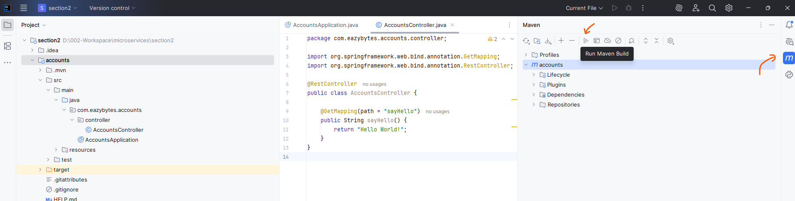

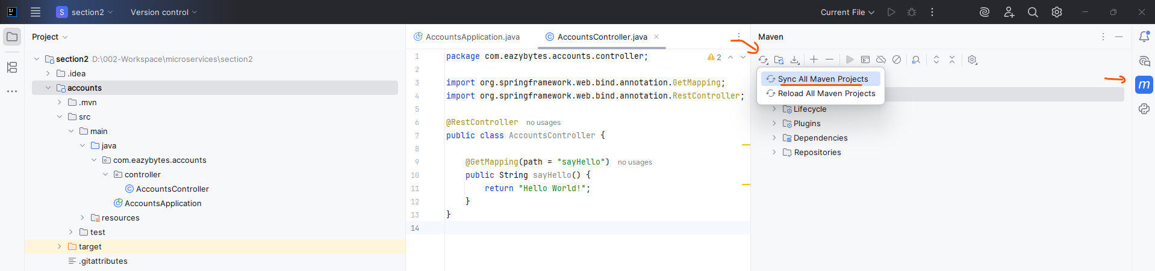

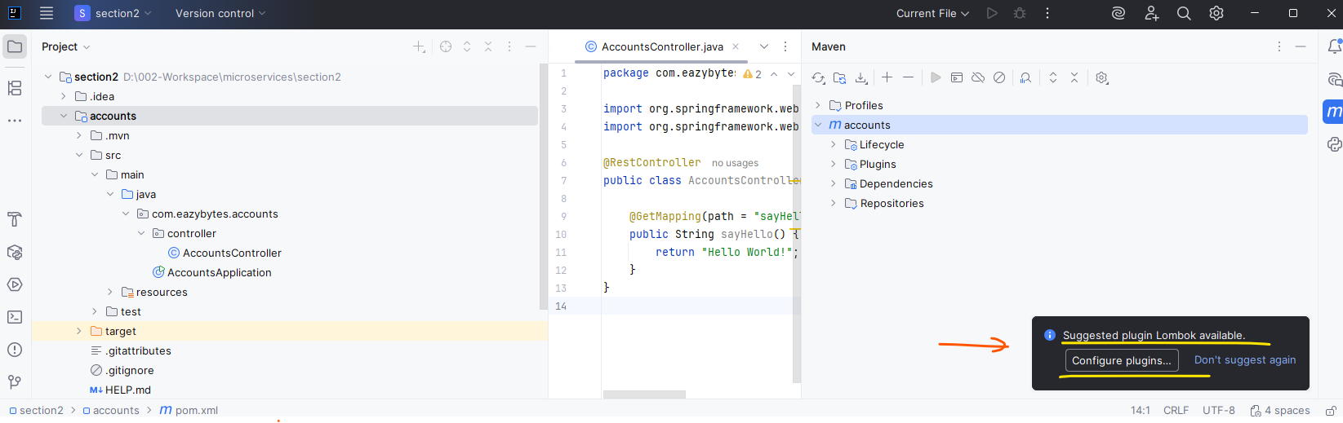

When you're trying to do a build very first time, your IDE will ask you to enable annotation processing because it identifies the Lombok inside your classpath. So please enable the annotations so that we can leverage the Lombok Library inside this course. So let me do this. After this, I'm going to do build again. Once the build is completed, I'm straight away going to the spring Boot main class, which is accounts application.

Install the Lombok Plugin

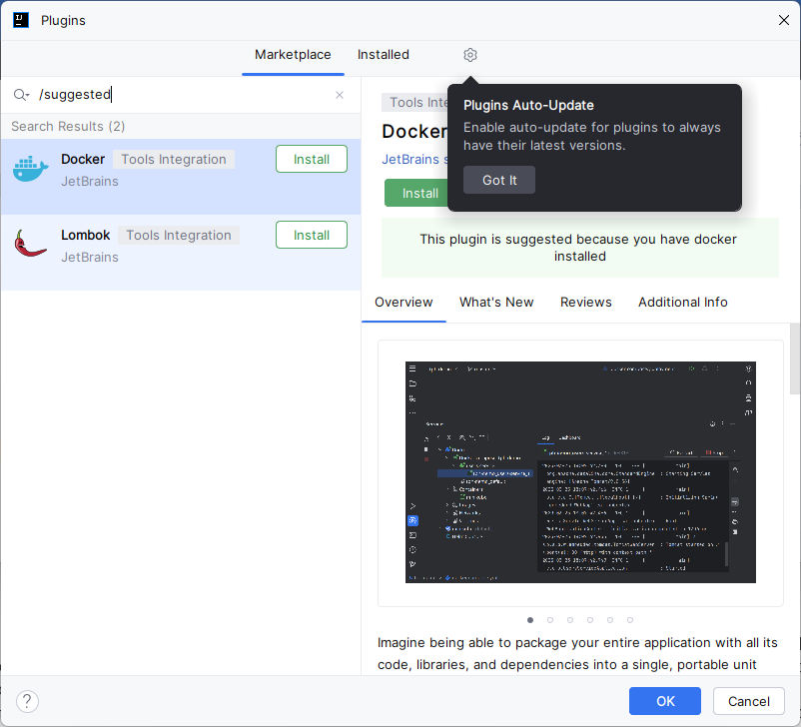

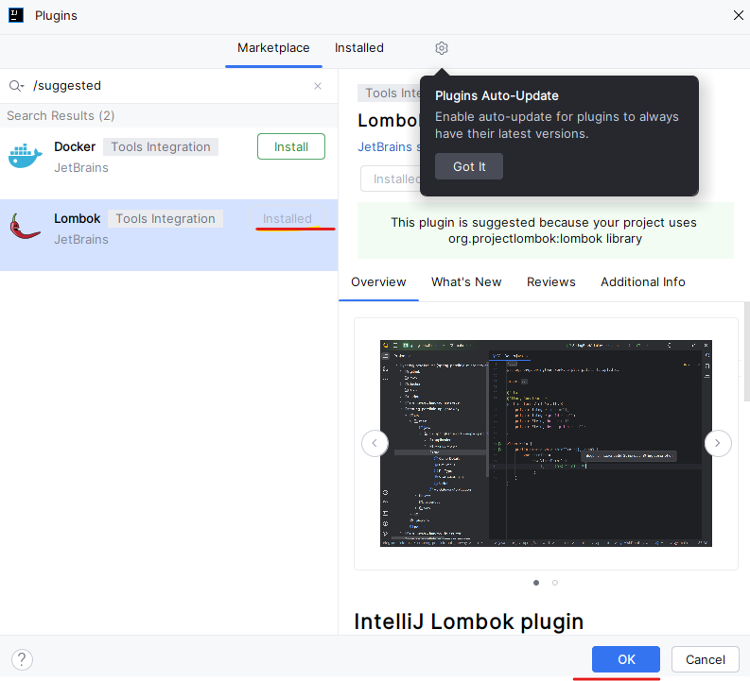

Lets do a maven build now

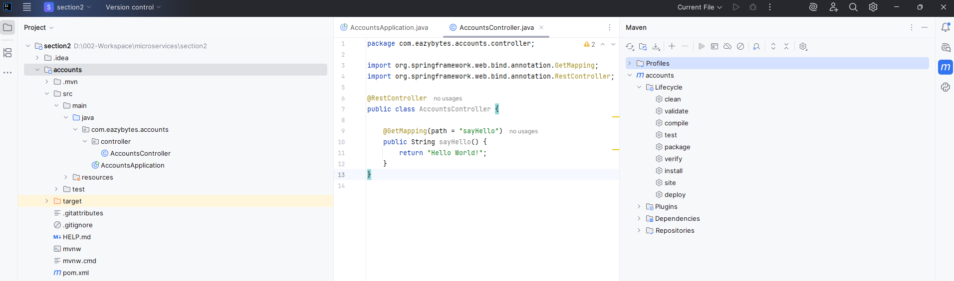

And here I'm trying to start my application in a debug mode. So let's see the magic that it is going to do behind the scenes.

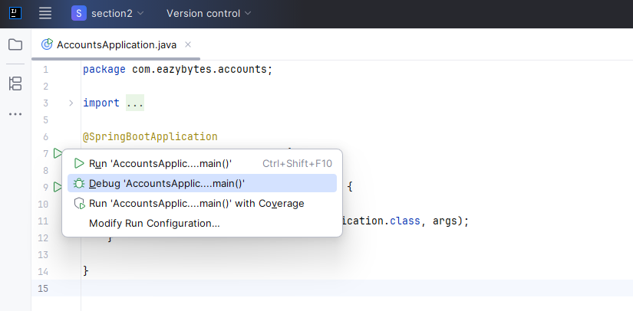

If you get a port 8080 is already in use and application cannot start error – use the following command in command prompt admin mode ( elevated privileges required )

D:\>tasklist | findstr 5904

AgentService.exe 5904 Services 0 5,768 K

D:\>netstat -nb

Active Connections

Proto Local Address Foreign Address State

TCP 127.0.0.1:55252 127.0.0.1:55253 ESTABLISHED

[firefox.exe]

TCP 127.0.0.1:55253 127.0.0.1:55252 ESTABLISHED

[firefox.exe]

TCP 127.0.0.1:55254 127.0.0.1:55255 ESTABLISHED

. . .

[kpm_service.exe]

TCP 192.168.0.238:55428 216.239.32.116:443 ESTABLISHED

[chrome.exe]

TCP 192.168.0.238:57308 142.250.192.3:443 TIME_WAIT

TCP 192.168.0.238:57371 142.250.183.42:443 TIME_WAIT

TCP 192.168.0.238:62528 142.250.67.206:443 TIME_WAIT

TCP 192.168.0.238:62530 104.120.67.240:80 TIME_WAIT

TCP 192.168.0.238:62531 142.250.77.67:80 TIME_WAIT

TCP 192.168.0.238:62532 23.38.59.250:80 TIME_WAIT

TCP 192.168.0.238:62533 199.232.214.172:80 TIME_WAIT

TCP 192.168.0.238:62534 172.66.168.73:443 TIME_WAIT

TCP 192.168.0.238:64690 74.125.200.188:5228 ESTABLISHED

[chrome.exe]

TCP [::1]:8080 [::1]:60153 ESTABLISHED

[AgentService.exe]

TCP [::1]:60153 [::1]:8080 ESTABLISHED

[chrome.exe]

I have killed the task 5904 via task manager

C:\Windows\System32>netstat -ano | findstr 8080

TCP 0.0.0.0:8080 0.0.0.0:0 LISTENING 6088

TCP [::]:8080 [::]:0 LISTENING 6088

TCP [::1]:8080 [::1]:50484 ESTABLISHED 6088

TCP [::1]:8080 [::1]:53141 ESTABLISHED 6088

TCP [::1]:50484 [::1]:8080 ESTABLISHED 14928

TCP [::1]:53141 [::1]:8080 ESTABLISHED 14928

TCP [::1]:61038 [::1]:8080 TIME_WAIT 0

TCP [::1]:63085 [::1]:8080 TIME_WAIT 0

C:\Windows\System32>taskkill /F /pid 6088

SUCCESS: The process with PID 6088 has been terminated.

Starting the application again now

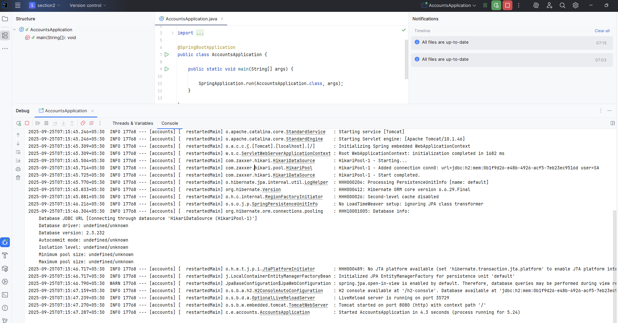

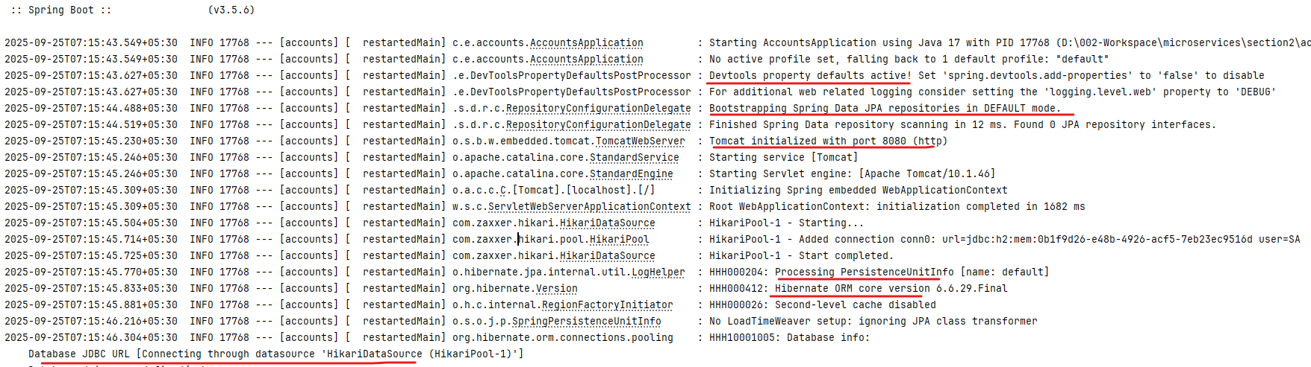

Like you can see here, my accounts application started at the port 8080 and it also identified that I have history database inside my dependency. That's why it completed all auto configuration related to H2 console. The same applies for the actuator. Since we have the actuator related dependency inside our pom.xml spring boot did all the auto configuration and apart from that it is also deployed our web application automatically into your Tomcat server at the port 8080 with the context path empty. This means my spring boot framework based upon dependencies that I have defined inside my web application. It is able to do a lot of auto configuration. It is not asking me to provide what is a port number where it has to deploy, what is the server, where it has to deploy, what are the connection details to my H2 database? It is not asking all those details and it is assuming and doing some default configurations. I'll be showing how to override these default configurations in the coming lectures. For now, let's try to access our API the help of port 8080. For the same inside my browser, I'm going to type localhost 8080 since our application started at the port 8080. And the path that we need to invoke is say hello. As soon as I try to invoke this API path, you will be able to see I'm getting Hello world response from my backend server.

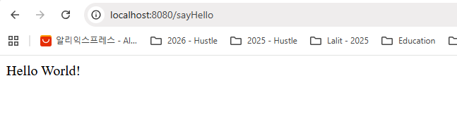

So whenever we try to invoke this path from browser, it is going to invoke with the help of history http get method only. That's why I'm getting the response. Hello world. I hope you are seeing the beauty of the spring boot framework, how easy it is to build a microservice if I'm aware of all these steps. I can create a micro service template or skeleton within one two minutes, post that I can update with my own business logic. And apart from this, like I said, there are some productivity tools available inside the spring boot framework like dev tools, which is going to help to improve the productivity of the developer.

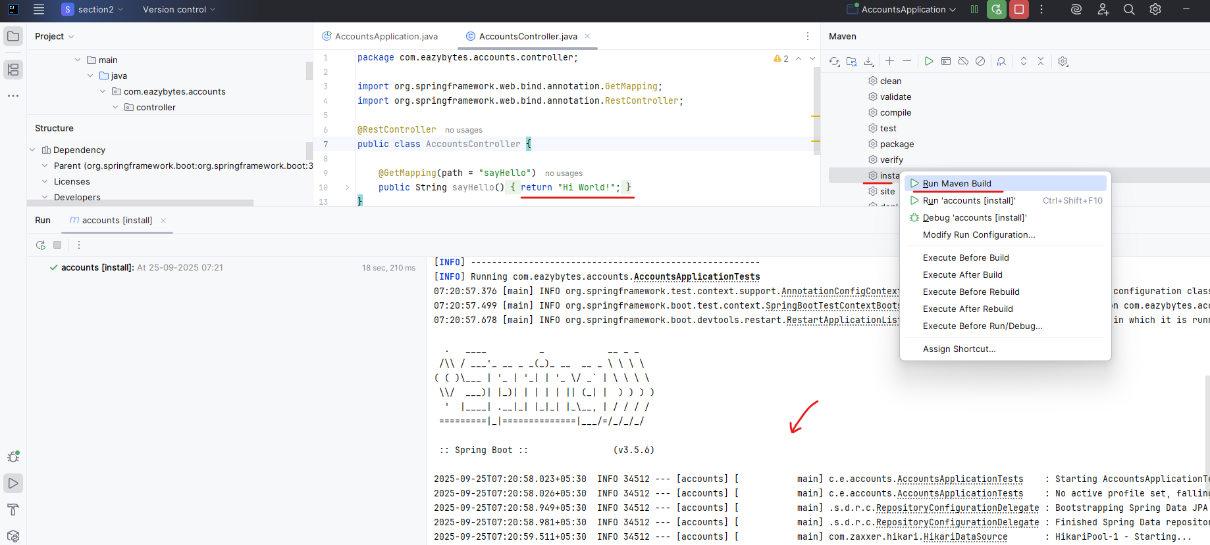

For example, if I try to update this string to hi world and I'm saving these changes and doing a build as soon as the build is completed, I'm not going to restart the server, I'll just go to the debug and I'll see what is there inside my console. You can see by default my spring boot framework itself restarted my application within eight milliseconds initially to start the server. Very first time it took 6.834 seconds. But later on when I make the changes, it restarted very quickly because it is trying to load the class, which is changed in our scenario. It is accounts controller. So now let me go to the browser and try to refresh. So here I'm trying to refresh my page and you can see I'm getting the latest response.

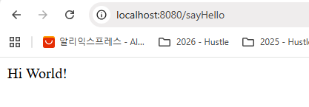

C:\software\apache-maven-3.8.3\bin\mvn.cmd -Didea.version=2025.2.2 -Dmaven.ext.class.path=C:\Program Files\JetBrains\IntelliJ IDEA Community Edition 2025.2.2\plugins\maven\lib\maven-event-listener.jar -Djansi.passthrough=true -Dstyle.color=always -s C:\Users\Lalit\.m2\settings.xml -Dmaven.repo.local=C:\Users\Lalit\.m2\repository install -f pom.xml

[INFO] Scanning for projects...

[INFO]

[INFO] -----------------------< com.eazybytes:accounts >-----------------------

[INFO] Building accounts 0.0.1-SNAPSHOT

[INFO] --------------------------------[ jar ]---------------------------------

[INFO]

[INFO] --- maven-resources-plugin:3.3.1:resources (default-resources) @ accounts ---

[INFO] Copying 1 resource from src\main\resources to target\classes

[INFO] Copying 0 resource from src\main\resources to target\classes

[INFO]

[INFO] --- maven-compiler-plugin:3.14.0:compile (default-compile) @ accounts ---

[INFO] Recompiling the module because of changed source code.

[INFO] Compiling 2 source files with javac [debug parameters release 17] to target\classes

[INFO]

[INFO] --- maven-resources-plugin:3.3.1:testResources (default-testResources) @ accounts ---

[INFO] skip non existing resourceDirectory D:\002-Workspace\microservices\section2\accounts\src\test\resources

[INFO]

[INFO] --- maven-compiler-plugin:3.14.0:testCompile (default-testCompile) @ accounts ---

[INFO] Recompiling the module because of changed dependency.

[INFO] Compiling 1 source file with javac [debug parameters release 17] to target\test-classes

[INFO]

[INFO] --- maven-surefire-plugin:3.5.4:test (default-test) @ accounts ---

[INFO] Using auto detected provider org.apache.maven.surefire.junitplatform.JUnitPlatformProvider

[INFO]

[INFO] -------------------------------------------------------

[INFO] T E S T S

[INFO] -------------------------------------------------------

[INFO] Running com.eazybytes.accounts.AccountsApplicationTests

08:28:09.683 [main] INFO org.springframework.test.context.support.AnnotationConfigContextLoaderUtils -- Could not detect default configuration classes for test class [com.eazybytes.accounts.AccountsApplicationTests]: AccountsApplicationTests does not declare any static, non-private, non-final, nested classes annotated with @Configuration.

08:28:09.858 [main] INFO org.springframework.boot.test.context.SpringBootTestContextBootstrapper -- Found @SpringBootConfiguration com.eazybytes.accounts.AccountsApplication for test class com.eazybytes.accounts.AccountsApplicationTests

08:28:10.200 [main] INFO org.springframework.boot.devtools.restart.RestartApplicationListener -- Restart disabled due to context in which it is running

. ____ _ __ _ _

/\\ / ___'_ __ _ _(_)_ __ __ _ \ \ \ \

( ( )\___ | '_ | '_| | '_ \/ _` | \ \ \ \

\\/ ___)| |_)| | | | | || (_| | ) ) ) )

' |____| .__|_| |_|_| |_\__, | / / / /

=========|_|==============|___/=/_/_/_/

:: Spring Boot :: (v3.5.6)

2025-09-25T08:28:10.909+05:30 INFO 24232 --- [accounts] [ main] c.e.accounts.AccountsApplicationTests : Starting AccountsApplicationTests using Java 17 with PID 24232 (started by Lalit in D:\002-Workspace\microservices\section2\accounts)

2025-09-25T08:28:10.909+05:30 INFO 24232 --- [accounts] [ main] c.e.accounts.AccountsApplicationTests : No active profile set, falling back to 1 default profile: "default"

2025-09-25T08:28:12.160+05:30 INFO 24232 --- [accounts] [ main] .s.d.r.c.RepositoryConfigurationDelegate : Bootstrapping Spring Data JPA repositories in DEFAULT mode.

2025-09-25T08:28:12.192+05:30 INFO 24232 --- [accounts] [ main] .s.d.r.c.RepositoryConfigurationDelegate : Finished Spring Data repository scanning in 17 ms. Found 0 JPA repository interfaces.

2025-09-25T08:28:12.874+05:30 INFO 24232 --- [accounts] [ main] com.zaxxer.hikari.HikariDataSource : HikariPool-1 - Starting...

2025-09-25T08:28:13.113+05:30 INFO 24232 --- [accounts] [ main] com.zaxxer.hikari.pool.HikariPool : HikariPool-1 - Added connection conn0: url=jdbc:h2:mem:7f95ee07-ef4d-4ee5-8a80-6a7c624822de user=SA

2025-09-25T08:28:13.113+05:30 INFO 24232 --- [accounts] [ main] com.zaxxer.hikari.HikariDataSource : HikariPool-1 - Start completed.

2025-09-25T08:28:13.240+05:30 INFO 24232 --- [accounts] [ main] o.hibernate.jpa.internal.util.LogHelper : HHH000204: Processing PersistenceUnitInfo [name: default]

2025-09-25T08:28:13.336+05:30 INFO 24232 --- [accounts] [ main] org.hibernate.Version : HHH000412: Hibernate ORM core version 6.6.29.Final

2025-09-25T08:28:13.383+05:30 INFO 24232 --- [accounts] [ main] o.h.c.internal.RegionFactoryInitiator : HHH000026: Second-level cache disabled

2025-09-25T08:28:13.863+05:30 INFO 24232 --- [accounts] [ main] o.s.o.j.p.SpringPersistenceUnitInfo : No LoadTimeWeaver setup: ignoring JPA class transformer

2025-09-25T08:28:13.985+05:30 INFO 24232 --- [accounts] [ main] org.hibernate.orm.connections.pooling : HHH10001005: Database info:

Database JDBC URL [Connecting through datasource 'HikariDataSource (HikariPool-1)']

Database driver: undefined/unknown

Database version: 2.3.232

Autocommit mode: undefined/unknown

Isolation level: undefined/unknown

Minimum pool size: undefined/unknown

Maximum pool size: undefined/unknown

2025-09-25T08:28:14.381+05:30 INFO 24232 --- [accounts] [ main] o.h.e.t.j.p.i.JtaPlatformInitiator : HHH000489: No JTA platform available (set 'hibernate.transaction.jta.platform' to enable JTA platform integration)

2025-09-25T08:28:14.381+05:30 INFO 24232 --- [accounts] [ main] j.LocalContainerEntityManagerFactoryBean : Initialized JPA EntityManagerFactory for persistence unit 'default'

2025-09-25T08:28:14.556+05:30 WARN 24232 --- [accounts] [ main] JpaBaseConfiguration$JpaWebConfiguration : spring.jpa.open-in-view is enabled by default. Therefore, database queries may be performed during view rendering. Explicitly configure spring.jpa.open-in-view to disable this warning

2025-09-25T08:28:15.099+05:30 INFO 24232 --- [accounts] [ main] c.e.accounts.AccountsApplicationTests : Started AccountsApplicationTests in 4.927 seconds (process running for 6.3)

Whereas if you can think about all these inside a monolithic application where you are not using a spring boot framework, you need to manually restart for each and every small change. And sometimes this manual restarts is going to take a lot of your efforts on day to day basis. I hope you are clear. Now I want to share an important note about IntelliJ IDE. By default, you may not have this look and feel in terms of this font and these colors and this dark theme. If you want to have the same theme like I'm showing here, please go to these IntelliJ idea and open the preferences here. Look for plugins under plugins. I'm clicking on this install. So as of now you can see I installed a theme which is dark purple theme from Jetbrains and also I installed one more theme which is one dark theme from Mark Skelton. So using these themes, I'm able to get all these look and feel so you can go to this marketplace and you can simply search for these themes like Dark Purple theme, and you will be seeing the result and there will be an install option for you since it is already installed inside my IDE, I'm getting it disabled option. Once you install this theme, you can enable these and you can search for theme inside your preferences. Once you search for the theme. Under these appearance and behavior, there is an appearance tab. Just click on that. Under this theme, you should be able to change to whatever theme that you want. And previously I'm telling to enable the annotations processing because we are going to use a lombok. For the same, you can also search for annotation here and you can see this is the annotation processor. So always make sure you are enable these annotation processing.

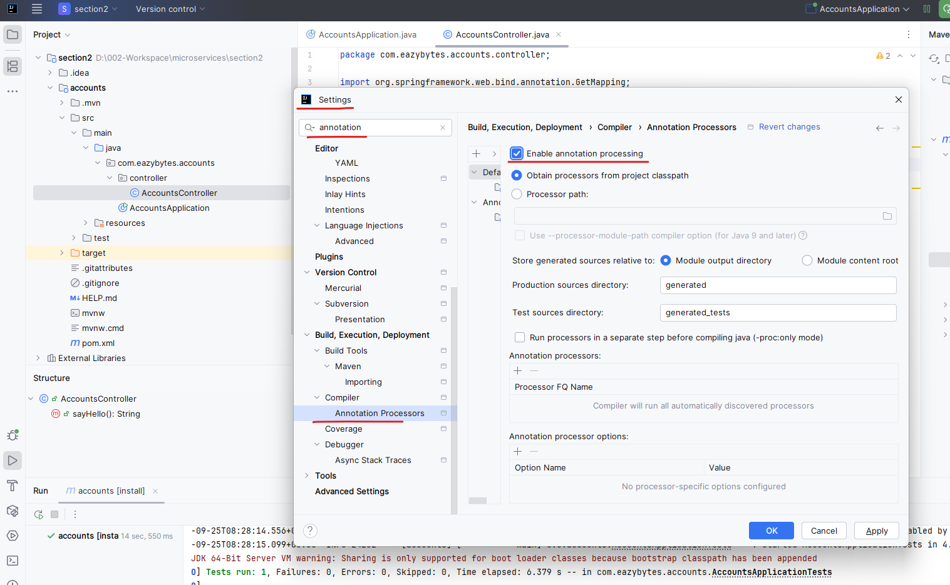

It will highlight the below, leave as is

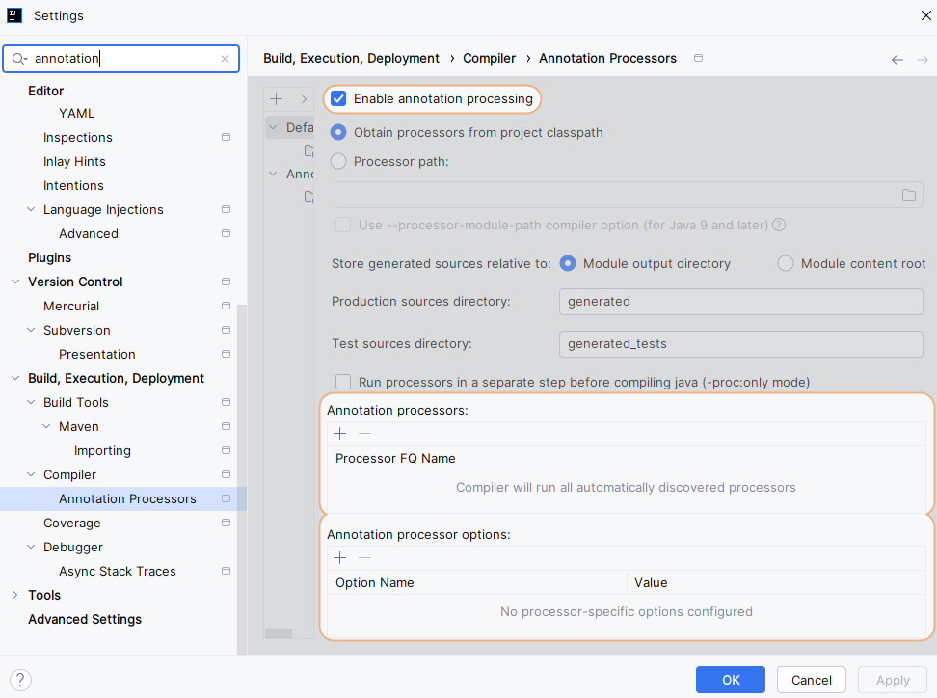

### Configuring H2 DB and YAML properties

We have created a simple rest API that says hello to the world. Now before we try to build other rest APIs which will help us to expose the CRUD operations to the clients. First, we need to make sure that our database related code is completed and it is available for us to interact with the database. As of now, we are using internal H2 database to use this history database. We can define some properties or configurations inside our application. For the same, we need to go to these resource folder and this resource folder. We have application.properties file. As of now you can see it is an empty file inside this property file only we can define all the configurations related to Spring Boot where we can mention the port number which needs to be considered by the spring boot, to start the service we can define database related configurations, we can define message queues, related configurations, we can define actuator related configurations. So there are good amount of properties or configurations that we can define inside this file, which will make developer life easy.

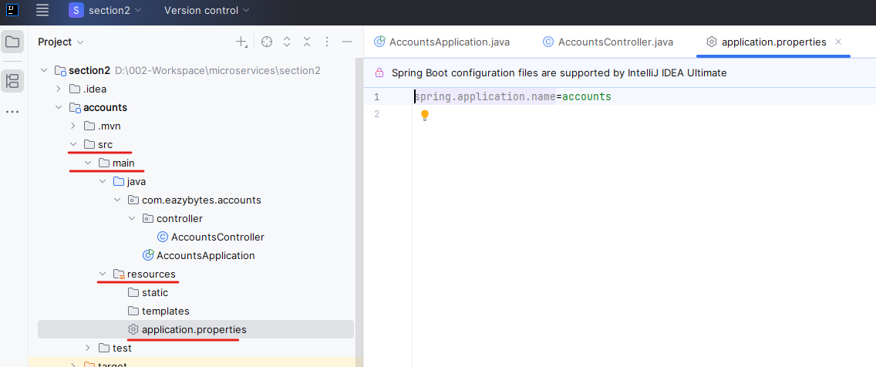

With the properties that we mentioned inside this file, Spring Boot is going to do a lot of work behind the scenes. So instead of we writing the Java code or lot of boilerplate code to handle all those logic, we simply mention the properties inside this file and Spring Boot is going to take care of connecting to database, starting the server at the mentioned port number and enabling certain features of actuator. This way we can achieve many functionality with these properties, but we are not going to write our properties with the format of key and value, which is the default way inside spring boot. Instead, we are going to define all our properties with the Yaml format. So for the same what I'm going to do is I'm going to close this application.properties and rename this file from application.properties to application.yml yml indicates that this file is going to support the yml format. So yml is a very famous format, just like XML and json. Yml is the latest and mostly used format.

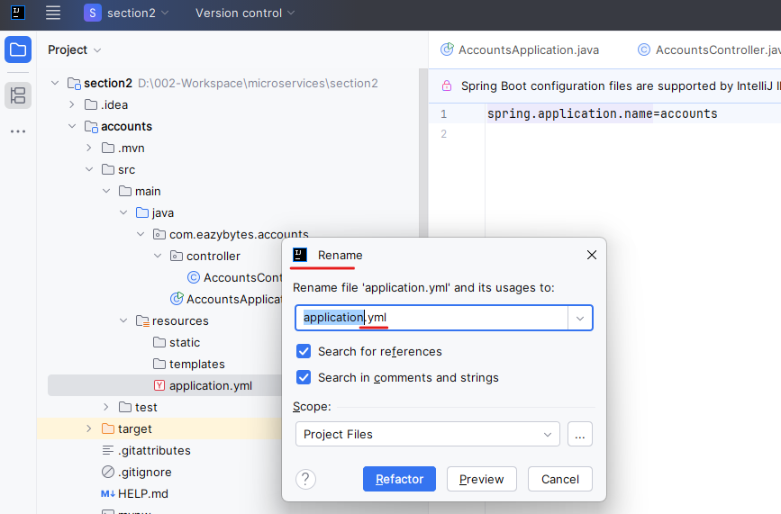

The reason why I'm using .yml format instead of .properties is Yml is very intuitive in nature. We can easily read the Yaml file very easily and the same Yml format is going to be used inside Docker, Kubernetes or any cloud providers that you go like AWS, GCP, Azure. Since many places this is being used in future also, definitely i'm confident that Spring Boot will move to the .yml format. So right now it is supporting both .properties and .yml since we can achieve more with the help of yaml format, I'm pretty sure that in future spring boot is going to migrate to .yml format. With that reasons, let's try to define the properties with the help of .yml. But here you may have questions like how can I define properties with the help of Yaml format? What is the syntax that I need to follow? So you may have many questions. So let me give a quick introduction about Yaml syntax. If you see this file, these are the normal property values that I can mention whenever I'm using .properties format. So you can see this is the key and this is the value. So there will be a key and there will be a value. The same applies for all other properties. Every property will have a key and it is going to have a corresponding value. So these are the properties and it is very clear for everyone there is no big complexity here there is a key, there is a value.

**Properties File**

server.port=8080

spring.datasource.url=jdbc:h2:mem:testdb

spring.datasource.driverClassName=org.h2.Driver

spring.datasource.username=sa

spring.datasource.password=

spring.jpa.database-platform=org.hibernate.dialect.H2Dialect

spring.h2.console.enabled=true

spring.jpa.hibernate.ddl-auto-update

spring.jpa.show-sql=true

So now let's try to understand how to represent this inside a yaml,yaml is going to work based upon indentation. When I say indentation you can see whenever I want to define this server.port as a key inside yaml I need to first mention server followed by : post that I should immediately go to a tab space inside my next row. Like you can see here I have given a tab space. Then only my Yaml is going to consider the key as server.port. And very similarly for spring.datasource.url. I need to mention spring followed by a tab space datasource: and since inside data source we are going to have the URL we need to mention the URL again with the tab space. So you can see I have mentioned the tab space here. The advantage of Yaml, you can see this spring is repeated unnecessarily inside properties file for every key, whereas with yaml it is going to have only once inside the same spring we can define data source only once, whereas in property you can see it is repeated four times and at last we reached to the end of the key which is URL. Once we reach, we need to give the : and post the : we need to make sure we are giving a single space followed by what is the value? This is the value that, i want to mention the same I have done for driverClassName and user name and password. And since I want to give empty password, I have given a single quote with empty value. And very similarly, if you see for this property which is spring.h2.console.enabled = true. I don't need to mention the spring again. I can straight away come to the same location where that data source is present and in the same location. I can start the new key, which is h2. This way I need to maintain this indentation properly. Then only my Yaml is going to work. If I screw up this indentation then my Yaml is not going to work. That's why Please please make sure you are giving the same space, same indentation like I was giving inside the GitHub repo. So let me copy these properties and I can mention inside the application.yml so you can see these are the values that I have mentioned inside my .yml file.

**YAML File**

server:

port: 8080

spring:

datasource:

url: jdbc: h2: mem: testdb

driverClassName: org.h2.Driver

username: sa

password: ''

h2:

console:

enabled: true

jpa:

database-platform: org.hibernate.dialect.H2Dialect

hibernate:

ddl-auto: update

show-sql: true

I also installed a Yaml related plugin inside my ID. That's why it is able to recognize this file as Yaml file based upon the extension that I have mentioned here. So with the server.port we are telling to the spring boot framework to start the port at 8080. This is the default port, even if you don't mention it is going to consider the same, but it is a good practice to mention the same inside your applications.yml file. And when we are going to build other microservice, definitely we can't leave with 8080 because it is already being used by the accounts Microservice. So in those microservice we are going to override to some other port number.

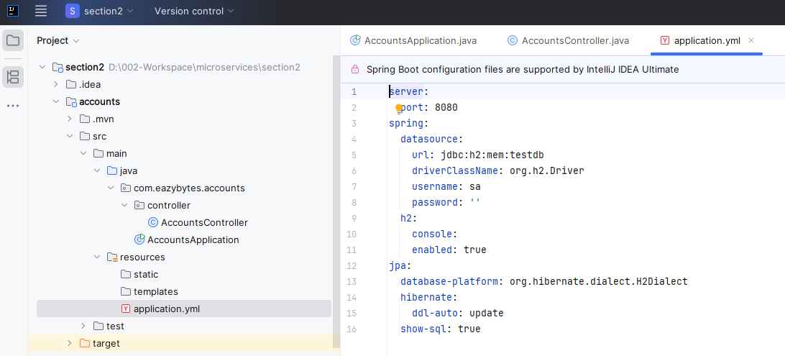

Now coming to these properties, all these related to the h2 database. So with the spring.datasource.url, I'm telling to the spring boot framework that this is the endpoint details where my application can connect to the internal h2 database. So Jdbc:h2:mem:testdb. So this is the value that we need to do and the driverClassName we need to do org.h2.Driver and username:sa This is the default username. If you want you can change and the password. Also, I want to go with the default password, which is an empty value with the help of this spring.h2.console.enabled. I'm telling to the spring boot framework to enable the h2 console so that I can login into this h2 console from my browser and I can see all the tables and records that are inserted are created into my internal h2 database.

And very similarly we need to mention other properties like spring.jpa.database platform and the database platform that we are using is 2 dialect. And with this spring.jpa.hibernate.ddl-auto as update we are telling to the spring boot framework. If there are no tables created inside my internal h2 database, please go ahead and create them based upon the SQL instructions that I'm going to provide automatically during the startup. So that's the purpose here. We don't want to create the tables every time manually inside our internal history database. We want that process to be automatically happen when server is being started because h2 database is an internal memory database whenever you shut down the server, all the data and all the tables that you have created will be wiped off that's why to overcome the challenge of creating the tables and data manually every time we can provide some SQL scripts based upon that, my spring boot framework can automatically create these tables behind the scenes during the startup.

And at last we also mentioned spring.jpa.show sql as true with this property we are telling to the spring boot framework. Please print all the SQL queries that you are going to execute against the history database on the console, and with this the developers can see what are the queries that are being executed behind the scenes by the Spring Data JPA framework. And these queries are going to help them during the debugging process. I hope you are clear with these properties, please make sure you are also using these Yaml format. This format is going to help you to work on multiple products like Docker, Kubernetes and cloud environments. So let me save these changes. Now, like I said, during startup we want some tables to be created so that we can store that data inside these tables. For the same Under these resources folder, you need to create a new file with the name schema.sql Whenever you want to create the tables columns, you need to define a file with the name shema.sql. Whereas if you want to create data with the help of insert scripts or update scripts, you can define a file with the name data.sql. For now, I just want to create the tables inside my internal database. So now inside this SQL file, I'm going to paste a few scripts. So these are the scripts that I have pasted just now. I'm not typing all of them in front of you just to save some time here, please get these scripts from the GitHub repo and you can also paste inside your \ schema.sql. The same you can do for application.yml file as well throughout the course i'm only going to type very important code in front of you to save some time.

CREATE TABLE IF NOT EXISTS `customer` (

`customer_id` int AUTO_INCREMENT PRIMARY KEY,

`name` varchar(100) NOT NULL,

`email` varchar(100) NOT NULL,

`mobile_number` varchar(20) NOT NULL,

`created_at` date NOT NULL,

`created_by` varchar(20) NOT NULL,

`updated_at` date DEFAULT NULL,

`updated_by` varchar(20) DEFAULT NULL

);

CREATE TABLE IF NOT EXISTS `accounts` (

`customer_id` int NOT NULL,

`account_number` int AUTO_INCREMENT PRIMARY KEY,

`account_type` varchar(100) NOT NULL,

`branch_address` varchar(200) NOT NULL,

`created_at` date NOT NULL,

`created_by` varchar(20) NOT NULL,

`updated_at` date DEFAULT NULL,

`updated_by` varchar(20) DEFAULT NULL

);

Not the ` it has to be like this and not '

Do a build once the build is completed. Since my application is already started and we have dev tools inside our classpath, my dev tools might have restarted the server. You can see this time my server restarted in 1.237 seconds and my spring boot framework considered all the details that we have given for the history database. And you can see by default the spring boot framework is going to expose the h2 console with this path, which is h2/console. So let me try to access this h2 console in the browser. So I need to go to the localhost 8080 followed by h2 /console and here I'm trying to access it. You can see you will get this page where you need to enter all your driver class, Jdbc URL, username and password. By default, these values will get automatically populated.

|  |  |
| --- | --- |
|  | Had to restart the application to get the right default values for some reason |

Click Connect

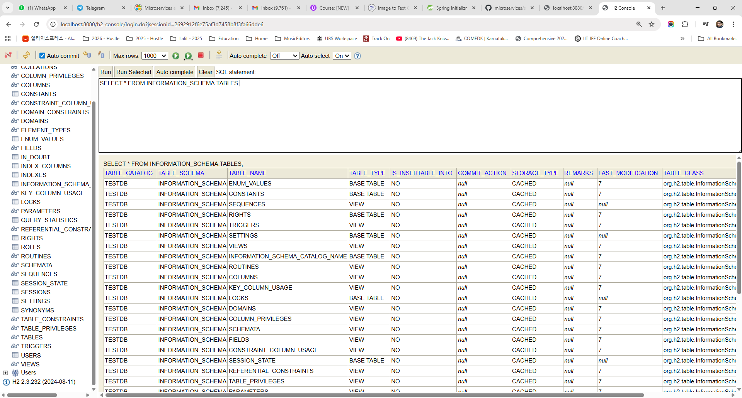

We do not see the tables here, lets rebuild and restart the application

Had forgotten to add the schema.sql file and now we can see the tables

|  |  |
| --- | --- |
|  | Please make sure the values are matching with what you have mentioned inside the applications.yml file. So the username is password is empty. I'm just clicking on this Connect with that. This is the h2 console where you can see there are two tables created with the name accounts and customers.  My accounts table has columns like customer_Id, account _Number, account_Type branch_Address created_At created_By updated_At and updated_By very similarly, if I click on this customer, it has columns like customer_Id, name, email, mobile_Number created_At, updated_At and updated_By. So these tables are created based upon the scripts that we have provided inside the schema.sql file.  So if you try to understand these scripts first, I'm trying to create a customer table where we are trying to save the name of the bank customer. What is his email? What is the mobile number? And a few metadata related columns like Created_At created_By,updated_At and updated_By |

So these four metadata columns are going to present in each of the table that I'm going to create inside this course. So this is the another standard that you need to follow inside the real projects.

These columns will help us who created the data, at what time the data is created and who updated the data at what time. I hope you understand. For this customer table, a primary key is going to be customer_Id column and it is going to be automatically incremented whenever I'm trying to insert a new record into the database. So this is what we are trying to achieve with these customer table creation. And the table will be created only if it not existed in the database. Now, coming to the accounts table, you can see I'm mentioning the customer_Id column and there is going to be a foreign key link between these customer and accounts table with these customer_Id column and inside these accounts table, we are going to have a column with the name account number which will act as a primary key and post that. We'll also have columns like what is the account_Type, whether the account type is saving account or current account, and what is the branch _Address followed by metadata columns. So I'm just trying to keep the things simple so that we can focus more on the microservice concept rather than creating complex tables, complex mappings and do a lot of unnecessary things. I hope you are fine with that. With this, we set up the h2 database with the help of this schema.sql file and with the properties mentioned inside the application.yml file in the next lecture.

Under src/main/resources folder we have application.yml and the schema.sql

|  |  |
| --- | --- |
| **application.yml**  server:  port: 8080  spring:  datasource:  url: jdbc:h2:mem:testdb  driverClassName: org.h2.Driver  username: sa  password: ''  h2:  console:  enabled: true  jpa:  database-platform: org.hibernate.dialect.H2Dialect  hibernate:  ddl-auto: update  show-sql: true | **schema.sql**  CREATE TABLE IF NOT EXISTS `customer` (  `customer_id` int AUTO_INCREMENT PRIMARY KEY,  `name` varchar(100) NOT NULL,  `email` varchar(100) NOT NULL,  `mobile_number` varchar(20) NOT NULL,  `created_at` date NOT NULL,  `created_by` varchar(20) NOT NULL,  `updated_at` date DEFAULT NULL,  `updated_by` varchar(20) DEFAULT NULL  );  CREATE TABLE IF NOT EXISTS `accounts` (  `customer_id` int NOT NULL,  `account_number` int AUTO_INCREMENT PRIMARY KEY,  `account_type` varchar(100) NOT NULL,  `branch_address` varchar(200) NOT NULL,  `created_at` date NOT NULL,  `created_by` varchar(20) NOT NULL,  `updated_at` date DEFAULT NULL,  `updated_by` varchar(20) DEFAULT NULL  ); |

Let's try to build the code with the help of spring Data JPA that will help us to interact with this h2 database and the tables that we can start leveraging this database for insert data, for reading data, for updating and deleting the data.

Stop/ Restart the application using the Run Menu displayed.

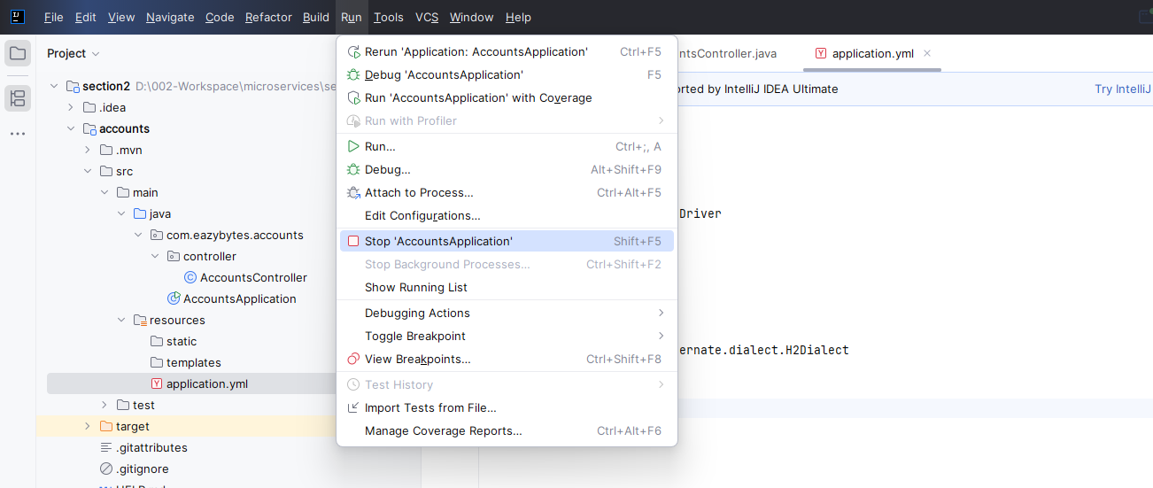

### Lombok Issues in IntelliJ

**LOMBOK ISSUE IN INTELLIJ IDEA**

Starting with the next lecture, we'll be using Lombok annotations in our code. However, some students using the latest version of IntelliJ IDEA might encounter compilation issues related to these annotations. To ensure a smooth experience, please follow the steps below.

If you’re not facing any issues, feel free to skip this instructions.

**🛠️ Step 1: Enable Annotation Processing in IntelliJ IDEA**

Open IntelliJ IDEA, navigate to Settings --> Build, Execution, Deployment --> Compiler --> Annotation Processors and ensure that the checkbox "Enable annotation processing" is checked

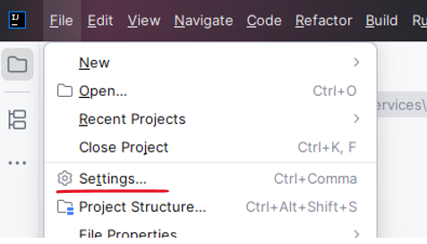

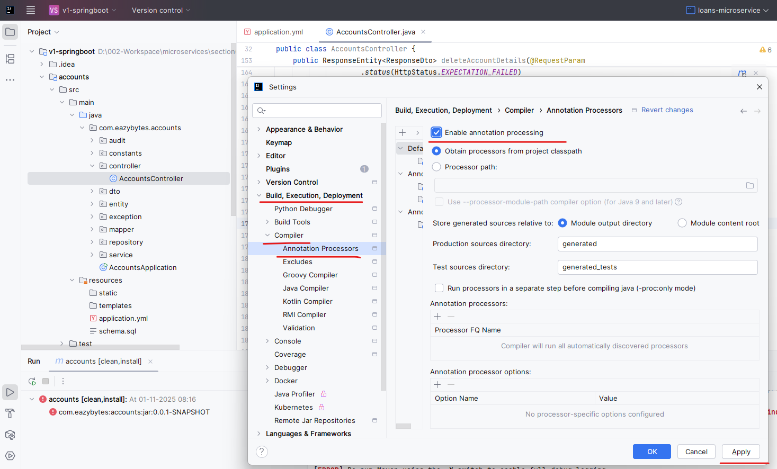

**🛠️ Step 2: Update pom.xml Build Configuration**

Open your pom.xml file and replace the existing build configuration with the following snippet:

<build>

<plugins>

<plugin>

<groupId>org.springframework.boot</groupId>

<artifactId>spring-boot-maven-plugin</artifactId>

</plugin>

<plugin>

<groupId>org.apache.maven.plugins</groupId>

<artifactId>maven-compiler-plugin</artifactId>

<configuration>

<annotationProcessorPaths>

<path>

<groupId>org.projectlombok</groupId>

<artifactId>lombok</artifactId>

<version>${lombok.version}</version>

</path>

</annotationProcessorPaths>

</configuration>

</plugin>

</plugins>

</build>

## Accounts Microservice Implementation

### Writing Spring Data JPA Entities & Repositories

We have created these two tables with the names, accounts and customer inside our internal H2 database. The same database structure, the same tables and columns we are going to use even when we migrate from H2 database to MySQL database in the coming sections. Right now we have the database and the tables inside it. As a next step, we need to write Java code to interact with these tables so that we can start saving the data into these tables. We can read from them. We can update and delete the data from these tables for the same. Inside our pom.xml. We already added a library with the name Spring Data JPA. So this is the library under which we have many interfaces and classes, which will help us to interact with the database tables whenever we want to use this framework. First, we need to create the Pojo classes representing each of the table that I have inside my database.

For the same, I'm going to create a new package and the package name is going to be entity. Since inside this entity package, I'm going to store all the entity classes of my database. That's why I have choose this name as of now. If you look at the table structure that we have, there are four columns that are going to be present in each of the tables that we are going to create. These four columns are the metadata columns that we maintain in each of the table. So it is a good idea to create a separate superclass that will maintain the details of these four columns. That's why inside this entity package, first I'm going to create a new Java class with the name base entity. Inside this base entity class, I'm going to create four different fields, each representing one of the metadata column.

The very first one is private local date time, and the field name is going to be created at. Please make sure this field name is matching with your column name that you have created inside the table. So created_at. You have to remove the underscore post that convert the first letter of the second word to capital letter like we are seeing here.

CREATE TABLE IF NOT EXISTS `accounts` (

`customer_id` int NOT NULL,

`account_number` int AUTO_INCREMENT PRIMARY KEY,

`account_type` varchar(100) NOT NULL,

`branch_address` varchar(200) NOT NULL,

`created_at` date NOT NULL,

`created_by` varchar(20) NOT NULL,

`updated_at` date DEFAULT NULL,

`updated_by` varchar(20) DEFAULT NULL

);

This way we don't have to tell to the Spring Data JPA framework to which column this field is mapped inside my database. The next field is private string. For this field, I'm going to mention the field name as created by. So this represents the second metadata column that we have which is created by. Very similarly I'm going to create the next two columns and rename these to updated at and updated by.

package com.eazybytes.accounts.entity;

import java.time.LocalDateTime;

public class BaseEntity {

private LocalDateTime createdAt;

private String createdBy;

private LocalDateTime updatedAt;

private String updatedBy;

}

Now as a next step, we are supposed to create the getter and setter methods for these fields, and creating all those getters and setters will be very cumbersome process. And at the same time, the code looks very lengthy, which we don't want. That's why we need to use our Lombok related annotations. The very first annotation that we need to mention on top of this class is @Getter. So when we mention this annotation behind the scenes, my Lombok library is going to generate the getter and setter the same I'm doing for the setter with the help of these @Setter annotation and if needed, we can also mention the two string annotation, which will help us to convert these base entity objects to the string format. So once we define all these Lombok related annotations, we should be good. So let me save these changes. Now if I try to show you the methods present inside these class, you can see there is a getter methods for each of the field like createdAt, createdBy and very similarly we have setter method @ToString method, also created by the Lombok annotation behind the scenes, which means you will not be seeing these getters and setters inside your code. But behind the scenes, Lombok is going to do the magic of generating them inside the bytecode of your classes. That's why whenever you are seeing them, list of the methods inside your classes. You are able to see all these methods.

package com.eazybytes.accounts.entity;

import lombok.Getter;

import lombok.Setter;

import lombok.ToString;

import java.time.LocalDateTime;

@Getter @Setter @ToString

public class BaseEntity {

private LocalDateTime createdAt;

private String createdBy;

private LocalDateTime updatedAt;

private String updatedBy;

}

Press Alt + 7 or to get a popup style window

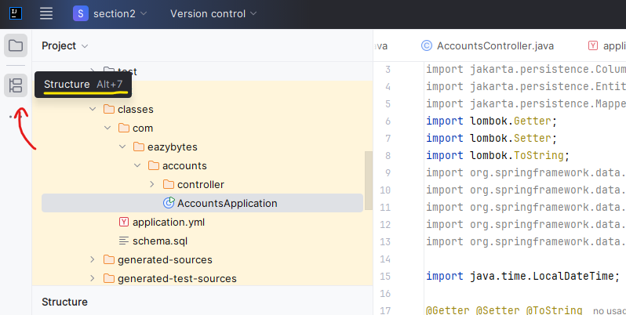

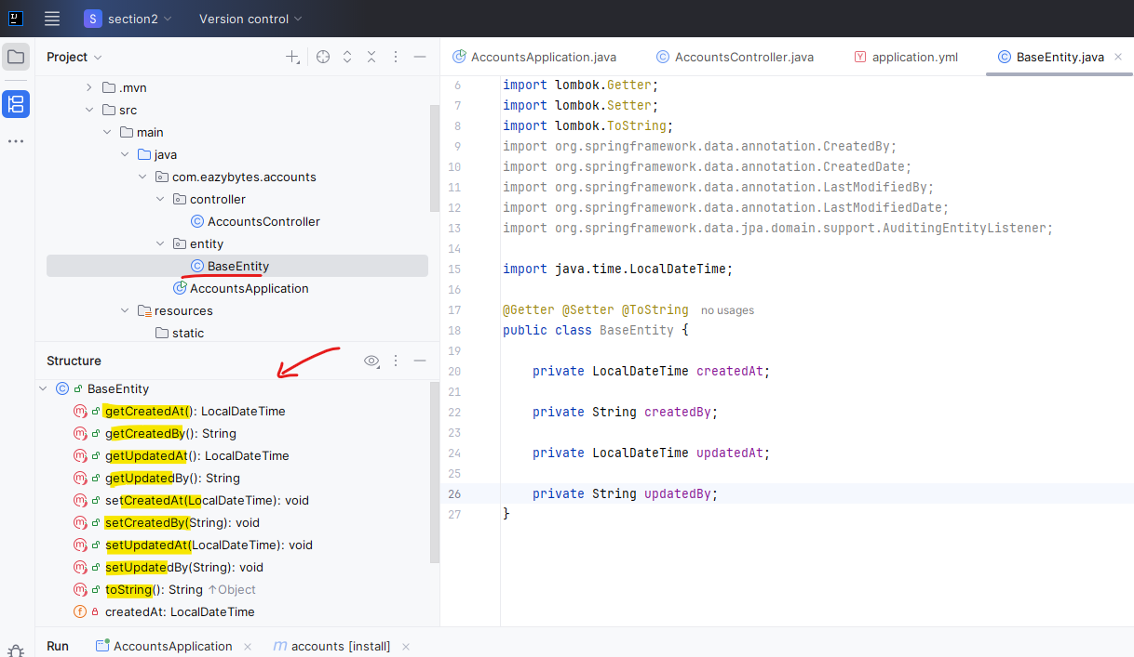

Once you have the annotations you can also Delombok if required

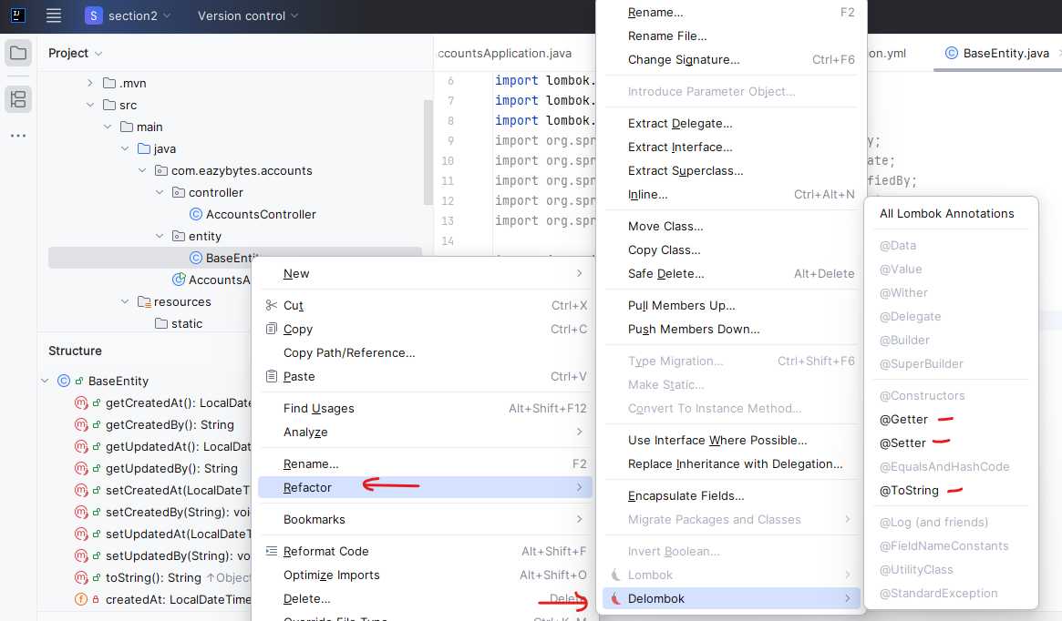

You can uncheck these inherited members, and you'll be able to see all the methods which are specific to this class only. I hope you're clear now, since we are trying to leverage these base entity class for all the other entity classes that we are going to create inside our project, we need to mention an annotation which is @MappedSuperclass. This indicates to the Spring Data JPA framework that this class is going to act as a superclass for all my entities, wherever I'm trying to extend this base entity class. So once we mention these details, we can also mention one more annotation on top of each field, which is @Column. Using this, @Column annotation, we can mention what is the column name inside the database that we are trying to map to this field. But since the column name and the field names are matching, we don't need to mention the column name manually with the help of these @Column annotation.

package com.eazybytes.accounts.entity;

import jakarta.persistence.Column;

import jakarta.persistence.MappedSuperclass;

import lombok.Getter;

import lombok.Setter;

import lombok.ToString;

import java.time.LocalDateTime;

@MappedSuperclass

@Getter @Setter @ToString

public class BaseEntity {

@Column

private LocalDateTime createdAt;

@Column

private String createdBy;

@Column

private LocalDateTime updatedAt;

@Column

private String updatedBy;

}

So what I'm trying to mention here is I'm going to mention updatable is equal to false. The purpose of this updatable is equal to false is whenever a record is being updated inside the database table. I don't want this column to be considered by the Spring Data JPA to populate the value and to update the value, which means this field will not be updated whenever I'm trying to update my record, because I only want to maintain this created at time to represent the what is the original time when my record is inserted, let me do the same for created by also.

@Column(updatable = false)

private LocalDateTime createdAt;

Now very similarly for the updated attribute, I'm going to mention the insert table is equal to false. Just like how we have updatable is equal to false, we also have inserted is equal to false. This tells to my Spring Data JPA framework - please do not populate or update these two columns whenever it is trying to insert a very new record inside the database. Of course, this makes sense because while we are trying to insert the record very first time, why do we want to update these two columns? We need to maintain them as null values. So now my base entity class is ready.

package com.eazybytes.accounts.entity;

import jakarta.persistence.Column;

import jakarta.persistence.MappedSuperclass;

import lombok.Getter;

import lombok.Setter;

import lombok.ToString;

import java.time.LocalDateTime;

@MappedSuperclass

@Getter @Setter @ToString

public class BaseEntity {

@Column(updatable = false)

private LocalDateTime createdAt;

@Column(updatable = false)

private String createdBy;

@Column(insertable = false)

private LocalDateTime updatedAt;

@Column(insertable = false)

private String updatedBy;

}

Let me go to the entity package. And here I'm going to create a new class which represents customer table. That's why I'm trying to create a class with the same name customer. So here the very first annotation that I need to mention is @Entity. So this delta my Spring Data JPA framework.

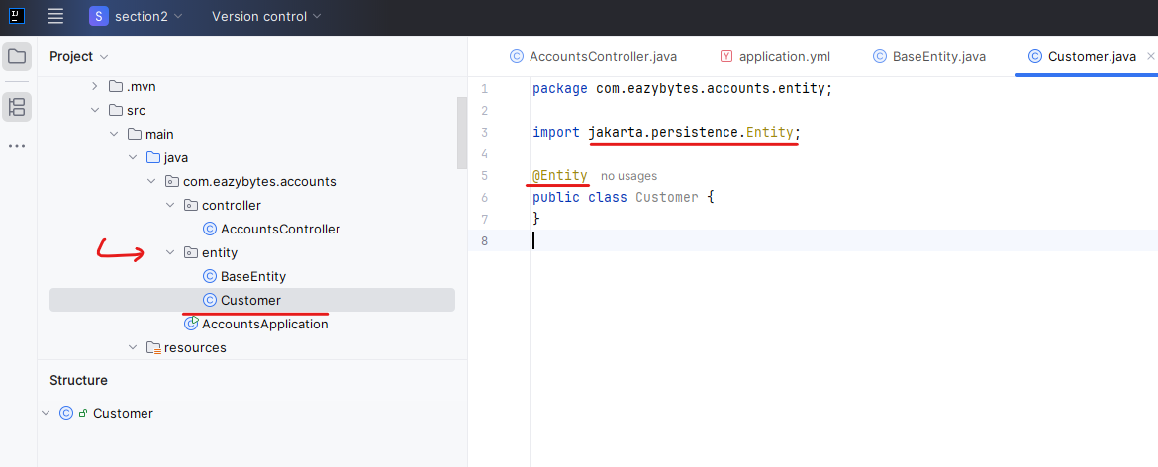

Please treat this Pojo class as a entity representation or an Pojo representation for my table with the name customer. So if you see the table name will match with the class name that we have. So this is matching if it is not matching, and if you are trying to use a different class name, then you can use the annotation which is @Table. And to this table annotation you can pass the name parameter, to which you can mention whatever table name that you have inside the database. Since right now the class name and table name is matching, I don't want to use @Table annotation with that.

import jakarta.persistence.Entity;

import jakarta.persistence.Table;

@Entity

@Table(name = "customer")

public class Customer {

}

First I want to create a field with the name private long customer ID. So this is going to hold the primary key value inside my database followed by private string name. And this name field is going to hold the name of the customer. And very similarly private string email followed by private string mobile number. So with this we have created the all the fields with the same names like we mentioned inside the table like customer ID name, email, mobile number.

import jakarta.persistence.Entity;

import jakarta.persistence.Table;

import lombok.*;

@Entity

@Getter @Setter @ToString @AllArgsConstructor @NoArgsConstructor

public class Customer extends BaseEntity {

private Long customerId;

private String name;

private String email;

private String mobileNumber;

}

Check the structure of the class now

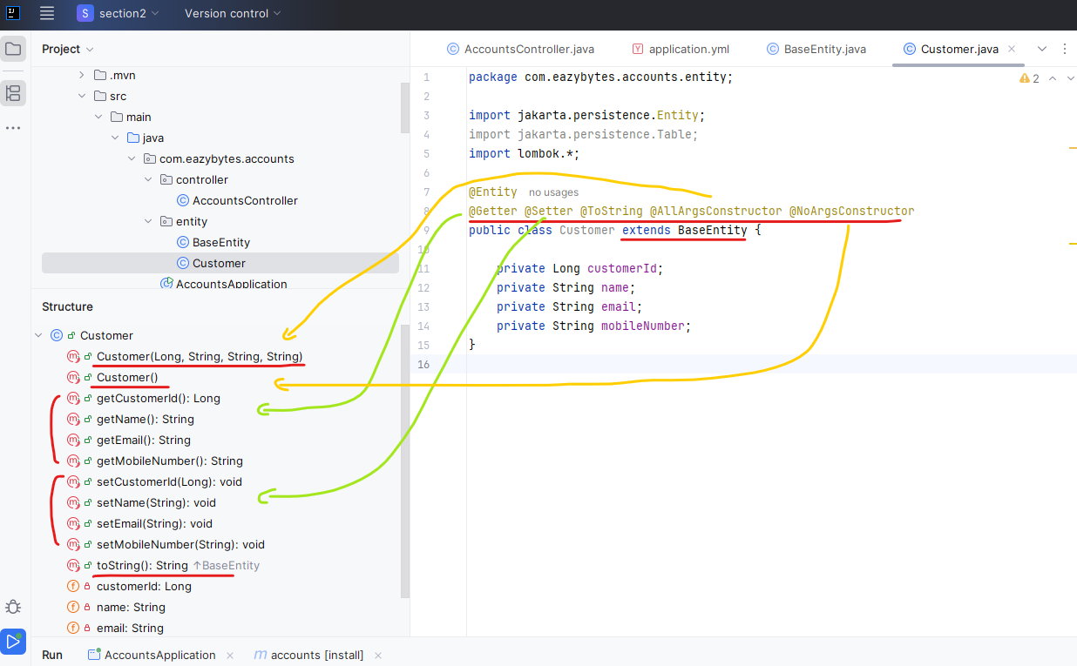

The other way to check the structure in a popup window is to press ctrl + shift + O ( opens a popup, click on inherited members, lambdas to show those details as well )

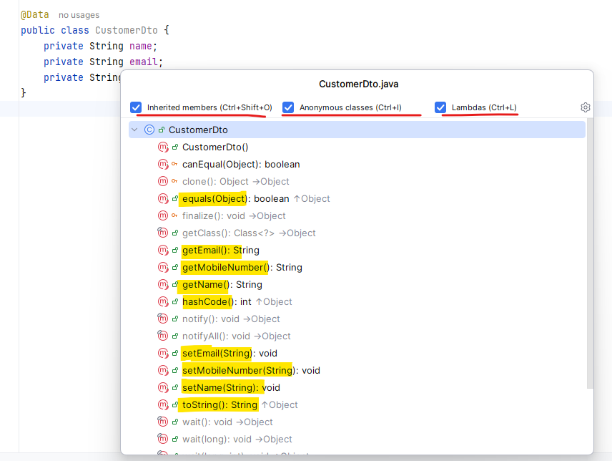

Now, since we also have metadata related columns inside our entity, we need to extend the entity class that we have created previously, which is base entity. So once we define these details, all the fields that we have inside the base entity will be considered by the Spring Data JPA framework. Whenever it is trying to insert a new record, or update a record, or delete a record as a next step, we need to also mention the Lombok annotations like @Getter, @Setter, @ToString and very similarly. I'm also going to mention @AllArgsConstructor and @NoArgsConstructor. With the help of @AllArgsConstructor, my Lombok is going to generate a constructor which accepts all the fields that we have inside this Pojo class, and very similarly with @NoArgsConstructor, it is going to generate an empty constructor. The reason why I'm mentioning these two annotations is in future, when we are trying to leverage this customer entity class, we need to create the object of this entity class. And when we are trying to create the object, obviously we need the constructor like @AllArgsConstructor and @NoArgsConstructor. That's why I'm mentioning here.

Now like I said, this is going to be a primary key column value. But how do I communicate that to the Spring Data JPA framework? There are four fields inside this class. But this field is going to represent the primary key value. So to communicate the same we need to use the annotation which which is @ID. Now I told to my Spring Data JPA that this field is going to represent as a primary key, but are we going to provide the primary key value manually to the Spring Data JPA framework? Are we want the Spring Data JPA framework to automatically generate a primary key value whenever it is trying to insert a new record into the table, it is a good idea to give the responsibility to the Spring Data JPA framework. For the same, we need to mention two annotations like you can see here these two annotations, which is @GeneratedValue and @GenericGenerator.

import jakarta.persistence.*;

import lombok.*;

import org.hibernate.annotations.GenericGenerator;

@Entity

@Getter @Setter @ToString @AllArgsConstructor @NoArgsConstructor

public class Customer extends BaseEntity {

@Id

@GeneratedValue(strategy= GenerationType.AUTO, generator = "native")

@GenericGenerator(name="native", strategy="native")

private Long customerId;

private String name;

private String email;

private String mobileNumber;

}

Note that @GenericGenerator is deprecated since 6.5 and we need to use the newer way

~~@GenericGenerator(name="native", strategy="native")~~

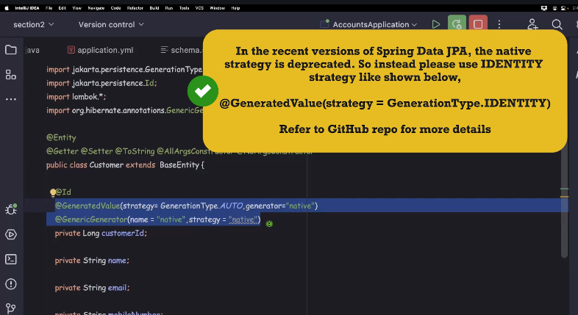

Docs mention this - <https://discourse.hibernate.org/t/replacement-of-genericgenerator-native/10130>

package com.eazybytes.accounts.entity;

import jakarta.persistence.*;

import lombok.*;

@Entity

@Getter @Setter @ToString @AllArgsConstructor @NoArgsConstructor

public class Customer extends BaseEntity {

@Id

@GeneratedValue(strategy = GenerationType.IDENTITY)

@Column(name="customer_id")

private Long customerId;

private String name;

private String email;

@Column(name="mobile_number")

private String mobileNumber;

}

With the native strategy, I'm telling to the Spring Data JPA framework. Whatever database that I'm using, please try to generate the sequence number or the primary key value based upon the native style of my database. For example, if I use my SQL database as my back end database, my Spring Data JPA framework is going to leverage a native strategy which is specific to my SQL database. So this is what we are communicating with these annotations. So please make sure you are using this annotation inside your code as well. And like I said before, we can also mention @Column annotation. And to this column annotation we can pass the what is our column name here the column name is customer_id, so the field name and the column name is matching. I'm again mentioning this so that you will have a reference in future. I'll also mention the same for mobile number. Like I said, even if we don't mention this @Column annotation, it is going to work perfectly because the column names and field names are matching in our scenario.

I'm just mentioning for your reference so that in future you are aware of these @Column annotation. So now I need to create one more entity class representing the second table that I have which is accounts.

package com.eazybytes.accounts.entity;

import jakarta.persistence.*;

import lombok.*;

@Entity

@Getter @Setter @ToString @AllArgsConstructor @NoArgsConstructor

public class Accounts extends BaseEntity {

@Column(name="customer_id")

private Long customerId;

@Column(name="account_number")

@Id

private Long accountNumber;

@Column(name="account_type")

private String accountType;

@Column(name="branch_address")

private String branchAddress;

}

So let me copy this customer entity and paste inside the same package. For this new entity I'm going to keep the name as accounts. So let me create this new class. So to this accounts entity class we are fine extending the base entity. And we are fine with all those annotations. And inside this entity class customer ID is not going to be the primary key value. It is only present to establish the link between accounts table and customer table. So let me remove all those ID values. Post that I'm going to create a new field with the name private long account number. And account number is going to act as a primary key value inside my table. That's why I need to mention @Id and on top of this field. Also, I can mention @Column just for your reference, like this is going to retrain the database column which is count underscore number. Let's check if this is matching with the schema.sql. Yes, this is matching. The next field that I want to create is account type to this field. Also I'll mention @Column the strategy that I'm using right now to mention this @Column is where the column names has underscore inside them. I'm just mentioning the @column. But like I said this is completely optional. If the column name and field names are matching. Ignoring the underscore value. But this is matching with the account type. Now let me do the same for branch address. So the field name is going to be branch address. And here I'm not mentioning any annotations related to generate the primary key value automatically. The reason is I am going to write a small logic inside my rest API service to generate the account number manually and assign the same into the database. We don't want our bank account numbers to start with sequence numbers like one, two, three, four. That won't look good. Account number usually will be ten digit number. That's why as a developer, it is my responsibility to generate the account number. And with that reason I have not mentioned the annotations related to primary key generation like we mentioned inside the customer table.

What we have done so far

|  |  |
| --- | --- |
|  |  |

|  |  |
| --- | --- |
| **settings.xml in the m2 folder**  <?xml version="1.0" encoding="UTF-8"?>  <settings xmlns="http://maven.apache.org/SETTINGS/1.2.0"  xmlns:xsi="http://www.w3.org/2001/XMLSchema-instance"  xsi:schemaLocation="http://maven.apache.org/SETTINGS/1.2.0 https://maven.apache.org/xsd/settings-1.2.0.xsd">  <localRepository>${user.home}/.m2/repository</localRepository>  <mirrors>  <mirror>  <id>central</id>  <url>https://repo.maven.apache.org/maven2/</url>  <mirrorOf>maven-central</mirrorOf>  </mirror>  </mirrors>  <profiles>  <profile>  <id>central-repository</id>  <activation>  <activeByDefault>true</activeByDefault>  </activation>  <repositories>  <repository>  <id>maven-central</id>  <url>https://repo1.maven.org/maven2/</url>  </repository>  </repositories>  </profile>  </profiles>    <activeProfiles>  <activeProfile>central-repository</activeProfile>  </activeProfiles>    </settings> | |
| **pom.xml generated**  <?xml version="1.0" encoding="UTF-8"?>  <project xmlns="http://maven.apache.org/POM/4.0.0" xmlns:xsi="http://www.w3.org/2001/XMLSchema-instance"  xsi:schemaLocation="http://maven.apache.org/POM/4.0.0 https://maven.apache.org/xsd/maven-4.0.0.xsd">  <modelVersion>4.0.0</modelVersion>  <parent>  <groupId>org.springframework.boot</groupId>  <artifactId>spring-boot-starter-parent</artifactId>  <version>3.5.6</version>  <relativePath/> <!-- lookup parent from repository -->  </parent>  <groupId>com.eazybytes</groupId>  <artifactId>accounts</artifactId>  <version>0.0.1-SNAPSHOT</version>  <name>accounts</name>  <description>Accounts Microservice</description>  <url/>  <licenses>  <license/>  </licenses>  <developers>  <developer/>  </developers>  <scm>  <connection/>  <developerConnection/>  <tag/>  <url/>  </scm>  <properties>  <java.version>17</java.version>  </properties>  <dependencies>  <dependency>  <groupId>org.springframework.boot</groupId>  <artifactId>spring-boot-starter-data-jpa</artifactId>  </dependency>  <dependency>  <groupId>org.springframework.boot</groupId>  <artifactId>spring-boot-starter-validation</artifactId>  </dependency>  <dependency>  <groupId>org.springframework.boot</groupId>  <artifactId>spring-boot-starter-web</artifactId>  </dependency>  <dependency>  <groupId>org.springframework.boot</groupId>  <artifactId>spring-boot-devtools</artifactId>  <scope>runtime</scope>  <optional>true</optional>  </dependency>  <dependency>  <groupId>com.h2database</groupId>  <artifactId>h2</artifactId>  <scope>runtime</scope>  </dependency>  <dependency>  <groupId>org.projectlombok</groupId>  <artifactId>lombok</artifactId>  <optional>true</optional>  </dependency>  <dependency>  <groupId>org.springframework.boot</groupId>  <artifactId>spring-boot-starter-test</artifactId>  <scope>test</scope>  </dependency>  </dependencies>  <build>  <plugins>  <plugin>  <groupId>org.apache.maven.plugins</groupId>  <artifactId>maven-compiler-plugin</artifactId>  <configuration>  <annotationProcessorPaths>  <path>  <groupId>org.projectlombok</groupId>  <artifactId>lombok</artifactId>  </path>  </annotationProcessorPaths>  </configuration>  </plugin>  <plugin>  <groupId>org.springframework.boot</groupId>  <artifactId>spring-boot-maven-plugin</artifactId>  <configuration>  <excludes>  <exclude>  <groupId>org.projectlombok</groupId>  <artifactId>lombok</artifactId>  </exclude>  </excludes>  </configuration>  </plugin>  </plugins>  </build>  </project> | |
| **application.yml**  server:  port: 8080  spring:  datasource:  url: jdbc:h2:mem:testdb  driverClassName: org.h2.Driver  username: sa  password: ''  h2:  console:  enabled: true  jpa:  database-platform: org.hibernate.dialect.H2Dialect  hibernate:  ddl-auto: update  show-sql: true | **schema.sql**  CREATE TABLE IF NOT EXISTS `customer` (  `customer_id` int AUTO_INCREMENT PRIMARY KEY,  `name` varchar(100) NOT NULL,  `email` varchar(100) NOT NULL,  `mobile_number` varchar(20) NOT NULL,  `created_at` date NOT NULL,  `created_by` varchar(20) NOT NULL,  `updated_at` date DEFAULT NULL,  `updated_by` varchar(20) DEFAULT NULL  );  CREATE TABLE IF NOT EXISTS `accounts` (  `customer_id` int NOT NULL,  `account_number` int AUTO_INCREMENT PRIMARY KEY,  `account_type` varchar(100) NOT NULL,  `branch_address` varchar(200) NOT NULL,  `created_at` date NOT NULL,  `created_by` varchar(20) NOT NULL,  `updated_at` date DEFAULT NULL,  `updated_by` varchar(20) DEFAULT NULL  ); |
| **AccountsApplication.java**  package com.eazybytes.accounts;  import org.springframework.boot.SpringApplication;  import org.springframework.boot  .autoconfigure.SpringBootApplication;  @SpringBootApplication  public class AccountsApplication {  public static void main(String[] args) {  SpringApplication.run(  AccountsApplication.class, args);  }  } | **AccountsController.java**  package com.eazybytes.accounts.controller;  import org.springframework.web.bind.annotation.GetMapping;  import org.springframework.web.bind.annotation.RestController;  @RestController  public class AccountsController {  @GetMapping(path = "sayHello")  public String sayHello() {  return "Hello World!";  }  } |
| **BaseEntity.java Entity**  import jakarta.persistence.Column;  import jakarta.persistence.MappedSuperclass;  import lombok.Getter;  import lombok.Setter;  import lombok.ToString;  import java.time.LocalDateTime;  @MappedSuperclass  @Getter @Setter @ToString  public class BaseEntity {  @Column(updatable = false)  private LocalDateTime createdAt;  @Column(updatable = false)  private String createdBy;  @Column(insertable = false)  private LocalDateTime updatedAt;  @Column(insertable = false)  private String updatedBy;  } | **Accounts.java**  package com.eazybytes.accounts.entity;  import jakarta.persistence.*;  import lombok.*;  @Entity  @Getter @Setter @ToString @AllArgsConstructor @NoArgsConstructor  public class Accounts extends BaseEntity {  @Column(name="customer_id")  private Long customerId;  @Column(name="account_number")  @Id  private Long accountNumber;  @Column(name="account_type")  private String accountType;  @Column(name="branch_address")  private String branchAddress;  } |
| **Customer.java**  import jakarta.persistence.*;  import lombok.*;  import org.hibernate.annotations.GenericGenerator;  @Entity  @Getter @Setter @ToString @AllArgsConstructor @NoArgsConstructor  public class Customer extends BaseEntity {  @Id  @GeneratedValue(strategy= GenerationType.AUTO, generator = "native")  @Generated  @GenericGenerator(name="native", strategy="native")  private Long customerId;  private String name;  private String email;  private String mobileNumber;  } | |

With this, we have successfully created entity classes representing each of the table that we have created inside our database. Now, as a next step, we should also create the repository classes representing each of the table. Because with these entity classes, we can only store our data into the entity Pojo class.

But we need some logic that will take the object of these entity classes and interact with the database tables that we have created by the same. We need to create the repository interfaces inside our web application. So I'm trying to create a new package here. The package name is going to be com dot easy bytes dot accounts dot repository. Inside this repository package I'm going to create a new interface CustomerRepository. And using this repository I'm going to interact with my customer database table with the help of Spring Data JPA framework.

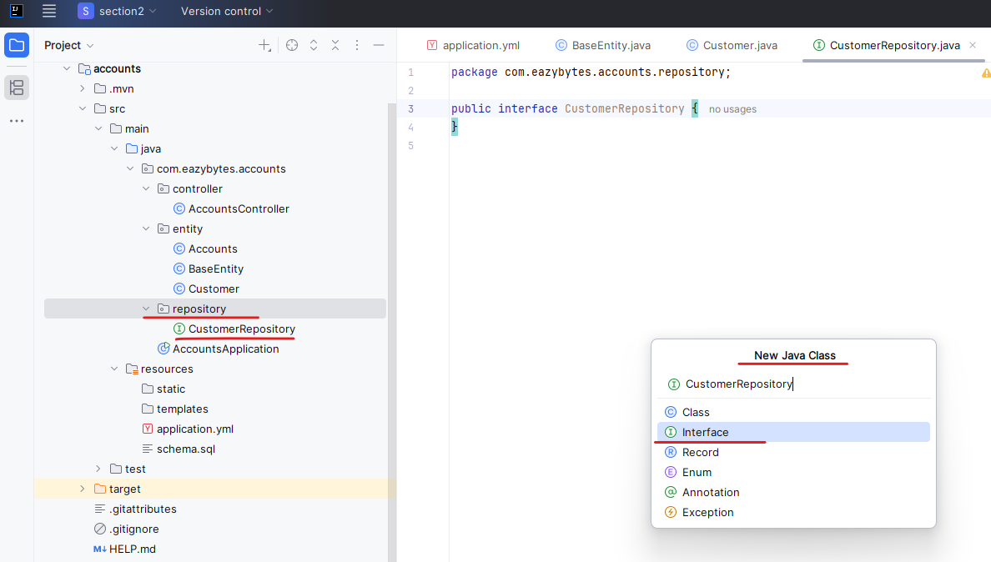

Now on top of this interface I'm going to mention an annotation which is repository. Whenever I'm mentioning this annotation on top of my interface class behind the scenes, my Spring Data JPA framework will create a bean implementation of this interface based upon the configurations that I'm going to provide. So this just an empty interface. The Spring Data JPA framework cannot create an object or bean from it in order to bring the. Magic of Spring Data JPA into this interface, we need to extend a class from the Spring Data JPA framework, which is JPARepository. It is going to accept two parameters. One is what is the entity class, which is going to be handled by this repository class. And the second parameter is what is the data type of your primary key field inside your entity. So if you open this customer table the primary key data type is long.

import com.eazybytes.accounts.entity.Customer;

import org.springframework.data.jpa.repository.JpaRepository;

import org.springframework.stereotype.Repository;

@Repository

public interface CustomerRepository extends JpaRepository<Customer, Long> {

}

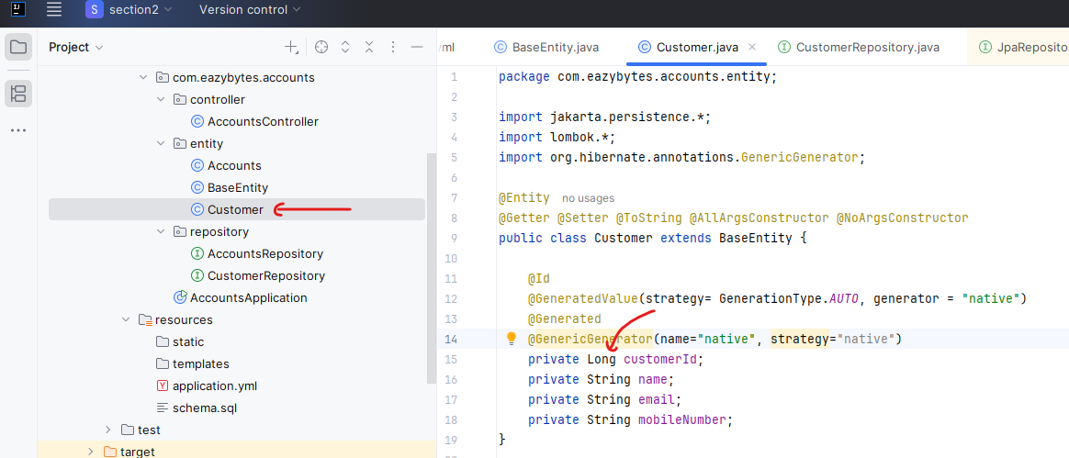

That's why we need to mention the same here. So whenever I'm creating a interface with other repository annotation that is extending JPA repository behind the scenes, my Spring Data JPA framework is going to generate the runtime code by providing large many methods. If you see all these methods are coming from the framework, like I can execute CRUD operations like find, delete, update and insert.

Open the auto generated file CustomerRepository.java

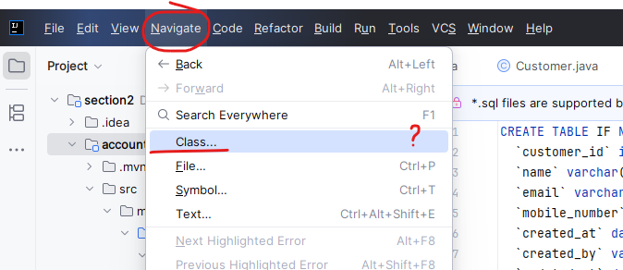

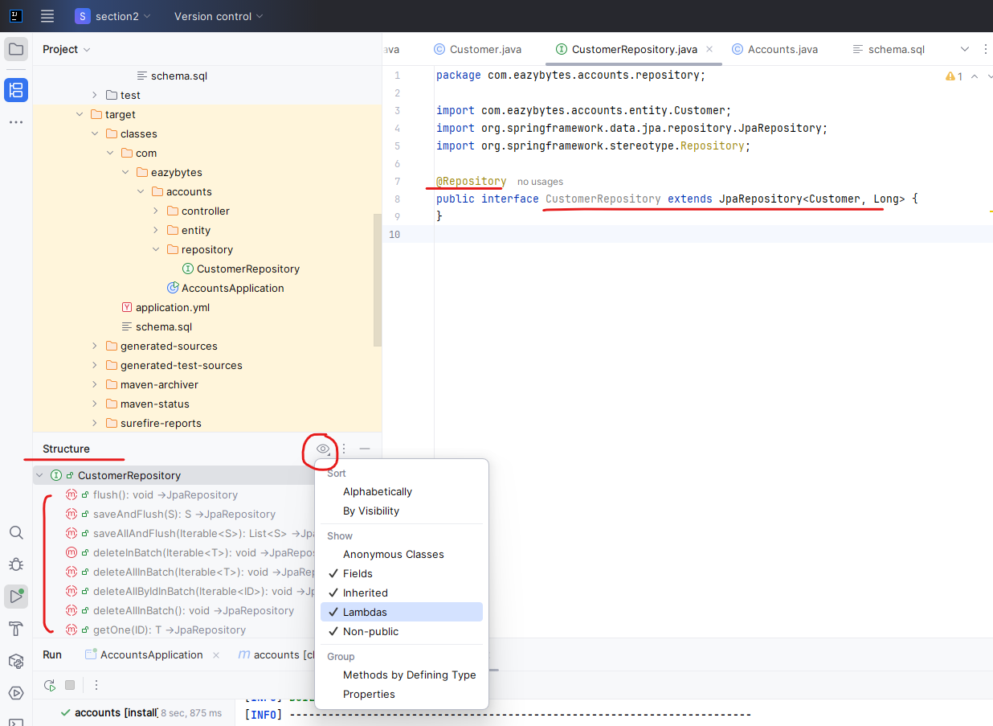

So these are all find methods will help me to find the records from the database. Similarly, we have saved methods to insert and update the records inside the database. This way I'm able to get all these methods from the Spring Data JPA framework without writing any SQL manually. Inside my business logic, I'm going to show you the demo of these repository interfaces in the coming lectures. For now, please note that that these JPA repository is coming from the Spring Data JPA framework.

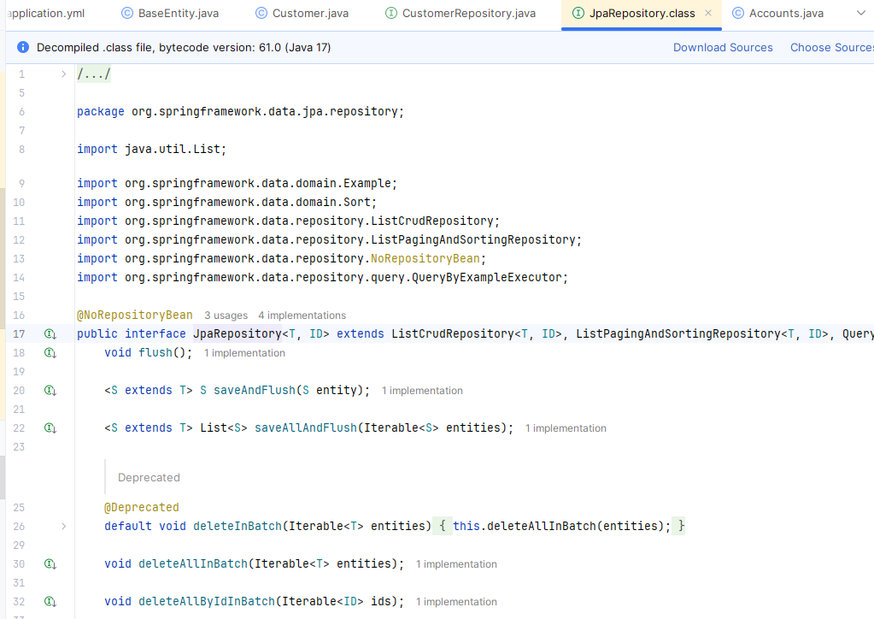

And this internally extends list of paging and sorting repository and other interface like query by example executor. Like I said, if you're not aware of these spring Data JPA framework in detail, please look for and spring course that explain more about these Spring Data JPA framework. For now, please note that with the help of this JPA repository, we don't have to write any code to execute the Crud operations on our table, which is customer. So now very similarly I'm going to create a one more repository interface. And this repository interface is going to be accounts repository.

import com.eazybytes.accounts.entity.Accounts;

import org.springframework.data.jpa.repository.JpaRepository;

public interface AccountsRepository extends JpaRepository<Accounts, Long> {

}

The only change that we need to do here is to update the entity class name. So the entity class name is accounts. And it is also having a primary key value that supports long. So we should be good with this long parameter value.

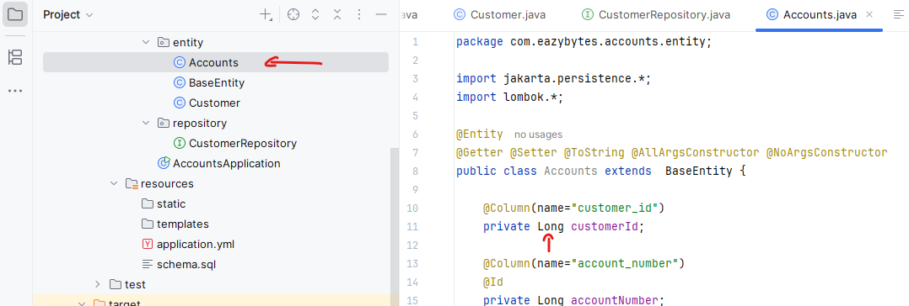

So like you can see these interface are empty as of now. And with the help of these interfaces we can invoke the methods from the framework to perform the Crud operations, which I'm going to show you the demo in the coming lectures with this. Inside this lecture we have created the entity classes for our database tables. And also we have created the repository interfaces using which we can interact with the database tables by using the methods available inside these Spring Data JPA framework.

### Data Transfer Object Pattern

We have created entities representing each of the database table that we have. So with these entities, we are supporting inside our web application to create new account customer details, to fetch the account and customer details to update and delete these details. What if one of the client application they want both your accounts and customer data together in a single request? Do you think we can send two different objects as a response? Off course not. We cannot send them two different objects. We can only send a single object inside a response. Maybe you can think like we can create an one more entity or pojo class. And inside them I can try to create the fields of Accounts and Customer. That way I can embed both these two classes inside another class. That's one of the basic approach, but we should not do that. The reason is all these entity classes, they are related to that database layer. You may end up into various scenarios where you may want to send the data in various formats or in various combinations. That's why we should never touch these database related entity classes. They should always clearly and purely represent the database tables. So to overcome this challenge, we have a standard with the name DTO pattern. So let's try to understand what is this DTO pattern?

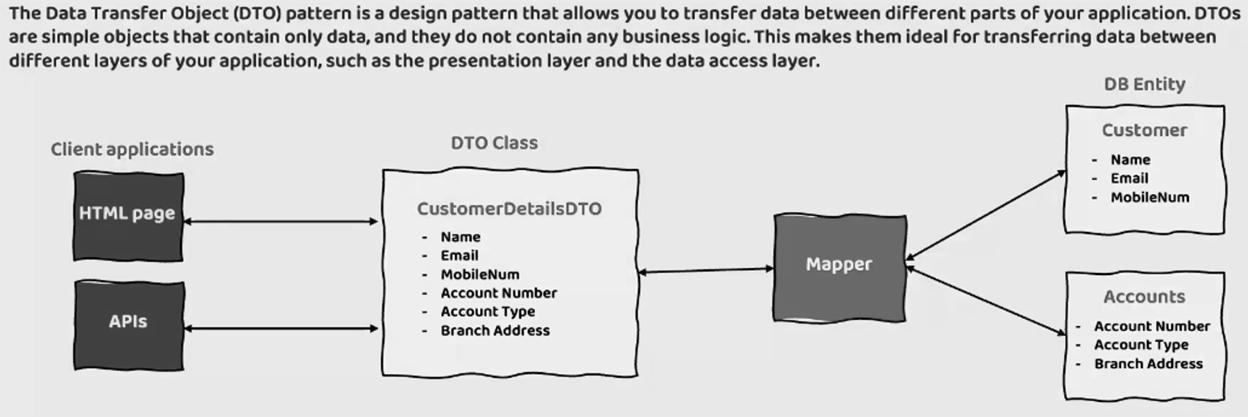

DTO means **Data Transfer Object**. What is this pattern is recommending is whenever a client is trying to communicate with a backend application to get the data, we should follow the detour pattern, which is a design pattern that will allow to transfer data between different parts of your application. For example, inside my application I can have a database layer, presentation layer service layer. So to flow the data between multiple layers of your web application, we should use these DTO pattern and inside these dto patterns, we should create the detour classes which holds the fields that you want to transfer to and fro from the different layers of your application. So here, let's take an example to understand this.

On the right hand side, I have a Customer entity class and Accounts entity, class. And inside these we have these fields which represent columns inside the database. I didn't mention metadata columns here just to save some space, but these Customer and Accounts, they represent the database entities and some client. They may request you to send both the customer and accounts in a single request. In such scenarios, what you can dto is we can create a class with the name like CustomerDetails. And inside this DTO class you can define all the fields that your client is asking from these entity classes. Once you define a class in between, you can write a mapper logic or aggregation logic that will take care of converting all your field values from DB entity to DTO class. So this is just a small piece of Java code that we need to write.

This way my client applications who are using web application like with the help of HTML page or who are trying to invoke my rest APIs with the help of other backend APIs. They can always request whatever data that they want from my database tables. Instead of I sending the data with the help of my database entity Pojo classes, I should rely on the DTO classes and following these pattern, we have various advantages. The very first advantage is it is going to reduce the network traffic. Think of a scenario if you don't have this DTO pattern. And if your UI application or if another client API they're trying to ask you, provide me both customer and accounts table data. So in that case you will ask them to send the two different requests one for customer and the other one for accounts, which is unnecessary. Whereas with the dto pattern they will make a single request and you will have a mapper logic which will take care of combining the data from the customer and accounts and transferring it to the CustomerDetails class . And the same you will be responding back to the client applications. And the second advantage that we have is encapsulate serialization. So these classes usually they represent only the data that they carry. We are not supposed to write any other business logic inside these dto classes.

**Here are some of the benefits of using the DTO pattern:**

**Reduces network traffic**: DTOs can be used to batch up multiple pieces of data into a single object, which can reduce the number of network requests that need to be made. This can improve performance and reduce the load on your servers.

**Encapsulates serialization**: DTOs can be used to encapsulate the serialization logic for transferring data over the wire. This makes it easier to change the serialization format in the future, without having to make changes to the rest of your application.

**Decouples layers**: DTOs can be used to decouple the presentation layer from the data access layer. This makes it easier to change the presentation layer without having to change the data access layer.

Apart from these data fields we can also write logic related to the serialization. When I say serialization, some clients, they may ask you to send the data as an XML or as an Json format or an Yaml format. So whatever serialization format that they need, you can always write that logic inside your DTO class, otherwise you will end up spreading or writing that serialization format in many places of your application, which is going to be again a cumbersome process to maintain whenever there is a serialization format is changing in future. And the last advantage that we have with the dto pattern is, it will decouple the layers. With the help of this pattern, your presentation layer is going to be decoupled from the data access layer. What is the meaning of decoupling between presentation layer and data access layer? This means your presentation layer, like your client applications. They never know what is that database entities, what is the fields that they hold, what kind of data that they hold. They don't have to worry. And if there is anything changing inside the database, entities that will never impact the client applications because client applications, they always work with the help of dto class. Suppose think like in future you are introducing new column inside the DB entity and the same will be reflected inside your DB entity classes. If it is not required to the clients, you don't need to send that to clients and you don't need to update the DTO class. This way the DB layer and presentation layer are client layer is always decoupled with the help of DTO pattern. I hope you are clear what is dto pattern? So as a next step, what we have to do is, for each of the DB entities that we have created inside our web application, we need to create a corresponding DTO class so that we can send that data or response to the client applications when they invoke our REST APIs or microservices with the help of these D2 pattern and DTO classes that we are going to create. I hope this is clear.

#### DTO for Accounts MicroService

Now coming to our DTO pattern, I'm going to create a new package here and the package name I'm going to keep it as dto and inside this dto package first, I'm going to create an DTO class with the name AccountsDto. It is always advisable to end your DTO classes with the name DTO. That way you can always know the difference between a DTO class and a normal spring data JPA entity class. So inside this DTO class, what I'm going to do is, I'll go to Accounts, I will take all the fields that I want to send to my client application. So I don't want to send the customerId to my client application. Why do they want the Id, which is specific to my internal database? So these kind of data filtering also we can do with the help of DTO pattern. That's why I'm ignoring these customerId into my DTO class. So what I can do is I can take this account number, account type and branch address and I can mention them inside my DTO class. I'm removing all the code related to the JPA. So these are the three fields that I have created inside my DTO class.

import lombok.Data;

@Data

public class AccountsDto {

private Long accountNumber;

private String accountType;

private String branchAddress;

}

As a next step, we need to create the getters and setters for these class also. So instead, so I'm going to use a lombok here instead of mentioning @Getter, @Setter. Separately, I can mention an annotation which is @Data. So if you open this Data annotation, you can see this is a combination of Getter, Setter, RequiredArgsConstructor, ToString, EqualsAndHashCode and value. So whenever I'm using this annotation behind the scenes it is going to generate all the Getters, Setters equals(), hashCode(), toString() everything it is going to generate. The reason why I have not used this @Data inside our entity classes is I don't want to generate the hashcode or equals code method for our entity classes because sometimes it is going to create issues with the Spring data JPA framework. With that reason, I have not used the @Data on top of our entity classes.

Project Lombok's @Data annotation in Java is a powerful tool for reducing boilerplate code in Plain Old Java Objects (POJOs) or data classes. When applied to a class, @Data automatically generates several common methods during the compilation phase, eliminating the need to manually write them.

Here's what @Data typically generates:

**Getters** for all non-static fields: For each field in the class, a public getter method (e.g., getFieldName()) is generated.

**Setters** for all non-final, non-static fields: For each non-final field, a public setter method (e.g., setFieldName(Type value)) is generated.

**equals()** method: An equals() method is generated that compares objects based on the equality of their fields.

**hashCode()** method: A hashCode() method is generated that calculates a hash code based on the values of the fields.

**toString()** method: A toString() method is generated that provides a string representation of the object, including the class name and field values.

**RequiredArgsConstructor**: If there are any final fields in the class, a constructor that takes arguments for these final fields is generated. If no explicit constructors are defined, and no final fields exist, a default no-argument constructor is implicitly available (unless other constructors are defined).

Now, as a next step, I'm going to create a next dto, so let me copy this class and paste it again and I'm going to rename it to CustomerDto. So here inside the CustomerDto, I want to use @Data annotation, but I want to maintain the fields related to customer. Like I don't want to send the CustomerId, I just wanted to send name, email and mobile number to my client applications. That's why I'm going to take these fields and mention them here and I'm removing the JPA specific annotations here. So with this we have the CustomerDto also ready, and I'm not creating any DTO class which is a combination of Customer and Accounts, entity class, because for now I'm not going to have that scenario inside our Rest API. But definitely when we progress in the coming sections, we are going to have a different, different DTOs which will aggregate the data and send the same to the client application.

import lombok.Data;

@Data

public class CustomerDto {

private String name;

private String email;

private String mobileNumber;

}

After this CustomerDto and AccountsDto, I want to create two more DTOs that will help me to send the response to the client application in certain scenarios. Think like my client application gave a request to save the data into the database. My rest API or my microservice will accept that data, will store the data inside database. So as a response, I may want to send a successful response or an error response. So in such scenarios I can't use this DTOs because they don't have any fields representing the status code and status message inside my response. So for the same, I'm going to create a first a new DTO class and the class is going to be ResponseDto. So let me create this class. Inside this class also, I'm going to mention @Data annotation, apart from @Data annotation, I'm also going to mention @AllArgsConstructor annotation. The reason why I'm mentioning these AllArgsConstructor is by default. The @Data annotation will not generate a constructor which accepts all arguments present inside my DTO class. That's why I'm creating this. In future I need the constructor that accepts all arguments as an input parameter. That's why I have mentioned this annotation.

|  |  |
| --- | --- |
| Now I want to mention two different fields here. The very first one is private string statusCode. So this is going to send the what is the status code to my client applications, like I can send 200 if it is successful or similarly, I can also send other status code like 500, which represents there is an error.  Very similarly, I'm going to mention private string instead of statusCode, I'm going to mention statusMsg, which is status message. With these two fields we are going to send what is the status code and status message inside the response using which my client can easily understand whether the given operation is successful or not. | import lombok.AllArgsConstructor;  import lombok.Data;  @Data @AllArgsConstructor  public class ResponseDto {  private String statusCode;  private String statusMsg;    } |

import lombok.AllArgsConstructor;

import lombok.Data;

@Data @AllArgsConstructor

public class ResponseDto {

private String statusCode;

private String statusMsg;

}

Now, just like normal ResponseDto, I also want to build a error response DTO which we can use whenever there is an error or exception happened inside the microservice. So the class name is going to be ErrorResponseDto and inside this DTO class I'm going to mention the same annotation which is @Data and @AllArgsConstructor. And we are going to create four fields here. The very first one is private string apiPath. So this represents what is the API path that my client application trying to invoke. I want to send inside the error response also that you invoke this path and it failed due to so and so error code and the error message and so & so error time. That's why let me try to create other three fields that we need private HttpStatus. What is the errorCode. So I'm going to send the error code which is of type HttpStatus to the client applications sharing what is the reason that the API invocation failed?

import lombok.AllArgsConstructor;

import lombok.Data;

import org.springframework.http.HttpStatus;

import java.time.LocalDateTime;

@Data @AllArgsConstructor

public class ErrorResponseDto {

private String apiPath;

private HttpStatus errorCode;

private String errorMessage;

private LocalDateTime errorTime;

}

Now, after errorCode, I'm going to create a new field with the name errorMsg and at last I'm going to create a new field with the name errorTime. So this is going to return LocalDateTime. So with these four fields, my clients will have all the information like which API they tried to invoke. What is the error code that they received, what is the error message and at what time the error happened. This will also help the developers and the client side to debug the logs inside their system and accordingly they can try to debug the issue. With this, we have created all the required DTOs for our accounts microservice. We can build the mapper logic or aggregation logic based upon the needs in the coming sections, but for now we have not implemented DTO pattern completely inside our microservice. We just created DTOs, we created entities, so there should be some mapper logic that we need to build and we are going to build that as we are making progress inside this course. Before I try to close this lecture, I want to highlight that this DTO pattern is initially recommended by Martin Fowler inside his blog.

<https://martinfowler.com/eaaCatalog/dataTransferObject.html>

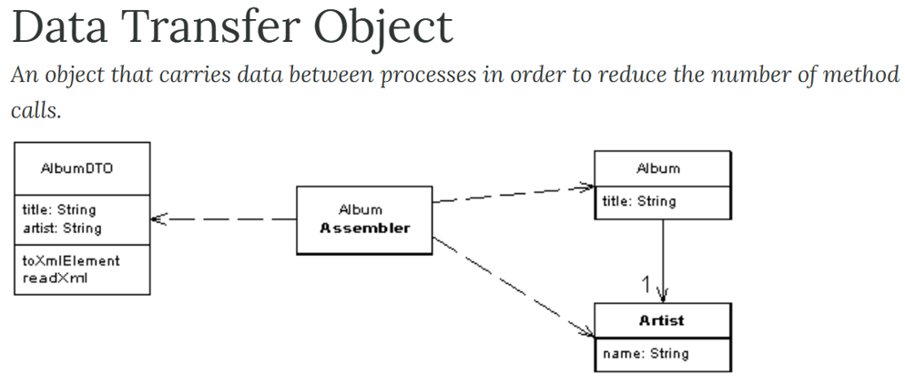

So like you can see, he gave a description why we should follow this data transfer object pattern. And he also gave a logic. Suppose inside a database, there is an album table and artist table which holds a title and name. And if one of the client they want the both title and the name of the artist inside the response, then definitely we will have an AlbumDto, which will hold both title and artist. All the data inside the entities will be mapped to dto with the help of this assembler logic or mapper logic in between and if needed, we can also write some serialization specific logic inside our DTO classes and in some project or in some organizations, they call this DTO objects as Value object or Transfer object. So regardless, the name that they are using, if they are using different pojo classes instead of database entity Pojo classes to transfer the data between multiple layers of the application, then they are following the DTO pattern. I'm going to mention this URL inside the GitHub repo page and at the same time I'm also going to attach this URL link to this lecture. If you are interested to read this page, feel free to do the same. With this, we have successfully created DTO classes inside our Accounts Microservice.

### Create API [ Accounts Microservice ]

Now is the time to build the actual business logic inside our Accounts Microservice. Inside this lecture, I'm going to build a REST API that will support the creation of a new account and new customer details inside our H2 database that we are maintaining. Please watch this video carefully because I'm going to cover a lot many standards, including exception handling, service layer logic and how to leverage the DTO pattern. So in order to create a new Rest API service, we need to go to the AccountsController. Because inside this controller class only we have created previously a sayHelloAPI and right now we don't need this let me delete this sayhelloAPI.

import org.springframework.web.bind.annotation.RestController;

@RestController

public class AccountsController {

}

In real projects, whenever we are trying to build REST APIs, it is always recommended to maintain a prefix API path which is common for your entire REST APIs present inside your controller class. For the same, we need to mention the annotation which is RequestMapping to this annotation. I'm going to pass the path parameter and to this path parameter. For now I'm giving the prefix path as /api, which means any REST API that I'm trying to implement inside this controller class. It is going to have this prefix path inside API if needed few projects they also maintain the version number of the API like V1 or V2.

@RequestMapping(path="/api/v1")

Or

@RequestMapping(path="/api/v2")

But right now, since this is not a real project, we don't need to maintain these versioning inside our API paths. That's why I'm just going to mention the prefix as /api.

import org.springframework.web.bind.annotation.RestController;

@RestController

@RequestMapping(path="/api")

public class AccountsController {

}

After this, It is also good practice to mention what is a return type data format from your REST API. So we are going to support the return type data type as Json. That's why we need to mention producers = MediaType. Please make sure you are selecting the media type from the springframework.http package. Using this media type, we can invoke a constant which is APPLICATION_JSON_VALUE. Like you can see I'm just selecting that Json value. So this conforms to my spring boot framework that the REST API is that I'm going to implement inside this controller are inside this microservice, they are going to support the response type of type Json.

import org.springframework.http.MediaType;

import org.springframework.web.bind.annotation.RestController;

@RestController()

@RequestMapping(path="/api", produces={MediaType.APPLICATION_JSON_VALUE})

public class AccountsController {

}

|  |  |
| --- | --- |
| So now I'm going to create a method that supports, create operation. So public ResponseEntity and inside this Response entity, I'm going to send the ResponseDto that we have created previously and the method name is going to be createAccount(). And to this createAccount() , I'm going to accept the request from my client applications. That's why I need to mention the RequestBody with the help of RequestBody annotation, whatever my clients are sending inside the RequestBody.  The same will be mapped into the Pojo class that I'm trying to mention after this RequestBody The Pojo class that I'm going to mention here is CustomerDto. This means anyone who is trying to invoke my createAccount method, they need to pass the input by following the data present Inside this dto. They need to pass what is the name of the customer? What is the email of the customer? What is the mobile number. | import lombok.Data;  @Data  public class CustomerDto {  private String name;  private String email;  private String mobileNumber;  } |

Now, on top of this method I need to mention the @PostMapping annotation because since this is a create operation like we discussed, we need to use Http post method and to this post method, the path that it is going to support is create. So anyone who wants to create a new account using my Accounts Microservice, they need to pass /api, /create along with this input data, then only the invocation will work.

import com.eazybytes.accounts.constants.AccountsConstants;

import com.eazybytes.accounts.dto.CustomerDto;

import lombok.AllArgsConstructor;

import org.springframework.http.ResponseEntity;

import org.springframework.http.HttpStatus;

import org.springframework.http.MediaType;

import org.springframework.web.bind.annotation.*;

@RestController

@RequestMapping(path="/api", produces = {MediaType.APPLICATION_JSON_VALUE})

@AllArgsConstructor

public class AccountsController {

@PostMapping("/create")

public ResponseEntity<ResponseDto> createAccount(@RequestBody CustomerDto

customerDto) {

return ResponseEntity

.status(HttpStatus.CREATED)

.body(new ResponseDto());

}

}

So let me write some logic inside the body of my method. First, let me write return statement. I'm going to return the object of Response entity. That's why using Response entity class post, I'm going to send what is a status. And whenever the creation of account is successful, I want to mention the HttpStatus.CREATED. This means the given resource is created successfully in the backend server post that using body method, I'm going to send the object of ResponseDto that we have created. Let me invoke this ResponseDto constructor and to this constructor I need to pass what is the statusCode and statusMsg that I want to return? So let's maintain all the status code, status message or any other constant values inside a separate file. That is a recommended standard. That's why I'm going to create a new package with the name constants. Inside this constants package, I'm going to create a new class with the name AccountsConstants and inside this Accounts class I'm going to create constants. So let me paste this constants values. Like you can see have created all these constants.

public class AccountsConstants {

private AccountsConstants() {

// restrict instantiation

}

public static final String SAVINGS = "Savings";

public static final String ADDRESS = "123 Main Street, New York";

public static final String STATUS_201 = "201";

public static final String MESSAGE_201 = "Account created successfully";

public static final String STATUS_200 = "200";

public static final String MESSAGE_200 = "Request processed successfully";

public static final String STATUS_417 = "417";

public static final String MESSAGE_417_UPDATE =

"Update operation failed. Please try again or contact Dev team";

public static final String MESSAGE_417_DELETE =

"Delete operation failed. Please try again or contact Dev team";

}

And at the same time we can use these constant values without creating the object of this class. And here you can also see I'm mentioning a private constructor with this private constructor. I don't want anyone creating an object of this class. The reason is, inside this class I want to maintain only constants. I don't want someone poluting this class with some methods or any other business logic. With that reason, I have created a private constructor, which means no one can create an object of this class. That's why I should also make sure I'm mentioning this static keyword for all the constants so that I can invoke them and use them with the help of class name itself. And whenever we are using static and final, it is a good standard and it is a recommended to use the field name or constant name completely with the all caps like you can see. And if you have multiple words inside your field name, just make sure you are separating them with the help of underscore. As of now, we have warnings that nowhere we have used these constants. But don't worry, we are going to use all these constants then these warnings will get resolved automatically. Now, coming to the AccountsController here to this response, I want to pass what is a statusCode and status response that I want to return to my client application. So using accounts constants, I'm going to invoke the constant which is status_201. This indicates a record is created successfully and very similarly using accounts constant. I'm going to invoke the constant of message_201.

@RestController

@RequestMapping(path="/api", produces = {MediaType.APPLICATION_JSON_VALUE})

@AllArgsConstructor

public class AccountsController {

@PostMapping("/create")

public ResponseEntity<ResponseDto> createAccount(@RequestBody CustomerDto

customerDto) {

return ResponseEntity

.status(HttpStatus.CREATED)

.body(new ResponseDto(AccountsConstants.STATUS_201,

AccountsConstants.MESSAGE_201));

}

}

With this, whenever an account is created successfully, we are sending a response saying that the resource is created with the help of this status. So this status will go in the response header. And similarly inside the body we can also send status as 201 and a message as account created successfully. So this is the standard that we need to follow with the help of Response entity. So Response entity is a class present inside the spring framework using which we can send the overall status, body and header values inside my response, you can see there is also a method like contentType(), header() using all these methods of Response entity. We can send a lot of information inside the Response to the client applications.

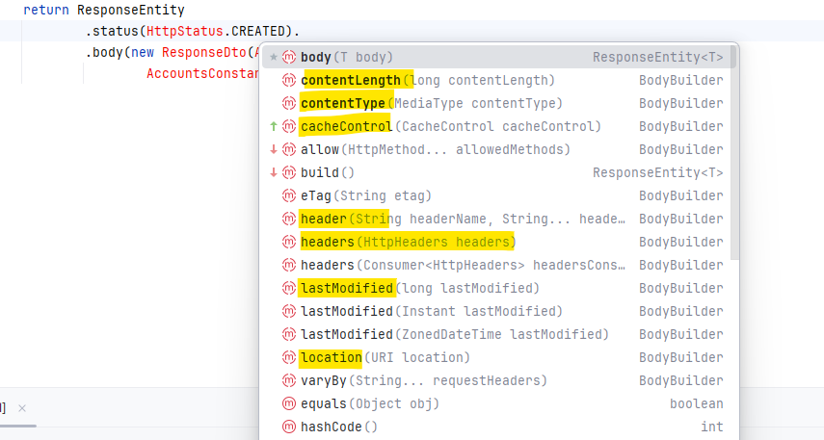

If you send only ResponseDto as a return object instead of ResponseEntity, whatever you have populated inside the ResponseDto, the same will be sent inside the body of the response, but the client will never receive what is the overall status? And similarly, this Response entity also give flexibility to send some header values or any other metadata information that we want to send.

Now we need to write the business logic to create the new account inside our H2 database. So all the business logic we should always write inside the service layer. The controller layer is only responsible to accept the request and to send the response and to perform any validations. That's why let's try to create a service layer with the help of an interface and its implementation. For the same, first, I need to create a new package with the name service.

Enable the below setting for Auto unambiguous Imports, also removes unused imports

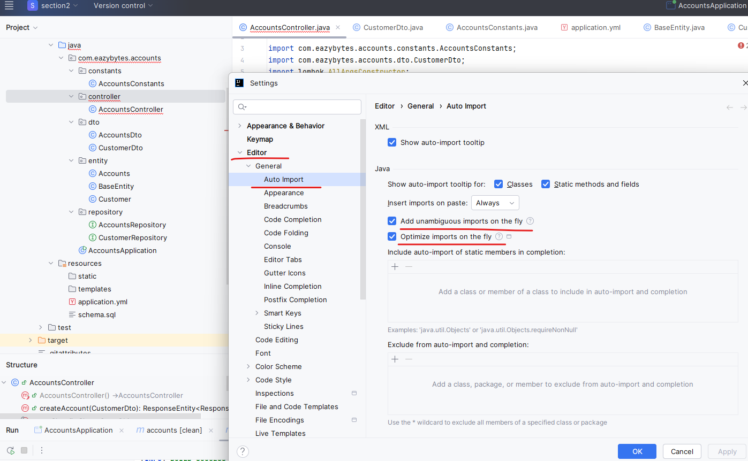

So inside this service package, first I'm going to create a new interface and the interface name is going to be IAccountsService. The I indicates interface. So this is a standard again followed by many projects. Whenever a class name starts with I, it indicates that it is an interface. You may ask me a question like then why you didn't follow the same naming standard for the repository layer, like for the Accounts repository and the Customer repository. But these repository classes, we never going to have any implementation classes. So that's why I didn't follow that standard. Whereas for the I account service, we are going to have an implementation class. So inside this interface I need to create a method that is responsible to create a new account. So let me create the method which is void create account. So this method is not going to return anything. That's why I'm mentioning the void as a return type was that this method is going to accept the CustomerDto as an input parameter. That's why I need to make sure I'm accepting this parameter. On top of this It is also a good standard to mention that Javadoc method comments. So you can see I'm just mentioning some method comments saying that that this method is going to accept a parameter of type CustomerDto object. And if your method is super, super complex, it is also a good recommendation inside your projects to write the few details about your method so that if someone joins in future inside your team and if you left the organization, they will know what is the purpose of this method. Right now I'm just going to leave it like this because this method is going to have simple logic.

import com.eazybytes.accounts.dto.CustomerDto;

public interface IAccountsService {

/**

*

* @param customerDto - CustomerDto Object

*/

void createAccount(CustomerDto customerDto);

}

As a next step inside the same service package. I'm going to create a new package with the name impl. So impl means implementation. Inside this implementation package, I'm going to create a new class with the name AccountServiceImpl. On top of this class, First, I need to mention @Service annotation to indicate to spring boot framework that this class is going to act as a service layer. So please create a bean. And once the bean is created by the Springboot framework, I can auto wire this bean to the controller layer. So as a next step, we need to make sure that this is implementing a IAccountService interface. As soon as we add this implement action details, it is asking me to override the abstract method present inside this IAccountService. So let me try to click on this implement methods and I'm trying to copy the Javadoc and insert override. So let me click on this okay. With this I have the empty abstract method. Inside this method we need to write the logic to create a new account. Before I try to write the logic inside this service class. First, let me try to autowire the two repository classes that we have created. That's why I'm trying to mention this AccountRepository and CustomerRepository inside the Service class. And on top of this Service class I'm going to mention an annotation which is AllArgsConstructor.

import com.eazybytes.accounts.dto.CustomerDto;

import com.eazybytes.accounts.service.IAccountsService;

import lombok.AllArgsConstructor;

import org.springframework.stereotype.Service;

@Service

@AllArgsConstructor

public class AccountsServiceImpl implements IAccountsService {

/**

* @param customerDto - CustomerDto Object

*/

@Override

public void createAccount(CustomerDto customerDto) {

}

}

With these, what will happen is behind the scenes my Lombok is going to generate a constructor that is going to accept all the arguments of this class.

Press ctrl + shift + O when inside the class to see all generated methods

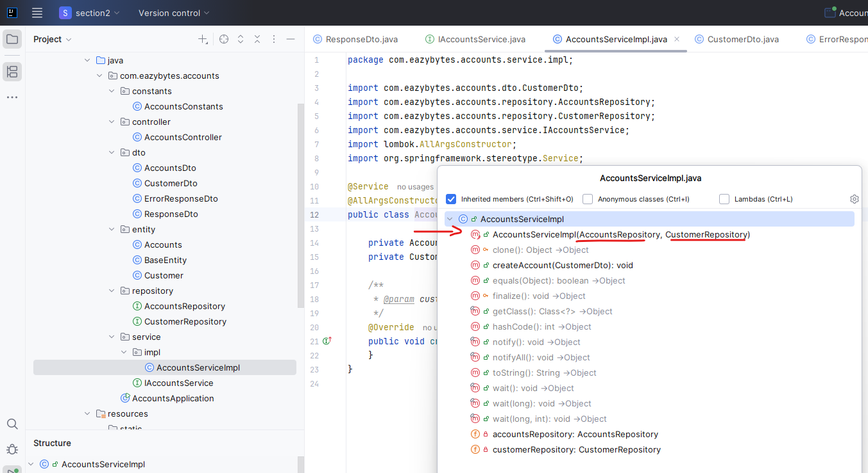

As of now we have only two arguments like AccountsRepository and CustomerRepository. If I try to see the list of methods, you can see there is a constructor created that accepts two parameters and whenever there is only a single constructor inside your class that is accepting parameters, you don't need to manually autowire these repository classes with the help of @Autowire. The spring framework can automatically do the Autowiring because there is only a single constructor and the single constructor is going to accept all these parameters. That's how the autowiring will work automatically in order to save the data into the database with the help of this repository interfaces, we need to send the object of Customer but not the class.

@Service

@AllArgsConstructor

public class AccountsServiceImpl implements IAccountsService {

private AccountsRepository accountsRepository;

private CustomerRepository customerRepository;

/**

* @param customerDto - CustomerDto Object

*/

@Override

public void createAccount(CustomerDto customerDto) {

}

}

There should be some mapping logic which will convert the Dto to Entity class and Entity Class to Dto. So that's why I'm going to create a new package here with the name Mapper inside this mapper package. I'm going to create a new class with the name AccountsMapper and this mapper is going to take care of mapping DTO to entity and entity to DTO to save some time I'm just pasting two methods here static methods.

import com.eazybytes.accounts.dto.AccountsDto;

import com.eazybytes.accounts.entity.Accounts;

public class AccountsMapper {

public static AccountsDto mapToAccountsDto(Accounts accounts, AccountsDto accountsDto) {

accountsDto.setAccountNumber(accounts.getAccountNumber());

accountsDto.setAccountType(accounts.getAccountType());

accountsDto.setBranchAddress(accounts.getBranchAddress());

return accountsDto;

}

public static Accounts mapToAccounts(AccountsDto accountsDto, Accounts accounts) {

accounts.setAccountNumber(accountsDto.getAccountNumber());

accounts.setAccountType(accountsDto.getAccountType());

accounts.setBranchAddress(accountsDto.getBranchAddress());

return accounts;

}

}

I'll explain you what these methods are doing. You can also get this code from the GitHub repo. So if you see here, the very first method will take the first parameter as entity Accounts object and the second parameter as DTO object. What this is going to do is it is going to map all the data from Accounts to AccountsDto with the help of the Setters and Getters methods. So this simple logic I have written here, it will copy all the account number, account type and branch address to the DTO and it is going to return that DTO to the method where is trying to invoke this method, which is mapToAccountDto and this is a static method. Very similarly, we also have mapToAccounts. This method is going to do the vice versa, like it is going to accept DTO and accounts and transfer the data from DTO to entity class. I hope you are clear with these mapper logic. Let me create the same for CustomerMapper also. So whenever you need some mapper between entity and DTO, you need to write such logic inside your projects. So with the help of this CustomerMapper, I'm going to convert the data from CustomerDto to Customer and vice versa. So for the same, I'm going to mention two methods here. You already know what these methods.

import com.eazybytes.accounts.dto.CustomerDto;

import com.eazybytes.accounts.entity.Customer;

public class CustomerMapper {

public static CustomerDto mapToCustomerDto(Customer customer, CustomerDto customerDto) {

customerDto.setName(customer.getName());

customerDto.setEmail(customer.getEmail());

customerDto.setMobileNumber(customer.getMobileNumber());

return customerDto;

}

public static Customer mapToCustomer(CustomerDto customerDto, Customer customer) {

customer.setName(customerDto.getName());

customer.setEmail(customerDto.getEmail());

customer.setMobileNumber(customerDto.getMobileNumber());

return customer;

}

}

So once we define these mapper logic and here you may have a question like do I need to write these mapper logic manually? Is there any automated way of doing this? Off course we have libraries that supports these automatic mapping between entity and Pojo Class two such libraries are modelmapper and map struct.

<https://modelmapper.org/> <https://mapstruct.org/>

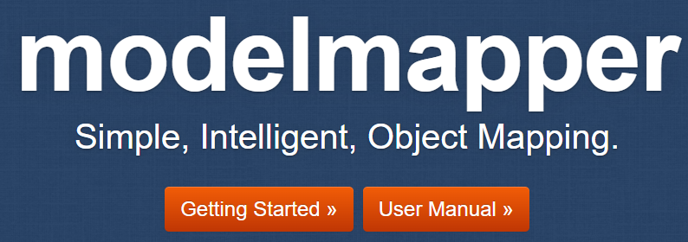 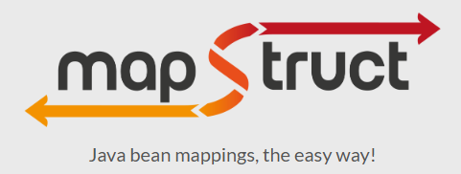

Using these two libraries, you can do the conversion between DTO to entity and entity to DTO by adding few dependencies and writing a few lines of code, but I'm not going to use these dependencies in my course. The reason is these are not officially recommended by the spring framework when you go to the start.spring.io. If you look for Lombok, you can see there is a dependency that you can add with the help of this website, which means this is officially recognized by the spring framework, whereas the maps tracked are any other mapper libraries, they are not officially recognized and I'm sure your client or your architect or your leads, they may not agree to bring these dependencies into your microservices because these are open source and we never know if there is some security issues with these libraries. You can also see these website does not have official certificate as well. I'm not blaming these libraries. I'm just saying please be cautious using these libraries. If your client and if your Project lead is accepting that, please go ahead and use them, learning them and using them also is super, super easy. But for now, I'm not going to use them. I'm going to use the old style like where I have the complete control. Like think of a scenario where maybe when I want to send this mobile number to one of the client, I don't want to send the complete mobile number, I only want to send the mobile number by masking it and displaying only the last four digits. Such kind of logic or serialization logic. We can write inside this CustomerMapper where this kind of flexibility you may not have with these two libraries.

Service Impl

In the AccountServiceImpl, I need to convert the input received CustomerDTO to Customer entity object. For the same, I'm going to write a piece of logic here. First, I'm going to create a field with the name customer. Post that with the help of customer mapper that we have created, I'm going to invoke the method, which is mapToCustomer and to this method we need to pass what is the DTO and post that we need to pass a new object of Customer. So with this line, all the data that I have inside this CustomerDto will be transferred to this Customer object and the same will be stored with the help of this customer field. Now I want to save these customer information into the customer table. For the same, I need to use the CustomerRepository interface and using this interface we can call a method called save(). You can see there are multiple save(), but since we want to save a single entity, we need to invoke the save method. And to this method we need to pass the Customer object that we have. So with this code, the Spring Data JPA framework will take care of taking the input object, preparing an SQL statement, creating a connection with the database, executing the statement, committing the transaction, closing the connection. So all those boilerplate code which developers use to write now will be taken care by the spring data JPA. So the save method I have not written inside the CustomerRepository. It is coming from the spring data JPA since we extended this JpaRepository class. So now we successfully save the customer details into the database. When this customer details is saved into the database. Very first time the customerId will be generated automatically by the spring Data JPA framework. So in order to know what is the customerId, we need to store the return type of the save() method into another variable called savedCustomers.

import com.eazybytes.accounts.constants.AccountsConstants;

import com.eazybytes.accounts.dto.CustomerDto;

import com.eazybytes.accounts.entity.Accounts;

import com.eazybytes.accounts.entity.Customer;

import com.eazybytes.accounts.exception.CustomerAlreadyExistsException;

import com.eazybytes.accounts.mapper.CustomerMapper;

import com.eazybytes.accounts.repository.AccountsRepository;

import com.eazybytes.accounts.repository.CustomerRepository;

import com.eazybytes.accounts.service.IAccountsService;

import lombok.AllArgsConstructor;

import org.springframework.stereotype.Service;

import java.util.Optional;

import java.util.Random;

@Service

@AllArgsConstructor

public class AccountsServiceImpl implements IAccountsService {

private AccountsRepository accountsRepository;

private CustomerRepository customerRepository;

/**

* @param customerDto - CustomerDto Object

*/

@Override

public void createAccount(CustomerDto customerDto) {

Customer customer = CustomerMapper.mapToCustomer(customerDto, new Customer());

Customer savedCustomer = customerRepository.save(customer);

accountsRepository.save(savedCustomer);

}

}

Now, with the help of this customer details, I want to create a new bank account for this customer. The customer is only going to give what is his name, email and mobileNumber with his customer details. I want to create a new bank account. For the same, we need to use the AccountsRepository and invoke the save method. To this method, We need to pass the object of Accounts entity populated with the values like customerId, accountNumber. What is the account type? What is the branch address? All those details. So to populate a new accounts object, let me create a new private method inside this service class to save some time. I'm pasting this private method. You can see this is the private method which is create new account. It is going to accept the customer entity and inside this customer entity there will be a customerId which is populated by the previous operation we have done here. So I'm taking the customerId from the customer and the same I'm populating into the accounts object which I have created inside this method. And now coming to the accountNumber previously I was telling it is the responsibility of the developer to generate the account number which is a primary key and send the same to the spring data JPA using the same account number, it is going to insert a new record. So here I have written a logic that will give me a ten digit random account number. Post that I'm setting the same random account number into the Account entity object followed by what is the account type and branch address. So this account type is coming from the accounts constraints we have created previously. The savings means it is a savings account and the branch address. I'm just putting it as 123 Main Street, New York. So this is a simple method which will take Customer entity class and will return a Accounts entity class. So to this save() method, Since I need to pass the Accounts entity pojo class, what I'm going to do is I'm going to invoke the new account method and pass the saved customer object that we have.

@Service

@AllArgsConstructor

public class AccountsServiceImpl implements IAccountsService {

private AccountsRepository accountsRepository;

private CustomerRepository customerRepository;

/**

* @param customerDto - CustomerDto Object

*/

@Override

public void createAccount(CustomerDto customerDto) {

Customer customer = CustomerMapper.mapToCustomer(customerDto, new Customer());

Customer savedCustomer = customerRepository.save(customer);

accountsRepository.save(createNewAccount(savedCustomer));

}

/**

* @param customer - Customer Object

* @return the new account details

*/

private Accounts createNewAccount(Customer customer) {

Accounts newAccount = new Accounts();

newAccount.setCustomerId(customer.getCustomerId());

long randomAccNumber = 1000000000L + new Random().nextInt(900000000);

newAccount.setAccountNumber(randomAccNumber);

newAccount.setAccountType(AccountsConstants.SAVINGS);

newAccount.setBranchAddress(AccountsConstants.ADDRESS);

return newAccount;

}

}

So behind the scenes, a new account will be created with the customerId that we have passed to this method, and that way we are establishing a link between a customer and new account that is created with this everything looking good, but we are not handling the exceptions properly. Think like someone is trying to use the same mobile number again and again. We don't want that to happen. We want only one customer to use a single mobile number, but multiple customers can have same email or same name, but we don't want the mobile number to be used by multiple customers. That's why we need to have some logic to handle these kind of scenarios. For the same, let me create a new package where I can store all the classes related to exception handling. So the package name is going to be exception. Inside this exception package, I'm going to create a new custom exception. And the name of this new custom exception is CustomerAlreadyExistsException.

import org.springframework.http.HttpStatus;

import org.springframework.web.bind.annotation.ResponseStatus;

@ResponseStatus(value = HttpStatus.BAD_REQUEST)

public class CustomerAlreadyExistsException extends RuntimeException {

public CustomerAlreadyExistsException(String message) {

super(message);

}

}

So this is the class name that I want to keep. And since I want to write my own custom exception, I need to make sure I'm extending the RuntimeException. So any custom exception that you want to create, it should extend the RuntimeException. Now, I also want to create a constructor for this class which is going to accept the exception message post that once this constructor is invoked with this message details. Since we are trying to extend another class, we need to make sure we are invoking the parent constructor also, for the same I'm using super(message). So with this what I'm trying to do is whenever someone is trying to create an object of this custom exception by passing this message, value the same I'm passing to this RuntimeException because I'm extending this as a superclass. Now, on top of this custom exception, I'm going to mention an annotation which is ResponseStatus to this ResponseStatus I'm going to send the value as HttpStatus.BAD_REQUEST. Whenever I'm trying to throw this exception in the response, my client is going to receive a status saying that 400 which represents bad requests. So this is the custom exception I have created. Now, as a next step, I can go to my Service class. Here first I need to make sure I'm validating if there is any existing customer with a given mobileNumber, which means I need to execute a query on my database by passing a mobileNumber and to identify if there is any existing record. Can we do that with the help of this CustomerRepository?

Think about it. We declared customerId as an primary key field inside our entity, so this CustomerRepository will have a find() with the help of Id, which is customerId. My framework can only provide a find() based upon my primary key values, which is customerId. That's why if you go and check the ServiceImpl class using this CustomerRepository, I can invoke find by method which will accept the customerId as a input because customerId is a primary key that we have defined. But are we receiving the customerId inside the request when they're trying to create the account very first time? Off course we won't receive that. That's why we need to write a different method that will help us to query the database based upon a mobileNumber. For the same, let's go to the CustomerRepository. Inside this interface, we need to define an abstract method by following some naming convention and the Spring Data JPA framework is going to write the logic of fetching the record based upon the column that we have mentioned.

So let's try to understand how to do that. So here I'm going to create a method that is going to return optional of customer, because for a given mobileNumber there can be a customer or they cannot be any customer. That's why I need to make sure I'm using optional of customer. So now I need to write a method with the name findByMobileNumber(). To this method I need to pass the input which is mobile number itself. So whenever I write this method inside my repository interface, my spring data JPA framework will take care of fetching the record based upon a mobileNumber. So here you may have a question like how your spring data JPA know that you are trying to query based upon a single column which is mobileNumber, but at the same you can see if you see the naming convention findBy whenever we are using findBy we're telling to the spring data JPA framework. We are trying to run a select query using the column mobileNumber. So this field name mobileNumber has to match with what you have mentioned inside your pojo entity class.

Don't worry about this small letter that we have. It is not case sensitive, but please make sure the spelling is correct like mobileNumber is matching with what you have mentioned here. This way we are telling to spring data JPA framework to fetch the records from this column. What if you have multiple columns inside your requirements? In that case, you need to write and followed by what is the second parameter and the second parameter also you need to pass as a method parameter to this method. I talked extensively about this concept inside my spring course. We call this concept as derived named method because based upon the method names, my spring data JPA framework is going to prepare the SQL queries and run the same onto the database. So now let's go and use these fineByMobileNumber inside our ServiceImpl class. So I'm just trying to invoke findByMobileNumber and to this method we need to pass the mobileNumber that we received inside the CustomerDto. So I'm trying to invoke CustomerDto.getMobileNumber(). So whatever returned by my spring data JPA framework, I'm going to catch that into an object with the name optional customer. So now using this optional customer object, I need to validate if there is an existing customer available inside the database or not. For the same, I'm going to write an If check here like you can see with the help of this OptionalCustumer.isPresent(), which means this is present is going to return a boolean value true . If there is a record inside this optional object. If there is a record, then I want to throw a CustomerAlreadyExistingException with a message customer already registered with a given mobile number. So this is what I'm doing inside this if block with this now I'm doing the validation and I'm throwing the custom validation exception. But where is the logic to handle this exception?

I'll throw this CustomerAlreadyExistingException to my parent method, which is inside my controller and inside my controller. I can handle the exception using catch block and I can send an error response to my client application. But in future, if there is some other place where you're trying to throw the same exception, you're going to throw again. A different controller method has to catch that. So there is a lot of exception handling logic is going to be duplicated inside your application.

Controller

@RestController

@RequestMapping(path="/api", produces = {MediaType.APPLICATION_JSON_VALUE})

@AllArgsConstructor

public class AccountsController {

private IAccountsService iAccountsService;

@PostMapping("/create")

public ResponseEntity<ResponseDto> createAccount(@RequestBody CustomerDto customerDto) {

iAccountsService.createAccount(customerDto);

return ResponseEntity

.status(HttpStatus.CREATED)

.body(new ResponseDto(AccountsConstants.STATUS_201,

AccountsConstants.MESSAGE_201));

}

}

ServiceImpl

@Service

@AllArgsConstructor

public class AccountsServiceImpl implements IAccountsService {

private AccountsRepository accountsRepository;

private CustomerRepository customerRepository;

/**

* @param customerDto - CustomerDto Object

*/

@Override

public void createAccount(CustomerDto customerDto) {

Customer customer = CustomerMapper.mapToCustomer(customerDto, new Customer());

Optional<Customer> optionalCustomer =

customerRepository.findByMobileNumber(customerDto.getMobileNumber());

if(optionalCustomer.isPresent()) {

throw new CustomerAlreadyExistsException("Customer already

registered with given mobileNumber " + customerDto.getMobileNumber());

}

Customer savedCustomer = customerRepository.save(customer);

accountsRepository.save(createNewAccount(savedCustomer));

}

/**

* @param customer - Customer Object

* @return the new account details

*/

private Accounts createNewAccount(Customer customer) {

Accounts newAccount = new Accounts();

newAccount.setCustomerId(customer.getCustomerId());

long randomAccNumber = 1000000000L + new Random().nextInt(900000000);

newAccount.setAccountNumber(randomAccNumber);

newAccount.setAccountType(AccountsConstants.SAVINGS);

newAccount.setBranchAddress(AccountsConstants.ADDRESS);

return newAccount;

}

}

That's why we have created a error response and we have annotated @AllArgsConstructor because we need a constructor that accept all these four parameters.

ErrorResponseDto

import lombok.AllArgsConstructor;

import lombok.Data;

import org.springframework.http.HttpStatus;

import java.time.LocalDateTime;

@Data @AllArgsConstructor

public class ErrorResponseDto {

private String apiPath;

private HttpStatus errorCode;

private String errorMessage;

private LocalDateTime errorTime;

}

To overcome this challenge. The best standard is you need to write a GlobalExceptionHandlingLogic. So for the same under these exception package, I'm going to create a new class, and the class name that I want to do here is GlobalExceptionHandler. So this is the class where I want to write all the Global exception logic. So whenever you want to write some global exception logic, we need to make sure you are mentioning the annotation @ControllerAdvice. Using this annotation, we are telling to the Springboard framework whenever an exception happens in any of my control not only accounts controller in future I may write different controller in all such controllers. If any exception happens, please invoke a method that I'm going to write inside this class. So here, inside this class I'm going to create a new method. Let me paste the method to save some time. You can also get this method from the GitHub repo so you can see the method name is handleCustomer handleCustomerAlreadyExistingException(). You can write any method name. This method is going to handle the exception which is CustomerAlreadyExistException.

ControllerAdvice – Global Exception Handler

import com.eazybytes.accounts.dto.ErrorResponseDto;

import org.springframework.http.HttpStatus;

import org.springframework.http.ResponseEntity;

import org.springframework.web.bind.annotation.ControllerAdvice;

import org.springframework.web.bind.annotation.ExceptionHandler;

import org.springframework.web.context.request.WebRequest;

import org.springframework.web.servlet.mvc.method.annotation.ResponseEntityExceptionHandler;

import java.time.LocalDateTime;

@ControllerAdvice

public class GlobalExceptionHandler extends ResponseEntityExceptionHandler {

@ExceptionHandler(CustomerAlreadyExistsException.class)

public ResponseEntity<ErrorResponseDto>

handleCustomerAlreadyExistsException(CustomerAlreadyExistsException exception,

WebRequest webRequest){

ErrorResponseDto errorResponseDTO = new ErrorResponseDto(

webRequest.getDescription(false),

HttpStatus.BAD_REQUEST,

exception.getMessage(),

LocalDateTime.now()

);

return new ResponseEntity<>(errorResponseDTO, HttpStatus.BAD_REQUEST);

}

}

And we should also pass this web request parameter to this method because inside our ErrorResponseDto we decided to send the what is the path that my client application is trying to invoke? So you can see using this web request, I'm trying to get the get description. When I pass this false value to this get description, I'll only get the API information. Whereas if I try to pass the true value, I'll get many other information like what is the IP address of my client? All those details. But for now I just wanted to send the only API path. So using ErrorResponseDto constructor I'm trying to pass what is the path that my client is trying to invoke and the HttpStatus as BAD_REQUEST and the message that we receive from the customer already CustomerAlreadyExistingException which we are trying to throw from the AccountService. So we will receive this message. And at last, what is our date and time right now when this exception happened?

So right now, with the help of this constructor, I have created a DTO object and the same I'm trying to send as inside the ResponseEntity as a body. So you can see here this ResponseEntity object. It is accepting the body as a very first parameter and the second parameter what is the HttpStatusCode . So I'm trying to send the bad request as a HttpStatusCode, which will throw 400 to the client application saying that you are sending some bad data.

@ControllerAdvice

public class GlobalExceptionHandler extends ResponseEntityExceptionHandler {

@ExceptionHandler(CustomerAlreadyExistsException.class)

public ResponseEntity<ErrorResponseDto> handleCustomerAlreadyExistsException(

CustomerAlreadyExistsException exception, WebRequest webRequest){

ErrorResponseDto errorResponseDTO =

new ErrorResponseDto(

webRequest.getDescription(false),

HttpStatus.BAD_REQUEST,

exception.getMessage(),

LocalDateTime.now()

);

return new ResponseEntity<>(errorResponseDTO, HttpStatus.BAD_REQUEST);

}

}

For more details, check the body of the Response. So now here I have written a method and in future I may return more methods which will handle more custom exception logics. How my spring boot framework will know that this method has to be invoked whenever there is an exception. CustomerAlreadyExist. Exception is being thrown. For the same, what we need to do is we need to mention an annotation which is ExceptionHandler. This annotation we need to pass what is the exception name that this method is supposed to handle. So this method is supposed to handle CustomerAlreadyExistsException. That's why I have mentioned this .class here. So now with these changes we should be good. Let's go to the AccountServiceImpl, here everything is looking good. We need to go to the controller class. Here first I need to do the autowiring of my service class to these AccountsController For the same, I'm going to mention private AccountService and accountService is the field name. Now I can mention @Autowired on top of these field which will take care of autowiring.

@RestController

@RequestMapping(path="/api", produces = {MediaType.APPLICATION_JSON_VALUE})

public class AccountsController {

@Autowired

private IAccountsService iAccountsService;

@PostMapping("/create")

public ResponseEntity<ResponseDto> createAccount(@RequestBody CustomerDto customerDto) {

return ResponseEntity

.status(HttpStatus.CREATED)

.body(new ResponseDto(AccountsConstants.STATUS_201,

AccountsConstants.MESSAGE_201));

}

}

But I don't want to go with the field autowiring. Instead I want to go with the constructor autowiring, which is the recommended approach. For the same, I need to mention an annotation which is AllArgsConstructor and with this Lombok annotation AccountsController is going to have a constructor that accepts the IAccountService as the input parameter. Like I said before, whenever you have only single constructor then you don't need to mention @Autowired annotation anywhere, either inside your constructor or inside your class.

@RestController

@RequestMapping(path="/api", produces = {MediaType.APPLICATION_JSON_VALUE})

@AllArgsConstructor

public class AccountsController {

private IAccountsService iAccountsService;

@PostMapping("/create")

public ResponseEntity<ResponseDto> createAccount(@RequestBody CustomerDto

customerDto) {

return ResponseEntity

.status(HttpStatus.CREATED)

.body(new ResponseDto(AccountsConstants.STATUS_201,

AccountsConstants.MESSAGE_201));

}

}

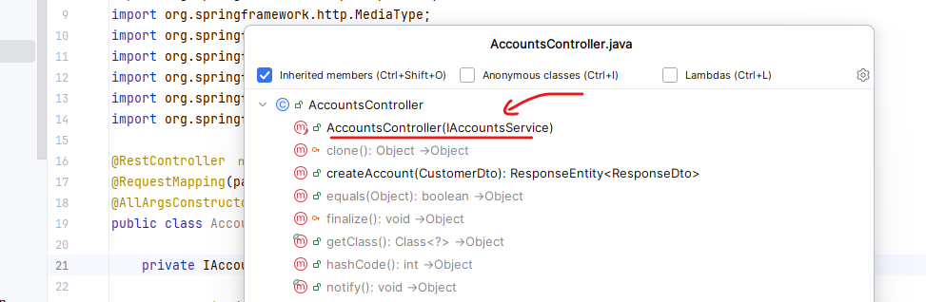

So now, using this AccountService, I'm going to invoke the createAccount method. And to this method I'm going to pass the CustomerDto object. And if there is no exception, which means my next line will be executed and here will be sending this successful response. Whereas if there is an exception inside my service due to this business exception, then definitely it will never reach to my controller layer. Instead, it will go to the GlobalExceptionHandler and this ErrorResponseDto will be written to my end user. But here you may have a question like what if there is some RuntimeException due to any other exceptions? Don't worry about that. I'm going to handle that in the coming lectures. For now, let's try to save these changes.

Do a build. You can see my automatic restart with the help of dev tools might have failed. That's why it wrote these hard swap fail. So whenever you get this kind of scenario because you might have done a lot many changes which can't be recognized by the dev tools, then you need to stop the server and start it again manually. So let me do a build. Once the build is completed. I'm trying to start my application. My application started successfully at the port 8080.

Controller

@RestController

@RequestMapping(path="/api", produces = {MediaType.APPLICATION_JSON_VALUE})

@AllArgsConstructor

public class AccountsController {

private IAccountsService iAccountsService;

@PostMapping("/create")

public ResponseEntity<ResponseDto> createAccount(@RequestBody CustomerDto customerDto) {

iAccountsService.createAccount(customerDto);

return ResponseEntity

.status(HttpStatus.CREATED)

.body(new ResponseDto(AccountsConstants.STATUS_201,

AccountsConstants.MESSAGE_201));

}

}

Service

public interface IAccountsService {

void createAccount(CustomerDto customerDto);

}

ServiceImpl

@Service

@AllArgsConstructor

public class AccountsServiceImpl implements IAccountsService {

private AccountsRepository accountsRepository;

private CustomerRepository customerRepository;

@Override

public void createAccount(CustomerDto customerDto) {

Customer customer = CustomerMapper.mapToCustomer(customerDto, new Customer());

Optional<Customer> optionalCustomer =

customerRepository.findByMobileNumber(customerDto.getMobileNumber());

if(optionalCustomer.isPresent()) {

throw new CustomerAlreadyExistsException("Customer already

registered with given mobileNumber " + customerDto.getMobileNumber());

}

Customer savedCustomer = customerRepository.save(customer);

accountsRepository.save(createNewAccount(savedCustomer));

}

private Accounts createNewAccount(Customer customer) {

Accounts newAccount = new Accounts();

newAccount.setCustomerId(customer.getCustomerId());

long randomAccNumber = 1000000000L + new Random().nextInt(900000000);

newAccount.setAccountNumber(randomAccNumber);

newAccount.setAccountType(AccountsConstants.SAVINGS);

newAccount.setBranchAddress(AccountsConstants.ADDRESS);

return newAccount;

}

}

Exception Class

@ResponseStatus(value = HttpStatus.BAD_REQUEST)

public class CustomerAlreadyExistsException extends RuntimeException {

public CustomerAlreadyExistsException(String message) {

super(message);

}

}

Global Exception Handler

@ControllerAdvice

public class GlobalExceptionHandler extends ResponseEntityExceptionHandler {

@ExceptionHandler(CustomerAlreadyExistsException.class)

public ResponseEntity<ErrorResponseDto> handleCustomerAlreadyExistsException(

CustomerAlreadyExistsException exception, WebRequest webRequest){

ErrorResponseDto errorResponseDTO = new ErrorResponseDto(

webRequest.getDescription(false),

HttpStatus.BAD_REQUEST,

exception.getMessage(),

LocalDateTime.now()

);

return new ResponseEntity<>(errorResponseDTO, HttpStatus.BAD_REQUEST);

}

}

Repository

@Repository

public interface AccountsRepository extends JpaRepository<Accounts, Long> {

Optional<Accounts> findByCustomerId(Long customerId);

}

@Repository

public interface CustomerRepository extends JpaRepository<Customer, Long> {

Optional<Customer> findByMobileNumber(String mobileNumber);

}

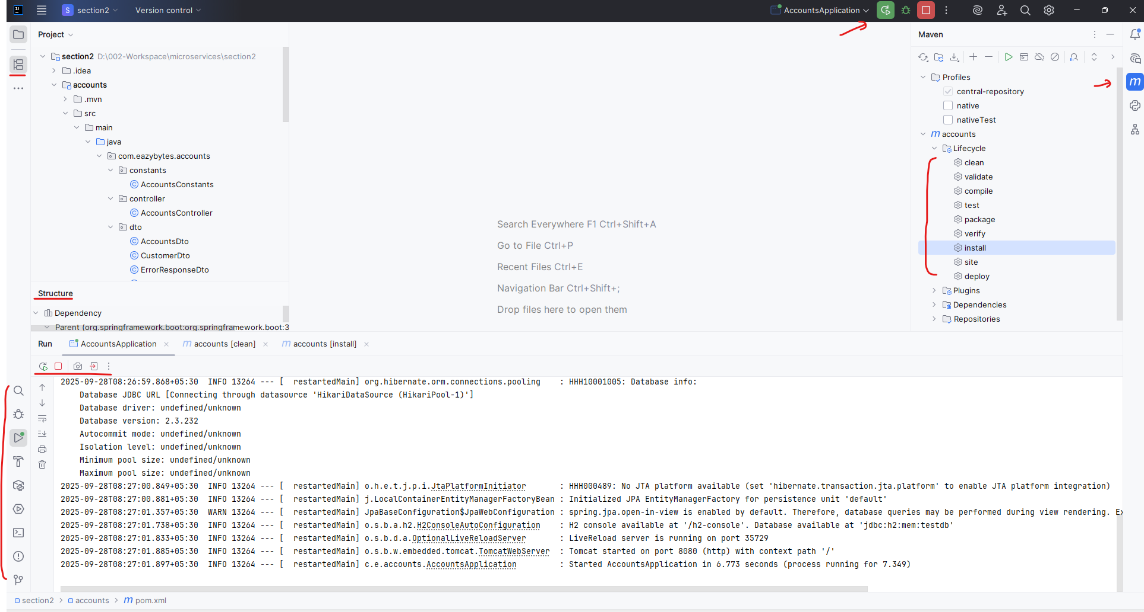

As a next step, we can go and send a request to my create API and validate if my account is successfully created or not. For the same, I came to the postman. Postman is an tool using which we can invoke REST APIs easily. If you don't have this tool, please download from the web and I'm going to show a lot many APIs inside this course and I'll populate lot many requests. So to make your life easy, what I'm going to do is I'm going to upload this entire microservices collection into the root location of my GitHub repo. What you can do is you can download this collection and you can go to the file and click on this import option that you have in the postman and you can drop the collection. Basically it is a Json file. As soon as you drop all the operations that I have inside, my collections will be downloaded into your postman.

You have to download and install postman, then login via the gmail account, [lalitgcp8@gmail.com](mailto:lalitgcp8@gmail.com) was used. After that download the collections json file and import via postman like this

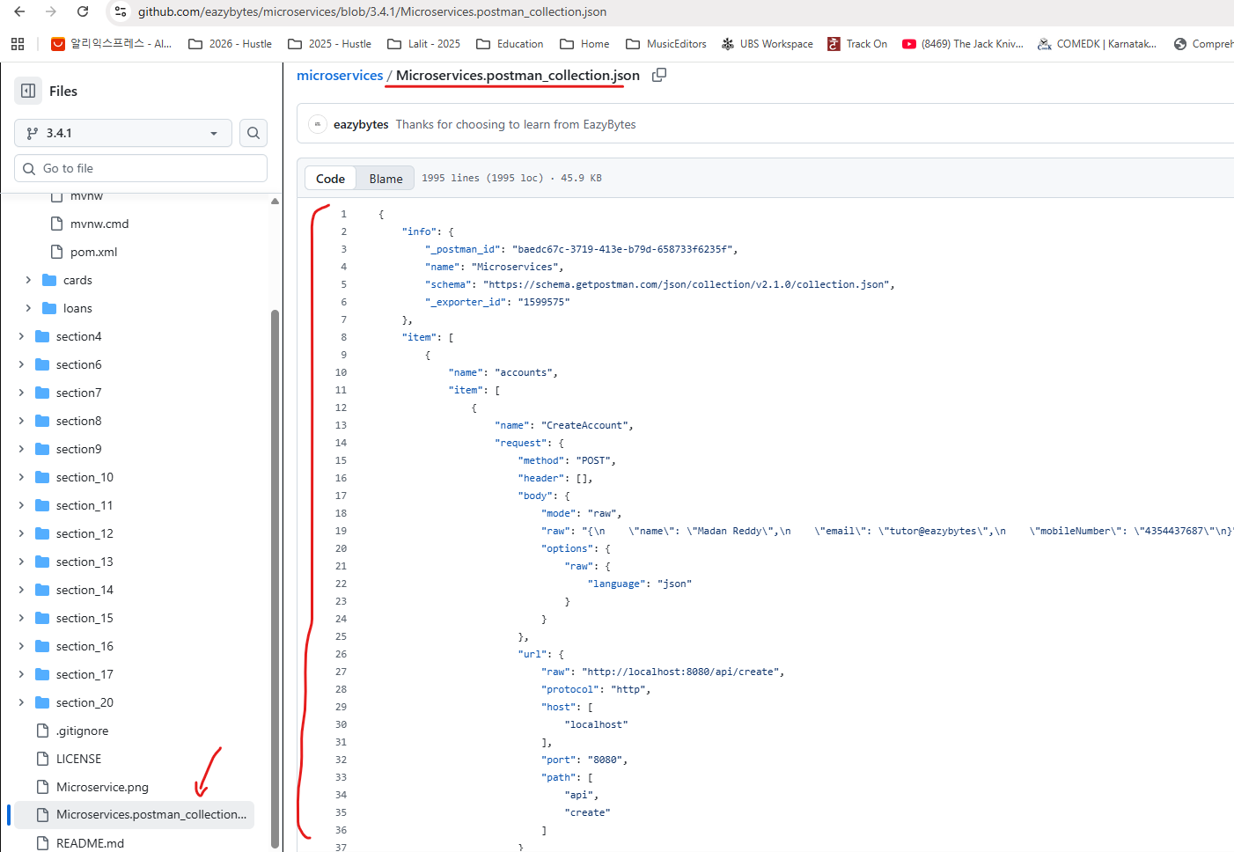

Now import it

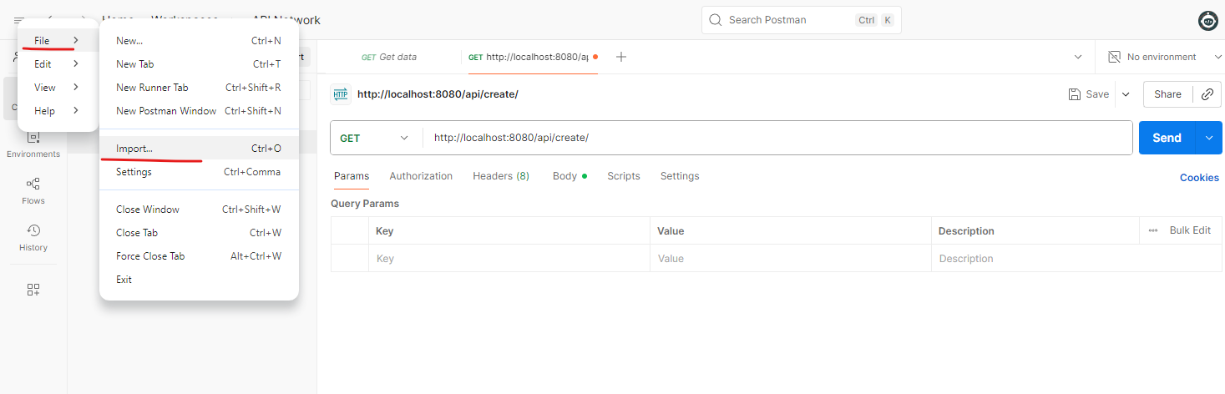

Drag and drop the file in the window popup that we get and we should see as below

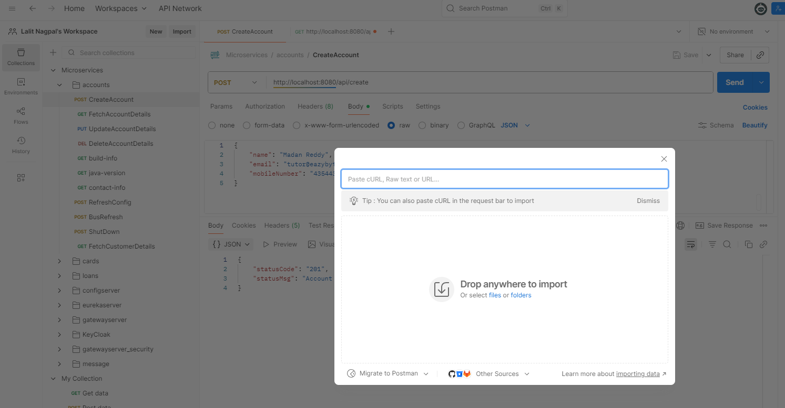

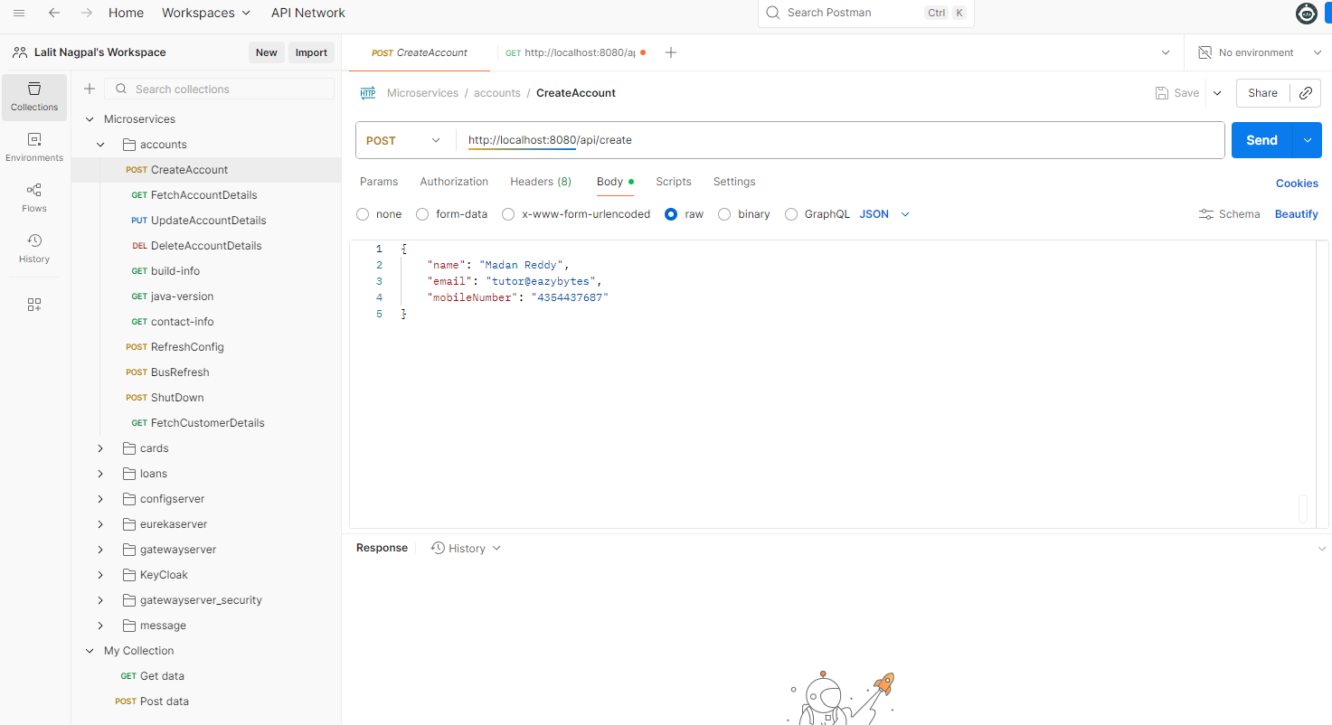

You just have to follow these instructions. You don't have to type all this one this way it will save some time for you. So as of now you can see I have create account request where I'm trying to send a post request this API which is localhost 8080/api/create to this API under the body. I need to send the json with the name as Madan Reddy. . This is my name. That's why I'm sending. Please feel free to send your own name. And this is my official email and this is the sample mobile number. I'm not mentioning my actual mobile number just for some privacy here, but please make sure this name email, mobile number has to match with the fields that you have inside your customer data. If you see inside the AccountsController, we're accepting the customer data as a input RequestBody. So the fields has to match like name, email and mobileNumber.

These names has to match with what you are sending inside the Json. If the fields are matching, then the spring boot is going to take care of converting this Json to the dto object. How this is going to happen Inside the spring boot, there are Jackson libraries with the help of those Jackson libraries, the conversion from Json to Pojo object. And similarly, when we return the Pojo object in the Response. The same will be converted to Json and send back to the client. So let me click on this send button. As soon as I click send you can see I'm getting an exception. The reason is my spring data JPA framework did not receive the data like createdBy and createdAt this are not null values. For the same, we can go to the service class before we try to save this customer information. We need to pass like customer.setCreatedAt(LocalDateTime.now()) So with that I'm populating the createdAt. Very similarly, I'll invoke the set createdBy. So for now I'm just trying to mention anonymous.

@Service

@AllArgsConstructor

public class AccountsServiceImpl implements IAccountsService {

private AccountsRepository accountsRepository;

private CustomerRepository customerRepository;

@Override

public void createAccount(CustomerDto customerDto) {

Customer customer = CustomerMapper.mapToCustomer(customerDto, new Customer());

Optional<Customer> optionalCustomer =

customerRepository.findByMobileNumber(customerDto.getMobileNumber());

if(optionalCustomer.isPresent()) {

throw new CustomerAlreadyExistsException("Customer already

registered with given mobileNumber " + customerDto.getMobileNumber());

}

customer.setCreatedAt(LocalDateTime.now());

customer.setCreatedBy("Anonymous");

Customer savedCustomer = customerRepository.save(customer);

accountsRepository.save(createNewAccount(savedCustomer));

}

private Accounts createNewAccount(Customer customer) {

Accounts newAccount = new Accounts();

newAccount.setCustomerId(customer.getCustomerId());

long randomAccNumber = 1000000000L + new Random().nextInt(900000000);

newAccount.setAccountNumber(randomAccNumber);

newAccount.setCreatedAt(LocalDateTime.now());

newAccount.setCreatedBy("Anonymous");

newAccount.setAccountType(AccountsConstants.SAVINGS);

newAccount.setBranchAddress(AccountsConstants.ADDRESS);

return newAccount;

}

So someone is trying to create this account. Later on I'll show you how to automatically populate this createdAt, createdBy the help of Spring Data JPA Framework. For now, let's try to populate this values manually. Very similarly, I'm also going to mention the same for Account object as well. So just after this branch address, I'm going to do the same for the Account object. So with this we should be good. Let me save the changes and do a build. Now the build is completed. The server also might have restarted successfully. Here let me try to invoke this API again. This time you can see I'm getting a successful response status code and status message, which is 201 account created successfully, and this is the status that we are returning with the help of ResponseEntity.status .

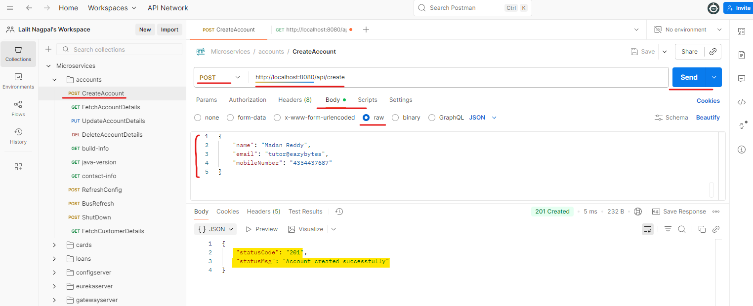

And this is the body that we are sending inside the Response. So let's try to invoke the operation again with the same mobileNumber. We should get a business exception. You can see I'm getting a API path like I tried to invoke this path error code, bad request error message like so and so user already registered with the so-and-so mobile number and this is the error time.

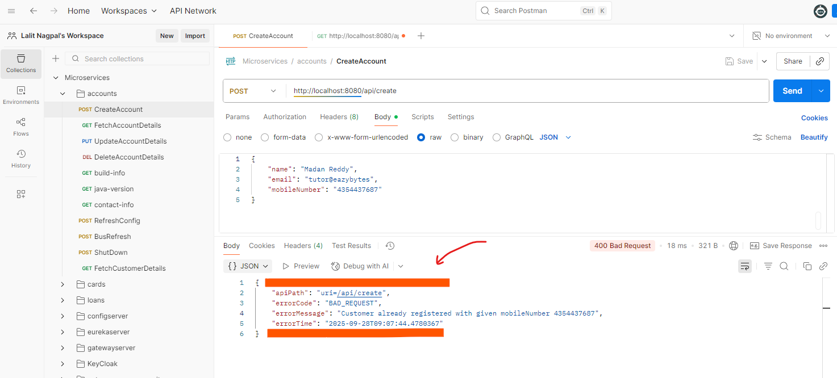

So my exception handling also working fine. Let's go to the H2 console and validate if the records are saved successfully or not. So here I need to invoke H2 console and connect to my H2 console. First I will try to invoke customer table here. You can see these are the details that we have inserted.

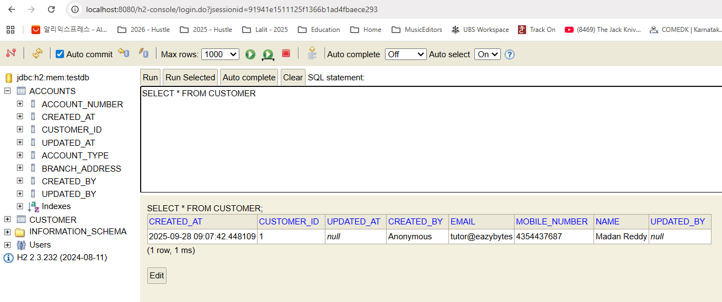

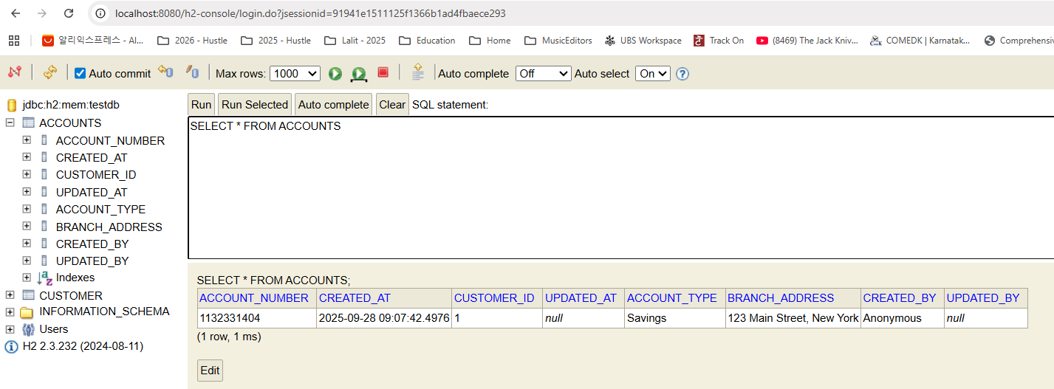

And very similarly I can check the accounts table and this is the account random account number that is created and the customer ID also link between accounts and customer table. This way we have successfully created create API inside accounts microservice. I hope you are super super clear. Please try to understand and digest all this information because I'm going to give an activity for you where you need to build all these logic for cards and loans microservice by yourself by referring to the code present inside the GitHub repo. So understanding this is very important. If you face any issues, don't worry, I'm going to explain cards and loans microservice very quickly as well. So with this we have developed only create operation inside our AccountsMicroservices . We should also develop, read, update and delete APIs.

#### Project Structure and all implemented classes so far

|  |  |
| --- | --- |
|  |  |

##### AccountsApplication.java

@SpringBootApplication

public class AccountsApplication {

public static void main(String[] args) {

SpringApplication.run(AccountsApplication.class, args);

}

}

##### AccountsController.java

import com.eazybytes.accounts.constants.AccountsConstants;

import com.eazybytes.accounts.dto.CustomerDto;

import com.eazybytes.accounts.dto.ResponseDto;

import com.eazybytes.accounts.service.IAccountsService;

import lombok.AllArgsConstructor;

import org.springframework.http.HttpStatus;

import org.springframework.http.MediaType;

import org.springframework.http.ResponseEntity;

import org.springframework.web.bind.annotation.PostMapping;

import org.springframework.web.bind.annotation.RequestBody;

import org.springframework.web.bind.annotation.RequestMapping;

import org.springframework.web.bind.annotation.RestController;

@RestController

@RequestMapping(path="/api", produces = {MediaType.APPLICATION_JSON_VALUE})

@AllArgsConstructor

public class AccountsController {

private IAccountsService iAccountsService;

@PostMapping("/create")

public ResponseEntity<ResponseDto> createAccount(@RequestBody CustomerDto

customerDto) {

iAccountsService.createAccount(customerDto);

return ResponseEntity

.status(HttpStatus.CREATED)

.body(new ResponseDto(AccountsConstants.STATUS_201,

AccountsConstants.MESSAGE_201));

}

}

**AccountConstants.java**

public class AccountsConstants {

private AccountsConstants() {

// restrict instantiation

}

public static final String SAVINGS = "Savings";

public static final String ADDRESS = "123 Main Street, New York";

public static final String STATUS_201 = "201";

public static final String MESSAGE_201 = "Account created successfully";

public static final String STATUS_200 = "200";

public static final String MESSAGE_200 = "Request processed successfully";

public static final String STATUS_417 = "417";

public static final String MESSAGE_417_UPDATE =

"Update operation failed. Please try again or contact Dev team";

public static final String MESSAGE_417_DELETE =

"Delete operation failed. Please try again or contact Dev team";

}

##### Entities, DTOs and Mappers

**Entities**

BaseEntity.java

import jakarta.persistence.Column;

import jakarta.persistence.MappedSuperclass;

import lombok.Getter;

import lombok.Setter;

import lombok.ToString;

import java.time.LocalDateTime;

@MappedSuperclass

@Getter @Setter @ToString

public class BaseEntity {

@Column(updatable = false)

private LocalDateTime createdAt;

@Column(updatable = false)

private String createdBy;

@Column(insertable = false)

private LocalDateTime updatedAt;

@Column(insertable = false)

private String updatedBy;

}

Account.java

import jakarta.persistence.*;

import lombok.*;

@Entity

@Getter @Setter @ToString @AllArgsConstructor @NoArgsConstructor

public class Accounts extends BaseEntity {

@Column(name="customer_id")

private Long customerId;

@Column(name="account_number")

@Id

private Long accountNumber;

@Column(name="account_type")

private String accountType;

@Column(name="branch_address")

private String branchAddress;

}

Customer.java

import jakarta.persistence.*;

import lombok.*;

import org.hibernate.annotations.GenericGenerator;

@Entity

@Getter @Setter @ToString @AllArgsConstructor @NoArgsConstructor

public class Customer extends BaseEntity {

@Id

@GeneratedValue(strategy= GenerationType.AUTO, generator = "native")

@Generated

@GenericGenerator(name="native", strategy="native")

private Long customerId;

private String name;

private String email;

private String mobileNumber;

}

**DTOs**

|  |  |
| --- | --- |
| **AccountsDto.java**  import lombok.Data;  @Data  public class AccountsDto {  private Long accountNumber;  private String accountType;  private String branchAddress;  } | **CustomerDto.java**  import lombok.Data;  @Data  public class CustomerDto {  private String name;  private String email;  private String mobileNumber;  } |
| **ErrorResponseDto.java**  import lombok.AllArgsConstructor;  import lombok.Data;  import org.springframework.http.HttpStatus;  import java.time.LocalDateTime;  @Data @AllArgsConstructor  public class ErrorResponseDto {  private String apiPath;  private HttpStatus errorCode;  private String errorMessage;  private LocalDateTime errorTime;  } | **ResponseDto.java**  import lombok.AllArgsConstructor;  import lombok.Data;  @Data @AllArgsConstructor  public class ResponseDto {  private String statusCode;  private String statusMsg;  } |

**Mappers**

AccountsMapper.java

import com.eazybytes.accounts.dto.AccountsDto;

import com.eazybytes.accounts.entity.Accounts;

public class AccountsMapper {

public static AccountsDto mapToAccountsDto(Accounts accounts, AccountsDto accountsDto) {

accountsDto.setAccountNumber(accounts.getAccountNumber());

accountsDto.setAccountType(accounts.getAccountType());

accountsDto.setBranchAddress(accounts.getBranchAddress());

return accountsDto;

}

public static Accounts mapToAccounts(AccountsDto accountsDto, Accounts accounts) {

accounts.setAccountNumber(accountsDto.getAccountNumber());

accounts.setAccountType(accountsDto.getAccountType());

accounts.setBranchAddress(accountsDto.getBranchAddress());

return accounts;

}

}

CustomerMapper.java

import com.eazybytes.accounts.dto.CustomerDto;

import com.eazybytes.accounts.entity.Customer;

public class CustomerMapper {

public static CustomerDto mapToCustomerDto(Customer customer, CustomerDto customerDto) {

customerDto.setName(customer.getName());

customerDto.setEmail(customer.getEmail());

customerDto.setMobileNumber(customer.getMobileNumber());

return customerDto;

}

public static Customer mapToCustomer(CustomerDto customerDto, Customer customer) {

customer.setName(customerDto.getName());

customer.setEmail(customerDto.getEmail());

customer.setMobileNumber(customerDto.getMobileNumber());

return customer;

}

}

##### Exception Handling

ErrorResponseDto.java

import lombok.AllArgsConstructor;

import lombok.Data;

import org.springframework.http.HttpStatus;

import java.time.LocalDateTime;

@Data @AllArgsConstructor

public class ErrorResponseDto {

private String apiPath;

private HttpStatus errorCode;

private String errorMessage;

private LocalDateTime errorTime;

}

CustomerAlreadyExistsException.java

import org.springframework.http.HttpStatus;

import org.springframework.web.bind.annotation.ResponseStatus;

@ResponseStatus(value = HttpStatus.BAD_REQUEST)

public class CustomerAlreadyExistsException extends RuntimeException {

public CustomerAlreadyExistsException(String message) {

super(message);

}

}

GlobalExceptionHandler.java

import com.eazybytes.accounts.dto.ErrorResponseDto;

import org.springframework.http.HttpStatus;

import org.springframework.http.ResponseEntity;

import org.springframework.web.bind.annotation.ControllerAdvice;

import org.springframework.web.bind.annotation.ExceptionHandler;

import org.springframework.web.context.request.WebRequest;

import org.springframework.web.servlet.mvc.method.annotation.ResponseEntityExceptionHandler;

import java.time.LocalDateTime;

@ControllerAdvice

public class GlobalExceptionHandler extends ResponseEntityExceptionHandler {

@ExceptionHandler(CustomerAlreadyExistsException.class)

public ResponseEntity<ErrorResponseDto> handleCustomerAlreadyExistsException(CustomerAlreadyExistsException exception,

WebRequest webRequest){

ErrorResponseDto errorResponseDTO = new ErrorResponseDto(

webRequest.getDescription(false),

HttpStatus.BAD_REQUEST,

exception.getMessage(),

LocalDateTime.now()

);

return new ResponseEntity<>(errorResponseDTO, HttpStatus.BAD_REQUEST);

}

}

##### Service & ServiceImpl

Service

import com.eazybytes.accounts.dto.CustomerDto;

public interface IAccountsService {

void createAccount(CustomerDto customerDto);

}

ServiceImpl

import com.eazybytes.accounts.constants.AccountsConstants;

import com.eazybytes.accounts.dto.CustomerDto;

import com.eazybytes.accounts.entity.Accounts;

import com.eazybytes.accounts.entity.Customer;

import com.eazybytes.accounts.exception.CustomerAlreadyExistsException;

import com.eazybytes.accounts.mapper.CustomerMapper;

import com.eazybytes.accounts.repository.AccountsRepository;

import com.eazybytes.accounts.repository.CustomerRepository;

import com.eazybytes.accounts.service.IAccountsService;

import lombok.AllArgsConstructor;

import org.springframework.stereotype.Service;

import java.time.LocalDateTime;

import java.util.Optional;

import java.util.Random;

@Service

@AllArgsConstructor

public class AccountsServiceImpl implements IAccountsService {

private AccountsRepository accountsRepository;

private CustomerRepository customerRepository;

@Override

public void createAccount(CustomerDto customerDto) {

Customer customer = CustomerMapper.mapToCustomer(customerDto, new Customer());

Optional<Customer> optionalCustomer =

customerRepository.findByMobileNumber(customerDto.getMobileNumber());

if(optionalCustomer.isPresent()) {

throw new CustomerAlreadyExistsException( "Customer already registered

with given mobileNumber " +customerDto.getMobileNumber());

}

customer.setCreatedAt(LocalDateTime.now());

customer.setCreatedBy("Anonymous");

Customer savedCustomer = customerRepository.save(customer);

accountsRepository.save(createNewAccount(savedCustomer));

}

private Accounts createNewAccount(Customer customer) {

Accounts newAccount = new Accounts();

newAccount.setCustomerId(customer.getCustomerId());

long randomAccNumber = 1000000000L + new Random().nextInt(900000000);

newAccount.setAccountNumber(randomAccNumber);

newAccount.setCreatedAt(LocalDateTime.now());

newAccount.setCreatedBy("Anonymous");

newAccount.setAccountType(AccountsConstants.SAVINGS);

newAccount.setBranchAddress(AccountsConstants.ADDRESS);

return newAccount;

}

}

### Read API [ Accounts Microservice ]

Let's try to create a REST API that will help to fetch the account and customer details present inside the database by accepting the mobile number as an input. Any end user or client application, they'll pass the mobile number to our REST API and based upon the data present inside the database, it is going to send all the customer and bank account details. For the same First, we need to create a new method inside the AccountsController. So the method access type is going to be public and we are going to send the customer DTO as a response. So let me mention customer DTO inside the response entity and the method name is going to be fetchAccountDetails(). And to this method we need to pass the annotation which is @RequestParam because since we are trying to accept only one request value which is mobile number with the help of query params, we need to make sure we are mentioning @RequestParam here and post that space followed by string, followed by mobile number which is the field name. Now inside this method I can write all the business logic, but before that I need to make sure I'm mentioning the GetMapping annotation on top of this method because this method is going to help you to fetch the resource details from the database. That's why we need to use the get mapping whenever we are trying to read the data and the API path that this method is going to support is /fetch. So whenever someone is trying to invoke the path, which is API /fetch, this method will be invoked.

@RestController

@RequestMapping(path="/api", produces = {MediaType.APPLICATION_JSON_VALUE})

@AllArgsConstructor

public class AccountsController {

private IAccountsService iAccountsService;

@PostMapping("/create")

public ResponseEntity<ResponseDto> createAccount(@RequestBody CustomerDto customerDto) {

iAccountsService.createAccount(customerDto);

return ResponseEntity

.status(HttpStatus.CREATED)

.body(new ResponseDto(AccountsConstants.STATUS_201,

AccountsConstants.MESSAGE_201));

}

@GetMapping("/fetch")

public ResponseEntity<CustomerDto> fetchAccountDetails(

@RequestParam @Pattern(regexp="(^$|[0-9]{10})",

message = "Mobile number must be 10 digits") String mobileNumber) {

CustomerDto customerDto = iAccountsService.fetchAccount(mobileNumber);

return ResponseEntity.status(HttpStatus.OK).body(customerDto);

}

}

Now as a next step, we need to go to the IAccountService and here we need to create one new abstract method with the name fetchAccount() that is going to accept the mobile number as the input parameter and going to return customer DTO as an output object. So once we define this abstract method, the very next step, obviously we need to go to the AccountServiceImpl and we need to make sure we are implementing the method. There will be an error like you can see here. Let's hover on that and click on this implement methods and click okay.

import com.eazybytes.accounts.dto.CustomerDto;

public interface IAccountsService {

/**

*

* @param customerDto - CustomerDto Object

*/

void createAccount(CustomerDto customerDto);

/**

*

* @param mobileNumber - Input Mobile Number

* @return Accounts Details based on a given mobileNumber

*/

CustomerDto fetchAccount(String mobileNumber);

}

import lombok.AllArgsConstructor;

import org.springframework.stereotype.Service;

import java.time.LocalDateTime;

import java.util.Optional;

import java.util.Random;

@Service

@AllArgsConstructor

public class AccountsServiceImpl implements IAccountsService {

private AccountsRepository accountsRepository;

private CustomerRepository customerRepository;

/**

* @param customerDto - CustomerDto Object

*/

@Override

public void createAccount(CustomerDto customerDto) {

Customer customer = CustomerMapper.mapToCustomer(customerDto, new Customer());

Optional<Customer> optionalCustomer =

customerRepository.findByMobileNumber(customerDto.getMobileNumber());

if(optionalCustomer.isPresent()) {

throw new CustomerAlreadyExistsException("Customer already registered

with given mobileNumber " + customerDto.getMobileNumber());

}

customer.setCreatedAt(LocalDateTime.now());

customer.setCreatedBy("Anonymous");

Customer savedCustomer = customerRepository.save(customer);

accountsRepository.save(createNewAccount(savedCustomer));

}

/**

* @param customer - Customer Object

* @return the new account details

*/

private Accounts createNewAccount(Customer customer) {

Accounts newAccount = new Accounts();

newAccount.setCustomerId(customer.getCustomerId());

long randomAccNumber = 1000000000L + new Random().nextInt(900000000);

newAccount.setAccountNumber(randomAccNumber);

newAccount.setCreatedAt(LocalDateTime.now());

newAccount.setCreatedBy("Anonymous");

newAccount.setAccountType(AccountsConstants.SAVINGS);

newAccount.setBranchAddress(AccountsConstants.ADDRESS);

return newAccount;

}

/**

* @param mobileNumber - Input Mobile Number

* @return Accounts Details based on a given mobileNumber

*/

@Override

public CustomerDto fetchAccount(String mobileNumber) {

Customer customer =

customerRepository.findByMobileNumber(mobileNumber)

.orElseThrow( () -> new ResourceNotFoundException("Customer",

"mobileNumber", mobileNumber)

);

Accounts accounts =

accountsRepository.findByCustomerId( customer.getCustomerId()).orElseThrow(

() -> new ResourceNotFoundException("Account", "customerId",

customer.getCustomerId().toString())

);

CustomerDto customerDto = CustomerMapper.mapToCustomerDto(customer, new CustomerDto());

customerDto.setAccountsDto(AccountsMapper.mapToAccountsDto(accounts, new AccountsDto()));

return customerDto;

}

}

The empty fetchAccount method created. Let me take this method and paste this after this Create new account method. That's where we have a proper sequence. So now inside this fetchAccount() method, we need to write a logic to fetch the account details and customer details from the database. But when we try to fetch the details from the database based upon a mobile number, there is a good chance there might be no customer, no account details for a given mobile number. In such scenarios, we should be able to throw an custom business exception For the same, we need to go to the exception package and here, just like customer already exception, I'm going to create a new exception with the name ResourceNotFound exception. So let me create this class and here instead of bad request, I'm going to mention the HttpStatus as not found because we are trying to throw an business error saying that so and so resource is not found, for the given input. And to this constructor this time I'm not going to pass a one parameter. I'm going to pass multiple parameters to throw a detail exception to my end user or to the client application.

The three fields are going to be what is the resource name like, whether it is accounts or customer and what is the field name and what is the field value? The field name, Obviously we are trying to fetch based upon the mobile number, so it will throw a detail message to the end user or client application that you are trying to fetch account details based upon your mobile number with so and so value, And we are not able to find that. That's how we are going to throw an message to the client application. Now we have a problem here. The problem is this runtime exception constructor.

import org.springframework.http.HttpStatus;

import org.springframework.web.bind.annotation.ResponseStatus;

@ResponseStatus(value = HttpStatus.NOT_FOUND)

public class ResourceNotFoundException extends RuntimeException {

public ResourceNotFoundException(String resourceName, String fieldName, String fieldValue) {

super( String.format("%s not found with the given input data %s : '%s'",

resourceName, fieldName, fieldValue));

}

}

It is going to accept only a single string as an input parameter. So what we have to do is we need to prepare a single string value based upon these three input fields from the ResourceNotFound exception constructor. For the same, I'm going to use a string.format() method using this string.format() method. I'm passing these three strings. These three strings will be replaced wherever I have mentioned these %s. So, so and so resource not found with the given input data field name. And what is the field value? So with this we should be good with these exception.

super( String.format("%s not found with the given input data %s : '%s'",

resourceName, fieldName, fieldValue));

As a next step, we need to go to the global exception handler and we need to make sure we are writing a method very similar to these handle customer already exist. Exception So let me copy this method and paste it. So now we have two methods with the same name. Let's try to fix this compilation error. So the very first method I'm trying to change to a new method name which is handle resource, ResourseNotFound exception. And this method is going to handle the exception which is ResourceNotFound exception. So here the logic is going to be the same, but instead of, bad requests we need to send Not_Found the same I want to send as part of the response entity status as well.

import com.eazybytes.accounts.dto.ErrorResponseDto;

import org.springframework.http.HttpStatus;

import org.springframework.http.ResponseEntity;

import org.springframework.web.bind.annotation.ControllerAdvice;

import org.springframework.web.bind.annotation.ExceptionHandler;

import org.springframework.web.context.request.WebRequest;

import org.springframework.web.servlet.mvc.method.annotation.ResponseEntityExceptionHandler;

import java.time.LocalDateTime;

@ControllerAdvice

public class GlobalExceptionHandler extends ResponseEntityExceptionHandler {

@ExceptionHandler(CustomerAlreadyExistsException.class)

public ResponseEntity<ErrorResponseDto> handleCustomerAlreadyExistsException(

CustomerAlreadyExistsException exception, WebRequest webRequest){

ErrorResponseDto errorResponseDTO = new ErrorResponseDto(

webRequest.getDescription(false),

HttpStatus.BAD_REQUEST,

exception.getMessage(),

LocalDateTime.now()

);

return new ResponseEntity<>(errorResponseDTO, HttpStatus.BAD_REQUEST);

}

@ExceptionHandler(ResourceNotFoundException.class)

public ResponseEntity<ErrorResponseDto> handleResourceNotFoundException(

ResourceNotFoundException exception, WebRequest webRequest) {

ErrorResponseDto errorResponseDTO = new ErrorResponseDto(

webRequest.getDescription(false),

HttpStatus.NOT_FOUND,

exception.getMessage(),

LocalDateTime.now()

);

return new ResponseEntity<>(errorResponseDTO, HttpStatus.NOT_FOUND);

}

}

So with this we are good from an exception handling perspective. Now let's go to the AccountServiceImpl. So here we need to write the logic to fetch the account details and customer details based upon the mobile number. So I'm going to write a code here first, with the help of customerRepository, I'm trying to invoke a method findByMobileNumber(). And to this method I'm going to pass the received mobile number. And if there is no record with the given mobile number, I'm going to invoke orElseThrow() method because this find by mobile number is going to return a optional of customer inside optional. We have a method called orElseThrow() using which we can throw an exception if there is no record present inside the optional. So here I'm going to write a lambda expression which is not going to accept any input parameter, but I'm simply going to throw an error which is new ResourceNotFound exception.

/**

* @param mobileNumber - Input Mobile Number

* @return Accounts Details based on a given mobileNumber

*/

@Override

public CustomerDto fetchAccount(String mobileNumber) {

Customer customer =

customerRepository.findByMobileNumber(mobileNumber)

.orElseThrow( () -> new ResourceNotFoundException("Customer",

"mobileNumber", mobileNumber)

);

Accounts accounts =

accountsRepository.findByCustomerId( customer.getCustomerId()).orElseThrow(

() -> new ResourceNotFoundException("Account", "customerId",

customer.getCustomerId().toString())

);

CustomerDto customerDto = CustomerMapper.mapToCustomerDto(customer, new CustomerDto());

customerDto.setAccountsDto(AccountsMapper.mapToAccountsDto(accounts, new AccountsDto()));

return customerDto;

}

And to this constructor I'm going to pass three parameters. The very first one is what is the resource that I'm not able to find? Customer is a resource because with a given mobile number we are not able to find the customer. And the second param value I'm going to mention as mobile number because using mobile number only, I'm not able to fetch the resource. And the third parameter obviously what is a mobile number value. So with this I should be able to throw an exception whenever there is no customer available with a given mobile number. But if there is a customer available, I need to make sure I'm catching that customer, into a variable called customer. So now I'm good with this. I'm able to fetch the customer details post that using the very similar logic, I need to make sure I'm fetching the account details as well. Because whenever someone is trying to invoke my rest API, they need all the details. Like what is the customer details? What is the account details that got created? So first, instead of customerRepository, I need to make sure I'm using accountRepository. Now inside my accounts table there is no mobile number using which I can query and at the same time I cannot invoke findByID() method because inside my accounts entity the primary key value is account number. But I received only mobile number from my client application. So what should I do here? I need to create a new method inside accountsRepository just like we created find by mobile number inside customerRepository. So let me go to the AccountsRepository here. I'm going to create a new method. The method is findByCustomerId(), So based upon the customer ID, it is going to fetch the account details. And here you may have a question like how do we know the customer ID? Because we didn't receive from the input request. That's where we will use the customer object that we fetched from the database based upon the mobile number to identify what is the customer ID for a given mobile number. So first I need to make sure I'm invoking findByCustomerId().

CustomerRepository.java

import com.eazybytes.accounts.entity.Customer;

import org.springframework.data.jpa.repository.JpaRepository;

import org.springframework.stereotype.Repository;

import java.util.Optional;

@Repository

public interface CustomerRepository extends JpaRepository<Customer, Long> {

Optional<Customer> findByMobileNumber(String mobileNumber);

}

AccountRepository.java

import com.eazybytes.accounts.entity.Accounts;

import jakarta.transaction.Transactional;

import org.springframework.data.jpa.repository.JpaRepository;

import org.springframework.data.jpa.repository.Modifying;

import org.springframework.stereotype.Repository;

import java.util.Optional;

@Repository

public interface AccountsRepository extends JpaRepository<Accounts, Long> {

Optional<Accounts> findByCustomerId(Long customerId);

@Transactional

@Modifying

void deleteByCustomerId(Long customerId);

}

Once I invoke this, findByCustomerId(), let me replace this customer to account so that I can resolve the compilation error that I have here. The variable name is going to be accounts. Now, instead of this mobile number, I'm going to pass customer.getCustomerId from this customer object. The same logic we are going to follow. If there is no account with the given customer ID, we are going to throw ResourceNotFound exception, but instead of customer here we need to mention account because we are not able to identify account resource for a given customer ID and the value is going to be customer.getCustomerId().toString(). Of course there won't be any scenario in our application if there is a customer exist, definitely there will be also an account resource will be available. But this just an in case someone messed up with the data. Then just a rare scenario that we are trying to handle here.

/**

* @param mobileNumber - Input Mobile Number

* @return Accounts Details based on a given mobileNumber

*/

@Override

public CustomerDto fetchAccount(String mobileNumber) {

Customer customer = customerRepository.findByMobileNumber(mobileNumber)

.orElseThrow(

() -> new ResourceNotFoundException("Customer",

"mobileNumber", mobileNumber)

);

Accounts accounts = accountsRepository.findByCustomerId( customer.getCustomerId() )

.orElseThrow(

() -> new ResourceNotFoundException("Account", "customerId",

customer.getCustomerId().toString())

);

}

Now we have customer entity and accounts entity. Can we send this directly to the client? Of course not, because these entities, they have a lot of sensitive information and metadata information like createdat created by at the same time customer ID, which is unnecessary for my client application. They only want useful information. That's why we need to convert these entities into the Dto classes. But as of now we have these CustomerDto and AccountsDto as two separate classes like accountsDto holds strictly the data related to accounts, and similarly, customer data holds the data related to customer only if you want to send the combined information or aggregated information of both CustomerDto and AccountsDto We have two options. Either we can create one more Dto class where we can try to refer both these Dto classes are inside these CustomerDto or we can create one more field, Of type AccountsDto and with the field name as AccountsDto. So this way also we can achieve the Dto pattern.

import lombok.Data;

@Data

public class CustomerDto {

private String name;

private String email;

private String mobileNumber;

private AccountsDto accountsDto;

}

So I'm going to follow this approach, but if you want, you can also create separate Dto class. But I would recommend that approach only if your Dto has lot number of fields and they are very big in nature. But for these smaller application this should be fine. I'll go to the AccountServiceImpl and here first, with the help of CustomerMapper, I'm going to invoke mapToCustomerDto() and to this method we need to pass what is the customer along with the new object of customerDto? The same I'm going to catch into a variable of type customerDto for this. I can go to the next line here. I'm going to invoke customerDto.setAccountsDto and to this setter method. I need to pass the Dto of my accounts entity. So let me invoke the AccountsMapper here and using this AccountsMapper, I'm going to invoke map two accounts and I'm going to pass accounts to new, AccountsDto.

@Override

public CustomerDto fetchAccount(String mobileNumber) {

Customer customer = customerRepository.findByMobileNumber(mobileNumber)

.orElseThrow(

() -> new ResourceNotFoundException("Customer",

"mobileNumber", mobileNumber)

);

Accounts accounts = accountsRepository.findByCustomerId( customer.getCustomerId() )

.orElseThrow(

() -> new ResourceNotFoundException("Account", "customerId",

customer.getCustomerId().toString())

);

CustomerDto customerDto = CustomerMapper.mapToCustomerDto(customer, new CustomerDto());

customerDto.setAccountsDto(AccountsMapper.mapToAccountsDto(accounts, new AccountsDto()));

return customerDto;

}

So with this we should be good and I'm going to return this customerDto from this method. So now let me go to the controller layer. Inside my controller layer. I'm going to write business logic here to invoke my IAccountService and the method fetchAccount(). And to this method I'm going to pass the mobile number. And from this method we are going to get the customerDto. So let me try to catch the same here on the left hand side with the help of this CustomerDto object. Once I have this CustomerDto object, I can try to write a return statement with the help of ResponseEntity.status and the status is going to be HttpStatus.OK. Okay means the operation is successful and I'm sending the data to you. So with the help of body() method, I'm invoking and passing the object of the CustomerDto.

@RestController

@RequestMapping(path="/api", produces = {MediaType.APPLICATION_JSON_VALUE})

@AllArgsConstructor

public class AccountsController {

private IAccountsService iAccountsService;

@PostMapping("/create")

public ResponseEntity<ResponseDto> createAccount(@RequestBody CustomerDto customerDto) {

iAccountsService.createAccount(customerDto);

return ResponseEntity

.status(HttpStatus.CREATED)

.body(new ResponseDto(AccountsConstants.STATUS_201,

AccountsConstants.MESSAGE_201));

}

@GetMapping("/fetch")

public ResponseEntity<CustomerDto> fetchAccountDetails(@RequestParam String mobileNumber) {

CustomerDto customerDto = iAccountsService.fetchAccount(mobileNumber);

return ResponseEntity.status(HttpStatus.OK).body(customerDto);

}

}

So with this, our method is ready right now. So let me save this changes and do a build. Once the build is completed, my server will be restarting. Like I said before, whenever my server is restarting, my data will be lost inside the h2database. We can also try to validate the same. So I'm trying to refresh the page here. So let me connect again. I'm trying to search for accounts so you can see the data. Everything is wiped off.

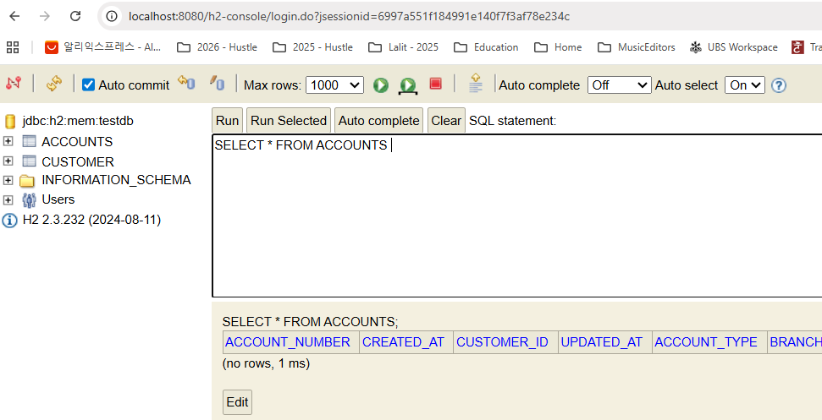

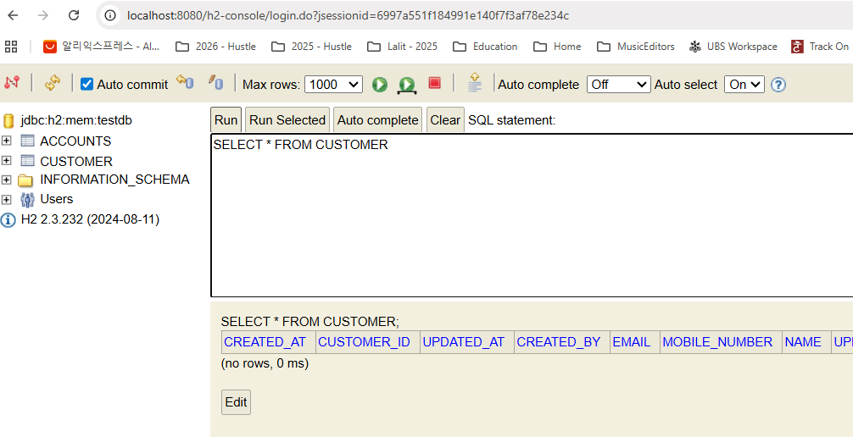

So what we can do is this is a temporary problem that we are going to face till we migrate to the MySQL database in the coming sections. As a workaround, I'm going to invoke this create API. Again, the account is created successfully. Now I'll take this mobile number. I'm going to open this fetch account details request and here I need to invoke localhost8080/api/fetch and mobile number is a query param that we need to pass. That's why there is a question mark. What is the query param name, mobile number. And to this query param I'm going to pass the value of my mobile number. Please make sure this name is matching with whatever you have mentioned here as a request param.

http://localhost:8080/api/fetch?**mobileNumber**=43544376872

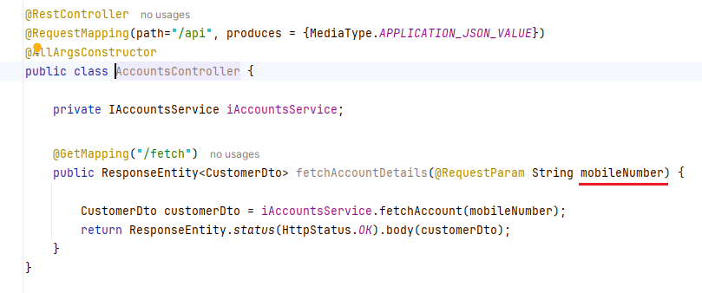

So now I'm going to click on this Send button and like you can see here, I got a response saying that that this is the name of the customer, this is the email, this is the mobile number. And inside this customer details there is an embedded object with the name account and it has details like account number, account type and branch address.

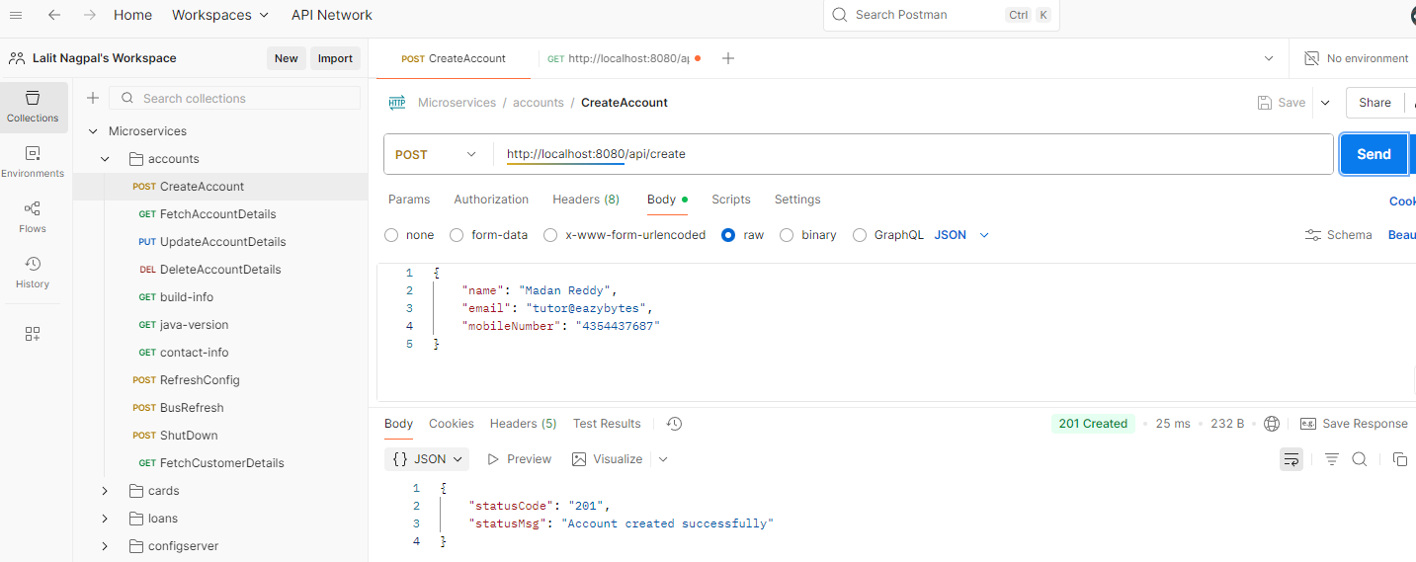

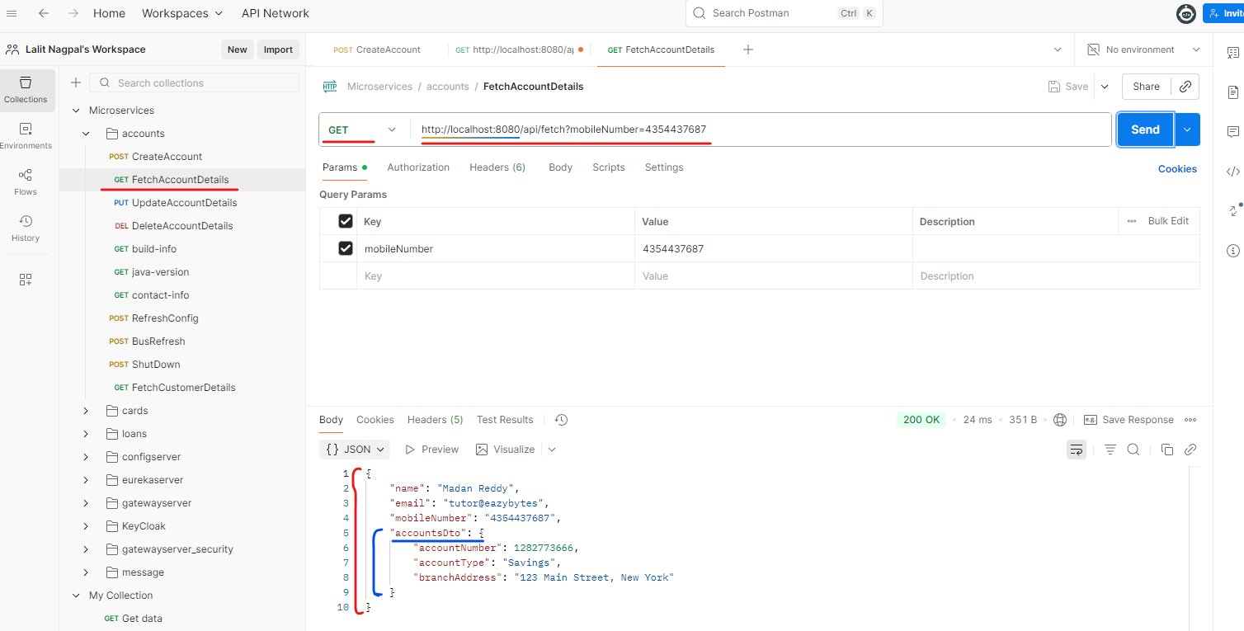

Now if I try to invoke the same API with a mobile number that does not exist inside my database, I should get an exception. I'm getting an exception, but it is not coming the way that I design.

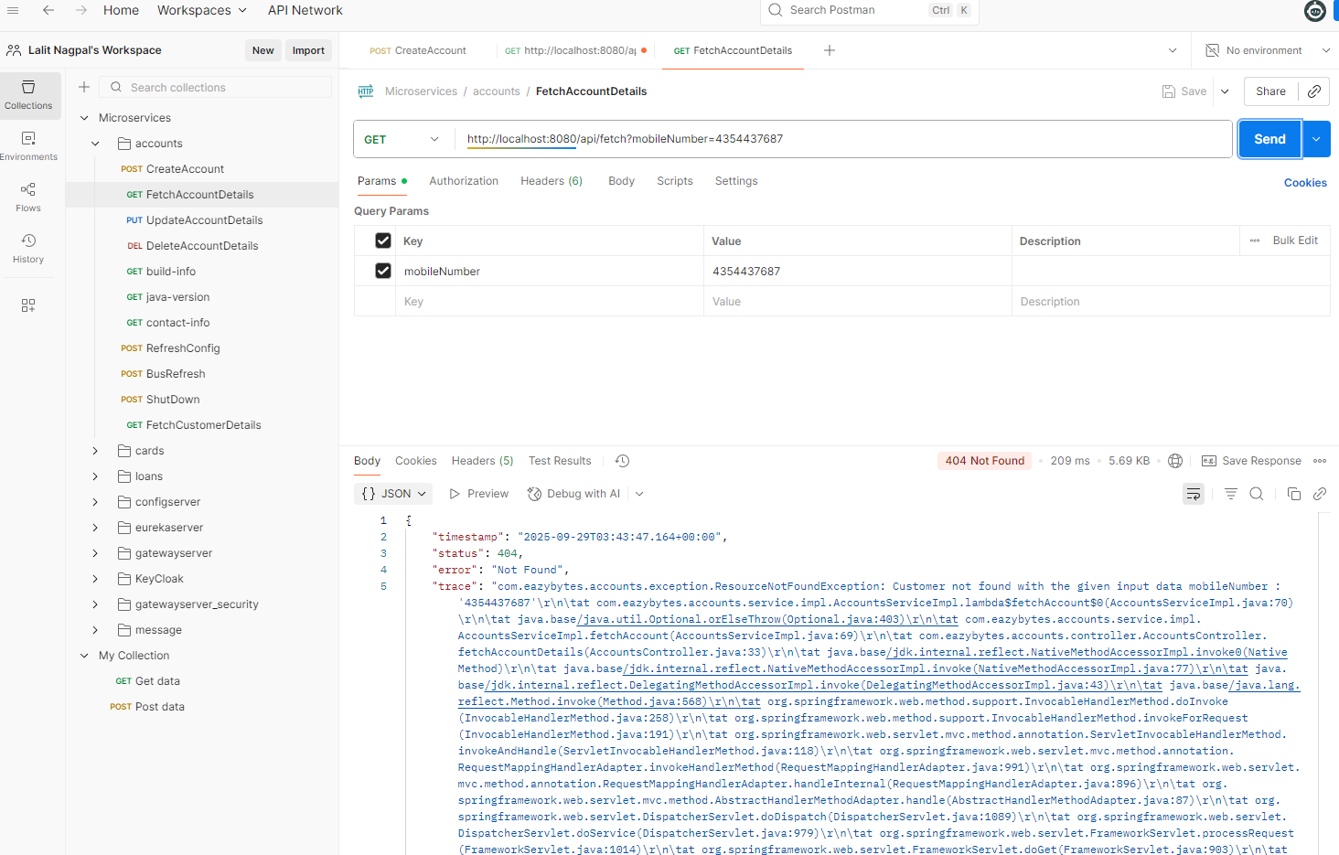

@ControllerAdvice

public class GlobalExceptionHandler extends ResponseEntityExceptionHandler {

@ExceptionHandler(CustomerAlreadyExistsException.class)

public ResponseEntity<ErrorResponseDto> handleCustomerAlreadyExistsException(

CustomerAlreadyExistsException exception, WebRequest webRequest){

ErrorResponseDto errorResponseDTO = new ErrorResponseDto(

webRequest.getDescription(false),

HttpStatus.BAD_REQUEST,

exception.getMessage(),

LocalDateTime.now()

);

return new ResponseEntity<>(errorResponseDTO, HttpStatus.BAD_REQUEST);

}

@ExceptionHandler(ResourceNotFoundException.class)

public ResponseEntity<ErrorResponseDto> handleResourceNotFoundException(

CustomerAlreadyExistsException exception, WebRequest webRequest) {

ErrorResponseDto errorResponseDTO = new ErrorResponseDto(

webRequest.getDescription(false),

HttpStatus.NOT_FOUND,

exception.getMessage(),

LocalDateTime.now()

);

return new ResponseEntity<>(errorResponseDTO, HttpStatus.NOT_FOUND);

}

}

So there is an issue in our code. Let me check the same,here we made a mistake. Like when we build this handle ResourceNotFound exception, we are accepting a customer already exist exception instead of **ResourceNotFoundException**. So let me correct this issue.

@ExceptionHandler(ResourceNotFoundException.class)

public ResponseEntity<ErrorResponseDto> handleResourceNotFoundException(

ResourceNotFoundException exception, WebRequest webRequest)

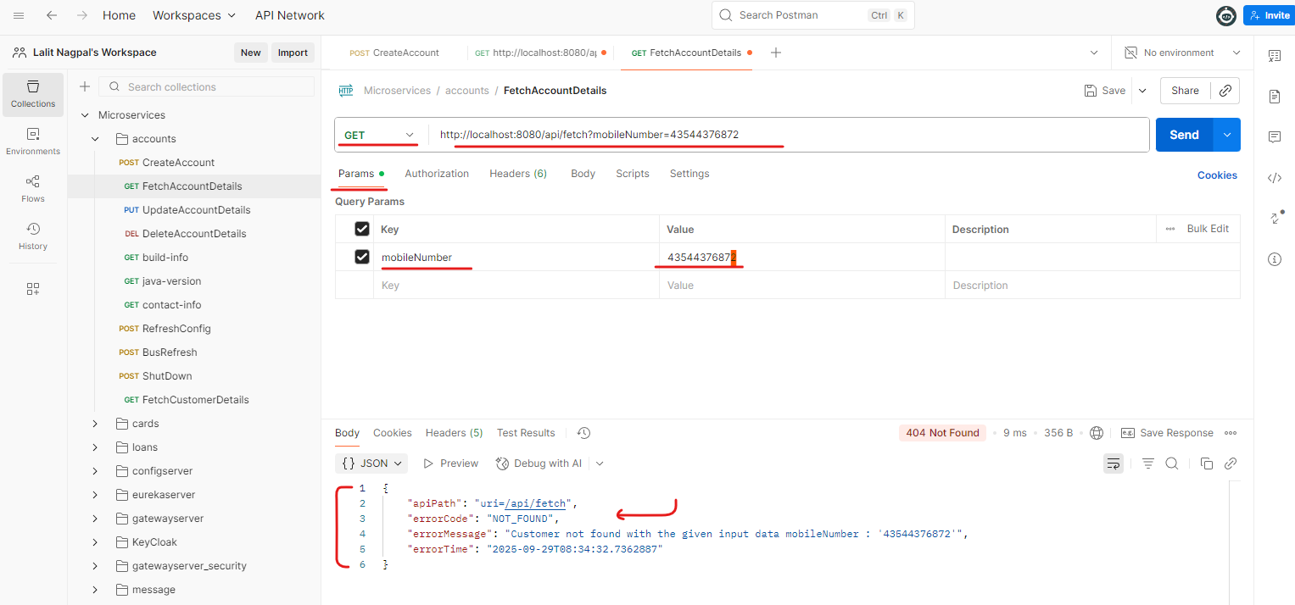

Please ignore my mistake here. Let me do a build. Sometimes these issues happen regardless how experienced you are. This kind of small mistakes will always happen. That's why debugging and unit testing is very important inside any project. So since I'm doing unit testing, I'm able to identify this issue. Now, my server might have restarted, but regardless, I can still test this API because we are trying to test the native scenario only here. So if I try to invoke here, you can see I'm getting a proper response saying that this is the error code, this is the error message saying that customer not found with the given input data mobile number. And this is a mobile number that I sent in the request with this. I'm assuming your super, super clear about the fetch operation that we have implemented inside AccountsService. So please validate your changes inside your local by comparing with the code that you have inside the GitHub repo.

#### Classes that we changed

##### Controller

@RestController

@RequestMapping(path="/api", produces = {MediaType.APPLICATION_JSON_VALUE})

@AllArgsConstructor

public class AccountsController {

private IAccountsService iAccountsService;

. . .

@GetMapping("/fetch")

public ResponseEntity<CustomerDto> fetchAccountDetails(@RequestParam String mobileNumber) {

CustomerDto customerDto = iAccountsService.fetchAccount(mobileNumber);

return ResponseEntity.status(HttpStatus.OK).body(customerDto);

}

}

##### DTO

@Data

public class CustomerDto {

private String name;

private String email;

private String mobileNumber;

private AccountsDto accountsDto;

}

##### Exception Class

import org.springframework.http.HttpStatus;

import org.springframework.web.bind.annotation.ResponseStatus;

@ResponseStatus(value = HttpStatus.NOT_FOUND)

public class ResourceNotFoundException extends RuntimeException {

public ResourceNotFoundException(String resourceName, String fieldName, String fieldValue) {

super(String.format("%s not found with the given input data %s : '%s'",

resourceName, fieldName, fieldValue));

}

}

##### Service Class

public interface IAccountsService {

. . .

CustomerDto fetchAccount(String mobileNumber);

}

##### Service Impl

@Service

@AllArgsConstructor

public class AccountsServiceImpl implements IAccountsService {

private AccountsRepository accountsRepository;

private CustomerRepository customerRepository;

. . .

@Override

public CustomerDto fetchAccount(String mobileNumber) {

Customer customer = customerRepository.findByMobileNumber(mobileNumber)

.orElseThrow( () -> new ResourceNotFoundException("Customer",

"mobileNumber", mobileNumber) );

Accounts accounts = accountsRepository.findByCustomerId(customer.getCustomerId())

.orElseThrow( () -> new ResourceNotFoundException("Account",

"customerId", customer.getCustomerId().toString())

);

CustomerDto customerDto = CustomerMapper.mapToCustomerDto(customer, new CustomerDto());

customerDto.setAccountsDto(AccountsMapper.mapToAccountsDto(accounts, new AccountsDto()));

return customerDto;

}

}

##### Repository Interface

@Repository

public interface CustomerRepository extends JpaRepository<Customer, Long> {

Optional<Customer> findByMobileNumber(String mobileNumber);

}

### Update API [ Accounts Microservice ]

As of now inside our Accounts Microservice we have REST API supporting create account and fetch account. Now as a next step we can build one more REST API that will allow my client application to update the account details inside my database so my clients application, they can send this entire data as an request to the update API. So whenever they're trying to invoke this, get API based upon mobileNumber, they will get all these customer and account details. They can pass the same data to the update API patch while passing these data. They can change any of these data except accountNumber, because based upon my business logic, once the account number is generated, I don't want to give a flexibility to my end user to update the account number. You can update the name, email, mobileNumber, he can update his accountType, he can update branchAddress, anything he can update, but not the account number. So I hope you are clear with the requirements.

Now let's go to the code. Here inside the IAccountService interface. First, I need to create an abstract method that supports updateAccount functionality. So I'm creating a new abstract method here. So I have pasted here just to save some time. The method name is going to be update account and it is going to return a boolean value indicating whether the update operation is successful or not. And this is going to accept the CustomerDto as an input, which we are going to receive from the client application. Now inside this AccountService, we need to override this method. So let me put the cursor towards the end post that I can go to the top and run this compilation error and click on this implement methods. So this will generate a new empty method at the place where I have put cursor. So now inside this method I'm going to copy some lines of code post that we can discuss.

So first I'm having a boolean value which is declared as false post that I'm trying to first get the AccountsDto from the CustomerDto which I have received from these accounts. I'm checking if it is not null then using the AccountsDto I'm trying to fetch the account number that I received from the client application. First using the account number, I'm trying to fetch the accounts record because like we discussed, we are not allowing the end user to change the account number. That's why I'm trying to consider account number as the search criteria here. And since the account number is the primary key inside my Accounts entity, I can use findById() method available inside the spring data JPA framework. So whenever we are using findById, my spring data JPA framework will go for the Accounts entity and it will look what is the primary key column. This is the primary key column because we have mentioned @Id,

So with this logic it is going to fetch the account details based upon the account number. If there is no record, we are throwing this ResourceNotFoundException with the details that you can see on the screen. Once we have these Accounts entity class fetched from the database based upon the account number, we are populating all the data from the dto two Accounts entity object. Using this mapper(). So all the data that we receive from the end user will be inside the accounts. The same will be transferred into the accounts. Here you may have a question like if my end user or my client application send a account number inside, the same will be copied over to the Accounts entity. That's fine because this logic will get executed only if there is an record inside the database with a given account number. So if we try to give a different account number, he will never be able to fetch a record from the database. So that's why it's fine. But if you want, you can put a logic inside this mapped.accounts to not set this account number based upon some boolean value or based upon some condition. But for now I just wanted to keep it simple.

**ServiceImpl**

@Service

@AllArgsConstructor

public class AccountsServiceImpl implements IAccountsService {

private AccountsRepository accountsRepository;

private CustomerRepository customerRepository;

. . .

/**

* @param customerDto - CustomerDto Object

* @return boolean indicating if the update of Account details is successful or not

*/

@Override

public boolean updateAccount(CustomerDto customerDto) {

boolean isUpdated = false;

AccountsDto accountsDto = customerDto.getAccountsDto();

if(accountsDto !=null ){

Accounts accounts = accountsRepository.findById(accountsDto.getAccountNumber())

.orElseThrow( () -> new ResourceNotFoundException(

"Account", "AccountNumber", accountsDto.getAccountNumber().toString()) );

AccountsMapper.mapToAccounts(accountsDto, accounts);

accounts = accountsRepository.save(accounts);

Long customerId = accounts.getCustomerId();

Customer customer = customerRepository.findById(customerId)

.orElseThrow( () -> new ResourceNotFoundException(

"Customer", "CustomerID", customerId.toString())

);

CustomerMapper.mapToCustomer(customerDto,customer);

customerRepository.save(customer);

isUpdated = true;

}

return isUpdated;

}

}

**Service**

public interface IAccountsService {

void createAccount(CustomerDto customerDto);

CustomerDto fetchAccount(String mobileNumber);

/**

*

* @param customerDto - CustomerDto Object

* @return boolean indicating if the update of Account details is successful or not

*/

boolean updateAccount(CustomerDto customerDto);

}

Remember CustomerRepository.java just has a findByMobileNumber method, nothing else, rest is all inherited and doing the job

CustomerRepository.java

import com.eazybytes.accounts.entity.Customer;

import org.springframework.data.jpa.repository.JpaRepository;

import org.springframework.stereotype.Repository;

import java.util.Optional;

@Repository

public interface CustomerRepository extends JpaRepository<Customer, Long> {

Optional<Customer> findByMobileNumber(String mobileNumber);

}

Once we have these data populated from these dto to accounts object, I'm simply passing to the save() method inside the AccountsRepository. And with this line we are saving the updated data into the database and the same is going to be returned again into these Accounts object. Post that with this Accounts object. I'm going to get the customerId using the customerId, I'm invoking the findById() and passing the same customerId to the CustomerRepository. Since the customerId is the primary key inside my customer table, findById() method should work. If there is no record, we are going to throw ResourceNotFoundException, but if there is a record first, we are trying to get the record from the database which is present based upon the customerId post that we are invoking this mapper()method and this method will transfer all the updated data from dto to Customer, and at last we are invoking the save(). So save() is a very smart method inside the spring data JPA. If we don't find any primary key values inside the given entity object, it is going to simply do the insert operation. Otherwise it is going to perform the update operation based upon the primary key value that we shared inside these entity Pojo class. Once all this operation is completed, we are setting, is updated, is equal to true and we are returning the same to the controller layer. I hope this is clear. Please take a pause and try to understand and digest this information.

Now as a next step, let's go to the controller layer, which is AccountsController. Here also, I'm going to create a new method that supports the update operation. So let me paste the code related to the new method. The reason I'm trying to paste all this code is we already know all this logic. You can get this code from the GitHub repo. I want to save some time because we have a lot of interesting stuff to discuss about the actual microservices architecture and challenges. So let's try to wrap all these changes related to microservices and rest APIs quickly. So here you can see this is a method with the name update account details that supports the operation /update. And this is going to return the ResponseDto inside Response entity. And to this method we are going to accept CustomerDto with the help of this RequestBody annotation and here we are invoking IAccountService.update account with the CustomerDto input object. And if the boolean is true, that means the update operation is successful. We are sending a response saying that okay, 200 and message as 200 which indicates request to process two successfully, whereas if the boolean is false for some reason we are sending the status as internal server error with the status 500 and the message saying that an error occurred, please try again or contact dev team. So with these changes we should be good. Let me save this changes.

**AccountsController.java**

@PutMapping("/update")

public ResponseEntity<ResponseDto> updateAccountDetails(CustomerDto customerDto) {

boolean isUpdated = iAccountsService.updateAccount(customerDto);

if(isUpdated) {

return ResponseEntity

.status(HttpStatus.OK)

.body(new ResponseDto(AccountsConstants.STATUS_200,

AccountsConstants.MESSAGE_200));

} else {

return ResponseEntity

.status( HttpStatus.EXPECTATION_FAILED )

.body( new ResponseDto(AccountsConstants.STATUS_417,

AccountsConstants.MESSAGE_417_UPDATE));

}

}

**DTOs**

|  |  |
| --- | --- |
| **CustomerDto.java**  import lombok.Data;  @Data  public class CustomerDto {  private String name;  private String email;  private String mobileNumber;  private AccountsDto accountsDto;  } | **AccountsDto.java**  import lombok.Data;  @Data  public class AccountsDto {  private Long accountNumber;  private String accountType;  private String branchAddress;  } |

**AccountsConstants.java**

public final class AccountsConstants {

private AccountsConstants() {

// restrict instantiation

}

public static final String SAVINGS = "Savings";

public static final String ADDRESS = "123 Main Street, New York";

public static final String STATUS_201 = "201";

public static final String MESSAGE_201 = "Account created successfully";

public static final String STATUS_200 = "200";

public static final String MESSAGE_200 = "Request processed successfully";

public static final String STATUS_417 = "417";

public static final String MESSAGE_417_UPDATE= "Update operation failed.

Please try again or contact Dev team";

public static final String MESSAGE_417_DELETE= "Delete operation failed.

Please try again or contact Dev team";

// public static final String STATUS_500 = "500";

// public static final String MESSAGE_500 = "An error occurred.

Please try again or contact Dev team";

}

Do a build with the build my dev tools will restart my application. That means I will lose all the data present inside my database. So let's try to recreate the data quickly here. I'm trying to create the account. I'm taking the same mobile number and trying to fetch the details with the get operation.

Now I'll take this response and I'll go to these update account details. And here you can see we are trying to invoke /api/update with the put operation and I'm going to paste the same content that we received previously, but here I'm going to change few details. Like instead of Madan Reddy, I'll say Madan Mohan post that instead of tutor I can say madan@eazybytes and mobile number Also I'm going to change to 88 and account type I'll change to current and address. Also I'll change to 1 to 4. Off course we can't change the account number, so let me click on the send button so you can see I'm getting a response saying that 200 request passes successfully. Now if I go to the get API and try to fetch the records based upon the latest mobile number, which is this is the one I'm trying to send. So if I try to send, you can see I'm getting the updated name, updated email, updated mobile number, account type and branch address. So this confirms it is working perfectly.

First lets create the account

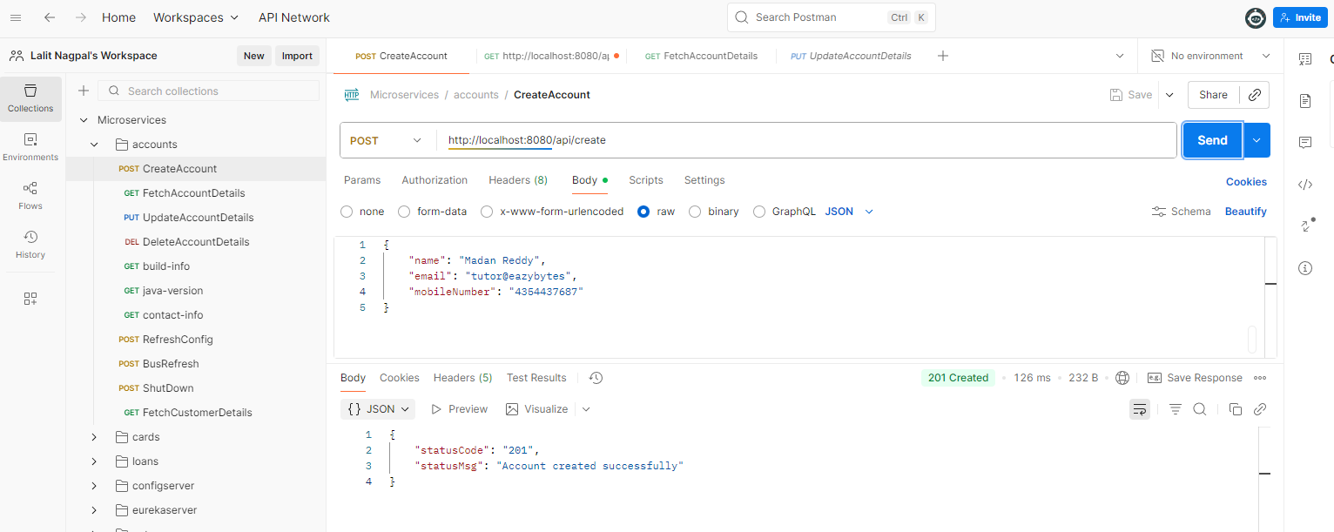

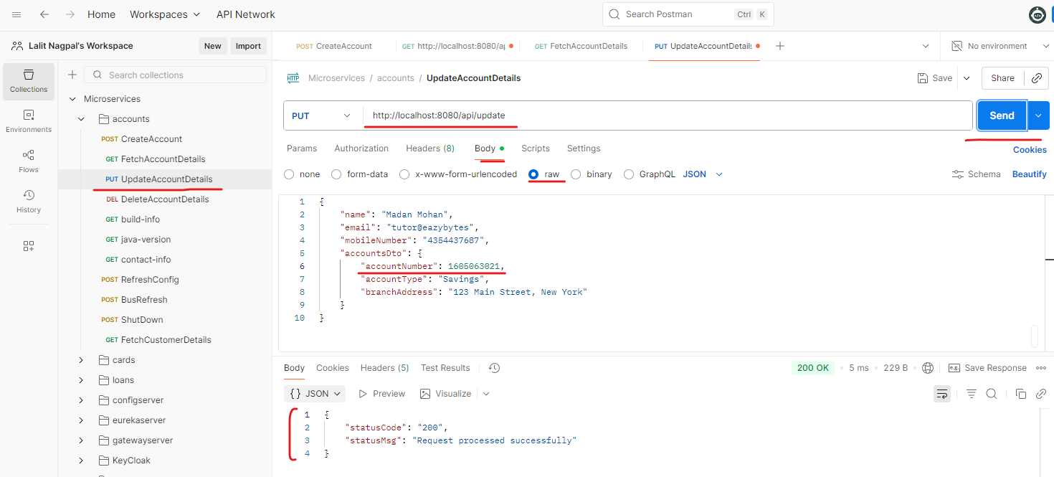

Let's try to test a negative scenario. So the negative scenario is going to be I'm going to give a account number that does not exist. So let me click on the send button. You can see I'm getting an error response saying that account not found with a given accountNumber so and so is the value. So with this, the update API operation inside accounts microservice is also completed. But before I try to close this lecture, let me give you a small bug that we have inside our code.

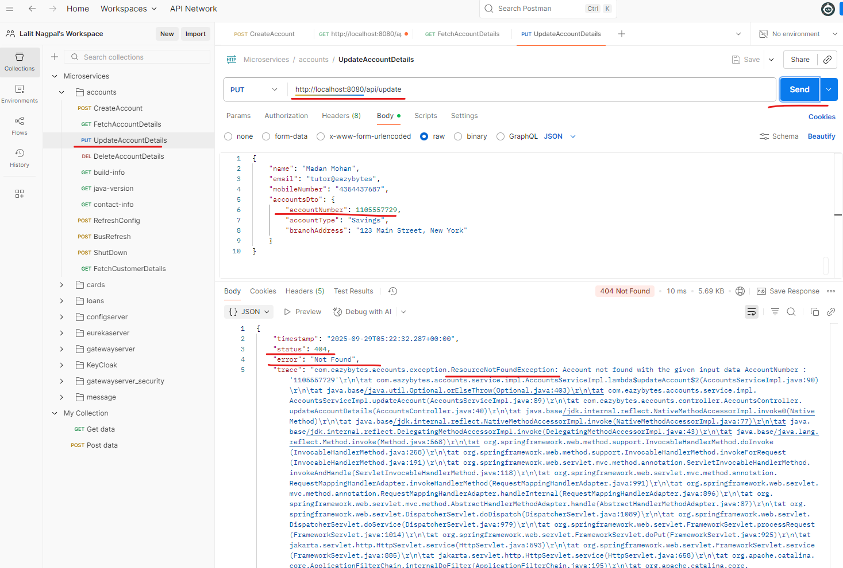

As of now, if you go and check the H2 console inside our database, we updated both account and customer, but when we are updating this updatedAt and updatedBy is not getting updated because we are not populating these values manually while we are trying to save the records into the database. So don't worry about this bug. I'm going to make few auditing related changes where all these createdAt and createdBy , updatedAt and updatedBy will be automatically taken care by the spring Data JPA framework. For now, let's bear this small bug for few lectures post that I'm going to fix this in the coming lectures.

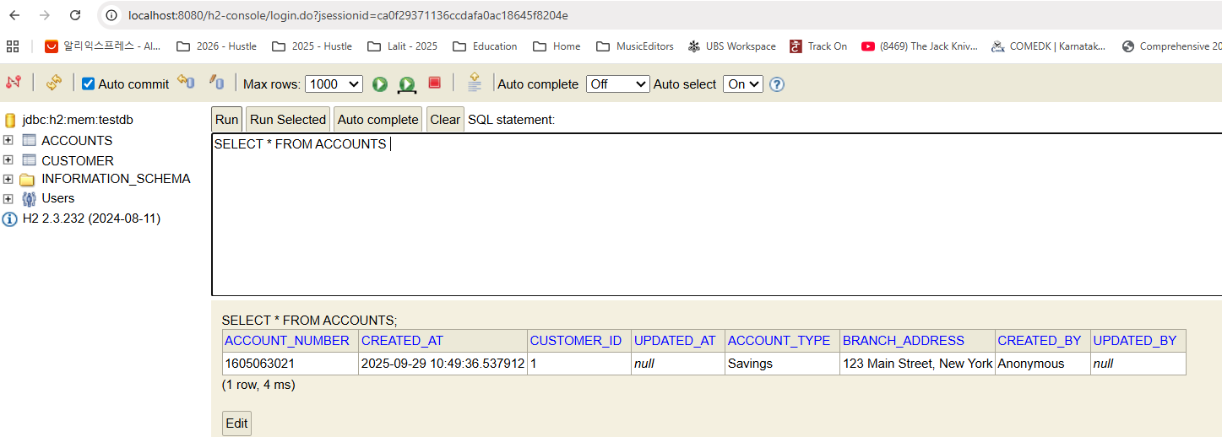

### Delete API [ Accounts Microservice ]

Let's try to create a new rest API inside accounts microservice that will help us to delete the existing customer and account details and how I'm going to support this API is my client application they have to invoke my delete API along with the mobile number. Based upon the given mobile number I Will try to load the customer entity details from the database. From the Customer entity. I'll be getting customerId, using customerId, I'm going to delete the records present in both tables, which is inside the accounts and customer because both tables have this common column, which is customerId. So let's do the same for the same. First, I need to create a new method inside my IAccountService interface. So let me create a new method here. So this is the new method with the name deleteAccount(). And this is also going to return a boolean value saying that if the delete operation is successful or not and it is going to accept the mobile number as an input parameter.

**IAccountsService**

import com.eazybytes.accounts.dto.CustomerDto;

public interface IAccountsService {

void createAccount(CustomerDto customerDto);

CustomerDto fetchAccount(String mobileNumber);

boolean updateAccount(CustomerDto customerDto);

/**

*

* @param mobileNumber - Input Mobile Number

* @return boolean indicating if the delete of Account details is successful or not

*/

boolean deleteAccount(String mobileNumber);

}

**IAccountsServiceImpl**

@Service

@AllArgsConstructor

public class AccountsServiceImpl implements IAccountsService {

private AccountsRepository accountsRepository;

private CustomerRepository customerRepository;

@Override

public void createAccount(CustomerDto customerDto) {

Customer customer = CustomerMapper.mapToCustomer(customerDto, new Customer());

Optional<Customer> optionalCustomer = customerRepository.findByMobileNumber(customerDto.getMobileNumber());

if(optionalCustomer.isPresent()) {

throw new CustomerAlreadyExistsException("Customer already registered with given mobileNumber "

+customerDto.getMobileNumber());

}

customer.setCreatedAt(LocalDateTime.now());

customer.setCreatedBy("Anonymous");

Customer savedCustomer = customerRepository.save(customer);

accountsRepository.save(createNewAccount(savedCustomer));

}

private Accounts createNewAccount(Customer customer) {

Accounts newAccount = new Accounts();

newAccount.setCustomerId(customer.getCustomerId());

long randomAccNumber = 1000000000L + new Random().nextInt(900000000);

newAccount.setAccountNumber(randomAccNumber);

newAccount.setCreatedAt(LocalDateTime.now());

newAccount.setCreatedBy("Anonymous");

newAccount.setAccountType(AccountsConstants.SAVINGS);

newAccount.setBranchAddress(AccountsConstants.ADDRESS);

return newAccount;

}

@Override

public CustomerDto fetchAccount(String mobileNumber) {

Customer customer = customerRepository.findByMobileNumber(mobileNumber)

.orElseThrow( () -> new ResourceNotFoundException("Customer", "mobileNumber",

mobileNumber)

);

Accounts accounts = accountsRepository.findByCustomerId(customer.getCustomerId())

.orElseThrow( () -> new ResourceNotFoundException("Account", "customerId",

customer.getCustomerId().toString())

);

CustomerDto customerDto = CustomerMapper.mapToCustomerDto(customer, new CustomerDto());

customerDto.setAccountsDto(AccountsMapper.mapToAccountsDto(accounts, new AccountsDto()));

return customerDto;

}

@Override

public boolean updateAccount(CustomerDto customerDto) {

boolean isUpdated = false;

AccountsDto accountsDto = customerDto.getAccountsDto();

if(accountsDto !=null ){

Accounts accounts = accountsRepository.findById(accountsDto.getAccountNumber())

.orElseThrow( () -> new ResourceNotFoundException("Account", "AccountNumber",

accountsDto.getAccountNumber().toString())

);

AccountsMapper.mapToAccounts(accountsDto, accounts);

accounts = accountsRepository.save(accounts);

Long customerId = accounts.getCustomerId();

Customer customer = customerRepository.findById(customerId)

.orElseThrow( () -> new ResourceNotFoundException("Customer", "CustomerID",

customerId.toString())

);

CustomerMapper.mapToCustomer(customerDto,customer);

customerRepository.save(customer);

isUpdated = true;

}

return isUpdated;

}

/**

* @param mobileNumber - Input Mobile Number

* @return boolean indicating if the delete of Account details is successful or not

*/

@Override

public boolean deleteAccount(String mobileNumber) {

Customer customer = customerRepository.findByMobileNumber(mobileNumber)

.orElseThrow( () -> new ResourceNotFoundException("Customer", "mobileNumber",

mobileNumber)

);

accountsRepository.deleteByCustomerId(customer.getCustomerId());

customerRepository.deleteById(customer.getCustomerId());

return true;

}

}

Now we can go to the AccountService and I'm going to put the cursor where I want my method to be generated. Now I'll go to the top and I'll run this error and click on this implement methods and click okay. So this will generate a new empty method inside deleteAccount(). So now, quickly, I'm going to paste a few lines of code which we can discuss, and this is going to be super, super easy. The reason why I'm saying easy is it's always easy to destroy, to delete something, but it's very hard to create something from scratch. That's why I always feel like deleting something is very easy. Now here I'm pasting few lines of code. First, I'm trying to fetch the customer details based upon the findByMobileNumber() method available inside CustomerRepository to this method we're passing mobile number as input. If there is no record exist, we are throwing the ResourceNotFoundException. Now I have Customer entity in my hand with this Customer entity I'm going to get the customerId and with the help of this AccountRepository and CustomerRepository, I'm going to invoke this methods deleteById() and deleteByCustomerId(). So this deleteById() is available from the framework. If you see this method available inside the CrudRepository belongs to the framework.

|  |  |
| --- | --- |
|  | So what this method is going to do is it is going to delete the record based upon the primary key value. Since inside the customer table the primary key is customerId, we are able to invoke the deleteById() But for the account table In order to invoke the deleteById(), we should pass the what is the account number so I can fetch the account number by firing a query again on top of the accounts table, but it is unnecessary firing of a query. Instead, I will try to delete the record based upon the customerId column present inside the accounts table. Since this customerId is not a primary key inside the accounts table, we need to write this method inside the AccountsRepository. So here I'm going to create this method which which will return void and the method name is deleteByCustomerId and it is going to accept customerId value as an input.  With this my Spring Data JPA Behind the scenes it is going to generate a delete query just like findBy() indicates select query deleteBy indicates to prepare a delete query to the spring data JPA framework and here the column name that we want to consider is customerId. That's why I have to mention the same field name present inside the Accounts entity like this is the customerId, the same field name I have mentioned here. |

Now here there is a catch. With the help of our custom methods, we are trying to change the data inside the database. Previously we are only trying to read the data. It is not going to change the data in any way, but whenever you are trying to update or delete with the custom methods that you have written, we need to make sure we are mentioning two annotations on top of these abstract methods. These two annotations are @Transactional and the second annotation is @Modifying. Modifying will tell to the spring data JPA framework that these method is going to modify the data. So that's why please execute the query of this method inside a Transaction. That's why we are mentioning Transactional annotation.

import com.eazybytes.accounts.entity.Accounts;

import org.springframework.data.jpa.repository.JpaRepository;

import org.springframework.stereotype.Repository;

import org.springframework.data.jpa.repository.Modifying;

import org.springframework.transaction.annotation.Transactional;

import java.util.Optional;

@Repository

public interface AccountsRepository extends JpaRepository<Accounts, Long> {

Optional<Accounts> findByCustomerId(Long customerId);

@Transactional

@Modifying

void deleteByCustomerId(Long customerId);

}

When my spring data JPA runs my query inside a Transaction and if there is some error happens at the runtime, any partial change of data that is resulted due to the queries will be rolled back because the entire transaction will be rolled back by the spring data JPA and we are in safe hands. It should not be a scenario where like we deleted the account but not the customer.

So those kind of scenarios we need to make sure we are handling with the help of this transactional and modifying. And here you may have a question like we are also invoking these deleteById method inside the CustumerRepository then why you are not mentioning Transactional and Modifying for this method. Please note that this method is from the framework. Framework is going to take care of it. But this method we have returned with our own hands since framework cannot identify that. We need to let framework that this method is going to modify data and please run it inside a Transaction. And if there is some error happen, please roll back the Transaction. That's what we are trying to communicate with these two annotations. Once the delete operation is completed, we are simply returning true post that I can go to the controller class inside controller class also, I'm going to create a new method. So here I'm pasting the new method just to save some time.

import lombok.AllArgsConstructor;

import org.springframework.http.HttpStatus;

import org.springframework.http.MediaType;

import org.springframework.http.ResponseEntity;

import org.springframework.web.bind.annotation.*;

@RestController

@RequestMapping(path="/api", produces = {MediaType.APPLICATION_JSON_VALUE})

@AllArgsConstructor

public class AccountsController {

private IAccountsService iAccountsService;

@PostMapping("/create")

public ResponseEntity<ResponseDto> createAccount(@RequestBody CustomerDto

customerDto) {

iAccountsService.createAccount(customerDto);

return ResponseEntity

.status(HttpStatus.CREATED)

.body(new ResponseDto(AccountsConstants.STATUS_201,

AccountsConstants.MESSAGE_201));

}

@GetMapping("/fetch")

public ResponseEntity<CustomerDto> fetchAccountDetails(@RequestParam String mobileNumber) {

CustomerDto customerDto = iAccountsService.fetchAccount(mobileNumber);

return ResponseEntity.status(HttpStatus.OK).body(customerDto);

}

@PutMapping("/update")

public ResponseEntity<ResponseDto> updateAccountDetails(@Valid @RequestBody CustomerDto customerDto) {

boolean isUpdated = iAccountsService.updateAccount(customerDto);

if(isUpdated) {

return ResponseEntity

.status(HttpStatus.OK)

.body(new ResponseDto(AccountsConstants.STATUS_200, AccountsConstants.MESSAGE_200));

}else{

return ResponseEntity

.status(HttpStatus.EXPECTATION_FAILED)

.body(new ResponseDto(AccountsConstants.STATUS_417, AccountsConstants.MESSAGE_417_UPDATE));

}

}

@DeleteMapping("/delete")

public ResponseEntity<ResponseDto> deleteAccountDetails(@RequestParam String mobileNumber) {

boolean isDeleted = iAccountsService.deleteAccount(mobileNumber);

if(isDeleted) {

return ResponseEntity

.status(HttpStatus.OK)

.body(new ResponseDto(AccountsConstants.STATUS_200, AccountsConstants.MESSAGE_200));

} else {

return ResponseEntity

.status(HttpStatus.EXPECTATION_FAILED)

.body(new ResponseDto(AccountsConstants.STATUS_417, AccountsConstants.MESSAGE_417_DELETE));

}

}

}

So like you can see the annotation is @DeleteMapping. We need to use delete() method only to delete the data and the API path that it is going to support is /delete. The method name is deleteAccountDetails(). It is going to accept mobile number and we are invoking the deleteAccount() method available inside the service layer and we're accepting a boolean. If the boolean is true, we are sending a ok response with the status 200 and the message has request to process successfully. But for some reason, if this boolean is false, we are sending these error saying that 500 is a code and the message has an error occurred. Please try again or contact dev team. So with this we should be good. Let me save this changes. Do a build like you know the build will restart my application and all the data will be lost inside the database. But don't worry, we can quickly create the data.

I know this is very annoying step right now, but later on when we move to a proper MySQL database, that is going to be super, super helpful. So first I'm creating the new account. I'm taking the same mobile number. I'll validate if the account details are present by invoking this get method so the details are created. That's why I'm getting the successful response. Now I'll go to this deleteAccountDetails() and the path that we need to invoke is /api/delete delete with the Http method as delete and we need to pass a query param mobile number with the same mobile number value. As soon as I click delete you can see I'm getting a successful response. Now, If we go and check the fetch API you will get not found error because the data is deleted successfully. Now coming to the native scenario, I can try to invoke the delete API again. You can see right now my delete API also throwing not found because there is no such data. We completed all the four crud operations inside our Accounts Microservice, I hope you are clear. We are yet to discuss more standards like proper RuntimException handling auditing of the metadata columns with the help of spring data JPA documenting the REST APIs.

Create the account first

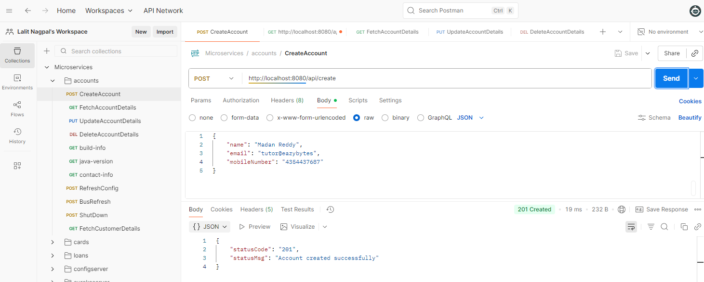

Delete the account now

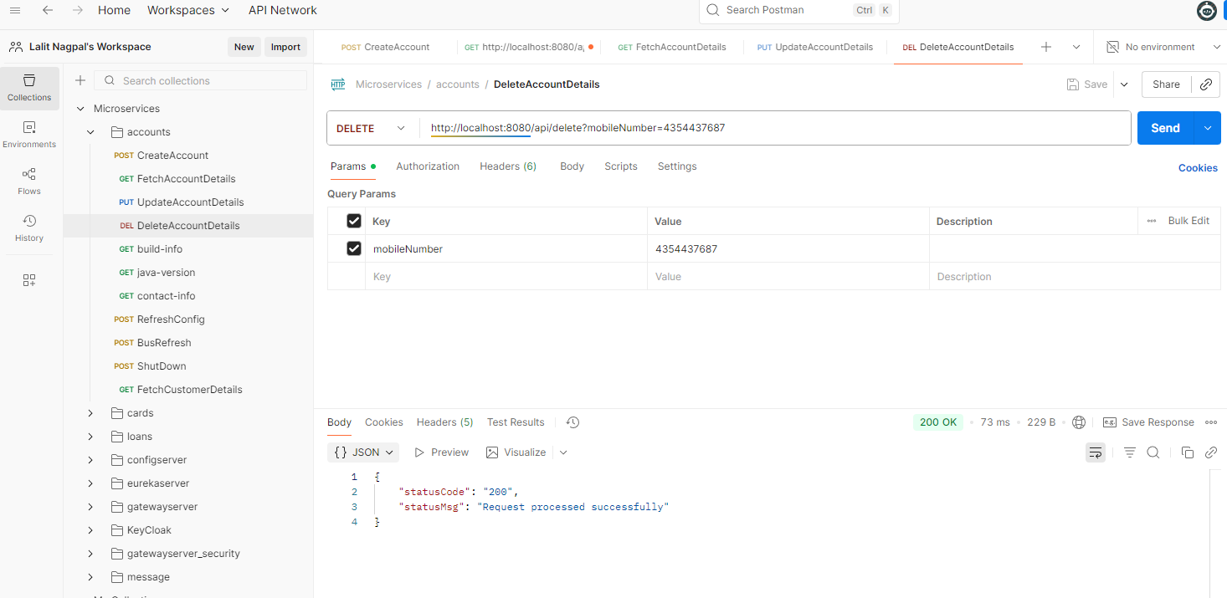

Try again, after deleting

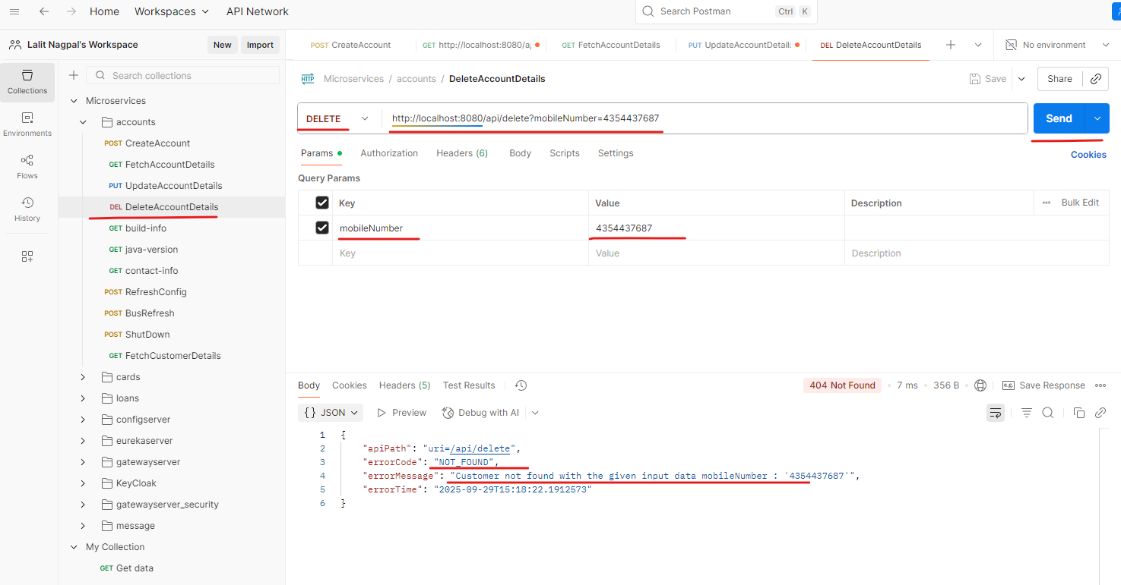

### Handle All Runtime Global Exceptions

As of now, inside our accounts. Microservice We have built four REST APIs supporting the Crud operations. Like you can see there are four different API operations

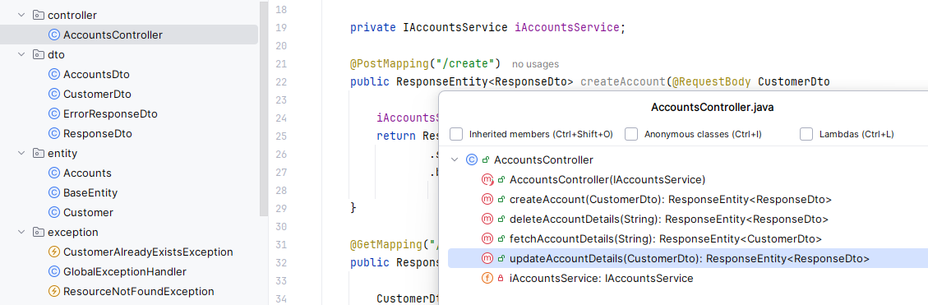

Let's try to handle the runtime exceptions that may happen inside our REST APIs at any time, at any location. As of now, if you go to the GlobalExceptionHandler inside this GlobalExceptionHandler, we are only handling two exceptions, and these two exceptions are business exceptions are user defined exceptions. So these are the two exceptions like **ResourceNotFound** and **CustomerAlreadyExistException** But what if there is some runtime exception happens inside your application? You should be able to send a proper response to the client application that so-and-so issue occurred so that they are aware that API invocation is failed for the same. It's going to be super, super easy. We just need to copy one of this method here and paste the same inside. The GlobalExceptionHandler here instead of **ResourceNotFoundException** class, I'm going to mention Exception.class inside Java, we know Exception is a class that can represent all kind of exceptions, including checked and unchecked exceptions.

import com.eazybytes.accounts.dto.ErrorResponseDto;

import org.springframework.http.HttpStatus;

import org.springframework.http.ResponseEntity;

import org.springframework.web.bind.annotation.ControllerAdvice;

import org.springframework.web.bind.annotation.ExceptionHandler;

import org.springframework.web.context.request.WebRequest;

import org.springframework.web.servlet.mvc.method.annotation.ResponseEntityExceptionHandler;

import java.time.LocalDateTime;

@ControllerAdvice

public class GlobalExceptionHandler extends ResponseEntityExceptionHandler {

@ExceptionHandler(**CustomerAlreadyExistsException**.**class**)

public ResponseEntity<ErrorResponseDto> handleCustomerAlreadyExistsException(

CustomerAlreadyExistsException exception, WebRequest webRequest ) {

ErrorResponseDto errorResponseDTO = new ErrorResponseDto(

webRequest.getDescription(false),

HttpStatus.BAD_REQUEST,

exception.getMessage(),

LocalDateTime.now()

);

return new ResponseEntity<>(errorResponseDTO, HttpStatus.BAD_REQUEST);

}

@ExceptionHandler(Exception.class)

public ResponseEntity<ErrorResponseDto> handleGlobalException(Exception exception,

WebRequest webRequest) {

ErrorResponseDto errorResponseDTO = new ErrorResponseDto(

webRequest.getDescription(false),

HttpStatus.INTERNAL_SERVER_ERROR,

exception.getMessage(),

LocalDateTime.now()

);

return new ResponseEntity<>(errorResponseDTO, HttpStatus.INTERNAL_SERVER_ERROR);

}

@ExceptionHandler(**ResourceNotFoundException**.**class**)

public ResponseEntity<ErrorResponseDto> handleResourceNotFoundException(

ResourceNotFoundException exception, WebRequest webRequest ) {

ErrorResponseDto errorResponseDTO = new ErrorResponseDto(

webRequest.getDescription(false),

HttpStatus.NOT_FOUND,

exception.getMessage(),

LocalDateTime.now()

);

return new ResponseEntity<>(errorResponseDTO, HttpStatus.NOT_FOUND);

}

}

With this, the method that I'm going to define right now is going to handle all kind of exceptions. But here you may have a question like user not found exception is also a type of exception. Only the way it is going to work is for Springboot framework is going to look for handler methods which are with the exact exception details. If there is no such handler exception, then the logic inside this ExceptionHandler is going to be invoked. Let me change this method name to handleGlobalException() and at the same time we need to change this ResourceNotFoundException to normal exception class. And apart from that here I want to return an ErrorResponseDto as an response. And I want to send what is the path that they invoked? And instead of NOT_FOUND, I want to send internal server error. So this indicates that there is some runtime error happened. And the same I'm going to mention here as well, post this internal server. We should be good with whatever exception message that we receive from the spring boot framework along with these LocalDateTime.now(). So with these changes now our application can handle the runtime exceptions and it can execute the logic that we have written here if needed in real time applications. You can enhance this method to trigger an email to operation or to make an entry into one of the table where you are maintaining all the exception details for reporting purpose. So the scenario can be anything based upon your business requirements. So now we have this logic available.

The question right now is how to test a runtime exception. That's going to be super, super easy. Let's try to introduce a runtime exception intentionally inside my AccountsController. As of now we have this AllArgsConstructor. I'm going to delete this. With that, there will be only default constructor for our class and with the default constructor the autowiring will not happen. And when no auto wiring happening then this IAccountService is going to be null and I'm going to get a null pointer exception in all my API operations. So let me save this changes and do a build.

@RestController

@RequestMapping(path="/api", produces = {MediaType.APPLICATION_JSON_VALUE})

~~@AllArgsConstructor~~

public class AccountsController {

private IAccountsService iAccountsService;

Once the build is completed, we can try to test one of the API, maybe we can try to test create API itself. So this is the API that I want to test. So let me invoke with a proper request. So I'm clicking on the Send button. You can see I got a runtime exception saying that this is the API path, this is the error code which is internal server error and the same we are getting here like 500 internal server, which is the Http status.

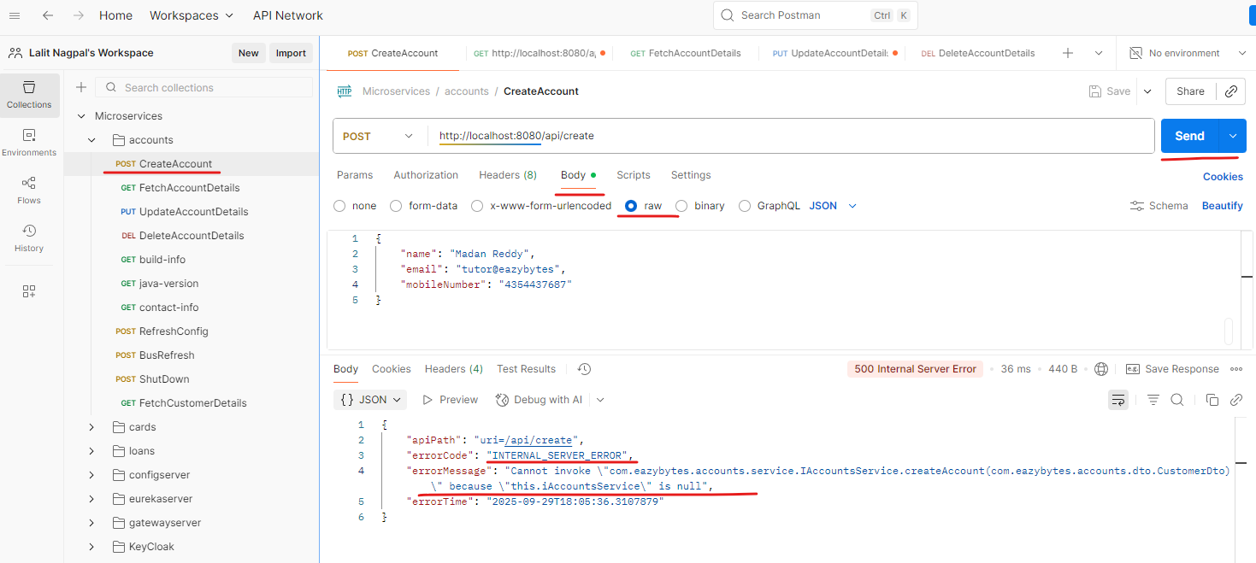

Now coming to the error message, you can see we are getting actual runtime exception saying that that so-and-so object is null because autowiring failed. The same will happen for all kind of APIs. Like you can see we we are getting the same here. Let's do the same for update account and the same for delete account. You can see the power of global exception. So this is going to be super, super important. And if someone want to test your spring boot knowledge and your rest API knowledge, they can simply ask you how to implement global exception logic inside an application. So please remember that we need to use this annotation like @ControllerAdvice and we need to write a method and on top of this method we need to make sure we are mentioning this annotation @ExceptioHandler post that you already know what we have to do inside this method. The short answer is the combination of ControllerAdvice and ExceptionHandler is going to help you to implement the global error logic inside all of your Controller methods.

### Input Data Validations [ Accounts Microservice ]

We handle runtime exceptions and custom exceptions inside our AccountsMicroservices. . One more standard that we need to follow when we are building microservices and REST APIs is, we need to perform validations on the input data that we receive from the client applications. We are right now accepting various kinds of data from our clients. Like you can see here they are passing the name, email and mobileNumber. What if someone is sending a nine digit or five digit mobile number instead of ten digit? What if someone is not following the email format? What if someone is sending a name with a value of only two characters and three characters? And very similarly, someone, while trying to invoke these get API, they can send a mobile number of five digit value or four digit value instead of ten digit value. Off course, in this scenario you may question me like there's nothing wrong going to happen anyway the end user is going to get a response saying that there is no such account with a given mobile number. That's a valid question, but you are unnecessarily firing a DB query with an invalid data. We should straight away reject such invalid data from our REST APIs.

Same applies for update account details. If they're trying to send some account number which is not of type ten digit and account type as empty branch address as empty. So there are multiple combinations. The client applications and end users they can miss and they can screw up. That's why as an developer we need to make sure we are doing enough validations on the input data that we receive to our REST APIs. So let's try to perform these input validations inside this lecture. Any time, whenever we want to perform validations first, we need to make sure we have added relevant dependency inside the pom.xml like we discussed before, we added this dependency, which is spring boot starter validation when we are trying to create this microservice with the help of start.spring.io website. This dependency has all the annotations and libraries that will help us to enforce the validations on the input data that we receive from the clients. So once we validated this step, we can go to the DTO classes.

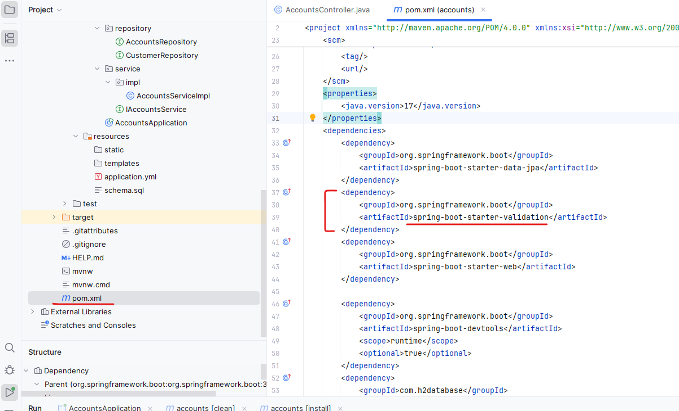

As of now we have four Dto's First, let's go to the CustomerDto the reason why I open these class is whatever data that we receive from the clients will get converted into CustomerDto. So these DTOs are going to hold the data that we are going to receive from clients, which means my spring boot has to perform the validations on the data stored inside the object of this CustomerDto or any other DTO like AccountsDto. So since we want to enforce some validations on the input received from the clients, we need to make sure we are mentioning all our validation requirements with the help of annotations inside the Spring Boot framework. The very first and basic attention that we can use is @NotEmpty. So whenever we are mentioning this @NotEmpty, we are making that field as mandatory field. So whenever someone is trying to send this name value, it has to be mandatory, like it should not be empty or null value. The same I want to mention for email as well. So let me mention the same. Now, whenever a validation fails due to this NotEmpty annotation that we mentioned here, we want to throw a custom message to the client application so that they are clear about which data is wrong. For the same, we need to invoke the message parameter against this annotation and inside this message parameter. I'm going to mention the message like name cannot be null or empty. The same I can do for email as well. I'm going to invoke the message here and mention the message saying that email address cannot be null or empty. So we have mentioned this NotEmpty validation on top of this name and email, which makes the fields as mandatory. If you see this NotEmpty annotation present inside this Jakarta.validations.constraints package. If I can open this annotation and go to the same package, you can see there are many other annotations that we can use to enforce the validations on top of our Java fields like digits will make sure we are accepting only numeric and similarly, email will validate the format of the email and future, will make sure that the date that we are accepting is of type future very similarly max, minimum,negative. NotBlank, NotEmpty, NotNull null past pattern to enforce some rejects patterns.

Press ctrl + P and type NotEmpty and select the jakarta.validations one

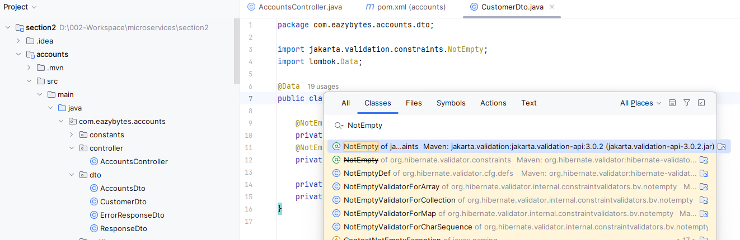

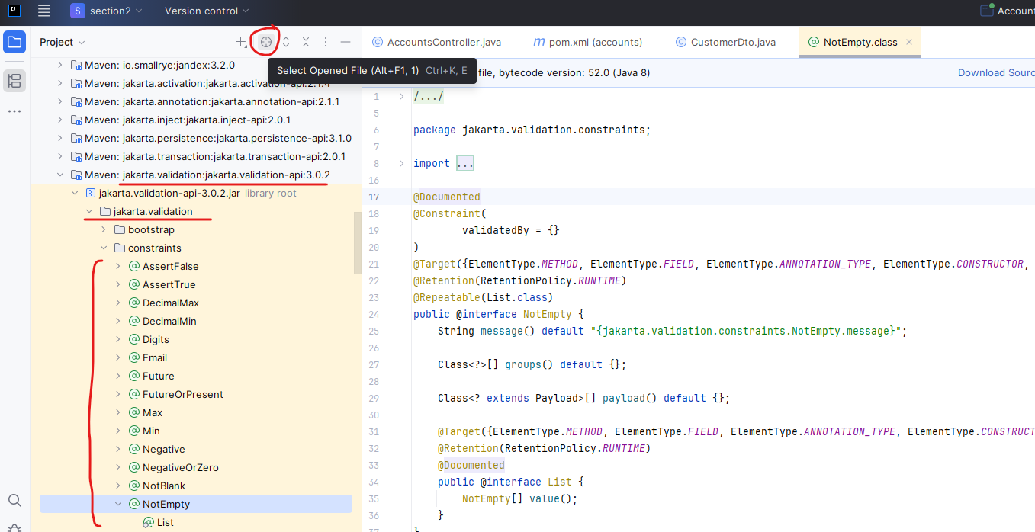

|  |  |
| --- | --- |
|  | import jakarta.validation.constraints.Email;  import jakarta.validation.constraints.NotEmpty;  import jakarta.validation.constraints.Pattern;  import jakarta.validation.constraints.Size;  import lombok.Data;  @Data  public class CustomerDto {  @NotEmpty(message = "Name can not be a null or empty")  @Size(min = 5, max = 30, message = "The length of  the customer name should be between 5 and 30")  private String name;  @NotEmpty(message = "Email address can not be  null or empty")  @Email(message = "Email address should be a valid value")  private String email;  @Pattern(regexp = "(^$|[0-9]{10})", message =  "Mobile number must be 10 digits")  private String mobileNumber;  private AccountsDto accountsDto;  }  This way we have a lot of annotations that you can use based upon your business requirements. Now I want to enforce one more validation on top of my name field with the help of Size annotation using the Size annotation, we can mention what is the minimum length of value that we are going to accept.  And similarly, using Max, we can mention what is the maximum value that we are going to accept. If this validation fails. I'm going to throw a message saying that the length of the customer name should be between 5 and 30. This will make sure we are receiving a name value with at least five length characters and at a maximum of 30 chars. So we are good with the name. |

Now on top of email, I want to enforce email format related validations, so that's why I need to invoke @Email annotation. And if these email validation fails, I want to throw a message saying that email address should be a valid value.

Suppose if I try to forget mentioning @Symbol inside my email value, then I'll get these validation error message. Now coming to the mobile number, we want to make sure that we always receive a mobile number in numeric format and the numeric value also should be exactly ten digit number and it should not be like nine digit or 11 digit. I want exactly ten digit numeric value. But these kind of requirements, we can use a annotation which is @Pattern with the help of @Pattern annotation, we can invoke rejects expression and to these rejects expression we can pass what is the expression that we want to follow.

import jakarta.validation.constraints.NotEmpty;

import jakarta.validation.constraints.Pattern;

import lombok.Data;

@Data

public class AccountsDto {

@NotEmpty(message = "AccountNumber can not be a null or empty")

@Pattern(regexp="(^$|[0-9]{10})", message = "AccountNumber must be 10 digits")

private Long accountNumber;

@NotEmpty(message = "AccountType can not be a null or empty")

private String accountType;

@NotEmpty(message = "BranchAddress can not be a null or empty")

private String branchAddress;

}

So this is the pattern that I want to follow. This will make sure that I'm accepting only numeric values with exactly ten digits post that I need to mention. What is the message that I want to throw in case of this validation fails? The message that I want to throw here is mobile number must be ten digits. So with this, we have mentioned all the validation related annotations inside CustomerDto.

Next, we can go to the AccountsDto here inside my AccountsDto. For the account number, I want to follow the same pattern like mobile number. Just like for mobile number, we are accepting ten digit numeric value for account number also, we should follow the same pattern. So here for account number also I'm going to mention these annotations like @Pattern and @NotEmpty that will make sure that my account number is going to be a mandatory value. Similarly, for account type, we can mention @NotEmpty, the same I can mention for branch address as well. So let me pass the message values. So the message value that I want to pass here is account type cannot be null or empty. Similarly, I want to follow the same for branch address as well. The validation message that I want to throw here is branch address cannot be a null or empty. So with this we have mentioned all the validation related annotations inside our DTO classes like Accounts and Customer.

We don't have to mention inside ResponseDto and ErrorResponseDto. The reason is these two DTOs we don't get as an input from the client applications. We always use these DTOs to send the response to them. That's why we don't have to perform validations or we don't have to mention any validations inside these DTO. Now as a next step, we need to go to the place where we are trying to use these AccountsDto and CustomerDto, like you expect we are accepting them as an input inside our AccountsController.

So you can see here I'm accepting the RequestBody in the format of CustomerDto and the same for the update operation as well. So here also we need to mention some annotations. The very first annotation that I want to mention here is @Validated on top of my AccountsController class. So this annotation will tell to my spring boot framework to perform validations on all the REST APIs that I have defined inside these AccountsController. . Now, as a next step, we need to mention an annotation which is @Valid just before the RequestBody . The v should be capital V, so this is the annotation which is @Valid. We need to mention just before the RequestBody annotation to communicate to the spring boot framework to perform all the validations that we mentioned inside this duo. So the same I have to mention for my update operation as well just before this RequestBody annotation. So we are good right now for create and update operations.

import com.eazybytes.accounts.constants.AccountsConstants;

import com.eazybytes.accounts.dto.CustomerDto;

import com.eazybytes.accounts.dto.ResponseDto;

import com.eazybytes.accounts.service.IAccountsService;

import jakarta.validation.Valid;

import jakarta.validation.constraints.Pattern;

import org.springframework.http.HttpStatus;

import org.springframework.http.MediaType;

import org.springframework.http.ResponseEntity;

import org.springframework.validation.annotation.Validated;

import org.springframework.web.bind.annotation.*;

@RestController

@Validated

@RequestMapping(path="/api", produces = {MediaType.APPLICATION_JSON_VALUE})

public class AccountsController {

private IAccountsService iAccountsService;

@PostMapping("/create")

public ResponseEntity<ResponseDto> createAccount(@Valid @RequestBody CustomerDto customerDto) {

iAccountsService.createAccount(customerDto);

return ResponseEntity

.status(HttpStatus.CREATED)

.body(new ResponseDto(AccountsConstants.STATUS_201,

AccountsConstants.MESSAGE_201));

}

@GetMapping("/fetch")

public ResponseEntity<CustomerDto> fetchAccountDetails(

@Pattern(regexp="(^$|[0-9]{10})", message = "Mobile number must be 10 digits")

@RequestParam String mobileNumber) {

CustomerDto customerDto = iAccountsService.fetchAccount(mobileNumber);

return ResponseEntity.status(HttpStatus.OK).body(customerDto);

}

@PutMapping("/update")

public ResponseEntity<ResponseDto> updateAccountDetails(@Valid @RequestBody CustomerDto customerDto) {

boolean isUpdated = iAccountsService.updateAccount(customerDto);

if(isUpdated) {

return ResponseEntity

.status(HttpStatus.OK)

.body(new ResponseDto(AccountsConstants.STATUS_200, AccountsConstants.MESSAGE_200));

}else{

return ResponseEntity

.status(HttpStatus.EXPECTATION_FAILED)

.body(new ResponseDto(AccountsConstants.STATUS_417, AccountsConstants.MESSAGE_417_UPDATE));

}

}

@DeleteMapping("/delete")

public ResponseEntity<ResponseDto> deleteAccountDetails(@RequestParam

@Pattern(regexp="(^$|[0-9]{10})", message = "Mobile number must be 10 digits")

String mobileNumber) {

boolean isDeleted = iAccountsService.deleteAccount(mobileNumber);

if(isDeleted) {

return ResponseEntity

.status(HttpStatus.OK)

.body(new ResponseDto(AccountsConstants.STATUS_200, AccountsConstants.MESSAGE_200));

}else{

return ResponseEntity

.status(HttpStatus.EXPECTATION_FAILED)

.body(new ResponseDto(AccountsConstants.STATUS_417, AccountsConstants.MESSAGE_417_DELETE));

}

}

}

What about these fetch account details and delete account details. Here we are not accepting the input data with the help of DTOs. We are directly accepting them with the help of query parameters. So to perform validations on these mobile number, what we can do is just after this request param, we can mention @Pattern validation, very similar to what we have mentioned inside the dto class. So with the help of @Pattern, I'm accepting a reject expression that will make sure that I'm receiving only ten digit numeric value. The same I can mention for deleteAccountDetails method as well. So here also I'm going to perform the same validation ten digit numeric value. So now we have mentioned all the input validations that we want to perform. As a next step we should let spring boot framework what it has to do whenever these validations fails, it knows what validations it has to perform. The framework also knows what message it has to throw to the end user or client application, but it does not know how to send that inside the error response or inside the body of the response.

For the same, what we have to do is we can go to the GlobalExceptionHandler. Here we need to extend a class with the name ResponseEntityExceptionHandler After extending this class, if you go to this class, there is a method inside this class which is handleMethodArgumentsNotValid() . So we need to override this method inside our GlobalExceptionHandler. If you see it is going to get all the validation exception details as the first parameter and header details, statusCode and WebRequest. We need to override with the same method parameters. So let me try to create this method and you can see this has right now empty method.

Press ctrl + T and select handleMethodArg. . .

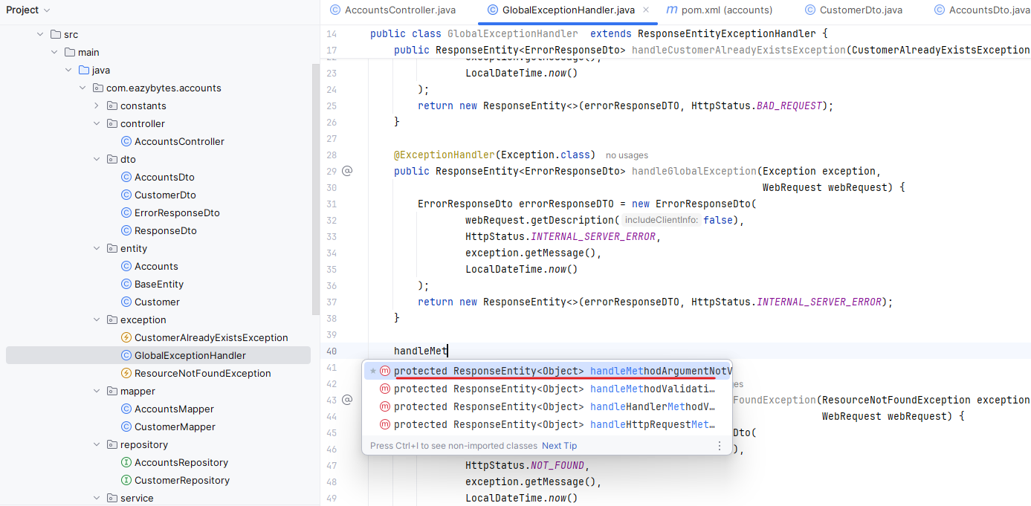

import com.eazybytes.accounts.dto.ErrorResponseDto;

import org.springframework.http.HttpHeaders;

import org.springframework.http.HttpStatus;

import org.springframework.http.HttpStatusCode;

import org.springframework.http.ResponseEntity;

import org.springframework.web.bind.MethodArgumentNotValidException;

import org.springframework.web.bind.annotation.ControllerAdvice;

import org.springframework.web.bind.annotation.ExceptionHandler;

import org.springframework.web.context.request.WebRequest;

import org.springframework.web.servlet.mvc.method.annotation.ResponseEntityExceptionHandler;

import java.time.LocalDateTime;

@ControllerAdvice

public class GlobalExceptionHandler extends ResponseEntityExceptionHandler {

@ExceptionHandler(CustomerAlreadyExistsException.class)

public ResponseEntity<ErrorResponseDto> handleCustomerAlreadyExistsException(CustomerAlreadyExistsException exception,

WebRequest webRequest){

ErrorResponseDto errorResponseDTO = new ErrorResponseDto(

webRequest.getDescription(false),

HttpStatus.BAD_REQUEST,

exception.getMessage(),

LocalDateTime.now()

);

return new ResponseEntity<>(errorResponseDTO, HttpStatus.BAD_REQUEST);

}

@ExceptionHandler(Exception.class)

public ResponseEntity<ErrorResponseDto> handleGlobalException(Exception exception,

WebRequest webRequest) {

ErrorResponseDto errorResponseDTO = new ErrorResponseDto(

webRequest.getDescription(false),

HttpStatus.INTERNAL_SERVER_ERROR,

exception.getMessage(),

LocalDateTime.now()

);

return new ResponseEntity<>(errorResponseDTO, HttpStatus.INTERNAL_SERVER_ERROR);

}

@Override

protected ResponseEntity<Object> handleMethodArgumentNotValid(MethodArgumentNotValidException ex, HttpHeaders headers,

HttpStatusCode status, WebRequest request) {

return super.handleMethodArgumentNotValid(ex, headers, status, request);

}

@ExceptionHandler(ResourceNotFoundException.class)

public ResponseEntity<ErrorResponseDto> handleResourceNotFoundException(ResourceNotFoundException exception,

WebRequest webRequest) {

ErrorResponseDto errorResponseDTO = new ErrorResponseDto(

webRequest.getDescription(false),

HttpStatus.NOT_FOUND,

exception.getMessage(),

LocalDateTime.now()

);

return new ResponseEntity<>(errorResponseDTO, HttpStatus.NOT_FOUND);

}

}

The method name has to be same and it needs to accept these four method parameters. Now we need to write a small logic inside this method which will process all the validation exceptions that failed and the same we need to send as part of the response with the help of this Response entity of object. So here I'm going to paste few lines of code. The code is going to be super, super simple. I'll explain line by line just to save some time. I have pasted the code here.

@Override

protected ResponseEntity<Object> handleMethodArgumentNotValid(MethodArgumentNotValidException ex, HttpHeaders headers,

HttpStatusCode status, WebRequest request) {

Map<String, String> validationErrors = new HashMap<>();

List<ObjectError> validationErrorList = ex.getBindingResult().getAllErrors();

validationErrorList.forEach((error) -> {

String fieldName = ((FieldError) error).getField();

String validationMsg = error.getDefaultMessage();

validationErrors.put(fieldName, validationMsg);

});

return new ResponseEntity<>(validationErrors, HttpStatus.BAD_REQUEST);

}

So first I'm trying to create an empty map with the name validation errors and it is going to hold the key and value of type string. Post that what I'm doing is using this exception parameter I'm invoking getBindingResult().getAllErrors(). So this will give me all validation errors failed in the input data that I receive. Using this list I'm trying to iterate one by one and from each error I'm trying to get what is the field where the validation failed and what is the validation message related to the field? If you recall, in all the places we have mentioned validation message, the same message will appear inside the error default message. Post that the same field name and validation message I'm populating into the HashMap validationErrors. Once we populate all the validationErrors, I'm trying to send the validation errors as part of Response entity with a status as BAD_REQUEST. With this, we all set. Let me save these changes.

Do a build once the build is completed inside the postman, first I'll try to invoke the Create API, but before that I'll try to screw up some data here, I'm just removing these .com and also I'm trying to make my mobile number as nine digit. Similarly, I'm going to make my name as only one char. So let me click on the send button. You can see I got the two validation errors like mobile number and name. So for mobile number, this is the validation fail.

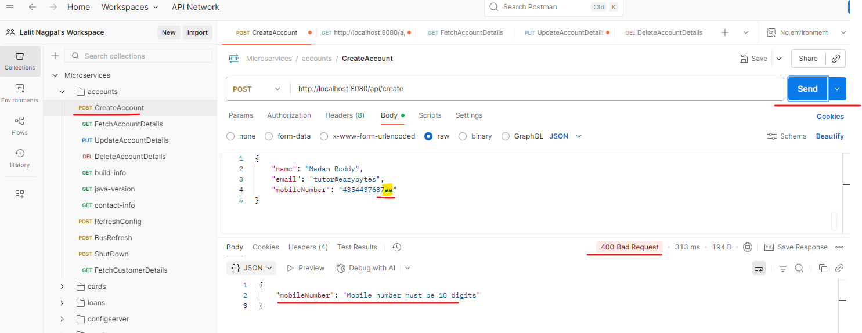

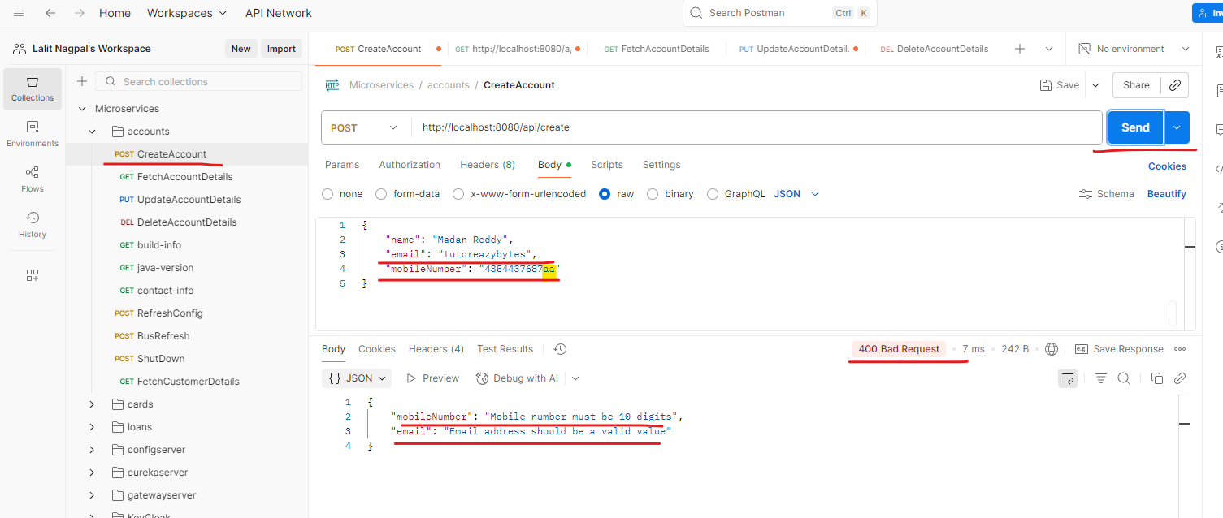

And for the name also this is the validation fail for email I didn't receive maybe because I have this @ so let me remove this and try again. So this time I'm also getting the validation error message for email as well. So this confirms my validations are working on my create operation. So let me roll back all these inside our AccountsController. We need to make sure we are mentioning the annotation AllArgsConstructor. Previously, if you recall, we reverted these annotation to create a RuntimeException. Right now we don't want that RuntimeException. With that, let me save changes and do a build. Now what I'm going to do is I'm going to invoke the Create account API with a valid data. So let me click on the send button. You will see the operation is successful right now because I'm sending a valid data, so I'll go to fetch account here instead of ten digit, I'm going to send the nine digit mobile number.

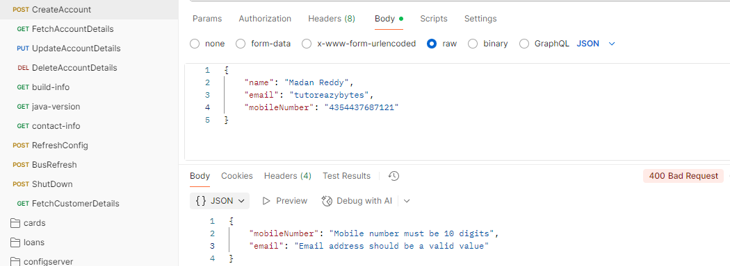

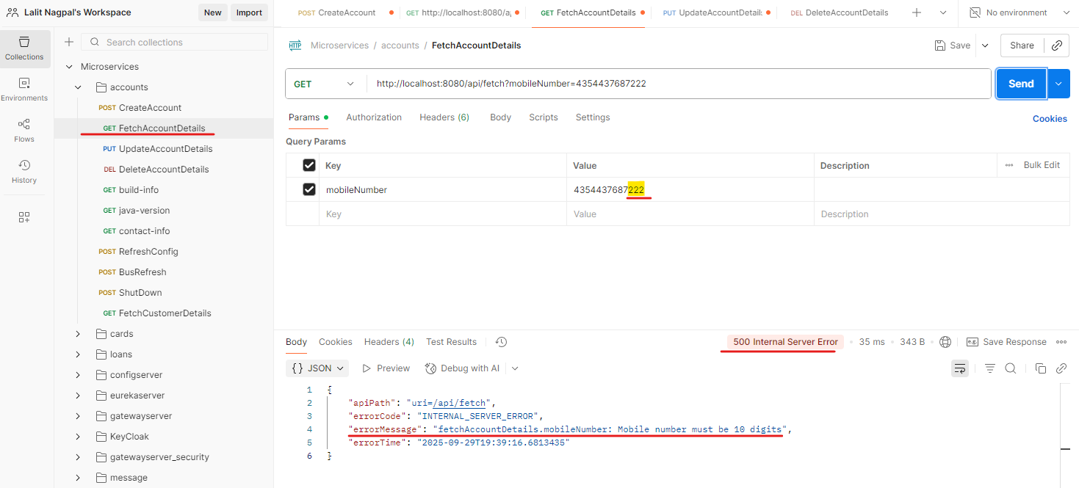

You see that my API failed because mobile number must be ten digit due to this validation, my API failed. So if I try to mention the ten digit mobile number, I'll get a proper response. Now, if I go to my update for update, also what I'm going to do is I'm just going to remove these @ and simply invoke these send. I'm getting a proper error response saying that email address should be a valid value. So for my update also it's working fine. Now I'll go to delete. For delete also, I'll make this mobile number as a nine digit number and click on the send button. You can see I'm getting the same validation error. If I try to send a valid mobile number and click on the send button, I'm getting a successful response. This way we are performing input validations on top of all our REST APIs. This is the standard approach that you need to follow. Off course you can enhance this further based upon your business requirements.

### Update Audit Columns using Spring Data

In all the tables of AccountsMicroservices we are maintaining these four metadata columns which will tell us when a record is created by whom and when it is updated and by whom. As of now, we are manually updating these CREATED_AT and CREATED_BY and there is a pending defect also where we are not updating these UPDATED_AT and UPDATED_BY whenever an update operation is happening. With the help of Spring Data JPA, we can update these metadata columns automatically, which means we can give this responsibility to the spring data JPA because anyway, the framework is going to take care of creating all the insert scripts, update scripts or delete scripts or select scripts, all kind of SQL scripts right now, everything is in the control of Spring data JPA framework. We have not written any single SQL query inside our application.

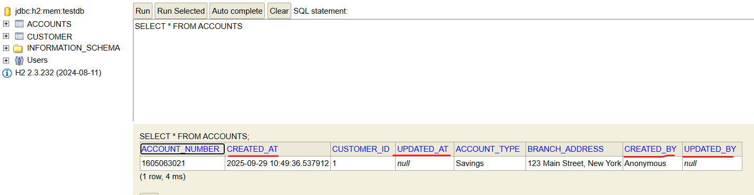

Since spring Data JPA is taking care of all SQL interactions and database interactions. We can hand over this responsibility of updating these four metadata columns. And spring data JPA also support these auditing feature. So in order to achieve these auditing by spring data JPA first we need to go to the entity class where we have these four metadata columns. So inside this BaseEntity we are mentioning these four metadata columns. So here on top of these createdAt, we need to mention an annotation which is CreatedDate and very similarly on top of @CreatedBy we need to mention an annotation which is @CreatedBy and on top of updated at field we need to mention an annotation which is LastModifiedDate and for updatedBy also we need to mention an annotation which is LastModifiedBy. So these are the four annotations supported by the spring data framework itself. With these annotations we are telling to the spring framework, whenever you see these fields inside a table or an entity, please make sure you are updating the date time based upon when the record is being updated or inserted.

import jakarta.persistence.Column;

import jakarta.persistence.EntityListeners;

import jakarta.persistence.MappedSuperclass;

import lombok.Getter;

import lombok.Setter;

import lombok.ToString;

import org.springframework.data.annotation.CreatedBy;

import org.springframework.data.annotation.CreatedDate;

import org.springframework.data.annotation.LastModifiedBy;

import org.springframework.data.annotation.LastModifiedDate;

import org.springframework.data.jpa.domain.support.AuditingEntityListener;

import java.time.LocalDateTime;

@MappedSuperclass

@EntityListeners(AuditingEntityListener.class)

@Getter @Setter @ToString

public class BaseEntity {

@CreatedDate

@Column(updatable = false)

private LocalDateTime createdAt;

@CreatedBy

@Column(updatable = false)

private String createdBy;

@LastModifiedDate

@Column(insertable = false)

private LocalDateTime updatedAt;

@LastModifiedBy

@Column(insertable = false)

private String updatedBy;

}

The same applies for last modified date as well, and with the help of @CreatedBy and @LastModifiedBy, we are telling to the Spring data JPA framework like who is trying to create or update the records inside the database table. But here there is a problem. My spring data framework can get that date time from the server or from the local system. How about who is creating or who is updating that data? It does not have any clue. For the same, we need to write a small logic in order to write the small logic. Let me create a new package with the name audit. So inside this audit package I'm going to create a new class with the name AuditAwareImpl. . So this is the class that I want to create. And this class should extend a class called AuditorAware since our createdBy and updatedBy are of type String, we need to make sure we are mentioning this String here.

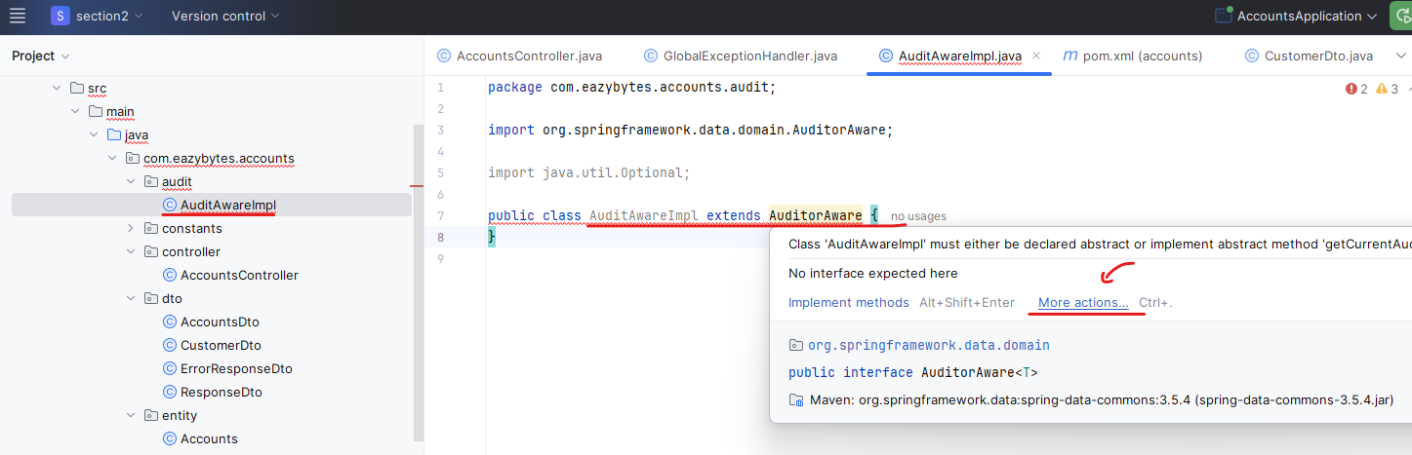

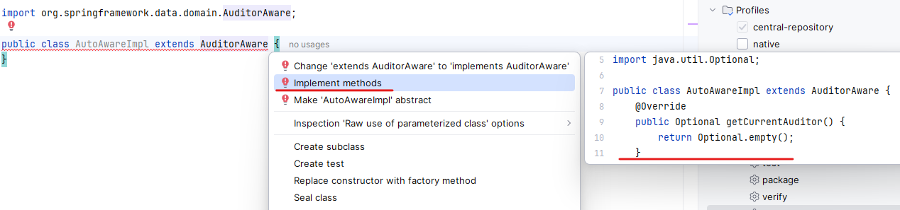

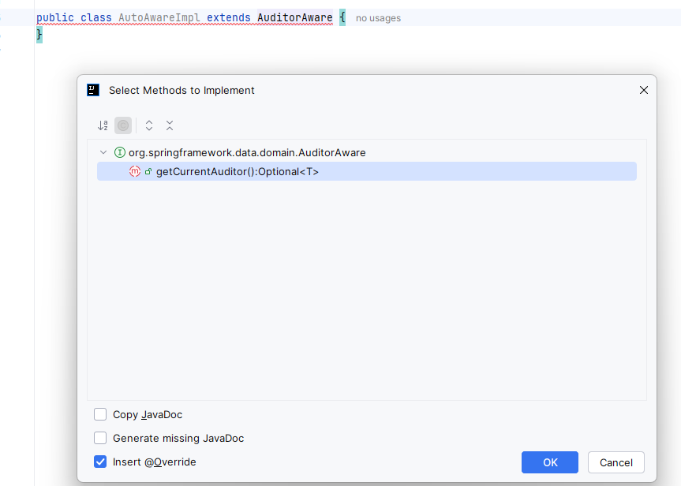

And we get the below

import org.springframework.data.domain.AuditorAware;

import java.util.Optional;

public class AuditAwareImpl extends AuditorAware {

@Override

public Optional getCurrentAuditor() {

return Optional.empty();

}

}

So whenever we extend this class we need to override a method so for the same, let me click on this more actions and implement methods. So this is the method that I need to implement. The method is getCurrentAuditor(). So I need to write a logic inside this method to make sure I am returning who is the current auditor so that my spring data JPA framework can leverage it to update the createdBy and updatedBy whenever is needed. I think this is an interface. We should use implements here, so let me use the implements. So now inside this method I'm going to write a small logic. The logic is instead of returning a empty value, I'm going to return an hardcoded value which is ACCOUNTS_MS. MS means micro service.

@Component("auditAwareImpl")

public class AuditAwareImpl implements AuditorAware {

@Override

public Optional getCurrentAuditor() {

return Optional.of("ACCOUNTS_MS");

}

}

So this is the value that I want to be considered by the Spring Data JPA framework whenever it is trying to populate the columns createdBy and updatedBy later on when we integrate our micro services with the Spring security framework to enforce security on micro services, I'll be showing you how to populate the logged in user or logged in client application till to the point we integrate to the spring security framework. We need to continue with this hardcoded value. So now I need to make sure that I'm mentioning @Component annotation on top of this and giving a name AuditAwareImpl. So this is a bean name that I want to consider. This name can be anything. I'm just trying to match with this class name.

So once we define this component, we need to go to the BaseEntity and here we need to mention an annotation which is @EntityListeners. And to this annotation I need to pass a class name which is AuditingEntityListener.class. So this is a class present inside the spring data framework. Now we have established all the details in order to perform the auditing by the Spring data framework.

import jakarta.persistence.Column;

import jakarta.persistence.EntityListeners;

import jakarta.persistence.MappedSuperclass;

import lombok.Getter;

import lombok.Setter;

import lombok.ToString;

import org.springframework.data.jpa.domain.support.AuditingEntityListener;

import java.time.LocalDateTime;

@MappedSuperclass

@EntityListeners(AuditingEntityListener.class)

@Getter @Setter @ToString

public class BaseEntity {

@Column(updatable = false)

private LocalDateTime createdAt;

@Column(updatable = false)

private String createdBy;

@Column(insertable = false)

private LocalDateTime updatedAt;

@Column(insertable = false)

private String updatedBy;

}

As a last step, we need to activate this feature provided by the Spring Data Framework. For the same, we need to go to the main class, which is application after the spring boot application, we need to mention an annotation which is @EnableJpaAuditing and using this EnableAuditing annotation. We need to invoke the param which is AuditorAwareRef to this AuditorAwareRef. We need to pass the bean name of the AuditoAwrae I am, so I need to take this post that I need to mention. The same here. This way we are telling to the spring boot framework. Please activate the JPAAuditing and please leverage the bean with the name audit aware to understand the current auditor. And apart from that, inside the BaseEntity we already mentioned these annotations like entity listeners createdAt, createdBy, lastModifiedDate and lastModifiedBy.

import org.springframework.boot.SpringApplication;

import org.springframework.boot.autoconfigure.SpringBootApplication;

import org.springframework.data.jpa.repository.config.EnableJpaAuditing;

@SpringBootApplication

@EnableJpaAuditing(auditorAwareRef = "auditAwareImpl")

public class AccountsApplication {

public static void main(String[] args) {

SpringApplication.run(AccountsApplication.class, args);

}

}

So we are good. As a next step, we can go to the AccountServiceImpl and delete the manual code where we are trying to populate these createdAt and createdBy. So this is the place I have written two lines of code, so let me remove that. And very similarly here also I have two lines of code. I'm just removing them. I'm saving the code and doing a build. I'll go to the postman and try to test these changes. First, I'll try to create a new record. So let me validate my database tables now so you can see first I'm trying to run the accounts related and as of now you can see createdBy these ACOUNTS_MS and this is the date. And let me check for customer as well. The same is being updated right now.

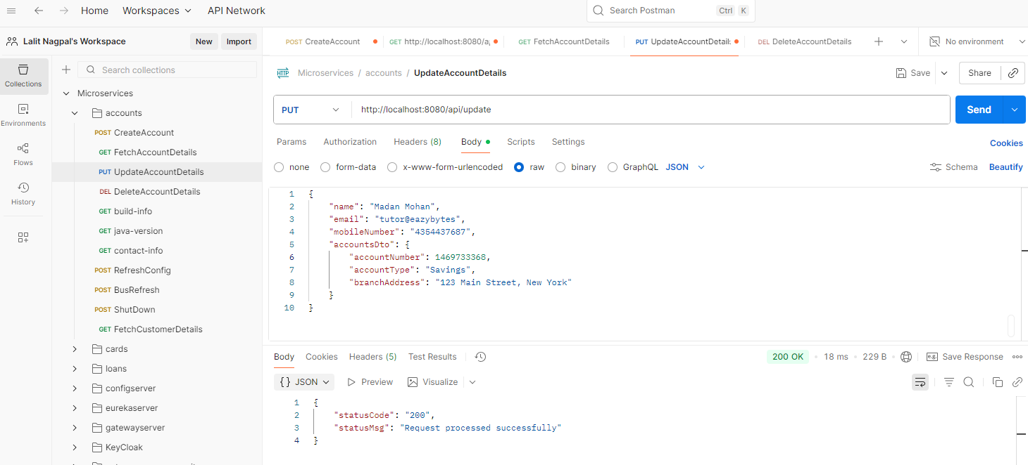

So as a next step, we can validate whether this is happening for updated columns as well. For the same, what we have to do is first we need to fetch the account details with the fetch operation. So these are the account details. So let me take this response and mention inside the RequestBody of the update account details and instead of ready, I'll mention Mohan. And very similarly, instead of one, two, three, I'll mention one, two, four. Now let me click on this send button. You can see the operation is successful. I can go to the database now. I'm trying to rerun this query and you can see the updatedBy and updatedAt is automatically coming. The same will happen for accounts as well. So this is working perfectly. So we right now gave the responsibility of auditing to the spring data framework. This is great and this is one of the standard that you can also follow inside your REST APIs and microservices.

## Documentation – Swagger

We need to implement one more standard inside our AccountsMicroservice, which is documenting all our REST APIs that we have developed so far. Here you may have a question like why should I document my own REST APIs? I know everything about them. I built my own REST APIs. I don't want to again document my REST APIs. To some extent you can live with that argument, but as soon as you start exposing your REST APIs and microservices for external agencies or to some other team inside your organization who are supposed to consume your microservices or REST APIs, think like there is an UI team or there is a mobile application team. They want to consume your backend logic with the help of your REST APIs or microservice. These kind of scenarios, they will have lot, many questions. The questions are like what is the request format that you are going to accept? What is the response format that they are going to receive? What are the validations that you have enforced inside your REST APIs? To some extent you can answer these questions by scheduling a meeting, and inside the meeting you can discuss everything about your REST APIs and you think you are good with that. But in long run, think about the pain process that you have to go through. If more and more third party applications are more and more other developers, they are trying to consume your REST APIs and even you may receive such requests from the testing team also. What is the request format? What is the response format? What is the validations that you have?

So all these questions will make your life tough and you need to repeat and share this information every time someone asks you. Instead, it will be a good idea to document our REST APIs by following a industry standard. Let's try to understand how to document our REST APIs. The standards that we need to follow here is Open API specification. Open API is a open source community who maintain how to document our Http APIs like REST APIs that provides a standardized means to define your API to others. So whoever is trying to consume your REST APIs or whoever is trying to test your REST APIs, they can quickly discover how an API works. They can configure infrastructure, they can also generate client code, server code and create test cases from your APIs quickly.

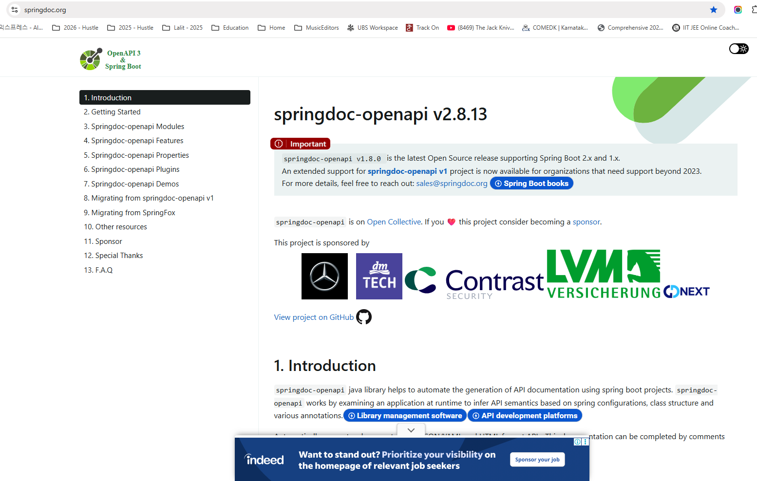

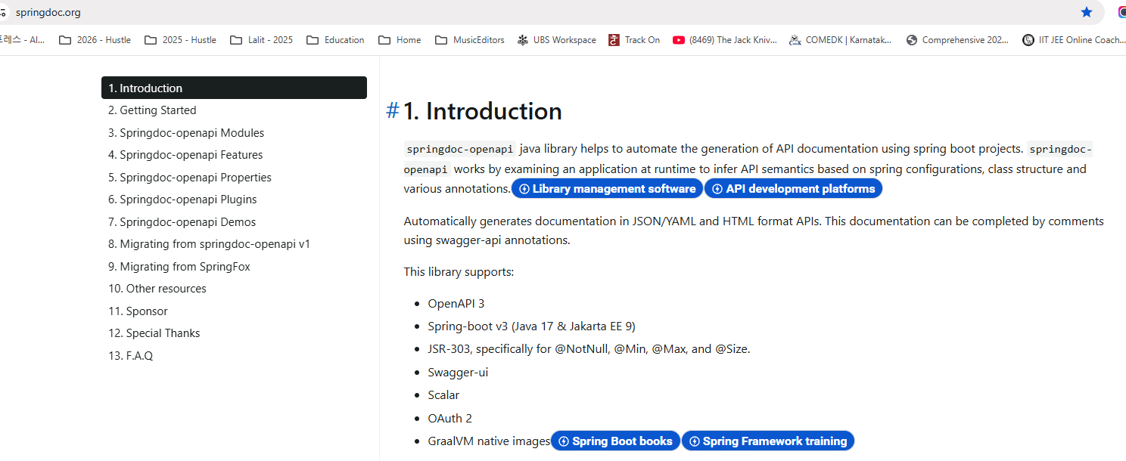

Whenever you document your REST APIs by using these open API specification. Here you might be under the assumption this is a very complex task and to document my REST service it need a lot of time. That's not correct. It is going to be super, super easy. With the help of the library called Spring Doc Open API. If you go to this website which is springdoc.org, it has all the details and it has all the steps that you need to follow to get started with documentation of our REST APIs. oSo let's try to explore more about these springdoc-openapi. If you can scroll down, there is a getting started page where you can simply add a maven dependency into your spring boot web application or microservice web application. And behind the scenes it is going to scan all your REST APIs and prepare the documentation for your rest APIs based upon the open API specification. And it is also going to provide you an swagger UI using which anyone can understand your REST APIs, the details about your REST APIs and the validations that you have enforced everything.

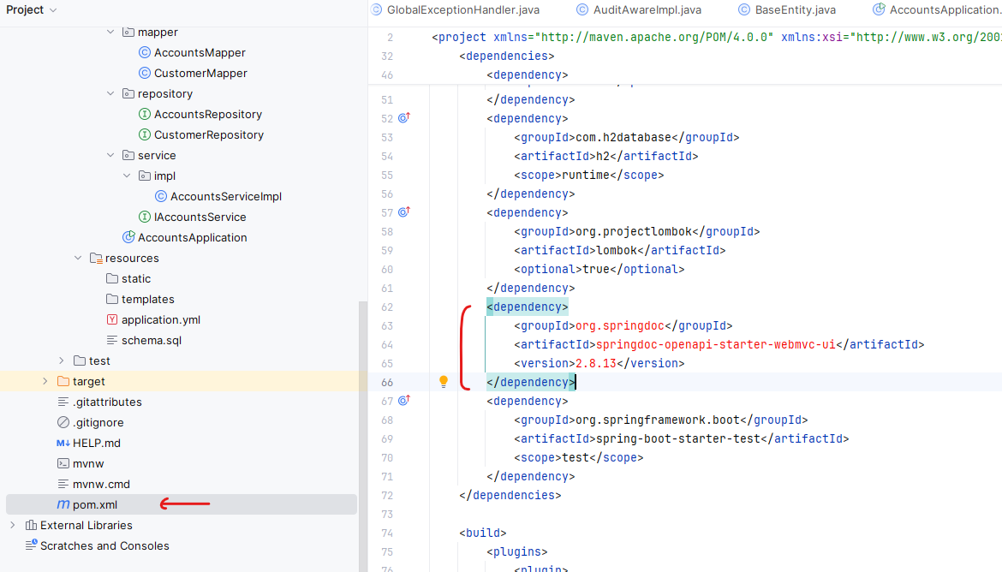

Run a maven clean and then install and we should get the dependency then

As a next step, let's try to add this dependency into our pom.xml, let me copy this dependency and this dependency is going to work only if you are using a spring boot version which is greater than or equal to 3.0. For some reason, if you are building your microservice with an older version of spring boot, then you need to use a different version of Openapi specification, which is spring.openapi v1.7.0. So you can see this version is going to support all the spring boot versions, which has a version of 2.x and 1.x. Since we are using a spring boot three c.x version, we need to make sure we are using this dependency. So let me take this and I'll go to the pom.xml inside my pom.xml just after this Lombok related dependency, I'm going to add my new dependency related to springdoc-openapi-starter-webmvc-ui.

Please make sure you are validating this version number with the code present inside the GitHub repo. In future, If there is a new version released for spring doc Openapi. I'm going to update the same inside the GitHub repo. So once we add this dependency please load the maven changes which will download these new dependencies that we have added. With this we should be good, let me save these changes and do a build. Once the build is completed, we can try to start our application. Since we added a new dependency, please make sure you are restarting your application. So let me click on this debug icon that I have here. Which will start my application at the default port 8080. So as a developer, I have not done anything. I simply added a springdock-openapi dependency inside our pom.xml. So now let's try to see the magic that it is going to do behind the scenes. I'm trying to open a path which is localhost:8080/swagger-ui/index.html. So as soon as I tried to access this page, you can see this is a beautiful documentation about my REST APIs that I have built inside the AccountsMicroservice, the server URL populated from the root of our application.

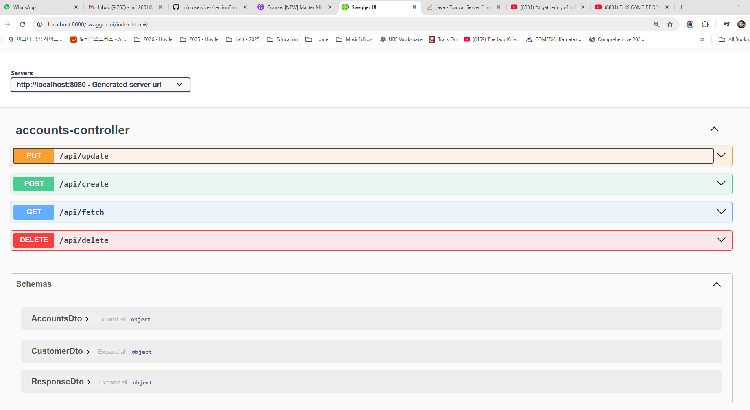

So you can see inside AccountsController. We have defined four different type of REST APIs and these are the REST API paths for all of these APIs that we have inside controller. This supports put operations similarly post, get and delete operation. If you try to open these any of these operation, you will be able to see here that for the put operation there are no parameters which is going to accept it is only going to accept a body which is a mandatory and it is going to accept a Json type. And this is the format that it is going to accept. Someone has to send what is the name, what is the email, what is the mobile number, what is the account number, account type and branch address. By using an separate embedded object which is AccountsDto, you can also click on the schema which will show you the input object schema. If you recall, inside our update operation, we are using CustomerDto as an input object. The same is getting reflected here.

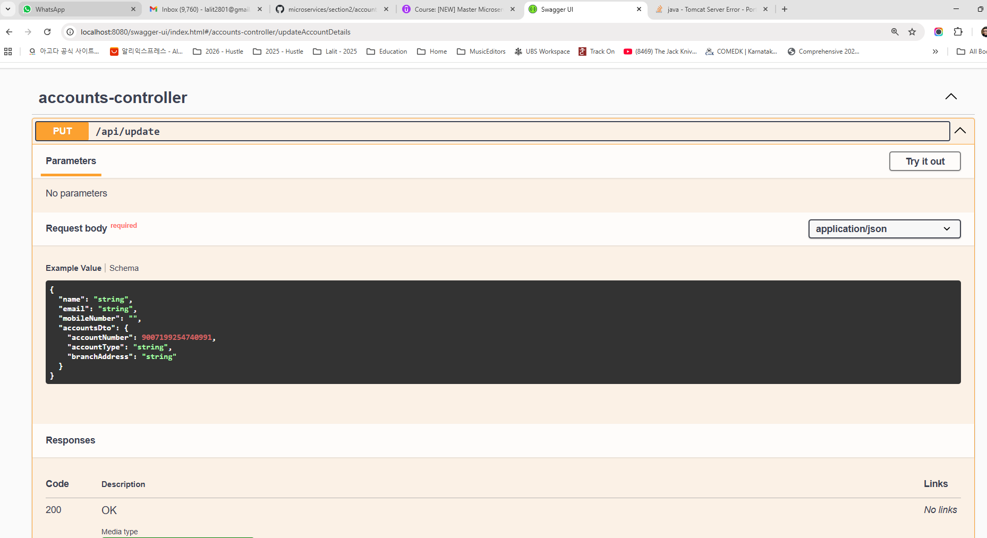

Click on schema tab below Request body

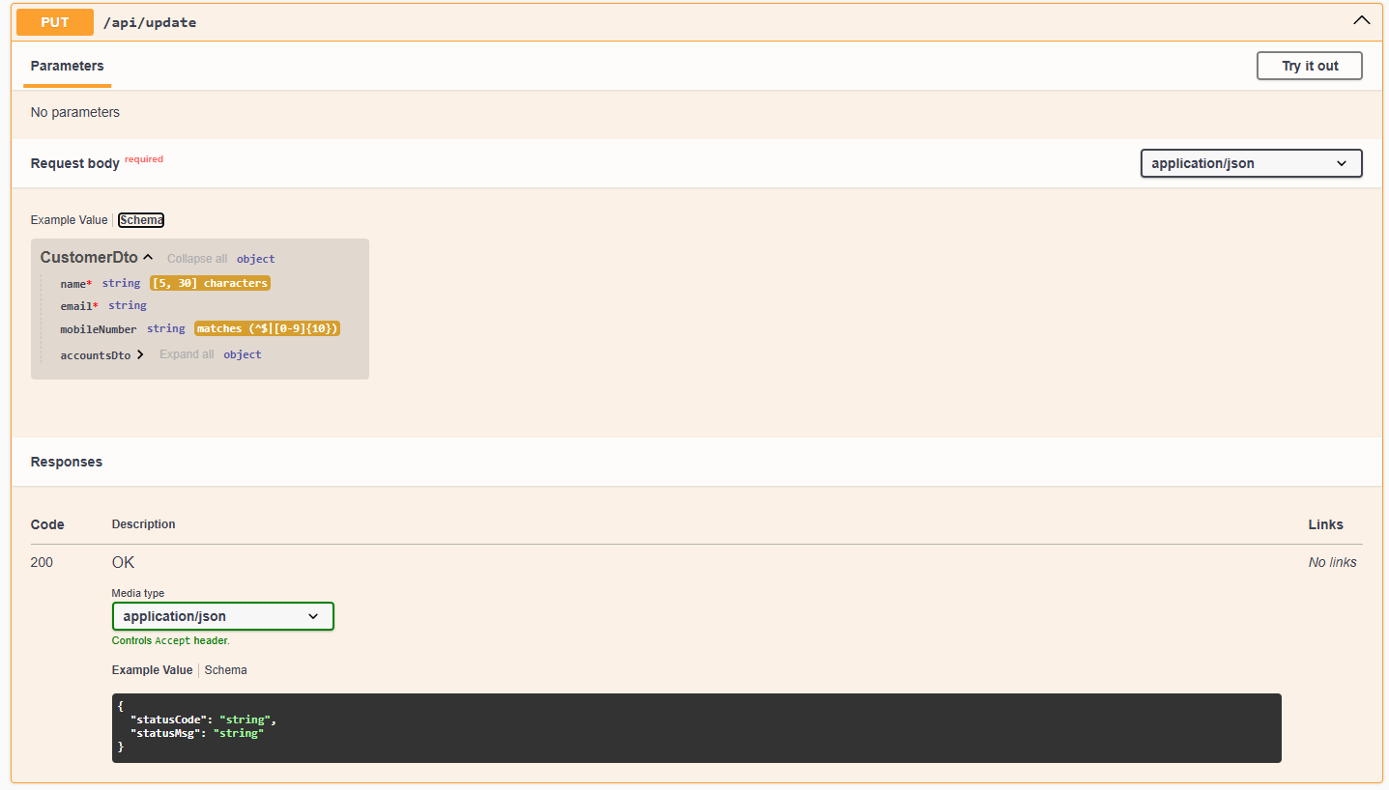

Like the name is going to be mandatory and it has a min length and a max based upon our annotations that we have defined and email is going to be mandatory for mobile number the patent is going to support is this is a pattern and similarly it has an embedded object with the name account and it has so many other inner fields. So all this information is coming from our DTO object. If you can open the any of the object like AccountsDto or CustomerDto inside these DTOs, we have defined all these annotations using which we are trying to perform input validations. The same information is being converted into the documentation so that anyone right now can understand about my REST APIs so they will know which fields are mandatory, what is the format, what are the validations that we have? And very similarly, they will also know what is the response they can expect when these operation invocation is successful. Like for this update operation, we are going to return a code 200 with the description okay. And the ResponseBody going to have statusCode and statusMessage.

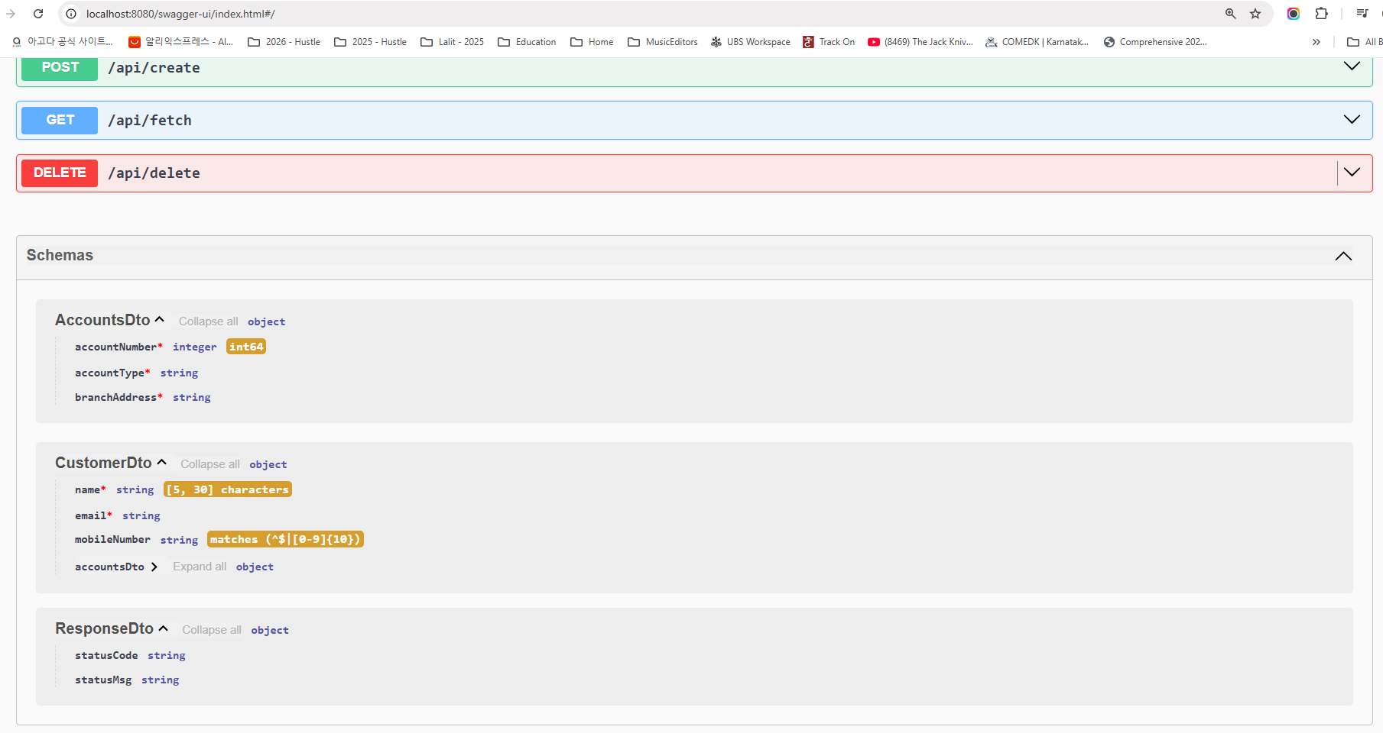

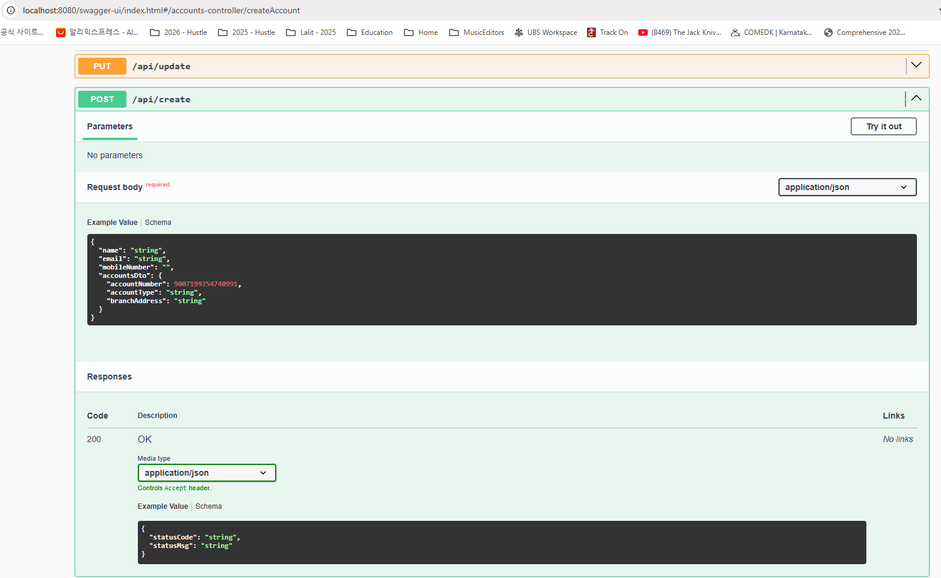

So very similarly, you can also validate post operation, which is going to accept a schema of type CustomerDto and here also we are going to return a sample status code and status message. Now coming to the API fetch, which is a get operation for these, we are going to accept the request with the help of a query param which is of type mobile number and mandatory. And you can see this is a mobile number. And very similarly we also have the what is the response format. Here the response format, you can see we are going to send with the help of the schema, which is CustomerDto and the same example structure is populated here. Very similarly for delete also we are going to accept a query param with the name mobile number and the response is going to be simply status code and status message. Towards the end you are going to see a schema section where you can see all the request and response objects that your Rest API is going to use inside a microservice. So here AccountsDto we know what is the structure and similarly CustomerDto we know what is the structure. And ResponseDto we also know what is a structure. So based upon all these documentation, anyone can easily understand about my REST APIs, you can simply give this URL to them. They can analyze if needed. They can also use this try it out option here like they can directly test by sending some mobile number and clicking on execute. They'll get a response saying that so-and-so is invalid because there is no customer found with a given input mobile so they can actually test from this page itself on a high level.

You can see there are many advantages documenting your REST APIs. So this is enough to get started with the documentation of your REST APIs and microservices. So please, please make sure at least your documenting by simply adding this maven dependency inside your microservices. I see many times even senior developers, they ignore this important step and they will struggle a lot when they deploy their microservices into production and someone is trying to consume their services. After going through all this pain process, they will come to know about this open API specification and swaggerui. Then only they are going to add these dependency. You don't have to follow that pain process.

So this is a very quick way of getting started. But sometimes we want to be more professional about our spring boot REST API documentation. Like you can see a lot of information is missing. Like we are displaying all technical information like controller name and similarly we are displaying the CustomerDto, which is a technical name of our object and there are no example values like we are just saying the name can be String, email can be String, AccountType can be a String branch address can be a String. We are not providing any example data to the clients. When you provide the example data, it will be more clear to the developers and client applications who are trying to consume your REST APIs. That's why we should use few of the annotations available inside the Spring Doc Open API Library. Using these annotations we can try to enhance this documentation further and will make it look very professional and production ready.

### Enhancing Documentation with @OpenAPIDefinition

We decided to improve our REST API documentation further. For the same, first, I want to target this the top section. So as of now you can see this section does not have any much information about what is the purpose of my REST APIs that I'm trying to expose here.

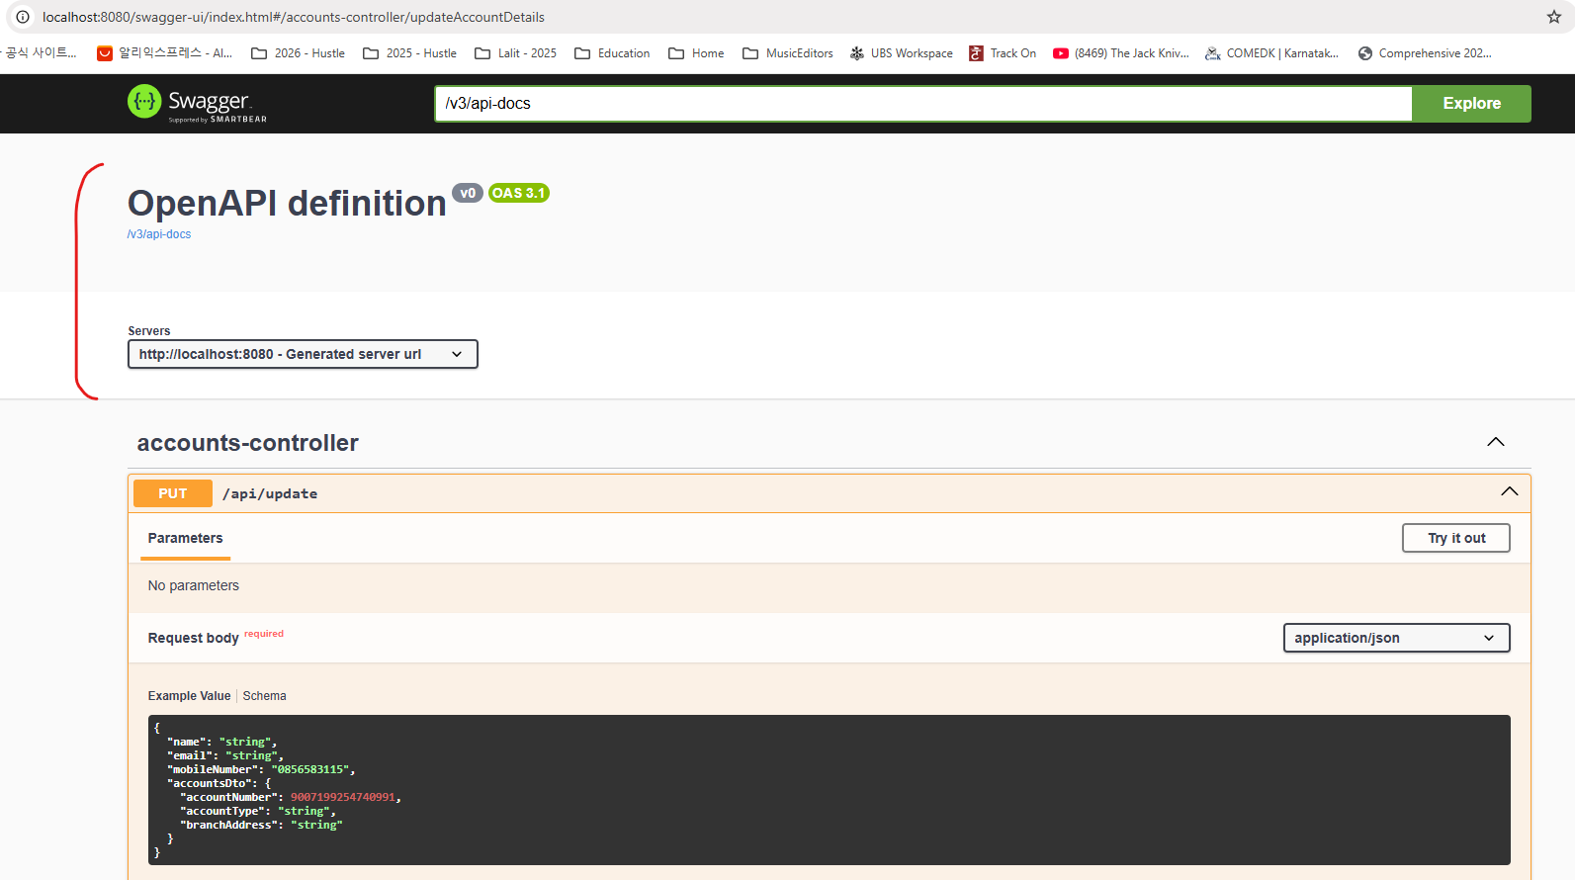

What is the summary? What is the description? Is there any contact information? Is there any licensing information? If someone has such questions, they can always check that kind of information inside my documentation itself. So let's try to document these details with the help of few annotations that we have. For the same, we need to go to the location where our Springboot main class is present. Here we have AccountsApplication. This is the main class. Here we need to mention an annotation with the name Openapi Definition. We are trying to provide the definition details with the help of open API. That's why we need to use this annotation. Using this annotation we need to invoke a param which is info and to this info param we should again invoke an annotation which is @Info. Using this annotation I can populate what is the title of my springboot documentation. So using this title you can mention a short summary about your REST APIs. So here I'm going to mention something like Accounts Microservice REST API Documentation. In real projects you can mention whatever makes sense to you based upon your business application. After this title, we can also mention description. Using this description, we can provide a good description about our REST APIs. Here also, I'm going to mention a description saying that EasyBank Accounts Microservice REST API Documentation. And post that, we can also mention version. As of now I'm trying to build a version v1 so if you are trying to build a new version, you can always change to v2, v3 based upon your business requirements. Post that I can also invoke contact param and to this contact param, since this is going to accept multiple information, we need to first invoke the Contact annotation available inside the spring doc library. So to this Contact annotation we can pass multiple details. These details are like what is the name of the person to whom you can try to contact whenever you have some questions or any issues with these documentation or with the REST APIs.

import io.swagger.v3.oas.annotations.ExternalDocumentation;

import io.swagger.v3.oas.annotations.OpenAPIDefinition;

import io.swagger.v3.oas.annotations.info.Contact;

import io.swagger.v3.oas.annotations.info.Info;

import io.swagger.v3.oas.annotations.info.License;

import org.springframework.boot.SpringApplication;

import org.springframework.boot.autoconfigure.SpringBootApplication;

import org.springframework.data.jpa.repository.config.EnableJpaAuditing;

@OpenAPIDefinition(

info = @Info(

title = "Accounts microservice REST API Documentation",

description = "EazyBank Accounts microservice REST API Documentation",

version = "v1",

contact = @Contact(

name = "Madan Reddy",

email = "tutor@eazybytes.com",

url = "https://www.eazybytes.com"

),

license = @License(

name = "Apache 2.0",

url = "https://www.eazybytes.com"

)

),

externalDocs = @ExternalDocumentation(

description = "EazyBank Accounts microservice REST API Documentation",

url = "https://www.eazybytes.com/swagger-ui.html"

)

)

@SpringBootApplication

@EnableJpaAuditing(auditorAwareRef = "auditAwareImpl")

public class AccountsApplication {

public static void main(String[] args) {

SpringApplication.run(AccountsApplication.class, args);

}

}

So here I'm just mentioning my name very similarly we can mention what is the email of this person, and this information don't have to be an individual information always. You can define an email of your team. It's up to you what kind of information you want to mention here and the name and email. Similarly, we can also mention what is a URL information where people can try to reach out to you. So here I'm just mentioning my website, which is eazybytes.com. Once we provide all this contact information, we can also provide license information. Because in real project we should also provide license details whether our REST APIs are free to use or you have any license restrictions. So so such kind of information you can always mention with the help of these License annotation and linside this License annotation we can invoke name parameter. So here I'm just passing the name as Apache 2.0, which is the licensing that I want to follow. After this name, we can also provide URL details where people can try to read more about your licensing details. So for now I'm just mentioning my website URL. So these are all sample data that I'm mentioning here, but I hope you understand in real project you should use something which is relevant to your project and your organization. Once we mention all these Info information, you can see under this info we have mentioned title, description, version, contact and license details.

We can also mention external documentation details. For example, if people want to learn more about our REST APIs, more about our business. So in such scenarios we can provide some external documentation that people can read in case if they want to gain more knowledge about our REST APIs and application. So here I'm trying to mention some description. The description is going to be EasyBank Accounts, Microservice REST API Documentation and post that we should also mention the URL details where people can read more about your REST APIs and your organization business. So here I'm just mentioning some dummy URL. So with this way we can provide many other details. Like if you if you can try to see what other details that we can mention, we can mention security details like what security that you follow. We can provide server details like URL details where our REST APIs are hosted, so we can provide tax information, extension details. So this is all advanced concepts inside Openapi specification which need its own discussion. If you want to know everything about Openapi specification and swagger ecosystem. You can enroll one of my course inside Udemy focusing on open API specification and swagger. With this changes, we should be good from these main class which is AccountsApplication. So let me save this changes.

Do a build. Once the build is completed I can go and refresh my swagger ui HTML. So here, as of now you can see this entire section is empty. So let me refresh this page and this time you can see I have an beautiful title description and contact details to whom they can send an email, they can visit a website and this is the licensing information and this is the external documentation information. This way we enhance this section, which is common for all our REST APIs. Now, as a next step, we should also enhance this documentation present. Under this controller, we should not display technical information like our class name and similarly, we are trying to display the host name, which is not good. On top of that, we should also provide some example data to our clients so that they can easily understand our REST APIs. We can try to enhance this documentation further in the next lecture before we try to close this lecture I just wanted to share one more important information about the Spring Boot main class, which is AccountsApplication. So whenever you see this annotation, it indicates that this is a main class of US spring boot web application or microservice. So as of now you can see all my packages I have created as a sub packages where my spring boot main class is present. My spring boot main class is present inside a package with the name com.eazybytes.accounts and all my remaining packages I have created inside them as a sub package. And this is the most recommended approach.

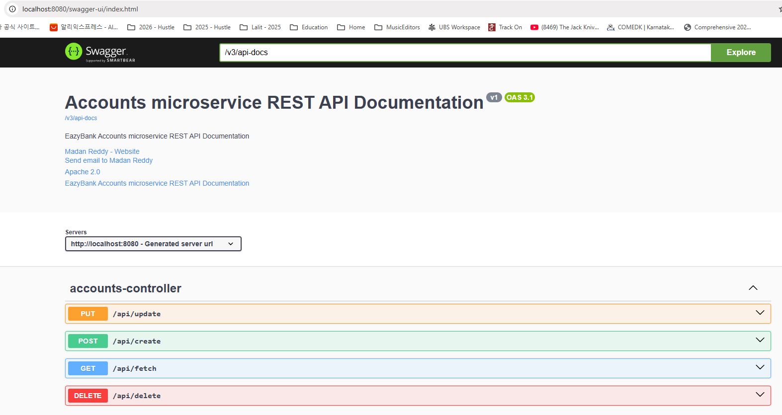

For some reasons if you are not following the standard like you are creating this controller package somewhere outside this package. So in such scenarios it is mandatory to mention details to spring boot where your controllers are, where your repositories are, where your entity classes. So all such information we are supposed to pass using certain annotations. So these annotations I'm going to mention for your reference, like you can see using ComponentScan, we need to mention all the packages where our beans are present. Like here under the controller we have beans and similarly we also have beans inside the service package. So all those packages we need to repeat with the help of this ComponentScan annotation inside these ComponentsScan annotation and similarly you need to mention where all your repositories are present like JpaRepositories and JpaEntities. So here I have commented these annotations because I don't need to mention them.

import io.swagger.v3.oas.annotations.ExternalDocumentation;

import io.swagger.v3.oas.annotations.OpenAPIDefinition;

import io.swagger.v3.oas.annotations.info.Contact;

import io.swagger.v3.oas.annotations.info.Info;

import io.swagger.v3.oas.annotations.info.License;

import org.springframework.boot.SpringApplication;

import org.springframework.boot.autoconfigure.SpringBootApplication;

import org.springframework.data.jpa.repository.config.EnableJpaAuditing;

@OpenAPIDefinition(

info = @Info(

title = "Accounts microservice REST API Documentation",

description = "EazyBank Accounts microservice REST API Documentation",

version = "v1",

contact = @Contact(

name = "Madan Reddy",

email = "tutor@eazybytes.com",

url = "https://www.eazybytes.com"

),

license = @License(

name = "Apache 2.0",

url = "https://www.eazybytes.com"

)

),

externalDocs = @ExternalDocumentation(

description = "EazyBank Accounts microservice REST API Documentation",

url = "https://www.eazybytes.com/swagger-ui.html"

)

)

@SpringBootApplication

/*@ComponentScans({ @ComponentScan("com.eazybytes.accounts.controller") })

@EnableJpaRepositories("com.eazybytes.accounts.repository")

@EntityScan("com.eazybytes.accounts.model")*/

@EnableJpaAuditing(auditorAwareRef = "auditAwareImpl")

public class AccountsApplication {

public static void main(String[] args) {

SpringApplication.run(AccountsApplication.class, args);

}

}

Reason is I maintain these packages as a sub package inside my main package where my AccountsApplication is present. I hope this is clear. I always recommend you to follow this approach, for some reason if you are creating your classes, beans, repositories and entities in a different package, then please please make sure you are using these annotations. Otherwise your code is not going to work.

### Enhancing with @Tag, @Operation and @ApiResponse

Let's try to enhance our documentation of REST APIs further. So as of now, you can see I'm showing a AccountsController, which is a technical name, and there is no description about all the APIs that I have under this controller. So you can see if I click on this, all the APIs will be closed. And very similarly, if I can open these, I'll have more details about each of the REST APIs.

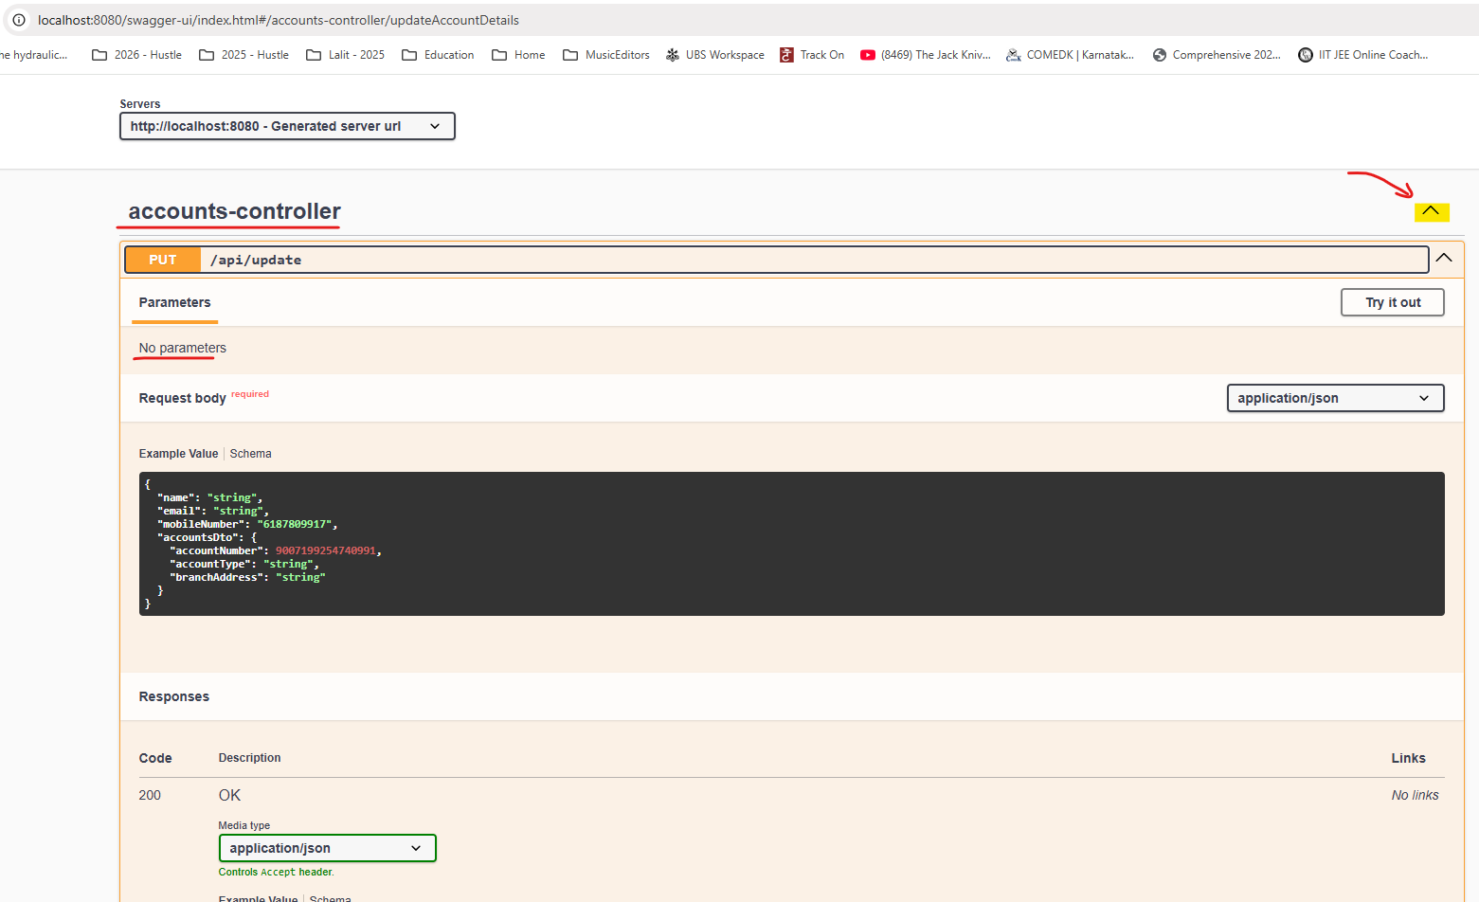

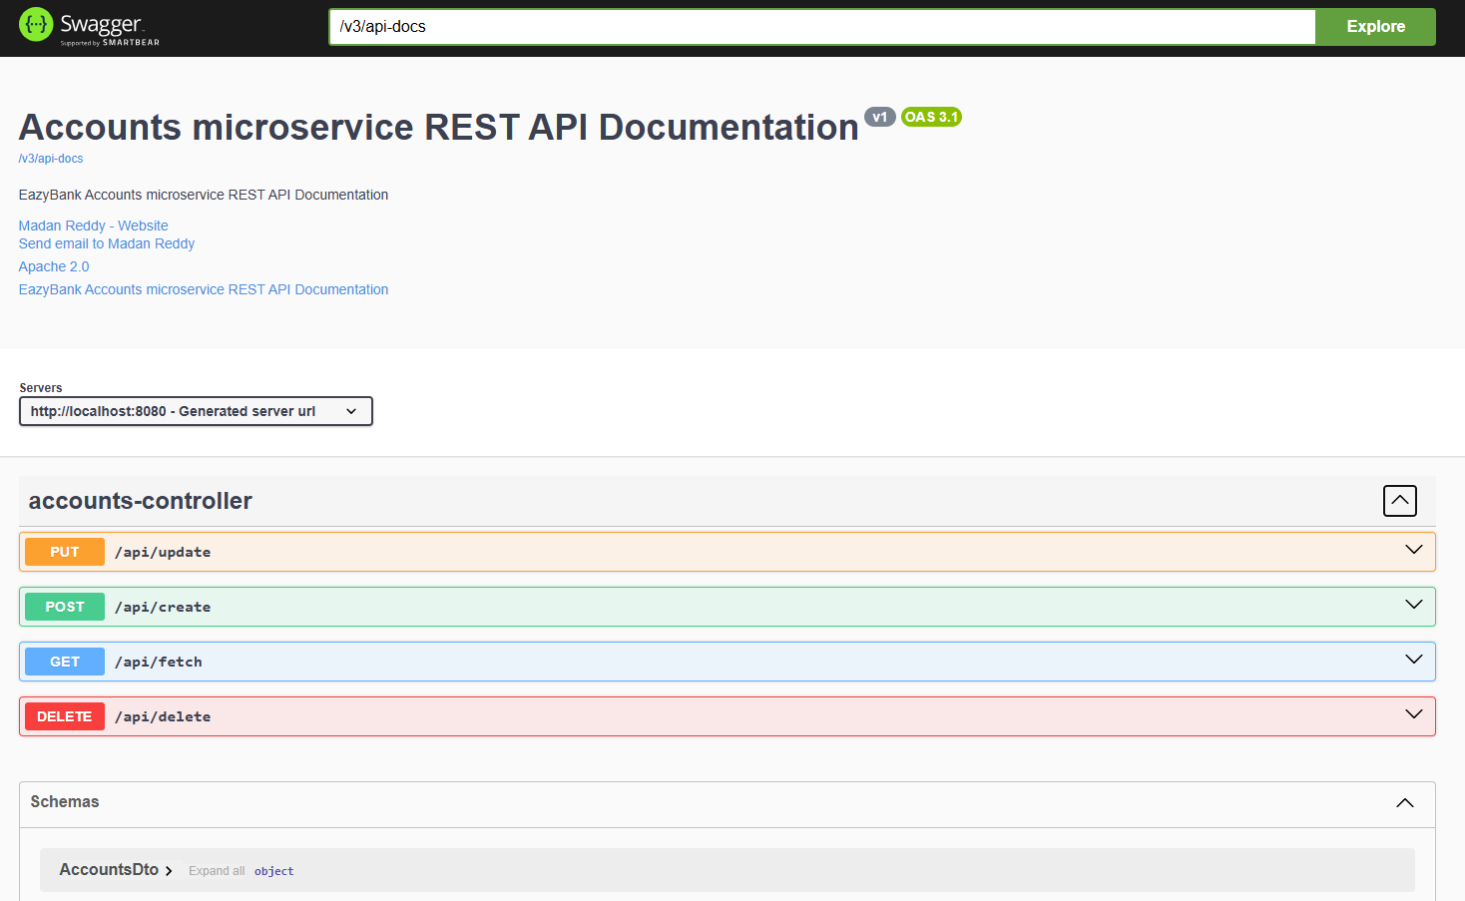

So if you have multiple controllers, you can close all of them like these and you can open and it is your responsibility to provide some good information about what is the purpose of the REST APIs that you have hosted under this controller are under this section, so let's try to enhance this further.

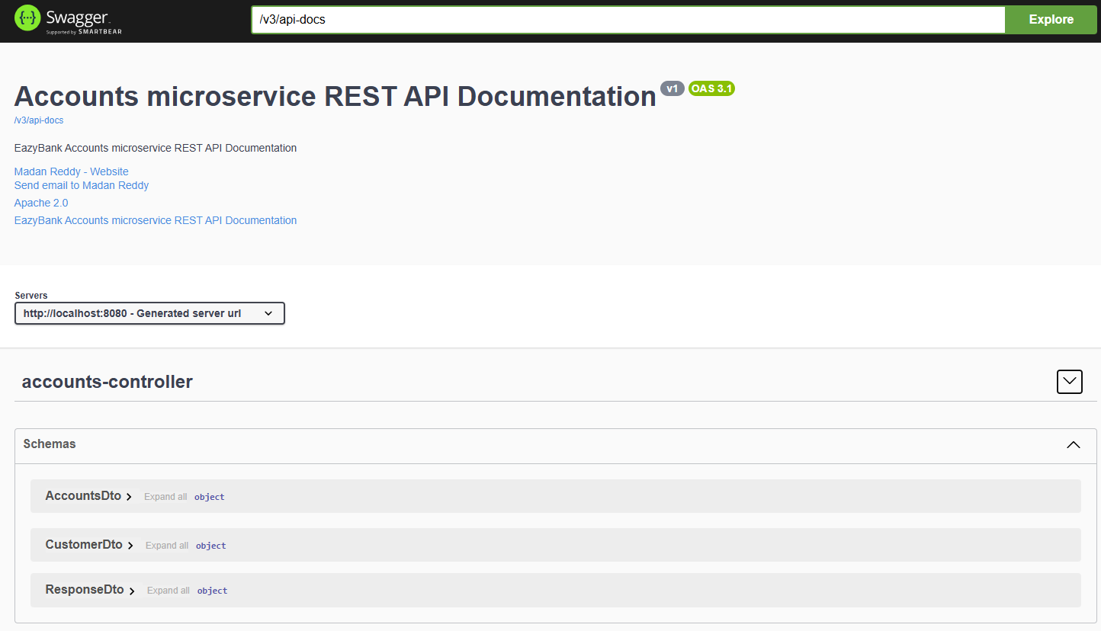

For the same, you need to go to the AccountsController class where we have this REST APIs. So here in order to provide some information which is specific to all the APIs present inside this controller class, we need to use an annotation which is @Tag. So let me try to use the same. So this annotation is also present inside the package of swagger and open APIs Spring Dock. So let me use this. And to this we can pass name using this name can provide some basic summary about all the APIs present inside this controller class. So here I'm just mentioning a summary saying that crud REST APIs for accounts in EasyBank. So this is what I want to provide here. Post that, we can also provide a description. So let me try to provide a description here. The description that I'm trying to mention here is crud REST APIs in EasyBank to create, update, fetch and delete account details. So now this makes sense to me. Let me save this changes. Do a build. with that, the rest API documentation also will get reflected inside my swaggerUI. So as of now you can see you are seeing only AccountsController, which is a technical name.

@Tag(

name = "CRUD REST APIs for Accounts in EazyBank",

description = "CRUD REST APIs in EazyBank to CREATE, UPDATE, FETCH AND DELETE account details"

)

@RestController

@RequestMapping(path="/api", produces = {MediaType.APPLICATION_JSON_VALUE})

@AllArgsConstructor

@Validated

public class AccountsController {

. . .

}

So if I try to refresh this page, you'll be able to see a beautiful name and description. This is more professional to the clients so they can easily understand. Under this section I have four REST APIs and the purpose of these four APIs are to handle the create update, fetch and delete operations. So now we provided a documentation about the controller layer.

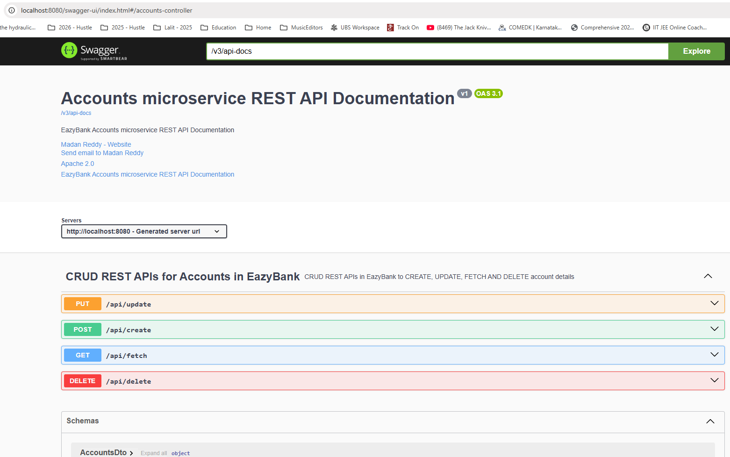

Similarly, we can also provide information at each api level. What is this API is supposed to do? What is the summary? What is the description? So all such information we can also mention for the same, we need to go to the method where we have developed these API inside the controller here, inside this class. First, I'm going to provide documentation for my post API, which is create.

So the annotation that we need to use here is @Operation. Since this is a API operation, we need to use this annotation and to this annotation first, we need to invoke summary, which is a parameter inside this annotation. And to this summary I'm going to mention something like Create Account REST API. Post this, we can also mention what is the description about this operation or API. So the description that I want to mention here, REST API to create new Customer and Account inside EasyBank. This will give more details to my client applications or end users. So now let me save this changes and do a build here.

import io.swagger.v3.oas.annotations.Operation;

import io.swagger.v3.oas.annotations.tags.Tag;

import jakarta.validation.Valid;

import jakarta.validation.constraints.Pattern;

import lombok.AllArgsConstructor;

import org.springframework.http.HttpStatus;

import org.springframework.http.MediaType;

import org.springframework.http.ResponseEntity;

import org.springframework.validation.annotation.Validated;

import org.springframework.web.bind.annotation.*;

@Tag(

name = "CRUD REST APIs for Accounts in EazyBank",

description = "CRUD REST APIs in EazyBank to CREATE, UPDATE, FETCH AND DELETE account details"

)

@RestController

@Validated

@RequestMapping(path="/api", produces = {MediaType.APPLICATION_JSON_VALUE})

@AllArgsConstructor

public class AccountsController {

private IAccountsService iAccountsService;

@Operation(

summary = "Create Account REST API",

description = "REST API to create new Customer & Account inside EazyBank"

)

@PostMapping("/create")

public ResponseEntity<ResponseDto> createAccount(@Valid @RequestBody CustomerDto

customerDto) {

iAccountsService.createAccount(customerDto);

return ResponseEntity

.status(HttpStatus.CREATED)

.body(new ResponseDto(AccountsConstants.STATUS_201,

AccountsConstants.MESSAGE_201));

}

As of now you can see for the post API nothing is visible like we're just showing the path.

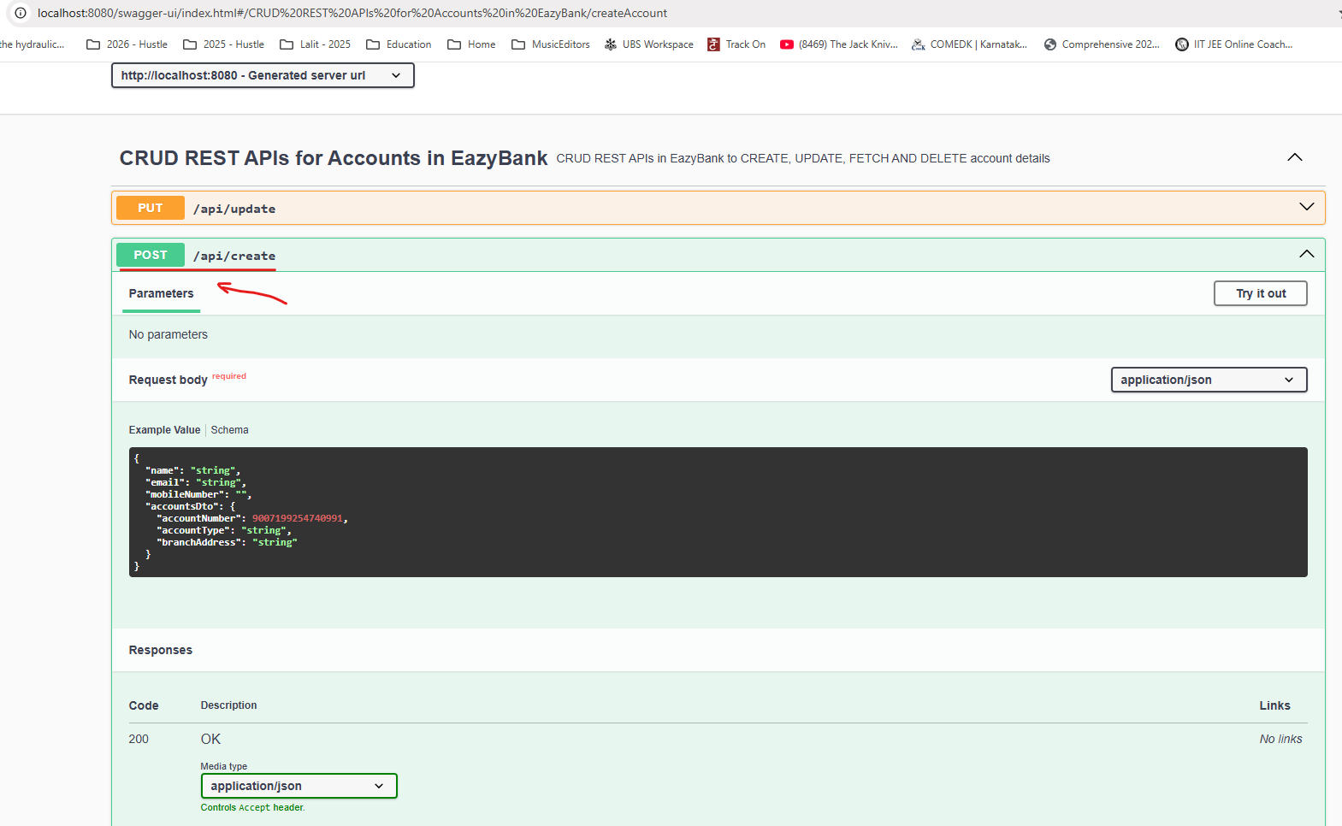

If I try to refresh this page this time you'll be able to see more information about my API. This is a summary like createAccount REST API and this is the description that we have mentioned and we also have good details about RequestBody coming to the Response, you can see it is always going to show you default 200 and okay with the default of schema value that we have inside the ResponseDto, which is status code and status message.

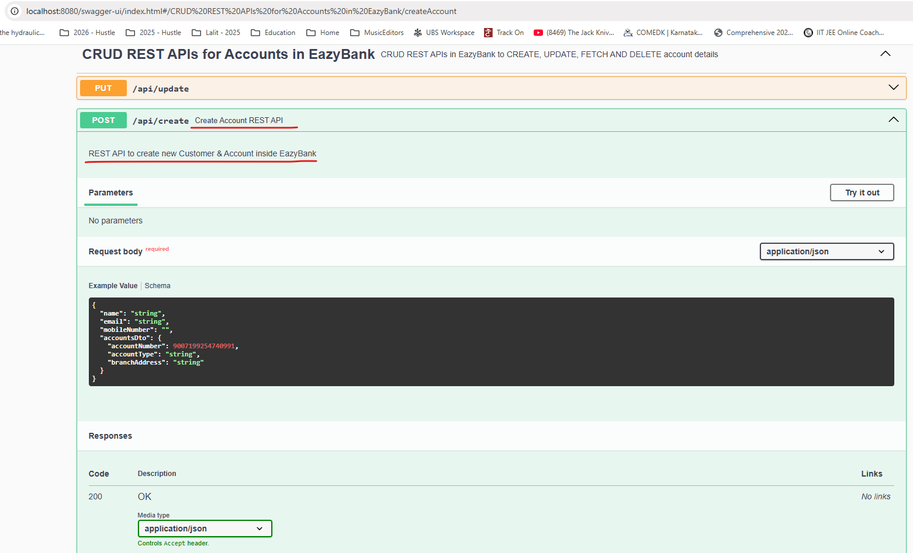

But here inside the code we are returning a 201 and different message, which is specific to 201. So how should we communicate this information to the REST API Documentation?

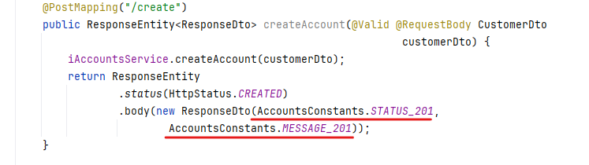

For the same, we can use one more annotation which is @ApiResponse. And to this ApiResponse annotation, we can pass response code using this response code I'm going to mention 201 which will override the default value of 200 that we are seeing inside the documentation. Post that we can also mention a description about this 201. So this 201 indicates HttpStatus.CREATED. So with this we should be good. Let me save this changes. Do a build. Once the build is completed, I'm going to refresh this page and this time you can see the response is also accurate like I'm going to return a status as 201 and description as HttpStatus.CREATED. And this is the application Json schema format like statusCode and statusMessage.

@Operation(

summary = "Create Account REST API",

description = "REST API to create new Customer & Account inside EazyBank"

)

@ApiResponses({

@ApiResponse(

responseCode = "201",

description = "HTTP Status CREATED"

),

@ApiResponse(

responseCode = "500",

description = "HTTP Status Internal Server Error",

content = @Content(

schema = @Schema(implementation = ErrorResponseDto.class)

)

)

}

)

@PostMapping("/create")

public ResponseEntity<ResponseDto> createAccount(@Valid @RequestBody CustomerDto customerDto) {

iAccountsService.createAccount(customerDto);

return ResponseEntity.status(HttpStatus.CREATED)

.body(new ResponseDto(AccountsConstants.STATUS_201, AccountsConstants.MESSAGE_201));

}

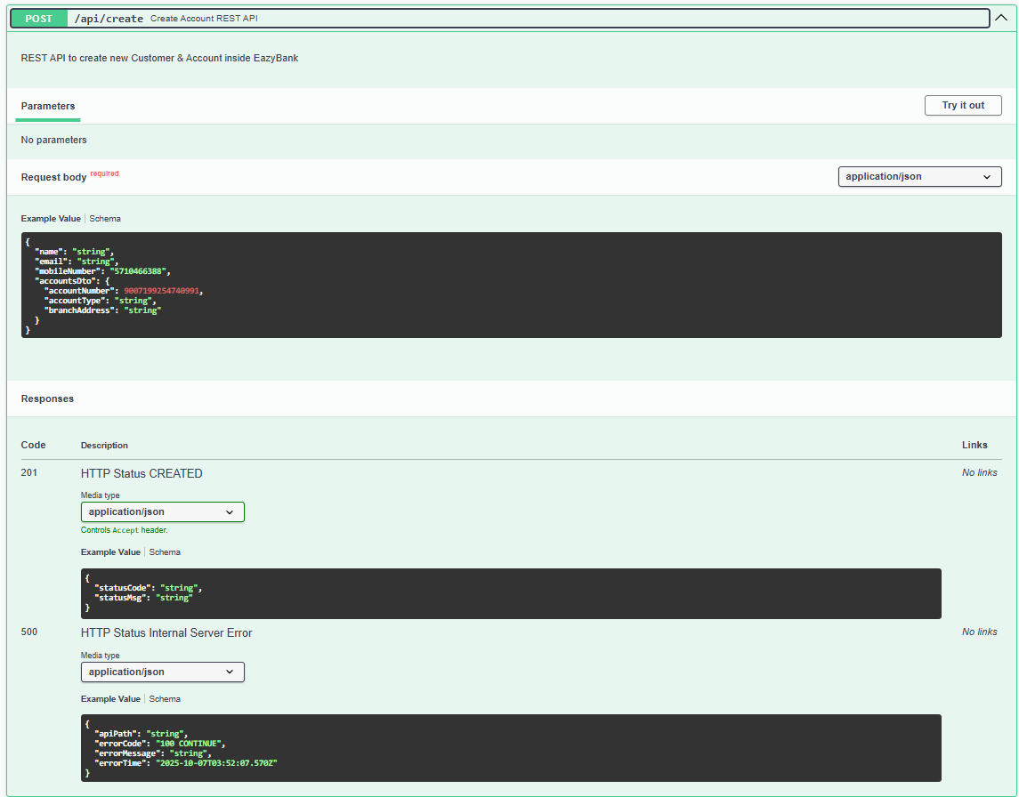

So this makes sense. We enhance this post API. Similarly, let's try to enhance other APIs that we have. So just to save some time here, let me try to pay some annotations here so that we can discuss quickly. You can also get this code from GitHub. So for this fetch, you can see I have used the same operation and the ApiResponse under which I have mentioned the summary, description, responseCode and description. So very similarly we can mention details for update as well. So for update I'm also pasting the code like under operation there will be a summary with the value update Account Details REST API and there is also a description. Now coming to the update operation. We are going to return two types of responses. If you see the code here, if the boolean is true, we are going to return 200. Otherwise we are going to return 500. So how do we communicate these kind of multiple responses possible inside documentation. For the same It's going to be super simple. You need to use @ApiResponses, which is a plural form of ApiResponse annotation, and inside this plural form annotation we can pass any number of API response annotation which are separated by comma. So please make sure you are using these structure and syntax. So here I have created two annotations for one for 200 and the second one for 500. Now let me do the same for delete operation as well. So here I'm pasting some lines of code like using operation, I'm mentioning what is a summary in description and for ApiResponses I have defined 205 hundred just like for update operation.

package com.eazybytes.accounts.controller;

import com.eazybytes.accounts.constants.AccountsConstants;

import com.eazybytes.accounts.dto.CustomerDto;

import com.eazybytes.accounts.dto.ErrorResponseDto;

import com.eazybytes.accounts.dto.ResponseDto;

import com.eazybytes.accounts.service.IAccountsService;

import io.swagger.v3.oas.annotations.Operation;

import io.swagger.v3.oas.annotations.media.Content;

import io.swagger.v3.oas.annotations.media.Schema;

import io.swagger.v3.oas.annotations.responses.ApiResponse;

import io.swagger.v3.oas.annotations.responses.ApiResponses;

import io.swagger.v3.oas.annotations.tags.Tag;

import jakarta.validation.Valid;

import jakarta.validation.constraints.Pattern;

import lombok.AllArgsConstructor;

import org.springframework.http.HttpStatus;

import org.springframework.http.MediaType;

import org.springframework.http.ResponseEntity;

import org.springframework.validation.annotation.Validated;

import org.springframework.web.bind.annotation.*;

@Tag(

name = "CRUD REST APIs for Accounts in EazyBank",

description = "CRUD REST APIs in EazyBank to CREATE, UPDATE, FETCH AND DELETE account details"

)

@RestController

@Validated

@RequestMapping(path="/api", produces = {MediaType.APPLICATION_JSON_VALUE})

@AllArgsConstructor

public class AccountsController {

private IAccountsService iAccountsService;

@Operation(

summary = "Create Account REST API",

description = "REST API to create new Customer & Account inside EazyBank"

)

@ApiResponses({

@ApiResponse(

responseCode = "201",

description = "HTTP Status CREATED"

),

@ApiResponse(

responseCode = "500",

description = "HTTP Status Internal Server Error",

content = @Content(

schema = @Schema(implementation = ErrorResponseDto.class)

)

)

}

)

@PostMapping("/create")

public ResponseEntity<ResponseDto> createAccount(@Valid @RequestBody CustomerDto

customerDto) {

iAccountsService.createAccount(customerDto);

return ResponseEntity

.status(HttpStatus.CREATED)

.body(new ResponseDto(AccountsConstants.STATUS_201,

AccountsConstants.MESSAGE_201));

}

@Operation(

summary = "Fetch Account Details REST API",

description = "REST API to fetch Customer & Account details based on a mobile number"

)

@ApiResponses({

@ApiResponse(

responseCode = "200",

description = "HTTP Status OK"

),

@ApiResponse(

responseCode = "500",

description = "HTTP Status Internal Server Error",

content = @Content(

schema = @Schema(implementation = ErrorResponseDto.class)

)

)

}

)

@GetMapping("/fetch")

public ResponseEntity<CustomerDto> fetchAccountDetails(

@Pattern(regexp="(^$|[0-9]{10})",message = "Mobile number must be 10 digits")

@RequestParam String mobileNumber) {

CustomerDto customerDto = iAccountsService.fetchAccount(mobileNumber);

return ResponseEntity.status(HttpStatus.OK).body(customerDto);

}

@Operation(

summary = "Update Account Details REST API",

description = "REST API to update Customer & Account details based on a account number"

)

@ApiResponses({

@ApiResponse(

responseCode = "200",

description = "HTTP Status OK"

),

@ApiResponse(

responseCode = "417",

description = "Expectation Failed"

),

@ApiResponse(

responseCode = "500",

description = "HTTP Status Internal Server Error",

content = @Content(

schema = @Schema(implementation = ErrorResponseDto.class)

)

)

}

)

@PutMapping("/update")

public ResponseEntity<ResponseDto> updateAccountDetails(@Valid @RequestBody CustomerDto customerDto) {

boolean isUpdated = iAccountsService.updateAccount(customerDto);

if(isUpdated) {

return ResponseEntity

.status(HttpStatus.OK)

.body(new ResponseDto(AccountsConstants.STATUS_200, AccountsConstants.MESSAGE_200));

}else{

return ResponseEntity

.status(HttpStatus.EXPECTATION_FAILED)

.body(new ResponseDto(AccountsConstants.STATUS_417, AccountsConstants.MESSAGE_417_UPDATE));

}

}

@Operation(

summary = "Delete Account & Customer Details REST API",

description = "REST API to delete Customer & Account details based on a mobile number"

)

@ApiResponses({

@ApiResponse(

responseCode = "200",

description = "HTTP Status OK"

),

@ApiResponse(

responseCode = "417",

description = "Expectation Failed"

),

@ApiResponse(

responseCode = "500",

description = "HTTP Status Internal Server Error",

content = @Content(

schema = @Schema(implementation = ErrorResponseDto.class)

)

)

}

)

@DeleteMapping("/delete")

public ResponseEntity<ResponseDto> deleteAccountDetails(@RequestParam

@Pattern(regexp="(^$|[0-9]{10})", message = "Mobile number must be 10 digits")

String mobileNumber) {

boolean isDeleted = iAccountsService.deleteAccount(mobileNumber);

if(isDeleted) {

return ResponseEntity

.status(HttpStatus.OK)

.body(new ResponseDto(AccountsConstants.STATUS_200, AccountsConstants.MESSAGE_200));

}else{

return ResponseEntity

.status(HttpStatus.EXPECTATION_FAILED)

.body(new ResponseDto(AccountsConstants.STATUS_417, AccountsConstants.MESSAGE_417_DELETE));

}

}

}

So with this we have provided all the details inside our APIs. So let me save this changes do a build. Once the build is completed, I can go to the swagger UI. So here I'm going to refresh this page and you can see all of my APIs, they have a summary and if I try to open any of them like update REST API, you can, you will be able to see a description and under responses here you can see I have two different responses, one for 200 and the second one is for 500. So this will give an heads up to my clients and developers or testers. These are the possible responses that you may get and accordingly develop your business logic.

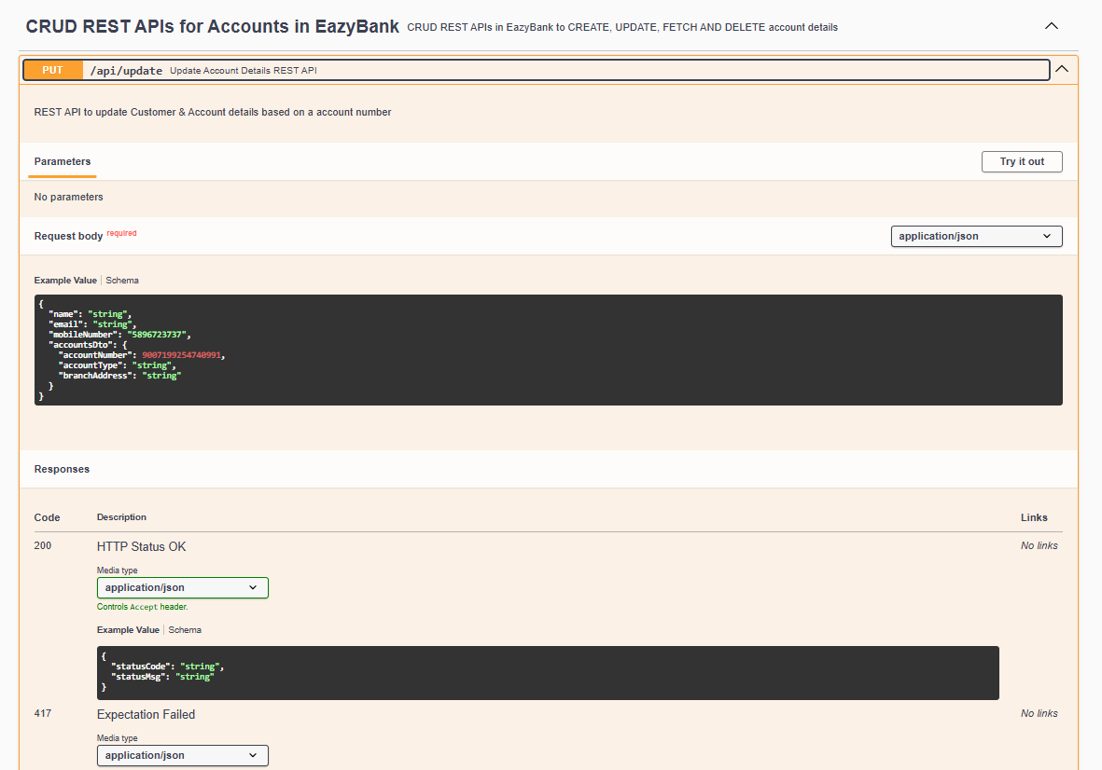

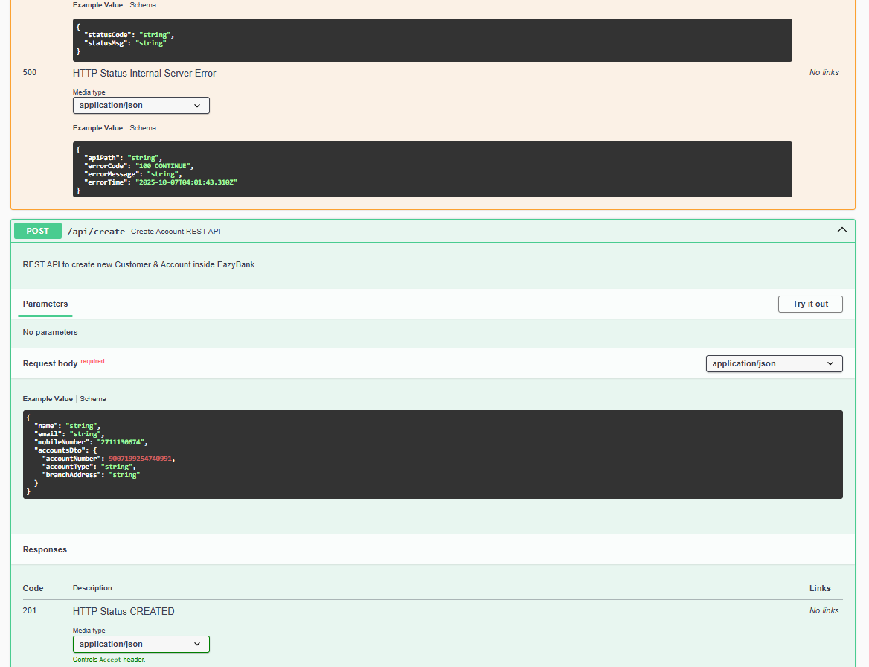

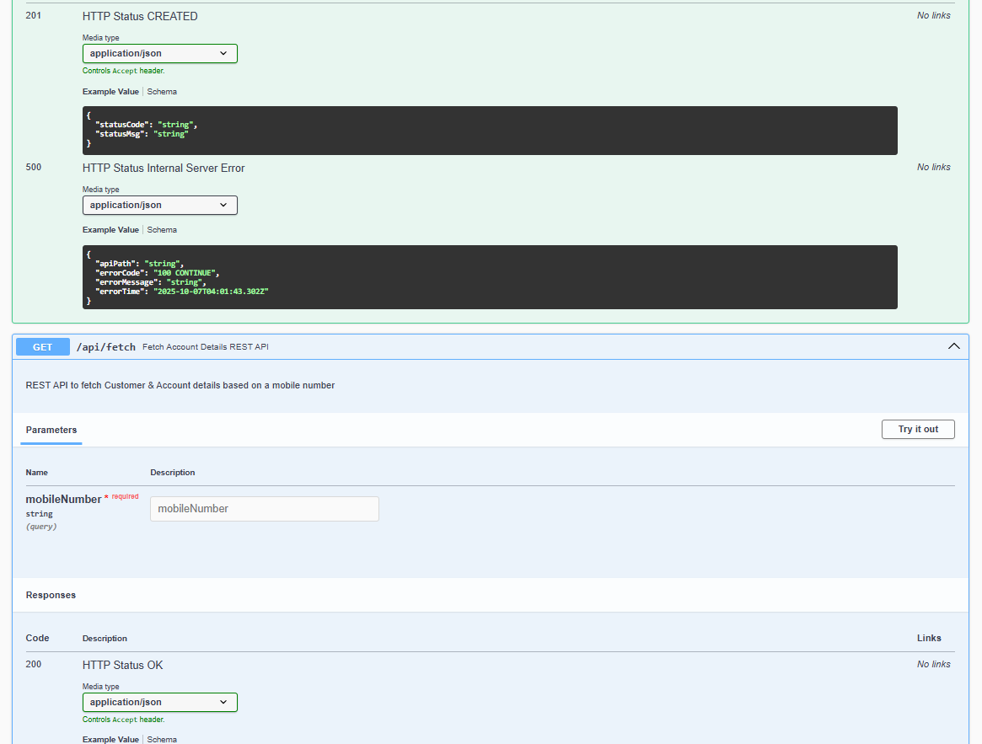

So we have enhanced our APIs as well. But as a next step, we should also enhance our schema objects, like as of now we're displaying technical name, which is accounts and there is no sample or example data.

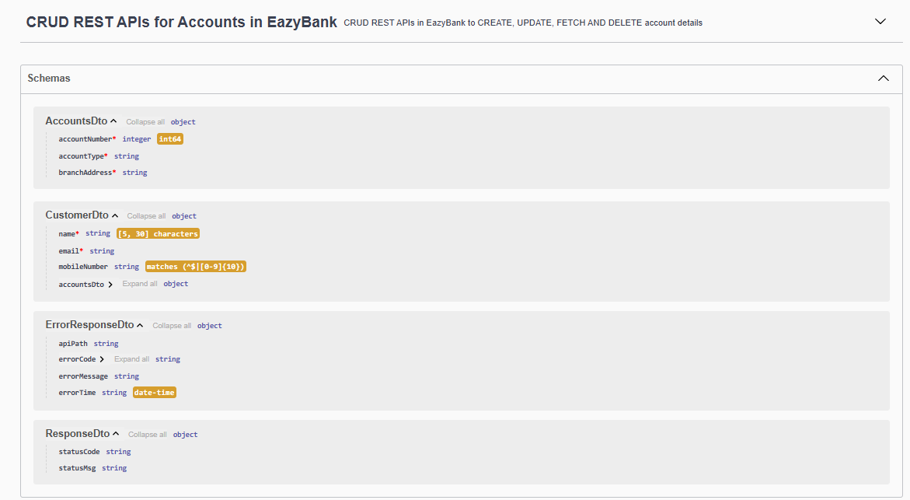

If I provide some example data, the same will be reflected inside my operations also, as of now you can see the example name is coming as String, which is indicates to my Customers and clients that you are supposed to send a String value, but it will be nice if you give an actual name as an example that will make more clear to them.

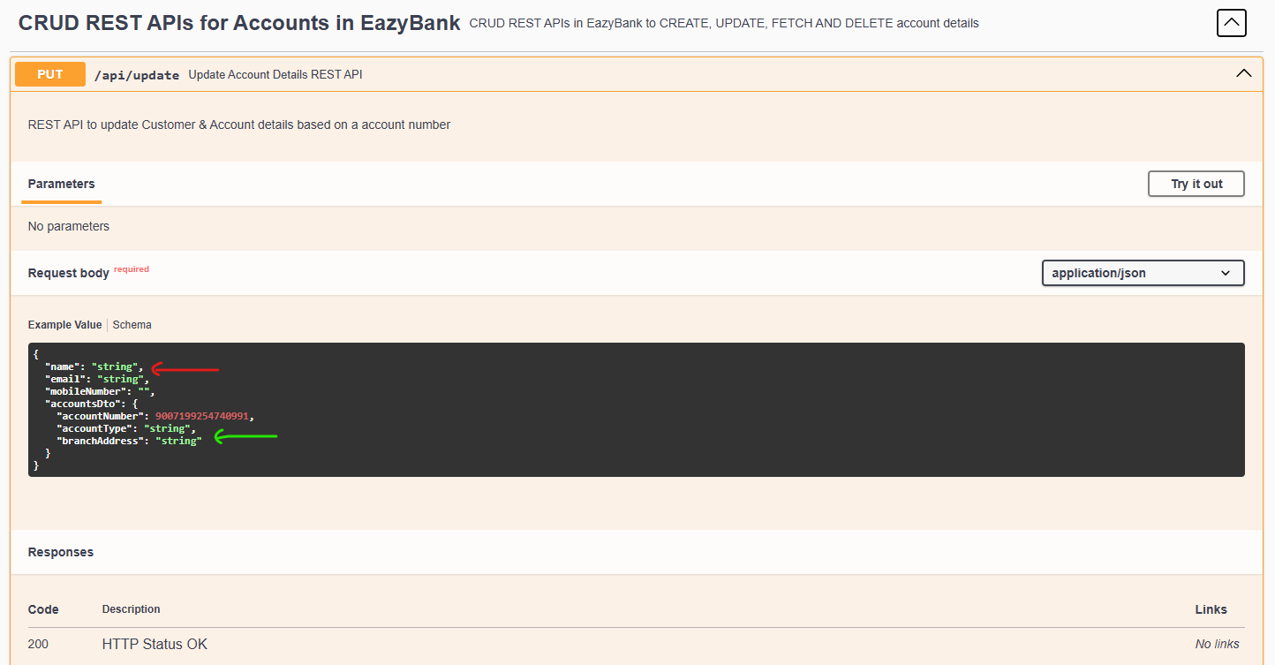

So let's try to enhance the schema object in the next lecture.

### Enhancing with @Schema and Example Data

Let's try to enhance documentation related to our schema objects. So using certain annotations, we can enhance this documentation further. Just like how we made some changes inside the controller class and on top of the Java methods inside controller class. Very similarly, we need to visit these dto classes that we have. Like first let me try to visit this CustomerDto.

|  |  |
| --- | --- |
|  | Here inside my CustomerDto. Since I don't want to display this technical name, I can choose a different name which which is going to be more business friendly. So for the same, I'm going to use a annotation which is @Schema. Using this annotation, we can invoke name and to this name I'm going to mention just simply Customer. The same name is going to be displayed inside my swagger UI as well. Now, coming to the description here, I can mention a description explaining about what these schema is going to hold. That's why I'm telling schema to hold customer and account information. So once we define these details, we can also define field level information as well, like whatever schema that we have mentioned here. Very similarly, we can also define these kind of information at the field level. For example, I can define schema annotation on top of my name field. I don't want to overwrite this name. I'm fine with whatever field name that I'm going to show. By default, the field name is going to be displayed in the open API documentation. So now I have to update the description. What is this field about? So that's why I'm going to mention a description which is Name of the customer. So this field is going to hold the name of the customer. And very similarly, I can also invoke example. Using example, I can provide some example data. So here I'm just going to mention a name like Eazy Byte. So the same example data is going to be displayed inside our open API documentation. So let me define similar schema details for remaining fields that we have here. |

So I'm just mentioning on top of email like the description is going to be email address of the customer and this is an example email value. And similarly for mobile number also I can describe. So this is what I'm mentioning for mobile number like description is mobile number of the customer and this is a sample mobile number value.

Now here on top of accounts, I'm going to mention schema information saying that this is the description like accounts details of the customer. And here I don't want to pass the example information because anyway, I'm going to provide more details about this data inside this class itself. So inside AccountsDto first, I need to make sure I'm mentioning similar information like schema here. So let me take this value and paste it here. And the name that I want to consider here is accounts, and this is going to hold the account information. So let me update the same here.

Now as a next step, I'm going to provide schema details on top of the accountNumber field. Like this is the description Account Number of Easy Bank Account and example is not a mandatory. That's why in order to show that I'm not giving any example information for accountNumber, people should be able to easily understand by seeing these rejects expression. So now coming to the account type, I'm going to mention the schema details. So here I'm just mentioning schema details, saying that description Account Type of Easy Bank Account and example is savings. So let me do the same for branch address as well. Here also, I'm not going to do any example data, I'm giving only description information.

import io.swagger.v3.oas.annotations.media.Schema;

import jakarta.validation.constraints.Email;

import jakarta.validation.constraints.NotEmpty;

import jakarta.validation.constraints.Pattern;

import jakarta.validation.constraints.Size;

import lombok.Data;

@Schema(

name = "Customer",

description = "Schema to hold Customer and Account information"

)

@Data

public class CustomerDto {

@Schema(

description = "Name of the customer", example = "Eazy Bytes"

)

@NotEmpty(message = "Name can not be a null or empty")

@Size(min = 5, max = 30, message = "The length of customer name should be between 5 & 30")

private String name;

@Schema(

description = "Email address of the customer", example = "tutor@eazybytes.com"

)

@NotEmpty(message = "Email address can not be a null or empty")

@Email(message = "Email address should be a valid value")

private String email;

@Schema( description = "Mobile Number of the customer", example = "9345432123" )

@Pattern(regexp = "(^$|[0-9]{10})", message = "Mobile number must be 10 digits")

private String mobileNumber;

@Schema( description = "Account details of the Customer" )

private AccountsDto accountsDto;

}

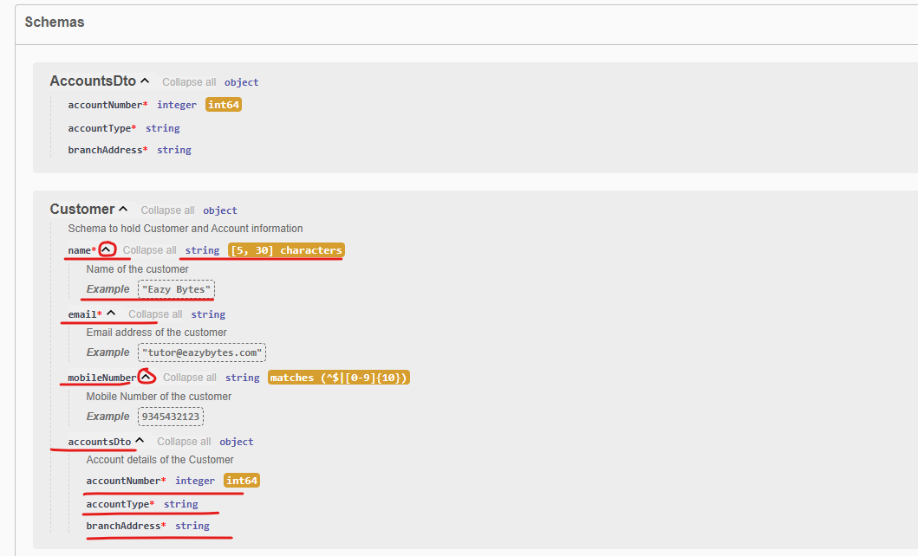

So it is up to us whether we want to give example information or not. Now, similarly, we need to go to the response that we have. Like let me go to ResponseDto on top of this ResponsDto we need to invoke an annotation which is schema, and to this annotation we need to invoke name. And the name that I want to have here is response and post that we can also invoke description inside the description. I'm just mentioning schema to hold successful response information. Now let me do the same for statusCode and statusMessage as well. So I'm just mentioning schema description as statusCode in the response and example as 200. So now for status message also I'm mentioning like description is status message in the response and example is request to process successfully.

import io.swagger.v3.oas.annotations.media.Schema;

import lombok.AllArgsConstructor;

import lombok.Data;

@Schema(

name = "Response",

description = "Schema to hold successful response information"

)

@Data @AllArgsConstructor

public class ResponseDto {

@Schema(

description = "Status code in the response"

)

private String statusCode;

@Schema(

description = "Status message in the response"

)

private String statusMsg;

}

As a next step let's go to the ErrorResponseDto and here I'm going to mention @Schema annotation post that I'm going to mention what is the name of this DTO. The name I just wanted to keep it as ErrorResponse. Now post that, I can also pass the description and under this description I'm going to mention schema to hold ErrorResponse information. As next step, we can also mention schema details on top of this path. Very similarly, we can mention for error code as well. So for error code I'm just mentioning error code representing the error happened. And similarly I'm going to mention for error message as well. So here I'm not mentioning any example values because these errors can keep change based upon the scenario. But if you have such requirements, you can always mention example details as well. So with this, all the dto are also well documented with the help of these Openapi specification annotations which is @Schema. So let me save these changes. Do a build. Once the build is completed, we can go to the swagger UI and try to understand how this information is being reflected inside the UI.

import io.swagger.v3.oas.annotations.media.Schema;

import lombok.AllArgsConstructor;

import lombok.Data;

import org.springframework.http.HttpStatus;

import java.time.LocalDateTime;

@Schema(

name = "ErrorResponse",

description = "Schema to hold error response information"

)

@Data @AllArgsConstructor

public class ErrorResponseDto {

@Schema(

description = "API path invoked by client"

)

private String apiPath;

@Schema(

description = "Error code representing the error happened"

)

private HttpStatus errorCode;

@Schema(

description = "Error message representing the error happened"

)

private String errorMessage;

@Schema(

description = "Time representing when the error happened"

)

private LocalDateTime errorTime;

}

As of now you can see the Dataverse has technical names, so let me try to refresh this page and you'll be able to see that these schemas right now has a meaningful business name like accounts and this is the overall information about the schema object. And similarly, you can go to the field and there will be a description. And for accounts you can see there is an example value also. Very similarly, if you go to the Customer, there is a name and this is the example value and this is a summary of the each field. Now if you go and check any of the APIs, you can see the schema right now has example values populated. Like this is a name, this is the email, this is a mobile number. So this is looking good except this account number and branch address. So let me try to mention that we'll go to AccountsDto and inside AccountsDto. I'm just going to mention example and this example I'm going to mention a ten digit account number. Similarly, I'll mention a example value saying that 123NewYork. So let me save this changes. Do a build.

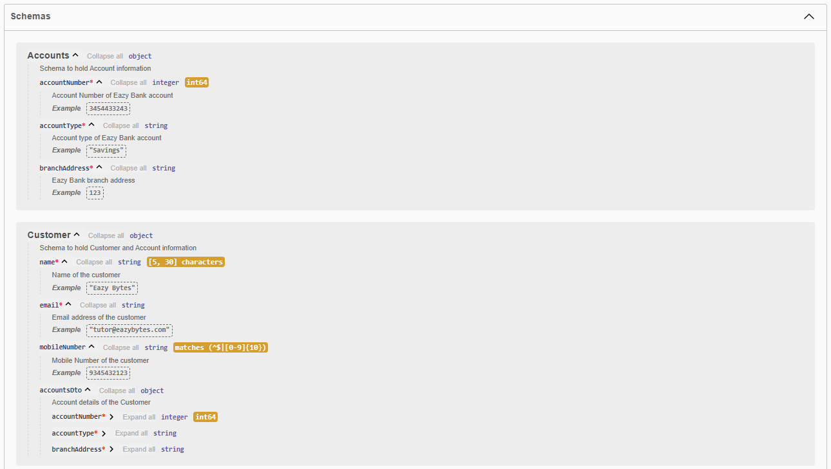

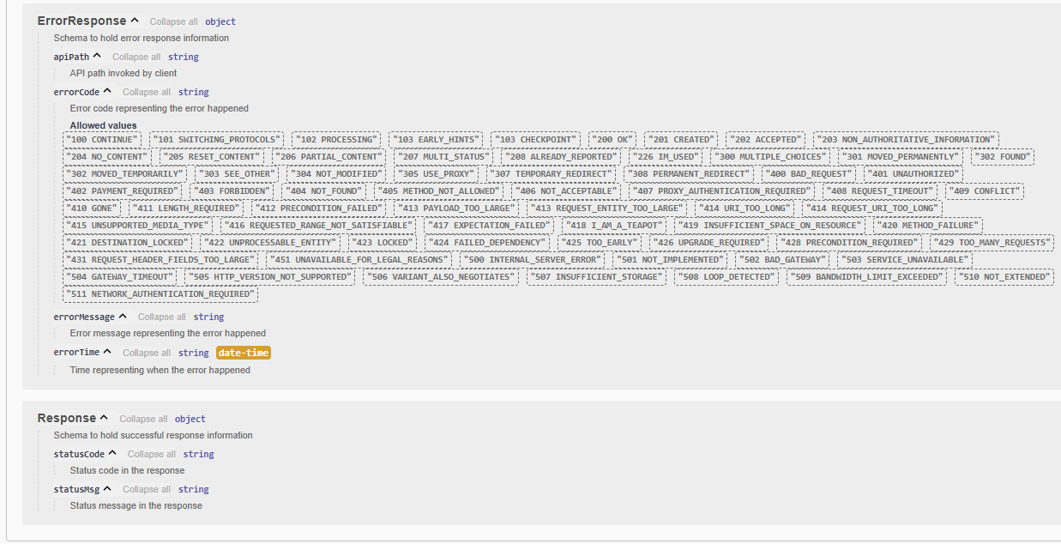

I'm refreshing this page this time you can see the same examples Information are being considered here. This way we enhanced our documentation to a great extent and right now everything is looking very professional inside our swagger UI. And here there is a small bug as of now you can see and a schemas there is one dto missing which is ErrorResponse. Why this information is missing is we are going to throw this ErrorResponseDto only from our GlobalExceptionLogic. So inside our GlobalExceptionLogic, whenever an exception occurs here we are trying to populate this ErrorResponseDto with an 500 status. So since my open API documentation cannot scan these GlobalExceptionHandlerLogic automatically, I need to provide that information inside my ApiResponse. So let's try to understand how to mention this information. For the same, what we can do is I'm going to show you for one of the API operations how to mention a schema object inside your ApiResponse. So after this description, I'm going to invoke content to this content. I'm going to mention an annotation content, and inside this annotation I'm going to invoke schema parameter. And to this schema parameter, I'm going to pass the schema annotation and inside this schema annotation I'm going to mention implementation. And what is the implementation class? The implementation class is ErrorResponsDto.class.

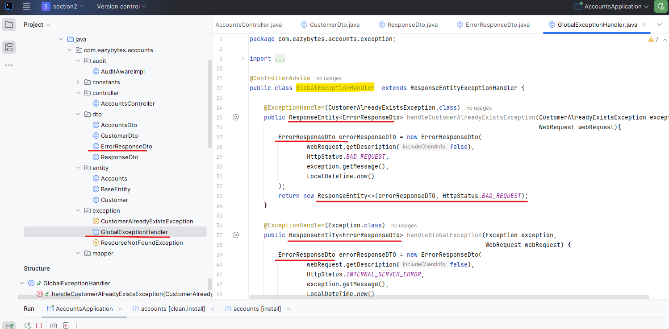

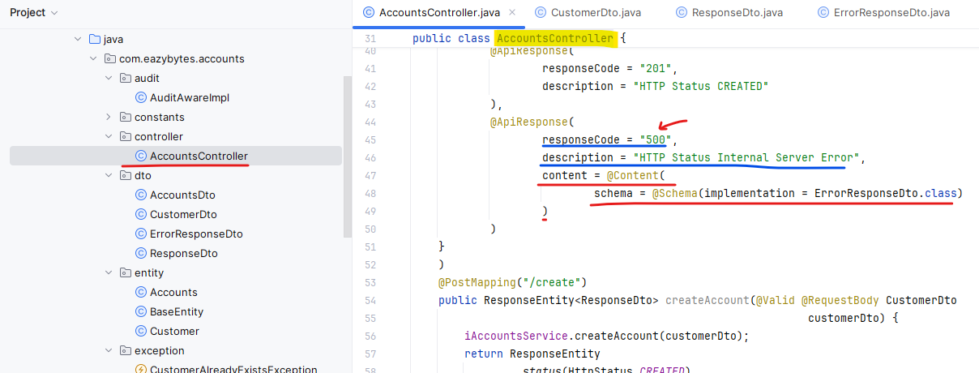

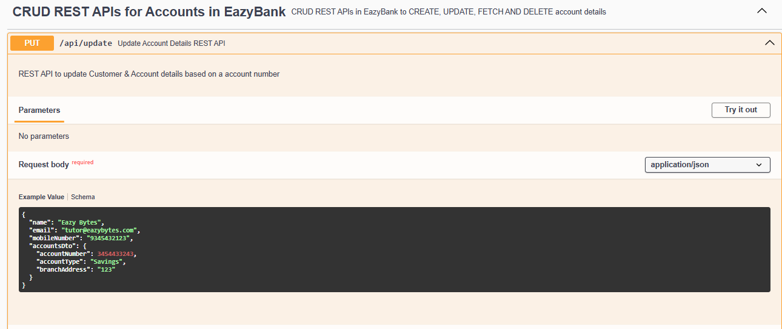

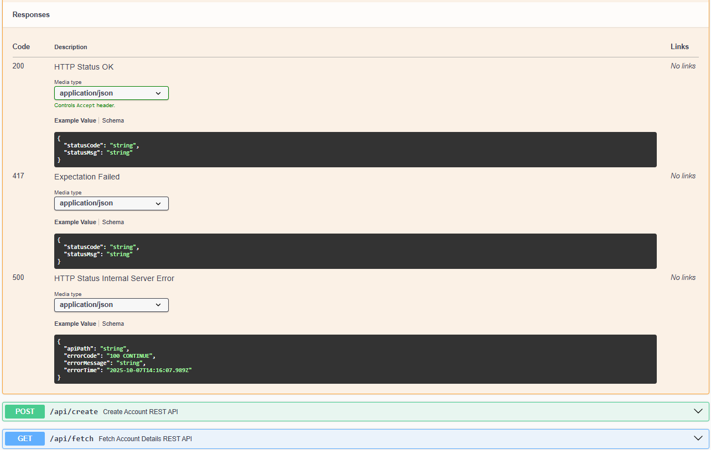

This I'm telling to my spring boot for these update operation, there is a good chance a 500 error can happen. Whenever that 500 error happened. I'm going to send the ErrorResponse by following the schema defined inside this ErrorResponseDto. So let me save this changes. Do a build. Once the build is completed, we should be able to validate this inside our swagger UI. So here, inside my swagger UI right now you can see there is an ErrorResponseDto appearing. If I go to my update operation under this 500 you'll be able to see a schema with API path error code and ErrorMessage and ErrorTime.

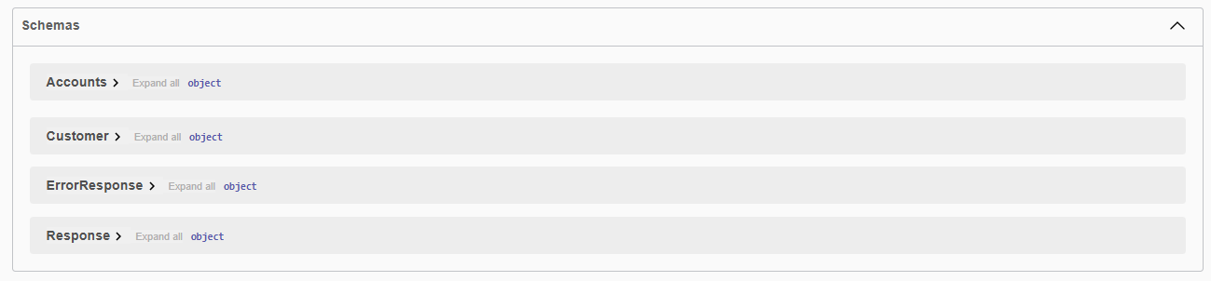

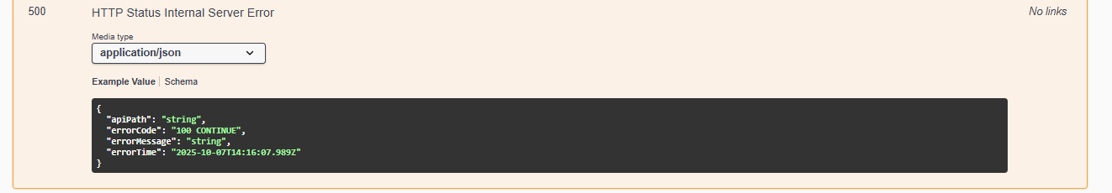

So this way we can define an schema object also for your ApiResponse with the help of these annotations @Content and @Schema. As of now inside our microservices we are sending these 500 event in the scenario of updation failed or deletion failed. So if it is confusion to your clients, you can choose some other error code or error response code so that you can define multiple response codes so it's up to you based upon your requirements. You can play with this schema definition. With this, we enhanced our microservices with one of the standards which is documenting the REST APIs.

@Tag(

name = "CRUD REST APIs for Accounts in EazyBank",

description = "CRUD REST APIs in EazyBank to CREATE, UPDATE, FETCH AND DELETE account details"

)

@RestController

@Validated

@RequestMapping(path="/api", produces = {MediaType.APPLICATION_JSON_VALUE})

@AllArgsConstructor

public class AccountsController {

private IAccountsService iAccountsService;

@Operation(

summary = "Create Account REST API",

description = "REST API to create new Customer & Account inside EazyBank"

)

@ApiResponses({

@ApiResponse(

responseCode = "201",

description = "HTTP Status CREATED"

),

@ApiResponse(

responseCode = "500",

description = "HTTP Status Internal Server Error",

content = @Content(

schema = @Schema(implementation = ErrorResponseDto.class)

)

)

}

)

@PostMapping("/create")

public ResponseEntity<ResponseDto> createAccount(@Valid @RequestBody CustomerDto customerDto) {

iAccountsService.createAccount(customerDto);

return ResponseEntity

.status(HttpStatus.CREATED)

.body(new ResponseDto(AccountsConstants.STATUS_201,

AccountsConstants.MESSAGE_201));

}

We discussed that the same error Code 500 is being used both for RuntimeException like inside the GlobalExceptionHandler. Whenever a RuntimeException happens, we are throwing an internal server error with the status code 500. And very similarly, we also use the same 500 error code both in update operation and delete operation whenever the update or delete operation fail. So this gives some confusion to the client. I said in the previous lecture you can change it based upon your requirements, but I thought about it and decided to correct it inside this small lecture because many students, they refer to my code and I don't want to create any confusion to them. That's why I have quickly fixed the issue behind the scenes let me show you what I have done inside the GlobalExceptionHandler. I have not changed anything, but if you go to the AccountsController class inside the update operation, whenever this boolean is false, I am using a new HttpStatus code which is 417. This indicates this ExpectationFailed.

Press ctrl + P and go to the class HttpStatus.java

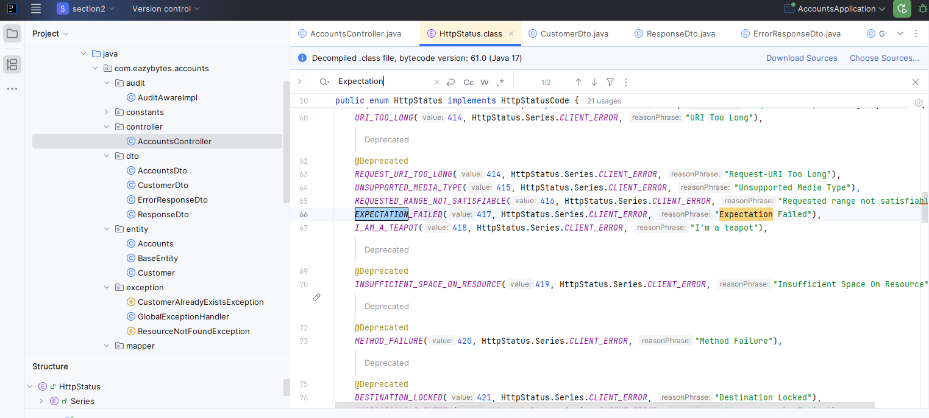

So I thought like this error code, I can use the same status code I am also sending as part of ResponseDto I have created a constant status 417 and there is also a message I have created for the update operation which tells update operation failed. Please try again or contact dev team.

public class AccountsConstants {

private AccountsConstants() {

// restrict instantiation

}

public static final String SAVINGS = "Savings";

public static final String ADDRESS = "123 Main Street, New York";

public static final String STATUS_201 = "201";

public static final String MESSAGE_201 = "Account created successfully";

public static final String STATUS_200 = "200";

public static final String MESSAGE_200 = "Request processed successfully";

public static final String STATUS_417 = "417";

public static final String MESSAGE_417_UPDATE= "Update operation failed. Please try again or contact Dev team";

public static final String MESSAGE_417_DELETE= "Delete operation failed. Please try again or contact Dev team";

}

@Tag(

name = "CRUD REST APIs for Accounts in EazyBank",

description = "CRUD REST APIs in EazyBank to CREATE, UPDATE, FETCH AND DELETE account details"

)

@RestController

@Validated

@RequestMapping(path="/api", produces = {MediaType.APPLICATION_JSON_VALUE})

@AllArgsConstructor

public class AccountsController {

private IAccountsService iAccountsService;

@Operation(

summary = "Create Account REST API",

description = "REST API to create new Customer & Account inside EazyBank"

)

@ApiResponses({

@ApiResponse(

responseCode = "201",

description = "HTTP Status CREATED"

),

@ApiResponse(

responseCode = "500",

description = "HTTP Status Internal Server Error"

)

}

)

@PostMapping("/create")

public ResponseEntity<ResponseDto> createAccount(@Valid @RequestBody CustomerDto customerDto) {

iAccountsService.createAccount(customerDto);

return ResponseEntity

.status(HttpStatus.CREATED)

.body(new ResponseDto(AccountsConstants.STATUS_201,

AccountsConstants.MESSAGE_201));

}

@Operation(

summary = "Fetch Account Details REST API",

description = "REST API to fetch Customer & Account details based on a mobile number"

)

@ApiResponses({

@ApiResponse(

responseCode = "200",

description = "HTTP Status OK"

),

@ApiResponse(

responseCode = "500",

description = "HTTP Status Internal Server Error",

content = @Content(

schema = @Schema(implementation = ErrorResponseDto.class)

)

)

}

)

@GetMapping("/fetch")

public ResponseEntity<CustomerDto> fetchAccountDetails(

@Pattern(regexp="(^$|[0-9]{10})",message = "Mobile number must be 10 digits")

@RequestParam String mobileNumber) {

CustomerDto customerDto = iAccountsService.fetchAccount(mobileNumber);

return ResponseEntity.status(HttpStatus.OK).body(customerDto);

}

@Operation(

summary = "Update Account Details REST API",

description = "REST API to update Customer & Account details based on a account number"

)

@ApiResponses({

@ApiResponse(

responseCode = "200",

description = "HTTP Status OK"

),

@ApiResponse(

responseCode = "417",

description = "Expectation Failed"

),

@ApiResponse(

responseCode = "500",

description = "HTTP Status Internal Server Error",

content = @Content(

schema = @Schema(implementation = ErrorResponseDto.class)

)

)

}

)

@PutMapping("/update")

public ResponseEntity<ResponseDto> updateAccountDetails(@Valid @RequestBody CustomerDto customerDto) {

boolean isUpdated = iAccountsService.updateAccount(customerDto);

if(isUpdated) {

return ResponseEntity

.status(HttpStatus.OK)

.body(new ResponseDto(AccountsConstants.STATUS_200, AccountsConstants.MESSAGE_200));

}else{

return ResponseEntity

.status(HttpStatus.EXPECTATION_FAILED)

.body(new ResponseDto(AccountsConstants.STATUS_417, AccountsConstants.MESSAGE_417_UPDATE));

}

}

@Operation(

summary = "Delete Account & Customer Details REST API",

description = "REST API to delete Customer & Account details based on a mobile number"

)

@ApiResponses({

@ApiResponse(

responseCode = "200",

description = "HTTP Status OK"

),

@ApiResponse(

responseCode = "417",

description = "Expectation Failed"

),

@ApiResponse(

responseCode = "500",

description = "HTTP Status Internal Server Error",

content = @Content(

schema = @Schema(implementation = ErrorResponseDto.class)

)

)

}

)

@DeleteMapping("/delete")

public ResponseEntity<ResponseDto> deleteAccountDetails(@RequestParam

@Pattern(regexp="(^$|[0-9]{10})", message = "Mobile number must be 10 digits")

String mobileNumber) {

boolean isDeleted = iAccountsService.deleteAccount(mobileNumber);

if(isDeleted) {

return ResponseEntity

.status(HttpStatus.OK)

.body(new ResponseDto(AccountsConstants.STATUS_200, AccountsConstants.MESSAGE_200));

}else{

return ResponseEntity

.status(HttpStatus.EXPECTATION_FAILED)

.body(new ResponseDto(AccountsConstants.STATUS_417, AccountsConstants.MESSAGE_417_DELETE));

}

}

}

And the same for delete operation I have created a separate message. To go to the delete operation as well. If the boolean is false, I'm sending the same 41 status with the same exception failed HttpStatus with a message delete operation failed. Please try again or contact dev team. With this we no more need the status 500 and message 500 constants. I'm going to comment them in case if you want to refer them for some other reason. So let me save this changes. And apart from these changes, if you go and check right now all the ApiResponses for my four APIs, you'll be seeing that for each operation I'm passing these ApiResponse with the schema as ErrorResponseDto. because any API can have RuntimeException. That's why with the response code 500 with this description, I have mentioned that I'm going to send this content with the schema of ErrorResponseDto. So the same 500 related ApiResponse I have mentioned for all the APIs. Similarly for the fetch operation, I have mentioned the RuntimeException related ApiResponse.

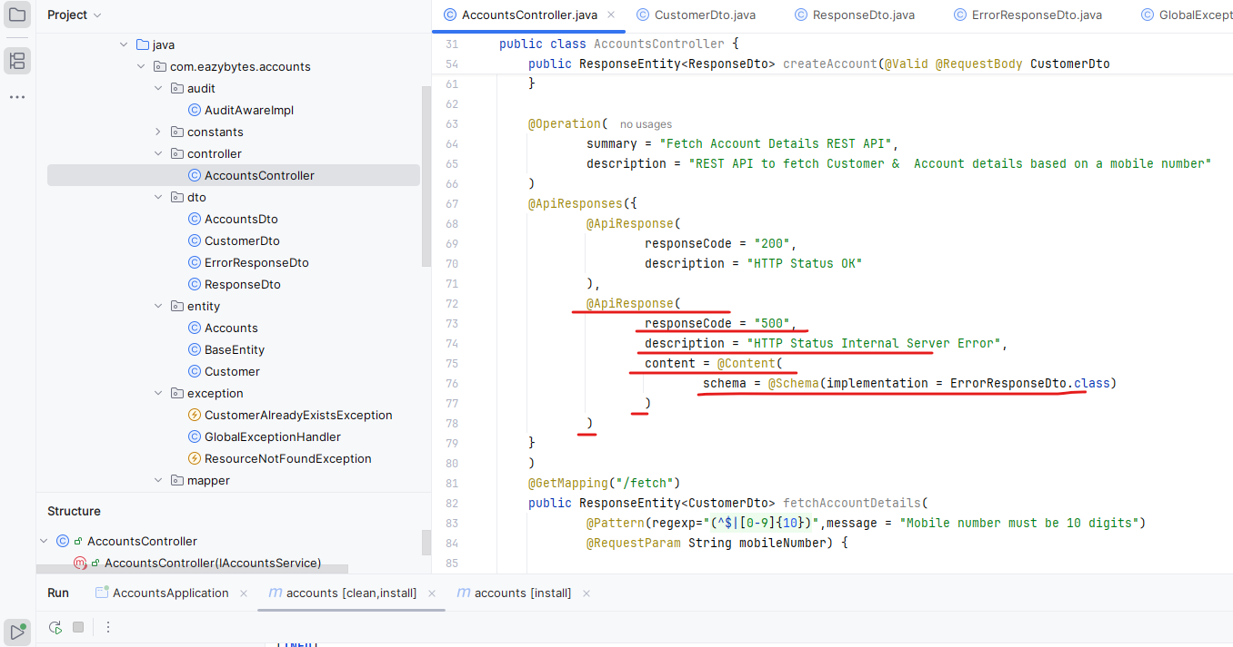

Now coming to the update operation. update operation is going to have one more extra ApiResponse with the response code 417 and description as exception failed. So update operation is going to have three different API response 204, one seven and 500.

@Operation(

summary = "Update Account Details REST API",

description = "REST API to update Customer & Account details based on account number"

)

@ApiResponses({

@ApiResponse(

responseCode = "200",

description = "HTTP Status OK"

),

@ApiResponse(

responseCode = "417",

description = "Expectation Failed"

),

@ApiResponse(

responseCode = "500",

description = "HTTP Status Internal Server Error",

content = @Content(

schema = @Schema(implementation = ErrorResponseDto.class)

)

)

}

)

@PutMapping("/update")

public ResponseEntity<ResponseDto> updateAccountDetails(@Valid @RequestBody CustomerDto

customerDto) {

boolean isUpdated = iAccountsService.updateAccount(customerDto);

if(isUpdated) {

return ResponseEntity

.status(HttpStatus.OK)

.body(new ResponseDto(AccountsConstants.STATUS_200,

AccountsConstants.MESSAGE_200));

}else{

return ResponseEntity

.status(HttpStatus.EXPECTATION_FAILED)

.body(new ResponseDto(AccountsConstants.STATUS_417,

AccountsConstants.MESSAGE_417_UPDATE));

}

}

And very similarly, the delete operation also, we are going to have three different responses.

@Operation(

summary = "Delete Account & Customer Details REST API",

description = "REST API to delete Customer & Account details based on mobile number"

)

@ApiResponses({

@ApiResponse(

responseCode = "200",

description = "HTTP Status OK"

),

@ApiResponse(

responseCode = "417",

description = "Expectation Failed"

),

@ApiResponse(

responseCode = "500",

description = "HTTP Status Internal Server Error",

content = @Content(

schema = @Schema(implementation = ErrorResponseDto.class)

)

)

}

)

@DeleteMapping("/delete")

public ResponseEntity<ResponseDto> deleteAccountDetails(@RequestParam

@Pattern(regexp="(^$|[0-9]{10})", message = "Mobile number must be 10 digits")

String mobileNumber) {

boolean isDeleted = iAccountsService.deleteAccount(mobileNumber);

if(isDeleted) {

return ResponseEntity

.status(HttpStatus.OK)

.body(new ResponseDto(AccountsConstants.STATUS_200,

AccountsConstants.MESSAGE_200));

}else{

return ResponseEntity

.status(HttpStatus.EXPECTATION_FAILED)

.body(new ResponseDto(AccountsConstants.STATUS_417,

AccountsConstants.MESSAGE_417_DELETE));

}

}

Now if I try to look at them in the UI, everything is going to be super, super cool. Like you can see for the update operation 200, 417 indicates there is an exception fail and 500, this is the object response that you are going to get. So this looks everything good, but you can see for 204 and 417, the status code is showing as 200. The reason is inside the ResponseDto we have mentioned the example values as 200 and request process successfully. So this gives some confusion to the clients. Like why in the case of 417, I'm going to receive the status code as 200. So that's why mentioning examples is not always a good advantage. Sometimes you don't want to mention the examples because it will create more confusion.

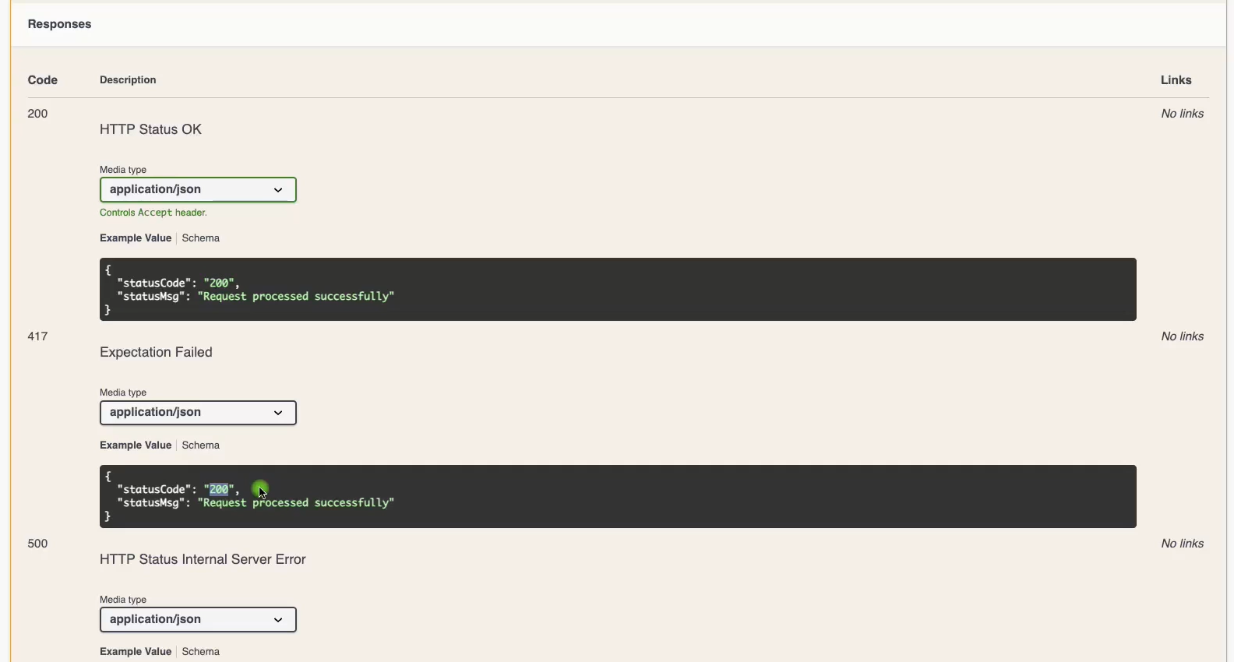

For that reason, let me go and remove these example value inside the ResponseDto. So here I'm just removing these example as 200 and very similarly, I'm going to remove these here as well. So with this, let me do a build.

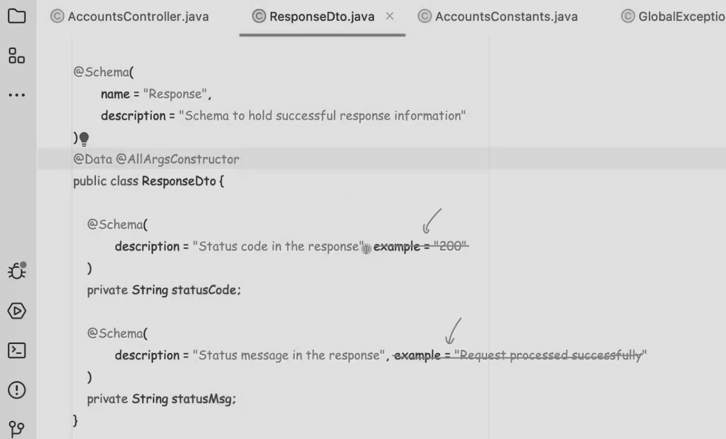

Now, if I try to refresh this page, you can see the status code is going to be String status message is going to be String the same for 417. So this is going to appear in all the API's like for the response codes. So each API is going to have at least two response formats, one for success scenario and the other one for RuntimeException scenario. And 417 is going to be present for both update and delete operation.

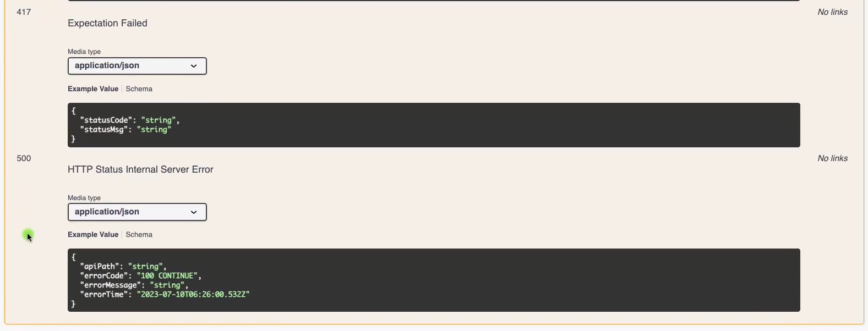

Now ErrorResponseDto is also appearing inside the schemas and with this I believe everything is looking perfect now.

### Important Annotations & Classes that supports building REST services

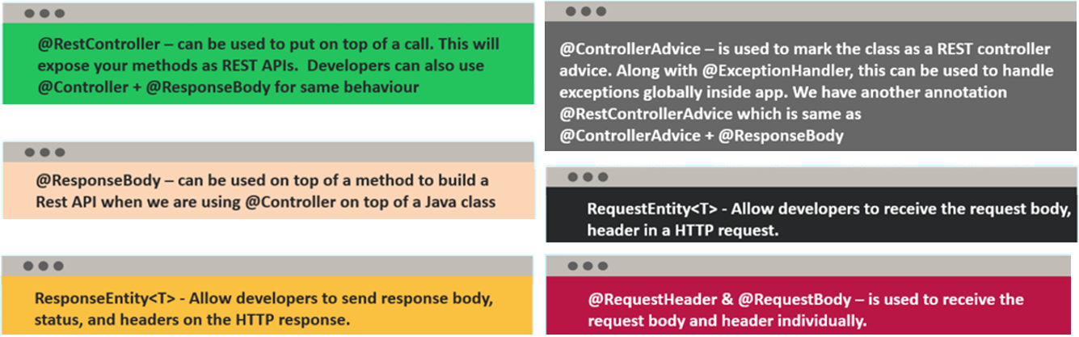

The very first annotation that we have used is RestController. Whenever we try to build REST APIs with the help of Java methods and Http annotations like @GetMapping, @PostMapping, we need to make sure we are putting @RestController on top of the class. This way we are communicating to the Spring boot framework to expose all your Java methods as a REST APIs. You will be seeing some people they will not use @RestController. Instead they will use @Controller annotation. If you ever be in a scenario where inside your Controller you want to write both REST APIs and spring MVC related methods, then mentioning RestController is not a good option. Instead, you should mention @Controller annotation on top of your class and whatever Java methods which you want to expose with the help of REST APIs on top of them, you can mention response body annotation. So a combination of Controller annotation and ResponseBody annotation will provide the same behavior of RestController.

The next important annotation that you need to aware is @ResponseBody. Like we discussed, whenever you are into a scenario where you are using the @Controller annotation on top of your Java class, you need to mention these @ResponseBody annotation to tell to the spring boot framework that you are expecting the response to be in a Json format but not in the spring MVC style like HTML format or any other UI format. Since we don't have any Java methods which we are trying to expose with the help of Spring MVC pattern, we didn't use this ResponseBody annotation and @Controller annotation instead we used @RestController annotation.

Moving on to the next important component whenever you are trying to build REST services is ResponseEntity. This is not a annotation, this is a class available inside the spring framework. Whenever you are trying to send all kind of information like headers, status and body inside the response to your clients, then it is a good idea to use this ResponseEntity and this class will have these generics with the help of these generics. We need to tell what type of object that I'm going to send inside my ResponseBody. If you are sending customer information, we need to mention the customer DTO and similarly you can mention any type of object whenever you are trying to mention this ResponseEntity in the return type of your Java method,

The next important component that you need to aware is @ControllerAdvice annotation using this annotation along with the ExceptionHandler annotation, we can write global exception logic. Whatever logic you have written inside a Java method that is annotated with @ExceptionHandler and tag that too against a exception type. Then, whenever that exception occurs inside your controller layer, the logic that you have written inside this ExceptionHandler methods will get executed. So to activate that behavior, we need to make sure we are using @ControllerAdvice annotation. We have another similar annotation also with the name @RestControllerAdvice. You can use this as well. This RestControllerAdvice annotation is a combination of @ControllerAdvice and @ResponseBody. Just like how we have the relationship between RestController and Controller. The same relationship works here between the ControllerAdvice and the RestControllerAdvice annotations. In our scenario, I have used @ControllerAdvice and it worked perfectly. But if you ever into a scenario where you want strictly your exception methods return the Json as an output, then please feel free to use @RestControllerAdvice, as of now, for me it worked perfectly inside our AccountsMicroservice With the help of ControllerAdvice, I'm able to achieve my functionality perfectly. That's why I have not used this @RestControllerAdvice. Even if you use this, you will get the same behavior.

The next important class that we have here is RequestEntity, just like how we have ResponseEntity. Very similarly, we can also use this RequestEntity. Whenever you have a scenario where you want to receive both requestBody and requestHeader as a method parameter inside your REST APIs. We have not used this inside our Microservice because we don't have a scenario where we want the requestHeader and requestBody. We always had a scenario where we want only requestBody but not the requestHeaders. That's why I have not used this. But if you ever have such scenarios, feel free to use the RequestEntity. Once you receive this RequestEntity object, you as a developer can extract all the requestHeaders and the requestBody post that you can execute your business logic.

The next set of annotations that we have here is @RequestHeader and @RequestBody. Using these individual annotations, you can receive a header inside the request as a method parameter, or you can also receive the entire request body as a method parameter. I hope this is clear. Please make a note of all these important annotations and classes that supports building REST services. So these are very, very important. If you go to any interview, they can simply ask you a question like how you are going to build REST APIs with the help of Springboot. In such scenarios, you can take these annotations and important classes and try to explain them as a sequence. First, I will create a class. On top of that, I'll mention other RestController class post that I'll create Java methods. On top of them, I'll keep the annotations like GetMapping, PostMapping followed by We'll use this RequestEntity, RequestHeader, RequestBody, ResponseEntity. And once I have written all the business logic, I can also define the global exception logic. With the help of this ControllerAdvisor, annotation and ExceptionHandler annotation.

## Loans Microservice Implementation

### pom.xml

|  |  |
| --- | --- |
|  | Like you can see inside the pom.xml file I have followed all the same naming conventions like I have used this version and groupId is com.easybytes and artifactId for loans is loans, whereas for accounts we have used as accounts and the name is also going to be loans. And this is the description. And I have used Java 17 version.  And you can see I have used the same maven dependencies like spring-boot-starter-actuator, spring-boot-starter-data-jpa, spring-boot-starter-web, spring-boot-starter-validation, spring-boot-devtools, H2 database project lombok and the class we have springdoc-openapi-starter-webmvc-ui project and by default you will get the spring-boot-starter-test whenever you are trying to create a Spring Boot Web application. |

<?xml version="1.0" encoding="UTF-8"?>

<project xmlns="http://maven.apache.org/POM/4.0.0" xmlns:xsi="http://www.w3.org/2001/XMLSchema-instance"

xsi:schemaLocation="http://maven.apache.org/POM/4.0.0 https://maven.apache.org/xsd/maven-4.0.0.xsd">

<modelVersion>4.0.0</modelVersion>

<parent>

<groupId>org.springframework.boot</groupId>

<artifactId>spring-boot-starter-parent</artifactId>

<version>3.4.1</version>

<relativePath/> <!-- lookup parent from repository -->

</parent>

<groupId>com.eazybytes</groupId>

<artifactId>loans</artifactId>

<version>0.0.1-SNAPSHOT</version>

<name>loans</name>

<description>Microservice for Loans</description>

<url/>

<licenses>

<license/>

</licenses>

<developers>

<developer/>

</developers>

<scm>

<connection/>

<developerConnection/>

<tag/>

<url/>

</scm>

<properties>

<java.version>21</java.version>

</properties>

<dependencies>

<dependency>

<groupId>org.springframework.boot</groupId>

<artifactId>spring-boot-starter-actuator</artifactId>

</dependency>

<dependency>

<groupId>org.springframework.boot</groupId>

<artifactId>spring-boot-starter-data-jpa</artifactId>

</dependency>

<dependency>

<groupId>org.springframework.boot</groupId>

<artifactId>spring-boot-starter-validation</artifactId>

</dependency>

<dependency>

<groupId>org.springframework.boot</groupId>

<artifactId>spring-boot-starter-web</artifactId>

</dependency>

<dependency>

<groupId>org.springframework.boot</groupId>

<artifactId>spring-boot-devtools</artifactId>

<scope>runtime</scope>

<optional>true</optional>

</dependency>

<dependency>

<groupId>com.h2database</groupId>

<artifactId>h2</artifactId>

<scope>runtime</scope>

</dependency>

<dependency>

<groupId>org.projectlombok</groupId>

<artifactId>lombok</artifactId>

<optional>true</optional>

</dependency>

<dependency>

<groupId>org.springdoc</groupId>

<artifactId>springdoc-openapi-starter-webmvc-ui</artifactId>

<version>2.8.1</version>

</dependency>

<dependency>

<groupId>org.springframework.boot</groupId>

<artifactId>spring-boot-starter-test</artifactId>

<scope>test</scope>

</dependency>

</dependencies>

<build>

<plugins>

<plugin>

<groupId>org.springframework.boot</groupId>

<artifactId>spring-boot-maven-plugin</artifactId>

</plugin>

<plugin>

<groupId>org.apache.maven.plugins</groupId>

<artifactId>maven-compiler-plugin</artifactId>

<configuration>

<annotationProcessorPaths>

<path>

<groupId>org.projectlombok</groupId>

<artifactId>lombok</artifactId>

<version>${lombok.version}</version>

</path>

</annotationProcessorPaths>

</configuration>

</plugin>

</plugins>

</build>

</project>

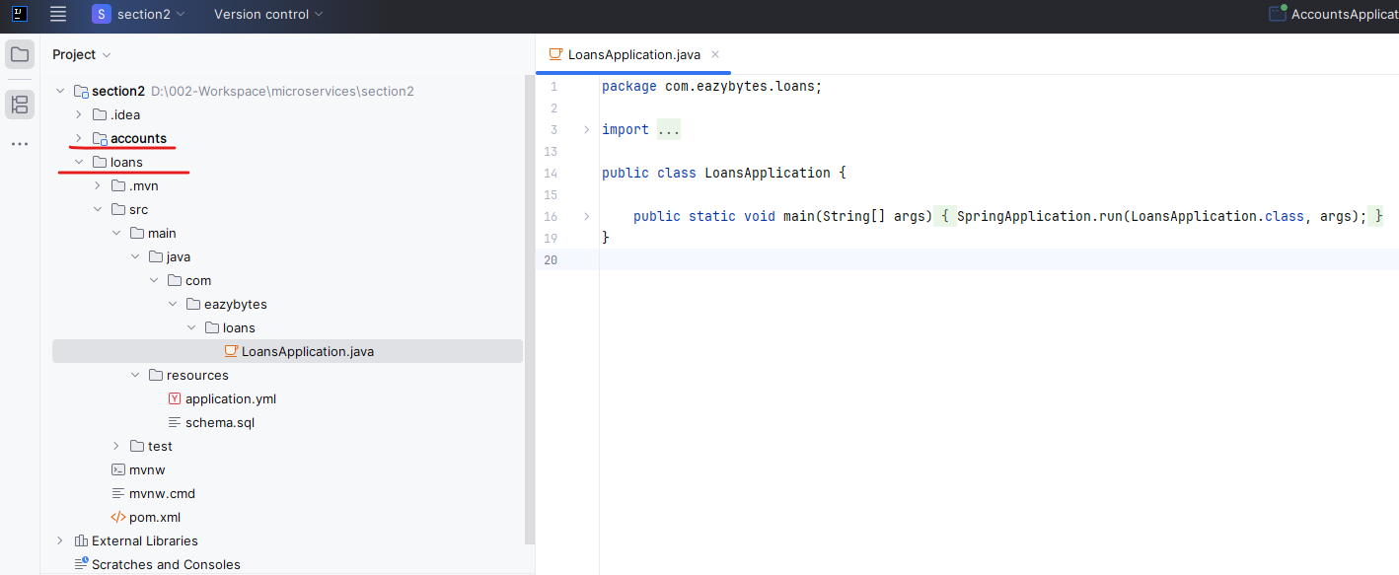

If the 2nd maven project we created i.e. loans is not being shown as a maven project – so that you can clean install etc. then right click on the pom.xml of the loans project and select "Add as a Maven Project" as shown in the pic below

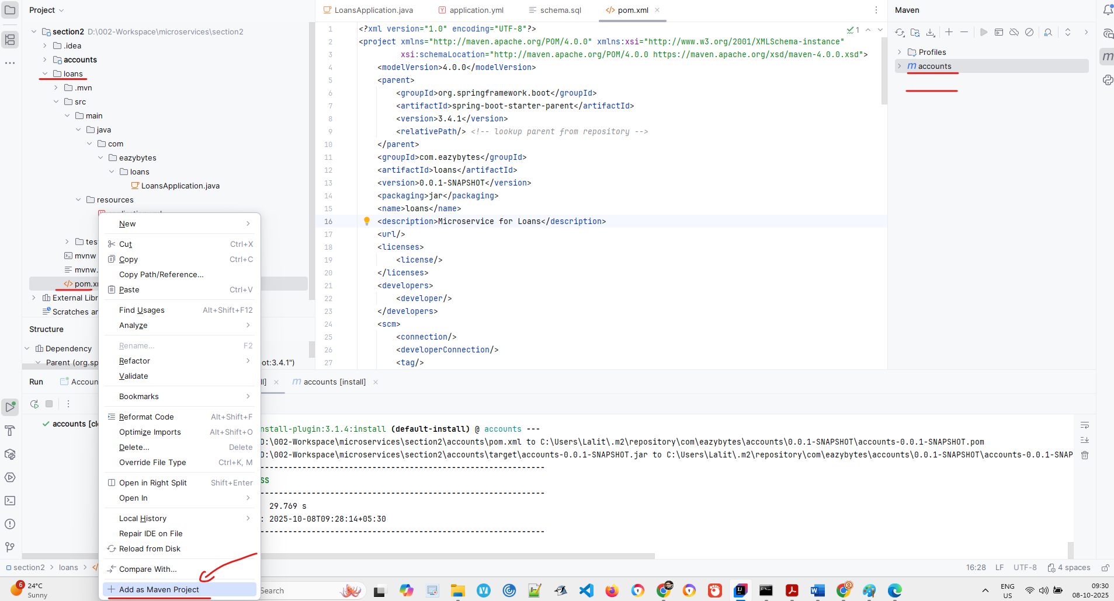

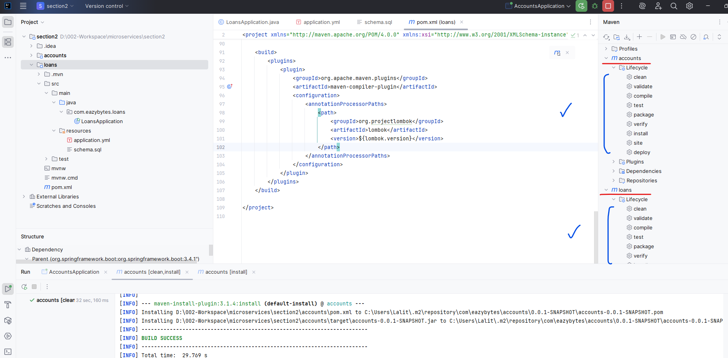

### application.yaml

|  |  |
| --- | --- |
| server:  port: 8090  spring:  application:  name: "loans"  profiles:  active: "prod"  datasource:  url: jdbc:h2:mem:testdb  driverClassName: org.h2.Driver  username: sa  password: ''  h2:  console:  enabled: true  jpa:  database-platform: org.hibernate.dialect.H2Dialect  hibernate:  ddl-auto: update  show-sql: true  config:  import: "optional:configserver:http://localhost:8071/"  management:  endpoints:  web:  exposure:  include: "*"  health:  readiness-state:  enabled: true  liveness-state:  enabled: true  endpoint:  shutdown:  access: unrestricted  health:  probes:  enabled: true  info:  env:  enabled: true  eureka:  instance:  preferIpAddress: true  client:  fetchRegistry: true  registerWithEureka: true  serviceUrl:  defaultZone: http://localhost:8070/eureka/  info:  app:  name: "loans"  description: "Eazy Bank Loans Application"  version: "1.0.0"  logging:  level:  com:  eazybytes:  loans: DEBUG | So post this we can go to the application.yaml to validate the H2 related changes. So inside the application.yaml for loans, please make sure you are using the port 8090 throughout this course for loans, the port we are going to use is 8090. That's why please don't try to give different port number. Otherwise you may need to change lot many configurations, docker files, Kubernetes files in the coming sections.  And we have provided the H2 related properties like what is the url, driverClassName, username, password and the H2 console enabled as true and database-platform as org.hibernate dialect.H2Dialect and hibernate: ddl-auto: as update and show-sql as true. This week, everything copied from accounts microservice only the port number will change, which is 8090. |

Now I'm opening the schema dot SQL. You can see inside loans microservice.

### schema.sql

CREATE TABLE IF NOT EXISTS `loans` (

`loan_id` int NOT NULL AUTO_INCREMENT,

`mobile_number` varchar(15) NOT NULL,

`loan_number` varchar(100) NOT NULL,

`loan_type` varchar(100) NOT NULL,

`total_loan` int NOT NULL,

`amount_paid` int NOT NULL,

`outstanding_amount` int NOT NULL,

`created_at` date NOT NULL,

`created_by` varchar(20) NOT NULL,

`updated_at` date DEFAULT NULL,

`updated_by` varchar(20) DEFAULT NULL,

PRIMARY KEY (`loan_id`)

);

### Tables Created

I'm going to have only single table with the name loans. The reason why I'm not creating a customer table is I already created a customer table inside the accounts microservice. What I'm going to do is inside all the microservices, I'm going to have a mobile number and using the same mobile number of the customer which is created inside the accounts microservice, we can create a loans record. We can also create a cards record inside the cards microservice. So you can see the structure of this loans database table is the loan ID is going to be primary key. Post that mobile number followed by what is the loan number which we are going to generate using a business logic. What is the loan type? What is the total loan amount? What is the amount paid so far? What is the outstanding amount. And these are the four metadata columns ( see above in blue ).

Build the project

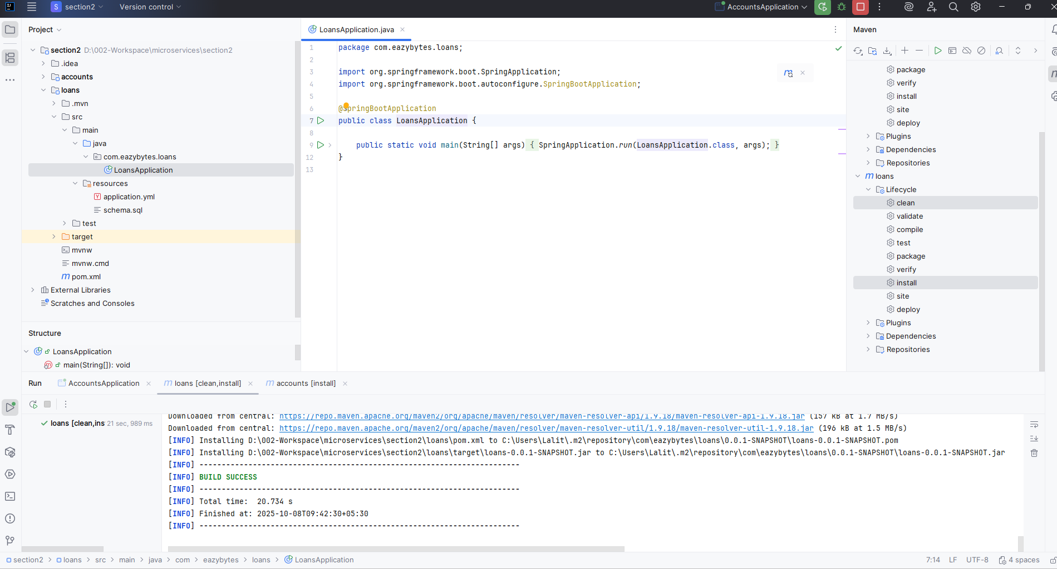

Run/ Debug configuration > Add New Configuration ( by clicking the + link )

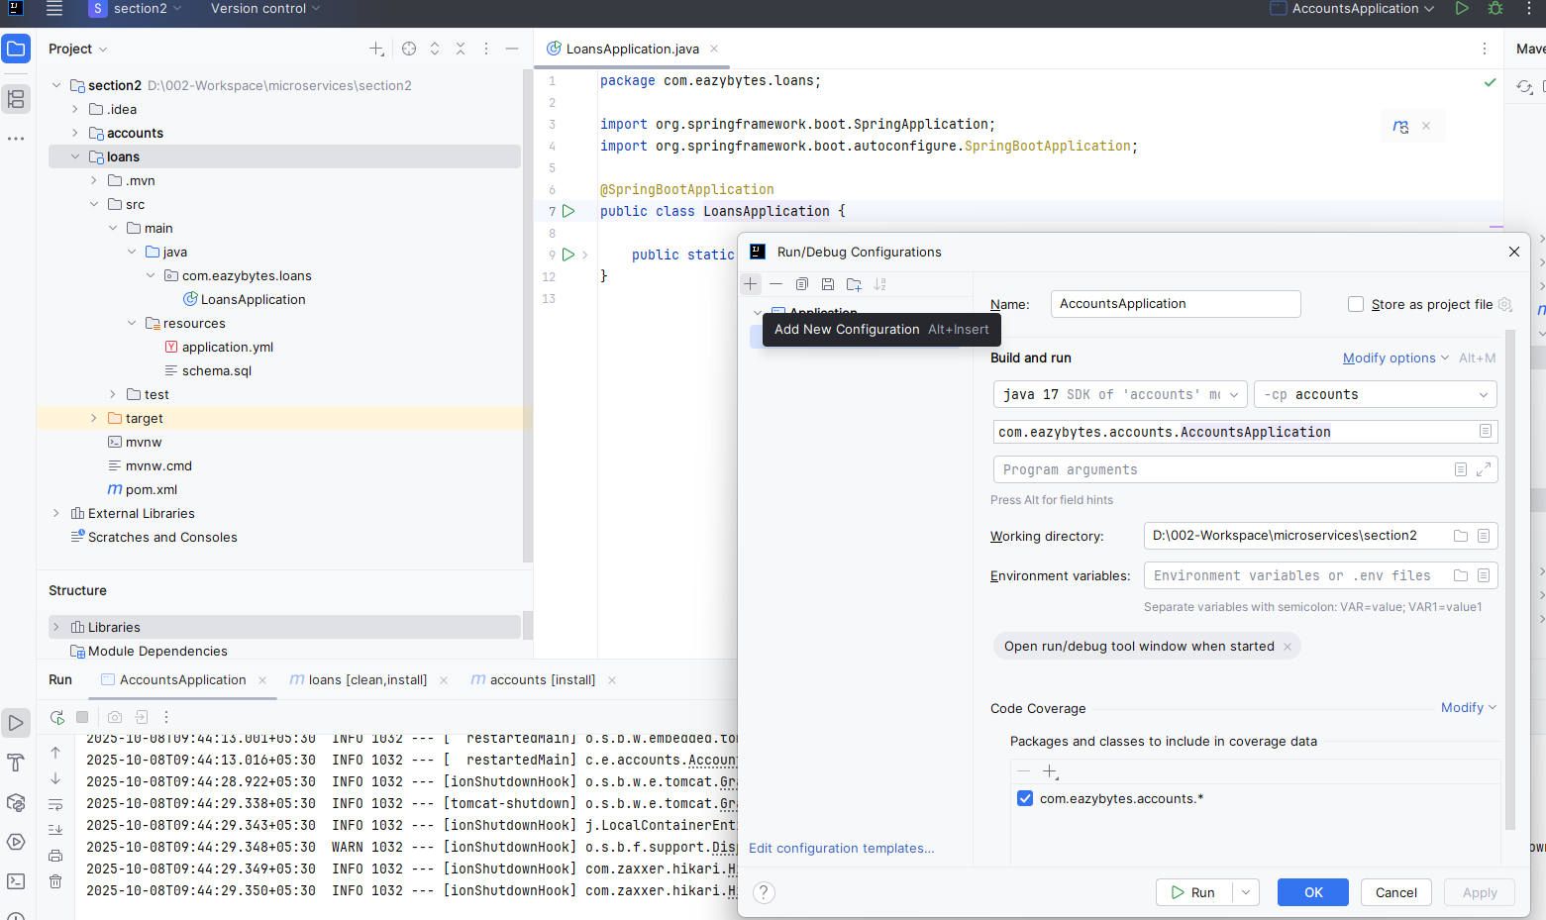

Or use the Copy Configuration and then change as requried

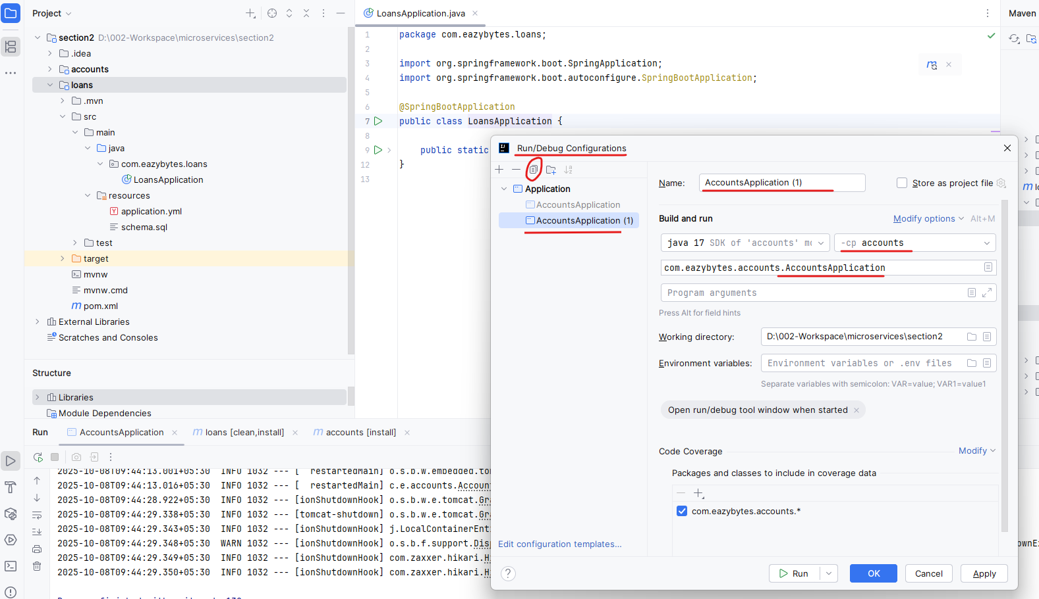

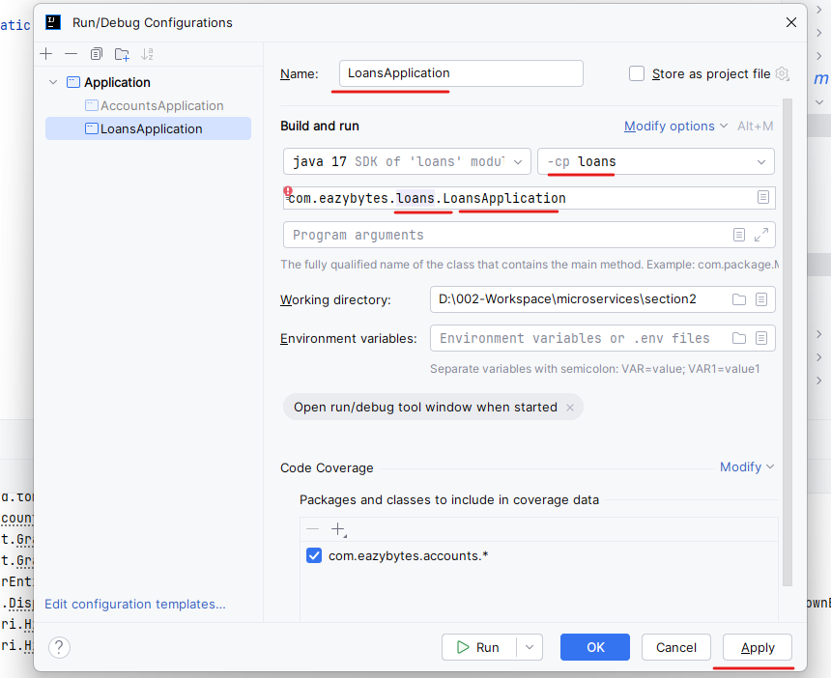

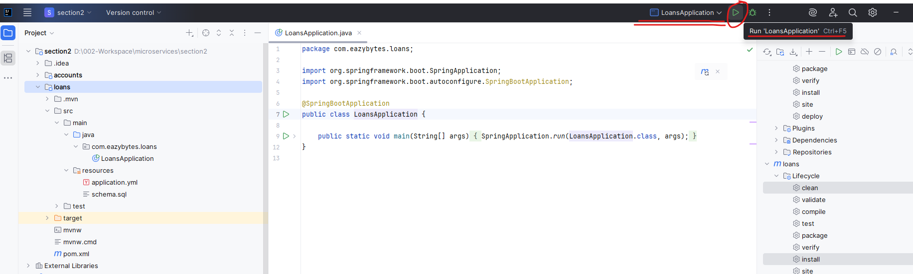

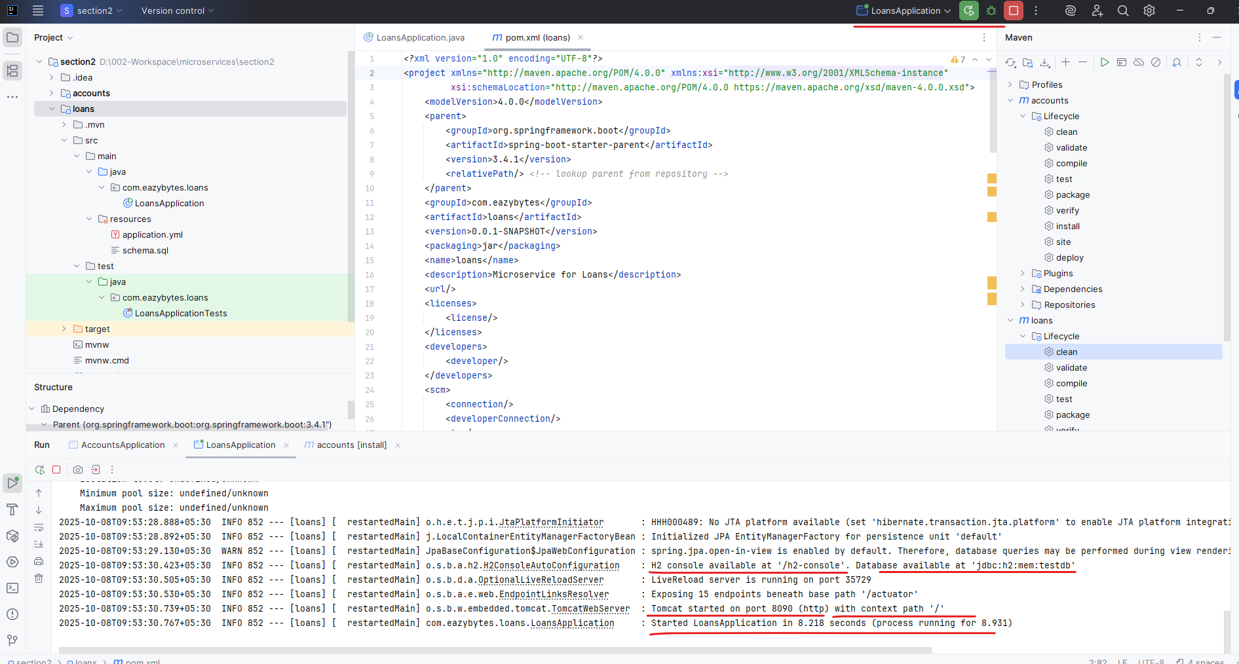

See the tables

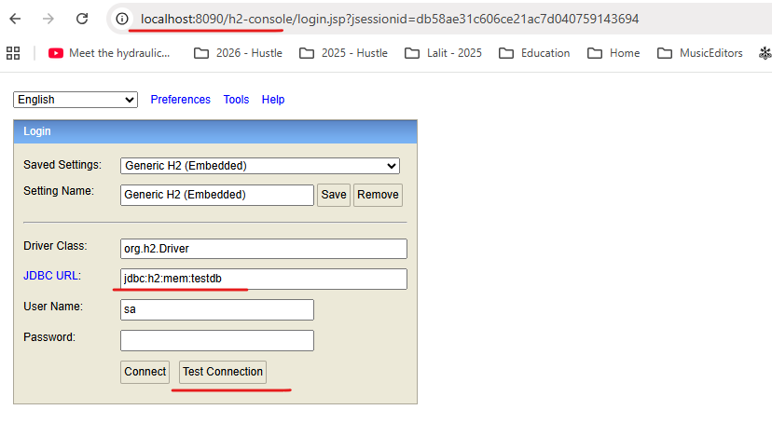

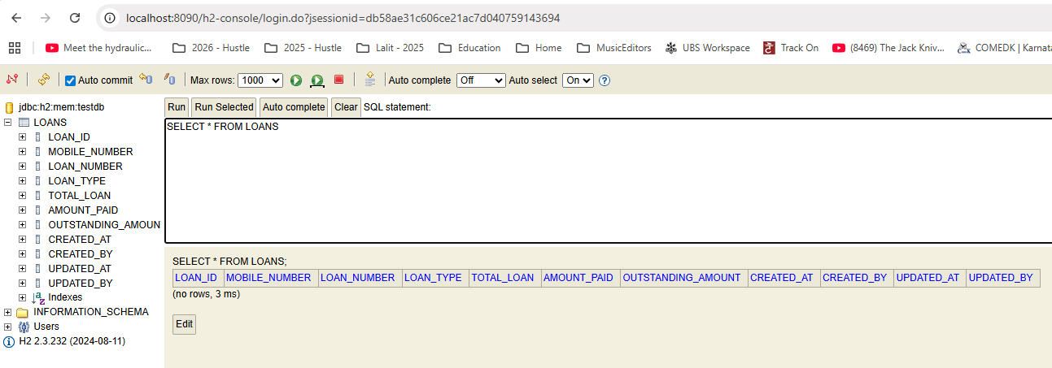

### JPA Entities and Repositories

#### BaseEntity, Entity

Now for this database table we need to create the JPA entities and repositories. If you can open these entity package. As usual there is a base entity class with all the metadata related columns. And along with that I have also mentioned the auditing related columns like created at created by last modified date and last modified by.

package com.eazybytes.loans.entity;

import jakarta.persistence.Column;

import jakarta.persistence.EntityListeners;

import jakarta.persistence.MappedSuperclass;

import lombok.Getter;

import lombok.Setter;

import lombok.ToString;

import org.springframework.data.annotation.CreatedBy;

import org.springframework.data.annotation.CreatedDate;

import org.springframework.data.annotation.LastModifiedBy;

import org.springframework.data.annotation.LastModifiedDate;

import org.springframework.data.jpa.domain.support.AuditingEntityListener;

import java.time.LocalDateTime;

@MappedSuperclass

@EntityListeners(AuditingEntityListener.class)

@Getter

@Setter

@ToString

public class BaseEntity {

@CreatedDate

@Column(updatable = false)

private LocalDateTime createdAt;

@CreatedBy

@Column(updatable = false)

private String createdBy;

@LastModifiedDate

@Column(insertable = false)

private LocalDateTime updatedAt;

@LastModifiedBy

@Column(insertable = false)

private String updatedBy;

}

So next I'll go to the loans entity. So inside this loans entity very similar to accounts. This is also going to extend base entity. And since loan ID we decided to have as an primary key, we are giving this responsibility of generating the primary key value every time to the Spring Data JPA framework. That's why we need to mention these two annotations.

And with the help of this update ID, we are making sure this is acting as a primary key and post that these are the fields representing each of the column inside that database, and I have not used @Column because the field names and the column names are matching that reason. We don't have to mention @Column annotation.

package com.eazybytes.loans.entity;

import jakarta.persistence.*;

import lombok.*;

@Entity

@Getter @Setter @ToString @AllArgsConstructor @NoArgsConstructor

public class Loans extends BaseEntity {

@Id

@GeneratedValue(strategy = GenerationType.IDENTITY)

private Long loanId;

private String mobileNumber;

private String loanNumber;

private String loanType;

private int totalLoan;

private int amountPaid;

private int outstandingAmount;

}

### Constants Class

public final class LoansConstants {

private LoansConstants() {

// restrict instantiation

}

public static final String HOME_LOAN = "Home Loan";

public static final int NEW_LOAN_LIMIT = 1_00_000;

public static final String STATUS_201 = "201";

public static final String MESSAGE_201 = "Loan created successfully";

public static final String STATUS_200 = "200";

public static final String MESSAGE_200 = "Request processed successfully";

public static final String STATUS_417 = "417";

public static final String MESSAGE_417_UPDATE

= "Update operation failed. Please try again or contact Dev team";

public static final String MESSAGE_417_DELETE

= "Delete operation failed. Please try again or contact Dev team";

// public static final String STATUS_500 = "500";

// public static final String MESSAGE_500

= "An error occurred. Please try again or contact Dev team";

}

### DTO for Entity, Response & ErrorResponse

As a next step, we need to make sure we are creating details for these entities. So like you can see ErrorResponseData which is very similar to Accounts.

**ResponseDto**

package com.eazybytes.loans.dto;

import io.swagger.v3.oas.annotations.media.Schema;

import lombok.AllArgsConstructor;

import lombok.Data;

@Schema(

name = "Response",

description = "Schema to hold successful response information"

)

@Data @AllArgsConstructor

public class **ResponseDto** {

@Schema( description = "Status code in the response" )

private String statusCode;

@Schema( description = "Status message in the response" )

private String statusMsg;

}

**ErrorResponseDto**

package com.eazybytes.loans.dto;

import io.swagger.v3.oas.annotations.media.Schema;

import lombok.AllArgsConstructor;

import lombok.Data;

import org.springframework.http.HttpStatus;

import java.time.LocalDateTime;

@Data @AllArgsConstructor

@Schema( name = "ErrorResponse", description = "Schema to hold error response information" )

public class ErrorResponseDto {

@Schema( description = "API path invoked by client" )

private String apiPath;

@Schema( description = "Error code representing the error happened" )

private HttpStatus errorCode;

@Schema( description = "Error message representing the error happened" )

private String errorMessage;

@Schema( description = "Time representing when the error happened" )

private LocalDateTime errorTime;

}

Coming to the loans DTO, inside this we have fields like mobile number, loan number, loan type, total loan amount paid and outstanding amount. Since I don't want to expose the primary key column which is loan ID, that's why I have not mentioned the loan ID related field inside the duo. I only want to send business related information, but not technical information to my clients. That's one of the advantage that we have with the DTO pattern. Apart from these fields, you can also observe that I have also used the open API specification related annotations like @Schema and very similarly, I have also mentioned validations with the help of annotations like @NotEmpty @Pattern.

package com.eazybytes.loans.dto;

import io.swagger.v3.oas.annotations.media.Schema;

import jakarta.validation.constraints.NotEmpty;

import jakarta.validation.constraints.Pattern;

import jakarta.validation.constraints.Positive;

import jakarta.validation.constraints.PositiveOrZero;

import lombok.*;

@Schema(name = "Loans", description = "Schema to hold Loan information" )

@Data

public class LoansDto {

@NotEmpty(message = "Mobile Number can not be a null or empty")

@Pattern(regexp="(^$|[0-9]{10})",message = "Mobile Number must be 10 digits")

@Schema( description = "Mobile Number of Customer", example = "4365327698" )

private String mobileNumber;

@NotEmpty(message = "Loan Number can not be a null or empty")

@Pattern(regexp="(^$|[0-9]{12})",message = "LoanNumber must be 12 digits")

@Schema( description = "Loan Number of the customer", example = "548732457654" )

private String loanNumber;

@NotEmpty(message = "LoanType can not be a null or empty")

@Schema( description = "Type of the loan", example = "Home Loan" )

private String loanType;

@Positive(message = "Total loan amount should be greater than zero")

@Schema( description = "Total loan amount", example = "100000" )

private int totalLoan;

@PositiveOrZero(message = "Total loan amount paid should be equal or greater than zero")

@Schema( description = "Total loan amount paid", example = "1000" )

private int amountPaid;

@PositiveOrZero(message = "Total outstanding amount should be equal or greater than zero")

@Schema( description = "Total outstanding amount against a loan", example = "99000" )

private int outstandingAmount;

}

And here there are new annotations like @positive, which will make sure we are accepting only positive numbers. Even zero also is not allowed whenever you are using positive and very. Similarly, we also have an annotation with the name positive or zero. Whenever we are using this validation annotation, that means we are okay to accept zero and greater than zero values, but not the negative numbers.

### RestController class

As usual, we need to go to the Controller class inside the Controller class. First, I make sure I have used the accurate @RestController annotation, followed by what is the @RequestMapping for this? Also, the prefix is going to be @API and these APIs are also going to produce Json format. After that you can see I have injected loanService related bean into this controller and there are four different APIs.

Inside this controller class there is a createLoan which will accept the mobileNumber based upon the mobile number, it is going to create a new loan. Please make sure you are giving the same mobile number that you have used for Accounts Microservice. Because in coming sections using the same mobileNumber, we are going to fetch all the records present inside the accounts, loans and cards Micro service by using various concepts available inside the Spring Cloud project. So this is the story of createLoan. Now coming to the fetchLoan details using the mobileNumber. It is going to fetch the loan details from the database, and it is going to return the same to the client application and post that. We also have update operation with the name updateLoanDetails. And this is going to accept a loan studio as an request body. And using these all the loans details will be updated in the database. And once the update operation is successful, we are going to return 200. Otherwise we are going to return the status as expectation failed with the status 417 and the corresponding message. And at last we also have delete operation with the name delete loan details that is going to accept mobile number as the input and based upon the input, we are going to fetch the loan details and delete them. Once the delete operation is successful, we are going to send the 200 response. Apart from this business logic, I'm also assuming you observe these OpenAPI specification related annotations like API response operation. So this is going to be very similar to what we have discussed for Accounts Micro Service only. Make sure you are changing the summary description which is specific to Loans Micro service.

package com.eazybytes.loans.controller;

import io.swagger.v3.oas.annotations.Operation;

import io.swagger.v3.oas.annotations.media.Content;

import io.swagger.v3.oas.annotations.media.Schema;

import io.swagger.v3.oas.annotations.responses.ApiResponse;

import io.swagger.v3.oas.annotations.responses.ApiResponses;

import io.swagger.v3.oas.annotations.tags.Tag;

import jakarta.validation.Valid;

import jakarta.validation.constraints.Pattern;

import lombok.AllArgsConstructor;

import org.springframework.http.HttpStatus;

import org.springframework.http.MediaType;

import org.springframework.http.ResponseEntity;

import org.springframework.validation.annotation.Validated;

import org.springframework.web.bind.annotation.*;

@Tag(

name = "CRUD REST APIs for Loans in EazyBank",

description = "CRUD REST APIs in EazyBank to CREATE, UPDATE, FETCH AND DELETE loan details"

)

@RestController

@RequestMapping(path = "/api", produces = {MediaType.APPLICATION_JSON_VALUE})

@AllArgsConstructor

@Validated

public class LoansController {

private ILoansService iLoansService;

@Operation(

summary = "Create Loan REST API",

description = "REST API to create new loan inside EazyBank"

)

@ApiResponses({

@ApiResponse(

responseCode = "201",

description = "HTTP Status CREATED"

),

@ApiResponse(

responseCode = "500",

description = "HTTP Status Internal Server Error",

content = @Content(

schema = @Schema(implementation = ErrorResponseDto.class)

)

)

}

)

@PostMapping("/create")

public ResponseEntity<ResponseDto> createLoan(@RequestParam

@Pattern(regexp="(^$|[0-9]{10})",

message = "Mobile number must be 10 digits")

String mobileNumber) {

iLoansService.createLoan(mobileNumber);

return ResponseEntity

.status(HttpStatus.CREATED)

.body(new ResponseDto(LoansConstants.STATUS_201, LoansConstants.MESSAGE_201));

}

@Operation(

summary = "Fetch Loan Details REST API",

description = "REST API to fetch loan details based on a mobile number"

)

@ApiResponses({

@ApiResponse(

responseCode = "200",

description = "HTTP Status OK"

),

@ApiResponse(

responseCode = "500",

description = "HTTP Status Internal Server Error",

content = @Content(

schema = @Schema(implementation = ErrorResponseDto.class)

)

)

}

)

@GetMapping("/fetch")

public ResponseEntity<LoansDto> fetchLoanDetails(@RequestParam

@Pattern( regexp="(^$|[0-9]{10})",

message = "Mobile number must be 10 digits")

String mobileNumber) {

LoansDto loansDto = iLoansService.fetchLoan(mobileNumber);

return ResponseEntity.status(HttpStatus.OK).body(loansDto);

}

@Operation(

summary = "Update Loan Details REST API",

description = "REST API to update loan details based on a loan number"

)

@ApiResponses({

@ApiResponse(

responseCode = "200",

description = "HTTP Status OK"

),

@ApiResponse(

responseCode = "417",

description = "Expectation Failed"

),

@ApiResponse(

responseCode = "500",

description = "HTTP Status Internal Server Error",

content = @Content(

schema = @Schema(implementation = ErrorResponseDto.class)

)

)

}

)

@PutMapping("/update")

public ResponseEntity<ResponseDto> updateLoanDetails(@Valid @RequestBody LoansDto loansDto) {

boolean isUpdated = iLoansService.updateLoan(loansDto);

if(isUpdated) {

return ResponseEntity

.status(HttpStatus.OK)

.body(new ResponseDto(LoansConstants.STATUS_200, LoansConstants.MESSAGE_200));

}else{

return ResponseEntity

.status(HttpStatus.EXPECTATION_FAILED)

.body(new ResponseDto(LoansConstants.STATUS_417, LoansConstants.MESSAGE_417_UPDATE));

}

}

@Operation(

summary = "Delete Loan Details REST API",

description = "REST API to delete Loan details based on a mobile number"

)

@ApiResponses({

@ApiResponse(

responseCode = "200",

description = "HTTP Status OK"

),

@ApiResponse(

responseCode = "417",

description = "Expectation Failed"

),

@ApiResponse(

responseCode = "500",

description = "HTTP Status Internal Server Error",

content = @Content(

schema = @Schema(implementation = ErrorResponseDto.class)

)

)

}

)

@DeleteMapping("/delete")

public ResponseEntity<ResponseDto> deleteLoanDetails(@RequestParam

@Pattern( regexp="(^$|[0-9]{10})",

message = "Mobile number must be 10 digits")

String mobileNumber) {

boolean isDeleted = iLoansService.deleteLoan(mobileNumber);

if(isDeleted) {

return ResponseEntity

.status(HttpStatus.OK)

.body(new ResponseDto(LoansConstants.STATUS_200, LoansConstants.MESSAGE_200));

}else{

return ResponseEntity

.status(HttpStatus.EXPECTATION_FAILED)

.body(new ResponseDto(LoansConstants.STATUS_417, LoansConstants.MESSAGE_417_DELETE));

}

}

}

### Service and Impl Class

As a next step, let's go to the LoanServiceImpl. This implementation class is going to implement an interface which is ILoanService. And this is very similar to IAccountService. So it has four methods like createLoan, fetchLoan, updateLoan and deleteLoan. So these abstract methods we have implemented inside these implementation class.

import com.eazybytes.loans.dto.LoansDto;

public interface ILoansService {

/**

*

* @param mobileNumber - Mobile Number of the Customer

*/

void createLoan(String mobileNumber);

/**

*

* @param mobileNumber - Input mobile Number

* @return Loan Details based on a given mobileNumber

*/

LoansDto fetchLoan(String mobileNumber);

/**

*

* @param loansDto - LoansDto Object

* @return boolean indicating if the update of card details is successful or not

*/

boolean updateLoan(LoansDto loansDto);

/**

*

* @param mobileNumber - Input Mobile Number

* @return boolean indicating if the delete of loan details is successful or not

*/

boolean deleteLoan(String mobileNumber);

}

And for this class we have auto add the loans repository. If you go and check the loans repository here we have defined two custom methods like findbyMobileNumber and findByLoanNumber. Like you know the primary key inside the loans is loanID. So whenever we have such scenarios where we want to fetch loan records based upon mobileNumber and loanNumber, we need to make sure we are using these custom methods that we have defined inside the loans repository. Now going to the loanService. Simple. Here we have createLoan and inside this createLoan.

package com.eazybytes.loans.service.impl;

import com.eazybytes.loans.constants.LoansConstants;

import com.eazybytes.loans.dto.LoansDto;

import com.eazybytes.loans.entity.Loans;

import com.eazybytes.loans.exception.LoanAlreadyExistsException;

import com.eazybytes.loans.exception.ResourceNotFoundException;

import com.eazybytes.loans.mapper.LoansMapper;

import com.eazybytes.loans.repository.LoansRepository;

import com.eazybytes.loans.service.ILoansService;

import lombok.AllArgsConstructor;

import org.springframework.stereotype.Service;

import java.util.Optional;

import java.util.Random;

@Service

@AllArgsConstructor

public class LoansServiceImpl implements ILoansService {

private LoansRepository loansRepository;

/**

* @param mobileNumber - Mobile Number of the Customer

*/

@Override

public void createLoan(String mobileNumber) {

Optional<Loans> optionalLoans= loansRepository.findByMobileNumber(mobileNumber);

If (optionalLoans.isPresent()){

throw new LoanAlreadyExistsException("Loan already registered with given mobileNumber "+mobileNumber);

}

loansRepository.save(createNewLoan(mobileNumber));

}

/**

* @param mobileNumber - Mobile Number of the Customer

* @return the new loan details

*/

private Loans createNewLoan(String mobileNumber) {

Loans newLoan = new Loans();

long randomLoanNumber = 100000000000L + new Random().nextInt(900000000);

newLoan.setLoanNumber(Long.toString(randomLoanNumber));

newLoan.setMobileNumber(mobileNumber);

newLoan.setLoanType(LoansConstants.HOME_LOAN);

newLoan.setTotalLoan(LoansConstants.NEW_LOAN_LIMIT);

newLoan.setAmountPaid(0);

newLoan.setOutstandingAmount(LoansConstants.NEW_LOAN_LIMIT);

return newLoan;

}

/**

*

* @param mobileNumber - Input mobile Number

* @return Loan Details based on a given mobileNumber

*/

@Override

public LoansDto fetchLoan(String mobileNumber) {

Loans loans = loansRepository.findByMobileNumber(mobileNumber)

.orElseThrow(

() -> new ResourceNotFoundException("Loan", "mobileNumber", mobileNumber)

);

return LoansMapper.mapToLoansDto(loans, new LoansDto());

}

/**

*

* @param loansDto - LoansDto Object

* @return boolean indicating if the update of loan details is successful or not

*/

@Override

public boolean updateLoan(LoansDto loansDto) {

Loans loans = loansRepository.findByLoanNumber(loansDto.getLoanNumber())

.orElseThrow(

() -> new ResourceNotFoundException("Loan", "LoanNumber",

loansDto.getLoanNumber()));

LoansMapper.mapToLoans(loansDto, loans);

loansRepository.save(loans);

return true;

}

/**

* @param mobileNumber - Input MobileNumber

* @return boolean indicating if the delete of loan details is successful or not

*/

@Override

public boolean deleteLoan(String mobileNumber) {

Loans loans = loansRepository.findByMobileNumber(mobileNumber)

.orElseThrow( () -> new ResourceNotFoundException(

"Loan", "mobileNumber", mobileNumber)

);

loansRepository.deleteById(loans.getLoanId());

return true;

}

}

If there is no loan available with a given mobileNumber, we are going to create a new loan by calling the save method. And to this save method we are invoking this createNewLoan method where all the details for the new loans is going to be populated. You can see I'm generating a random two digit number here, because that I'm setting the same loanNumber to the loan object, followed by what is the mobile number? What is the loan type? By default, I'm setting the loanType as home loan and the total loan by default I'm trying to give 100 K dollar or 100 K whatever currency you are using.

public final class LoansConstants {

private LoansConstants() {

// restrict instantiation

}

public static final String HOME_LOAN = "Home Loan";

public static final int NEW_LOAN_LIMIT = 1_00_000;

. . .

}

I'm not sure if you are aware of this format where we can use **underscore inside numerical values**. This is a new feature that got introduced in Java seven or Java eight. So to improve the readability we can mention underscore values like this. But behind the scenes, when my JVM is trying to convert these Java code into byte code, it is going to remove these underscore values. This is amounts that I'm trying to provide for the totalLoan amount. And initially the amount paid is going to be zero and outstanding amount will be 100 K -0 which will be the same which is newLoanAmount. So once the loan is created, save operation will be successful.

### Exception Classes

First we are trying to understand if there are any existing loan details with the given mobile number. If there is any. We are throwing an business exception which is LoanAlreadyExistsException. So this is very similar to AccountsAlreadyExistException.

**LoanAlreadyExistsException.java**

package com.eazybytes.loans.exception;

import org.springframework.http.HttpStatus;

import org.springframework.web.bind.annotation.ResponseStatus;

@ResponseStatus(value = HttpStatus.BAD_REQUEST)

public class LoanAlreadyExistsException extends RuntimeException {

public LoanAlreadyExistsException(String message){

super(message);

}

}

**ResourceNotFoundException.java**

package com.eazybytes.loans.exception;

import org.springframework.http.HttpStatus;

import org.springframework.web.bind.annotation.ResponseStatus;

@ResponseStatus(value = HttpStatus.NOT_FOUND)

public class ResourceNotFoundException extends RuntimeException {

public ResourceNotFoundException(String resourceName, String fieldName, String fieldValue){

super(String.format("%s not found with the given input data %s : '%s'", resourceName, fieldName, fieldValue));

}

}

### Mapper Class

And if you go and observe right now which loan method here based upon the mobileNumber, we are trying to fetch the loan details. If there is no loan details we are throwing ResourceNotFoundException, but if there is a loan available we are going to get the object the entity object form, but we need to convert that into a duo form. That's why I'm using these LoansMapper class and invoking these mapToLoans DTO. So just like how we have AccountsMapper very similarly here also we have these map methods which is going to accept loans entity and it is going to convert to loans DTO.

LoansMapper.java

package com.eazybytes.loans.mapper;

import com.eazybytes.loans.dto.LoansDto;

import com.eazybytes.loans.entity.Loans;

public class LoansMapper {

public static LoansDto mapToLoansDto(Loans loans, LoansDto loansDto) {

loansDto.setLoanNumber(loans.getLoanNumber());

loansDto.setLoanType(loans.getLoanType());

loansDto.setMobileNumber(loans.getMobileNumber());

loansDto.setTotalLoan(loans.getTotalLoan());

loansDto.setAmountPaid(loans.getAmountPaid());

loansDto.setOutstandingAmount(loans.getOutstandingAmount());

return loansDto;

}

public static Loans mapToLoans(LoansDto loansDto, Loans loans) {

loans.setLoanNumber(loansDto.getLoanNumber());

loans.setLoanType(loansDto.getLoanType());

loans.setMobileNumber(loansDto.getMobileNumber());

loans.setTotalLoan(loansDto.getTotalLoan());

loans.setAmountPaid(loansDto.getAmountPaid());

loans.setOutstandingAmount(loansDto.getOutstandingAmount());

return loans;

}

}

### Main Class

package com.eazybytes.loans;

import io.swagger.v3.oas.annotations.ExternalDocumentation;

import io.swagger.v3.oas.annotations.OpenAPIDefinition;

import io.swagger.v3.oas.annotations.info.Contact;

import io.swagger.v3.oas.annotations.info.Info;

import io.swagger.v3.oas.annotations.info.License;

import org.springframework.boot.SpringApplication;

import org.springframework.boot.autoconfigure.SpringBootApplication;

import org.springframework.data.jpa.repository.config.EnableJpaAuditing;

@SpringBootApplication

/*@ComponentScans({ @ComponentScan("com.eazybytes.loans.controller") })

@EnableJpaRepositories("com.eazybytes.loans.repository")

@EntityScan("com.eazybytes.loans.model")*/

@EnableJpaAuditing(auditorAwareRef = "auditAwareImpl")

@OpenAPIDefinition(

info = @Info(

title = "Loans microservice REST API Documentation",

description = "EazyBank Loans microservice REST API Documentation",

version = "v1",

contact = @Contact(

name = "Madan Reddy",

email = "tutor@eazybytes.com",

url = "https://localhost:8080/swagger-ui.html"

),

license = @License(

name = "Apache 2.0",

url = "https://localhost:8080/swagger-ui.html"

)

),

externalDocs = @ExternalDocumentation(

description = "EazyBank Loans microservice REST API Documentation",

url = "https://localhost:8080/swagger-ui.html"

)

)

public class LoansApplication {

public static void main(String[] args) {

SpringApplication.run(LoansApplication.class, args);

}

}

### Service Interface and Impl – Methods Explained

So this way the fetchLoan is going to work. And coming to the updateLoan. We are trying to fetch the loan details with the help of a loan number. Since loan number cannot be changed, we are trying to fetch the details with the help of loanNumber. Once we fetch the details, we will try to convert that into loans. Entity object with the help of this mapper map to loans. So the input is going to be the result DTO and the destination object is going to be whatever we fetched from the database with the help of loanNumber. If you are not able to identify any records, we are going to throw these resourceNotFoundException.

@Service

@AllArgsConstructor

public class LoansServiceImpl implements ILoansService {

private LoansRepository loansRepository;

. . .

@Override

public boolean updateLoan(LoansDto loansDto) {

Loans loans = loansRepository.findByLoanNumber(loansDto.getLoanNumber())

.orElseThrow(

() -> new ResourceNotFoundException("Loan", "LoanNumber",

loansDto.getLoanNumber()));

LoansMapper.mapToLoans(loansDto, loans);

loansRepository.save(loans);

return true;

}

}

At last we are going to invoke the save method, since there is already an record inside the database with the given primary key value, the same method internally is going to do the update operation instead of insert operation. At last, we are going to return a boolean with the value true and deleteLoan is going to be super, super simple. First, we are trying to fetch based upon the mobileNumber. If there is no record, we are throwing ResourceNotFoundException. But if there is a loan record we are trying to delete by ID and to this deleteById, we are passing the what is the primary key value.

@Service

@AllArgsConstructor

public class LoansServiceImpl implements ILoansService {

private LoansRepository loansRepository;

. . .

@Override

public boolean deleteLoan(String mobileNumber) {

Loans loans = loansRepository.findByMobileNumber(mobileNumber)

.orElseThrow( () -> new ResourceNotFoundException(

"Loan", "mobileNumber", mobileNumber) );

loansRepository.deleteById(loans.getLoanId());

return true;

}

}

And this primary key value is loanId, which we fetched from the database by using the find by mobile number method. This way we implemented all the business logic and all the packages are similar. There is a very simple which is going to insert the order name as loans underscore microservice, and there is a constant file with all the relevant constant fields.

### Repository Class

package com.eazybytes.loans.repository;

import com.eazybytes.loans.entity.Loans;

import org.springframework.data.jpa.repository.JpaRepository;

import org.springframework.stereotype.Repository;

import java.util.Optional;

@Repository

public interface LoansRepository extends JpaRepository<Loans, Long> {

Optional<Loans> findByMobileNumber(String mobileNumber);

Optional<Loans> findByLoanNumber(String loanNumber);

}

### AuditAwareImpl.java

package com.eazybytes.loans.audit;

import org.springframework.data.domain.AuditorAware;

import java.util.Optional;

public class AuditAwareImpl implements AuditorAware {

@Override

public Optional getCurrentAuditor() {

return Optional.of("LOANS_MS");

}

}

### LoanConstants.java

package com.eazybytes.loans.constants;

public final class LoansConstants {

private LoansConstants() {

// restrict instantiation

}

public static final String HOME_LOAN = "Home Loan";

public static final int NEW_LOAN_LIMIT = 1_00_000;

public static final String STATUS_201 = "201";

public static final String MESSAGE_201 = "Loan created successfully";

public static final String STATUS_200 = "200";

public static final String MESSAGE_200 = "Request processed successfully";

public static final String STATUS_417 = "417";

public static final String MESSAGE_417_UPDATE= "Update operation failed. Please try again or contact Dev team";

public static final String MESSAGE_417_DELETE= "Delete operation failed. Please try again or contact Dev team";

// public static final String STATUS_500 = "500";

// public static final String MESSAGE_500 = "An error occurred. Please try again or contact Dev team";

}

And we also have exception package where we have GlobalExceptionHandler where we have tried to handle all the input validation failures RuntimeExceptions with this ExceptionHandler. So most of the stuff is very similar to accounts microservice. And I hope it is very, very clear to you.

### Exception Handler

package com.eazybytes.loans.exception;

import com.eazybytes.loans.dto.ErrorResponseDto;

import org.springframework.http.HttpHeaders;

import org.springframework.http.HttpStatus;

import org.springframework.http.HttpStatusCode;

import org.springframework.http.ResponseEntity;

import org.springframework.validation.FieldError;

import org.springframework.validation.ObjectError;

import org.springframework.web.bind.MethodArgumentNotValidException;

import org.springframework.web.bind.annotation.ControllerAdvice;

import org.springframework.web.bind.annotation.ExceptionHandler;

import org.springframework.web.context.request.WebRequest;

import org.springframework.web.servlet.mvc.method.annotation.ResponseEntityExceptionHandler;

import java.time.LocalDateTime;

import java.util.HashMap;

import java.util.List;

import java.util.Map;

@ControllerAdvice

public class GlobalExceptionHandler extends ResponseEntityExceptionHandler {

@Override

protected ResponseEntity<Object> handleMethodArgumentNotValid(

MethodArgumentNotValidException ex, HttpHeaders headers, HttpStatusCode status, WebRequest request) {

Map<String, String> validationErrors = new HashMap<>();

List<ObjectError> validationErrorList = ex.getBindingResult().getAllErrors();

validationErrorList.forEach((error) -> {

String fieldName = ((FieldError) error).getField();

String validationMsg = error.getDefaultMessage();

validationErrors.put(fieldName, validationMsg);

});

return new ResponseEntity<>(validationErrors, HttpStatus.BAD_REQUEST);

}

@ExceptionHandler(Exception.class)

public ResponseEntity<ErrorResponseDto> handleGlobalException(Exception exception,

WebRequest webRequest) {

ErrorResponseDto errorResponseDTO = new ErrorResponseDto(

webRequest.getDescription(false),

HttpStatus.INTERNAL_SERVER_ERROR,

exception.getMessage(),

LocalDateTime.now()

);

return new ResponseEntity<>(errorResponseDTO, HttpStatus.INTERNAL_SERVER_ERROR);

}

@ExceptionHandler(ResourceNotFoundException.class)

public ResponseEntity<ErrorResponseDto> handleResourceNotFoundException(ResourceNotFoundException exception,

WebRequest webRequest) {

ErrorResponseDto errorResponseDTO = new ErrorResponseDto(

webRequest.getDescription(false),

HttpStatus.NOT_FOUND,

exception.getMessage(),

LocalDateTime.now()

);

return new ResponseEntity<>(errorResponseDTO, HttpStatus.NOT_FOUND);

}

@ExceptionHandler(LoanAlreadyExistsException.class)

public ResponseEntity<ErrorResponseDto> handleLoanAlreadyExistsException(LoanAlreadyExistsException exception,

WebRequest webRequest){

ErrorResponseDto errorResponseDTO = new ErrorResponseDto(

webRequest.getDescription(false),

HttpStatus.BAD_REQUEST,

exception.getMessage(),

LocalDateTime.now()

);

return new ResponseEntity<>(errorResponseDTO, HttpStatus.BAD_REQUEST);

}

}

Now as a next step I can go to the loans application. This is my main spring boot class. You can also see that there is a Spring Boot application annotation here. I will try to start the application in a debug mode. Once the application is started in a debug mode, we can go to the postman and we can try to validate the Rest APIs of loans. Microservice. Do you know at what point my application is going to start? It is going to start at the port 8090. This is what we have followed for the loans microservice. Now I'm onto the postman. Like I said before, you can always import the collection from the GitHub repo. If you import the collection by using this file import option, you will get an collection with the name microservice. And here open the loans folder and inside the loans folder you will be able to see very first one which is create loan. So this is a post operation and this is the API path like localhost:8090/api/create. And we are going to pass a query param with the mobileNumber value. So like I said please make sure you are using the same mobileNumber in accounts loans and cards. So there is no validation. Please, please make sure you are trying to follow that. This is just to make sure our life easy. When you try to integrate all these microservices to get a combined response from all the microservices. So I'm clicking on this send button. You see, I got a response saying that 201 loan created successfully.

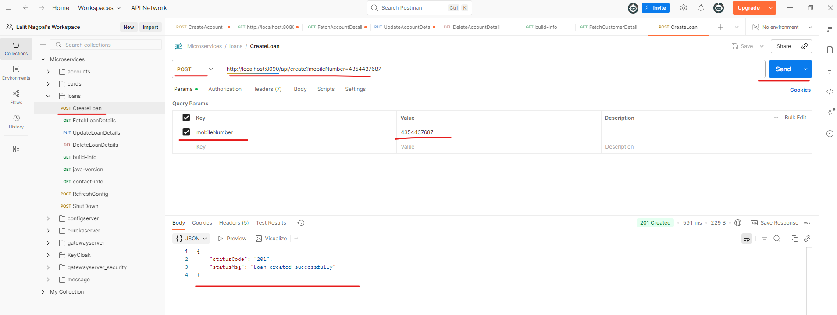

Now taking the same mobileNumber I'll go to the fetchLoan details. And this is a Get operation with the API path fetch. And to this one I'm going to pass the same mobileNumber and I'm clicking on the send button. And you'll be able to see this is the mobileNumber. This is the loan type. Total loan is 100 K. Amount paid is zero. Outstanding amount is 100 K.

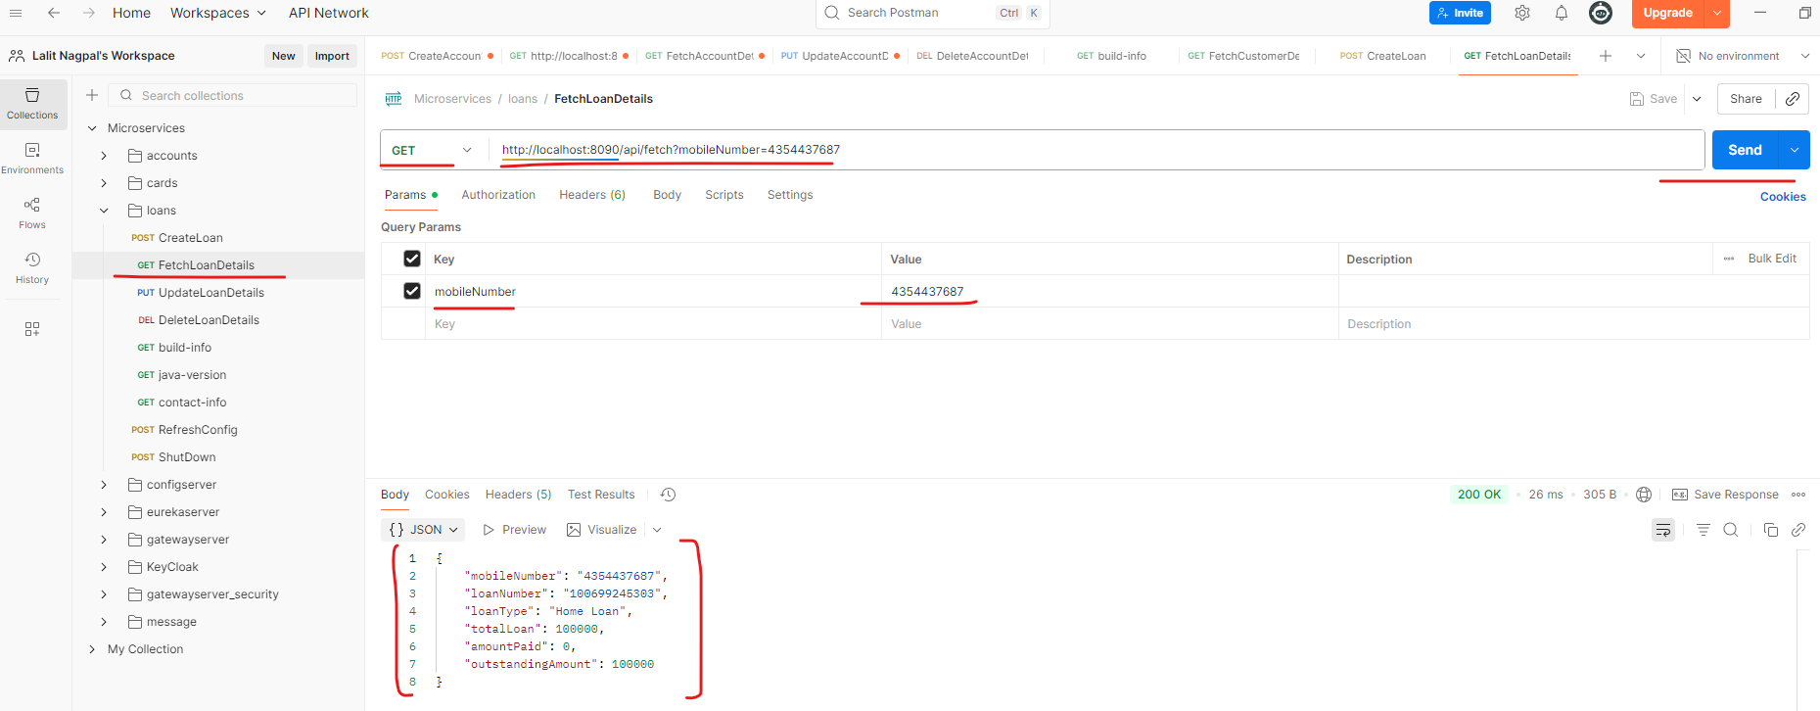

So now I can take this body inside the response. And I'll go to the updateLoanDetails. And here I'm going to paste the body that I have pasted from the previous operation. I'll try to change few details here. Instead of home loan I'll say vehicle loan and amount paid. I'll also make sure I'm mentioning some 10,000 here and outstandingAmount obviously will be 90 K which is 90,000. Now if I try to click on the send button, you can see it is working perfectly. If I try to go and fetch the loan details again, you can see this is the amount paid which is ten k and outstanding amount is 90 k. And loan type also is changed to vehicle loan.

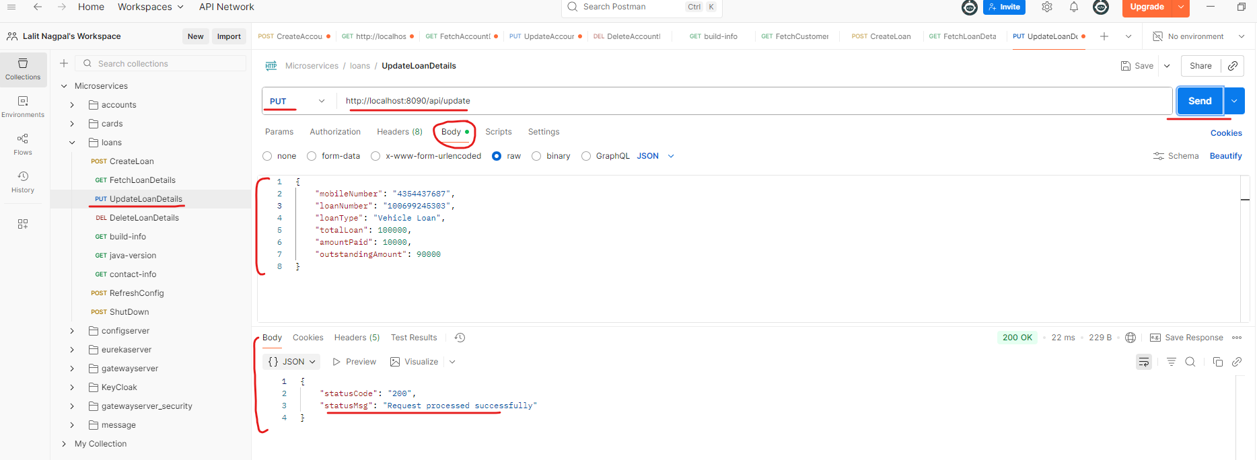

So this is working perfectly. Before I try to delete the loan details, let's test some negative scenarios like inside the updateLoans. If I try to give a negative amount for the total loans and amountPaid and outstandingAmount and loanNumber. Also, I'll try to give some more than 12 digit number if I try to send it. You can see I'm getting all the validation errors, so this is working perfectly even for the fetchLoan details. I'll try to give some nine digit mobileNumber. I'll get a validation error.

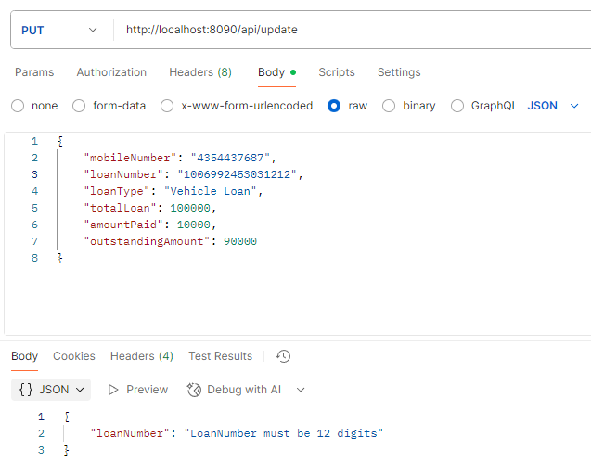

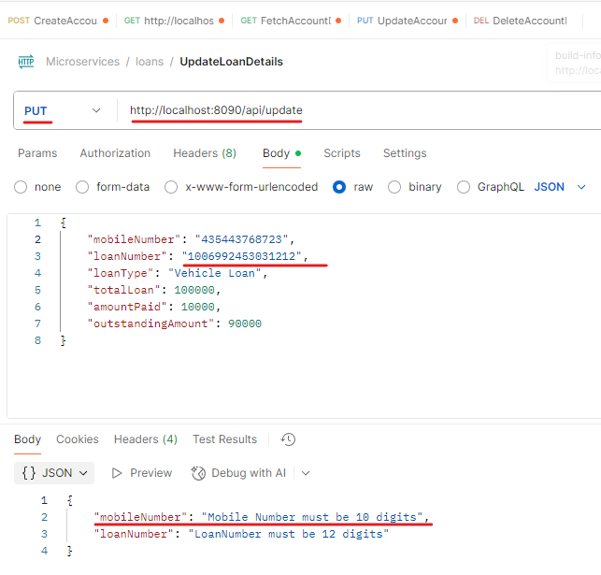

It is working fine. Now. Instead of giving a valid ten digit number, I'll try to give a invalid ten digit number which does not exist inside our database. So with this mobileNumber you can see I'm getting a ResourceNotFoundException which is loan not found with the given input data mobileNumber. So this is also working fine. Let me try to fetch again with a valid mobileNumber I'm able to. Get it here. Now here we can invoke the delete operation and I'm passing the valid mobileNumber. If I try to click send here you can see the loan details are successfully deleted. If I try to fetch the loan details now, you will be getting a not found exception.

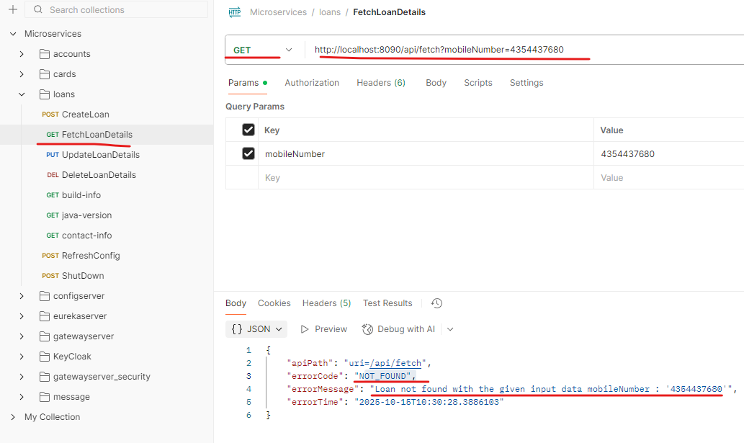

So this confirms all our negative scenarios. Exception handling, business logic. Everything is working perfectly like we expect. I hope you are super super clear and super super happy with the progress that we are making.

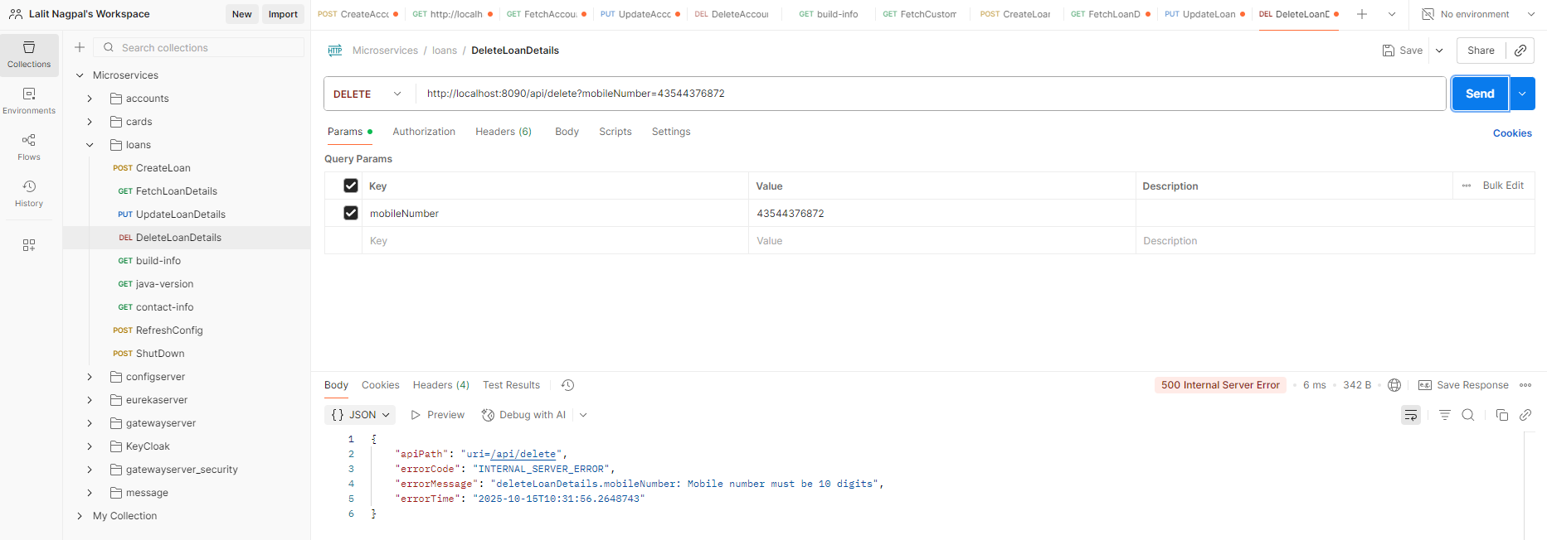

In the next lecture, I'm going to explain very similarly about cards microservice. If you got bored and if you already aware about all these cards microservice, you can skip the next lecture. But if you want to quickly check, I'm fine with that as well. The reason I'm trying to demo all these microservice multiple times is so that all the business logic and the coding standards that we have followed will enter into your subconscious memory. The plan is if I try to explain all these three different microservices like accounts, loans and cards, by the end of the course, each concept, each configuration, we are going to repeat three times. One time I'll be showing in the live, which you can see and observe the information and if needed, you can practice the same with the help of two other microservices like cards and loans. But if you want to sit back and enjoy the course, you can also do that. And I'm going to do the same thing three times in three different microservices. That way this is going to be super, super helpful and you will never forget these concepts.

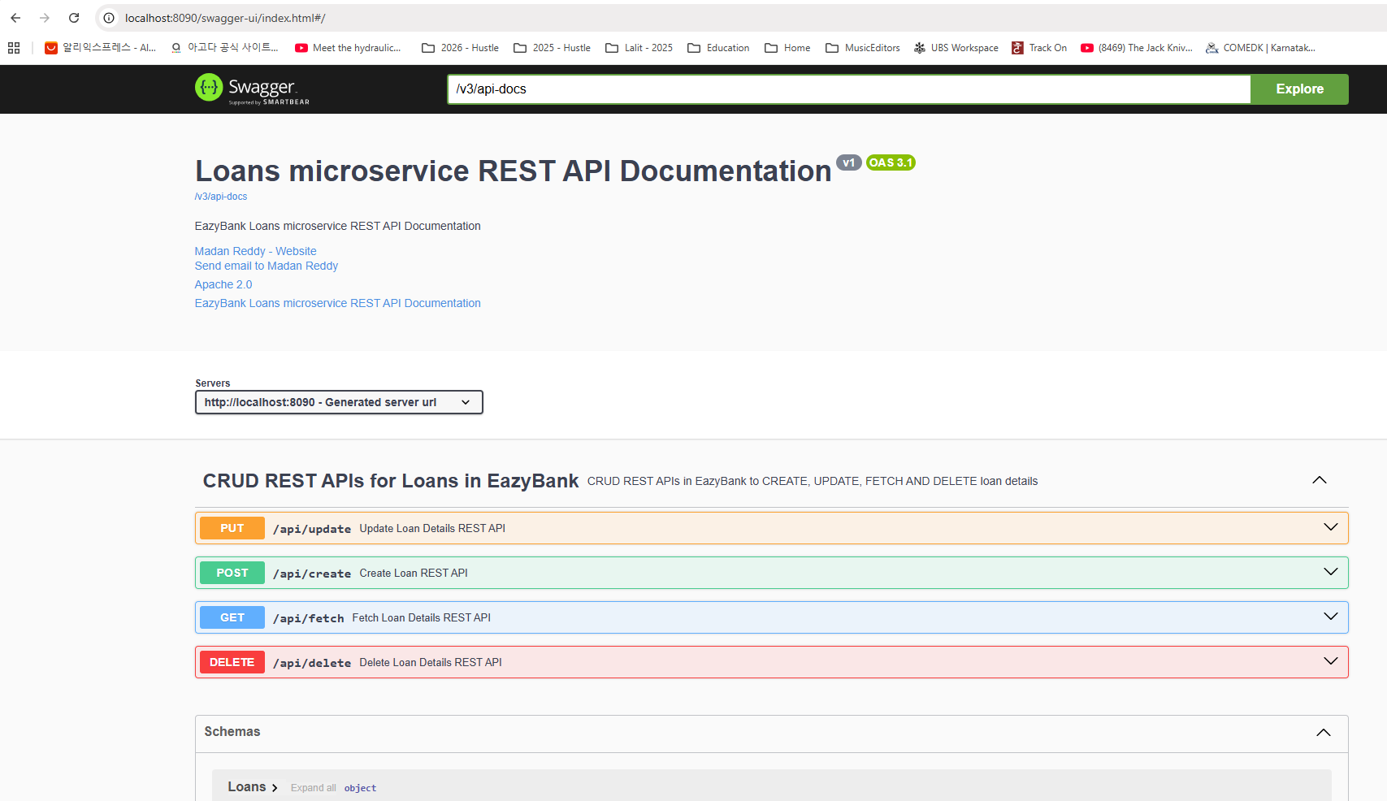

### Project Structure

|  |  |
| --- | --- |
|  |  |

|  |  |
| --- | --- |
|  |  |